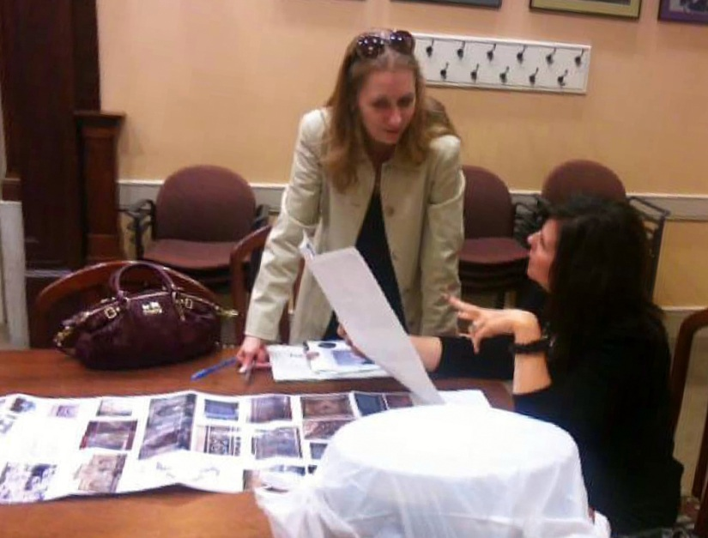
2012 AKP Joint Reception at Harvard

September 24, 2012 – Hosted by Sharon C. Smith, András J. Riedlmayer, and Ophelia Celine, this year's Aga Khan Program reception brought together Documentation Center and library staff, students, postdoctoral scholars, administrators, and faculty from GSAS, the GSD, and MIT.

