Add Assignments to Standing Team Member

Purpose
This document will outline how to add assignments to a standing team member. Standing Team Owners are responsible for making team assignments by role and org which will dictate who defaults on project admin team and who will receive notifications and to-dos for the project.
Note: It is not necessary to add a role unless there are assignments to give since being on the team provide the functionality under the scope.
Access GMAS Gateway
- To access GMAS go to https://gmas.harvard.edu/gmas
- Log in with HarvardKey. The GMAS Homepage will open.
- From the homepage, select the Standing Teams link
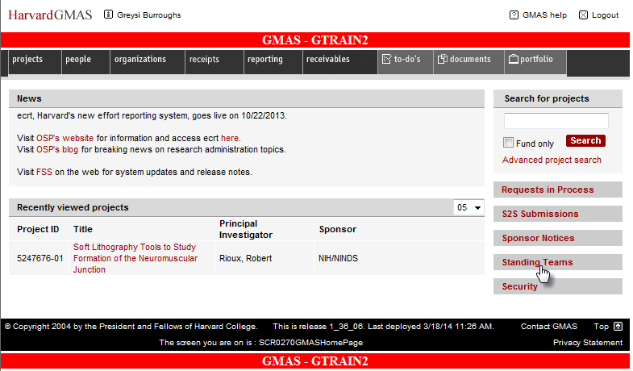

- Enter the standing team name or partial name in the Team Name search bar and select Search
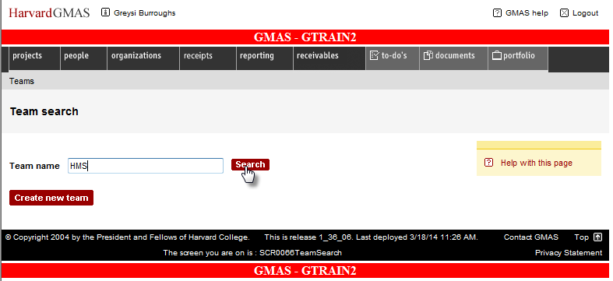
- A list of all the standing teams that match your search will appear; the screen displays 20 per page. Select desired standing team
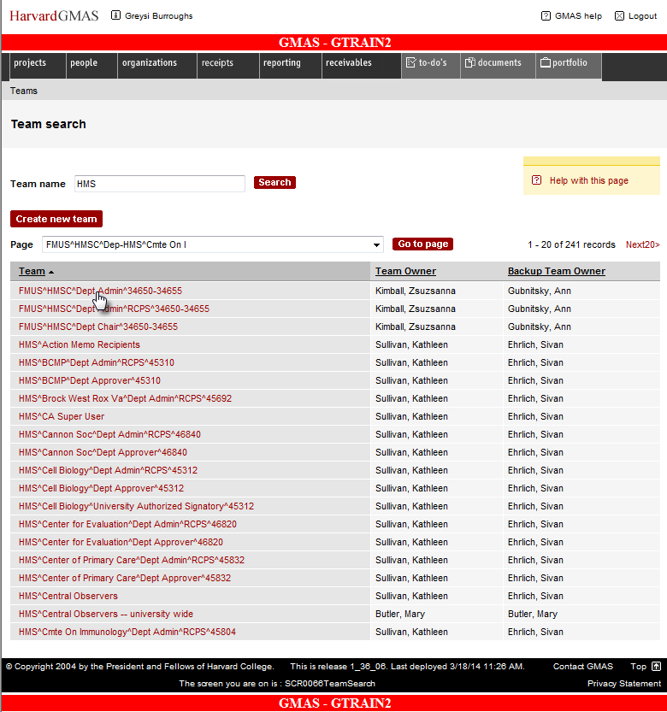

- Select team member that needs new assignment
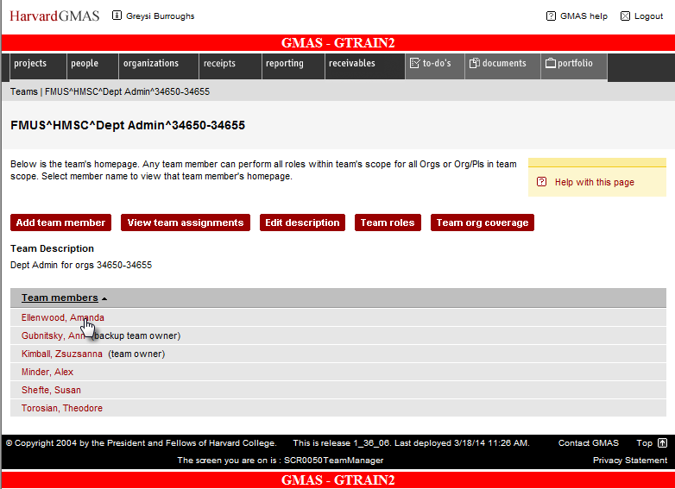

- Click the Add roles button
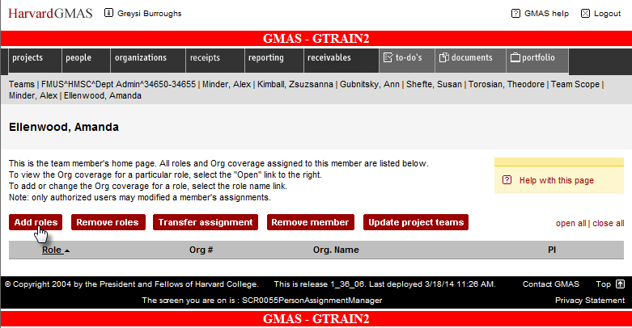

- Select role by checking the box next to it and click OK
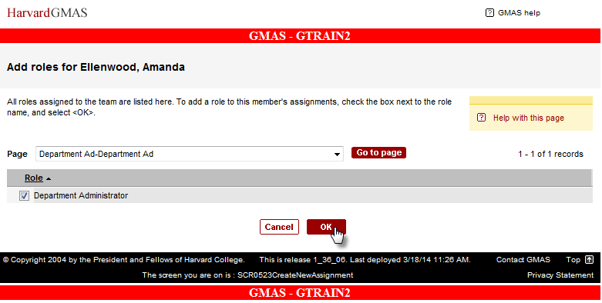

- Click on the new role which is displayed
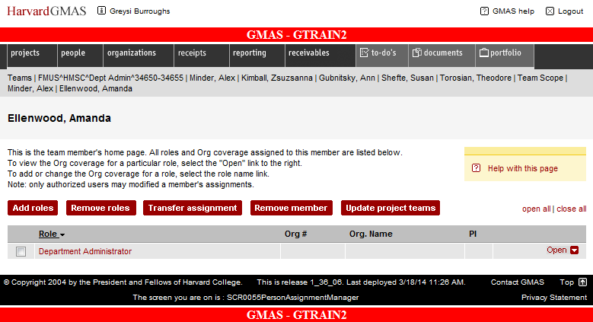

- Click on Add coverage for one or more Orgs or Add full team coverage for all Orgs assigned to team to determine the Org coverage the user should have for this role.
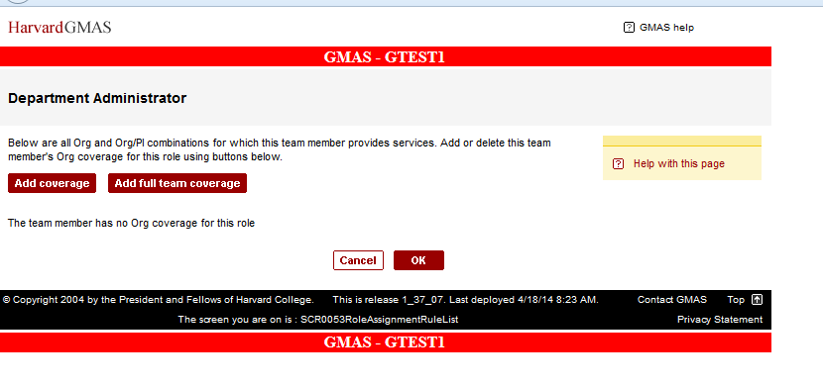

- If selecting Add coverage you will see a screen listing the Org coverage for the team, select the Org(s) you want to add and then click OK.
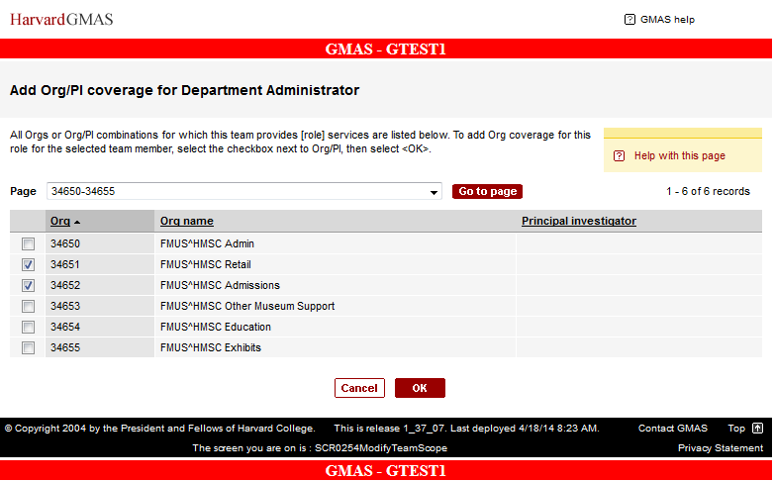

- If you select Add full team coverage you have more options. If you wish to Add full team coverage click Add full team coverage and then click OK. (Note that if you are looking to remove coverage that option is here as well)
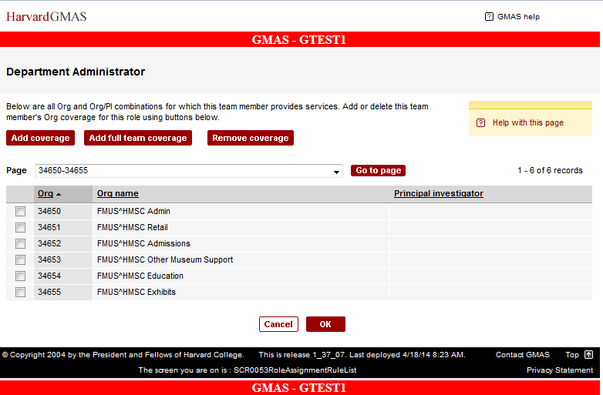

- You are brought back to Member page. Click on the team name.
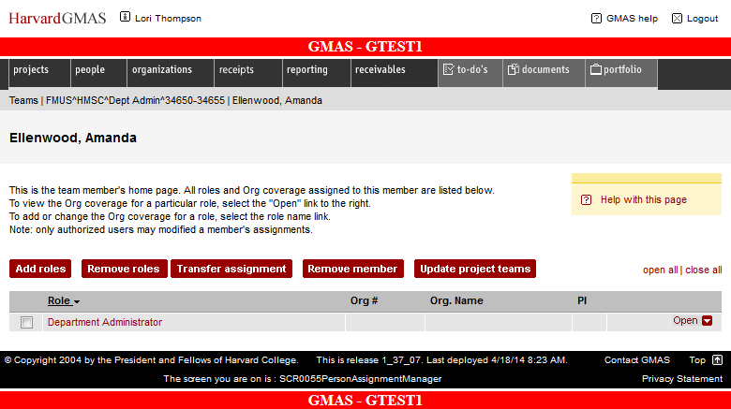

- Click on View team assignments
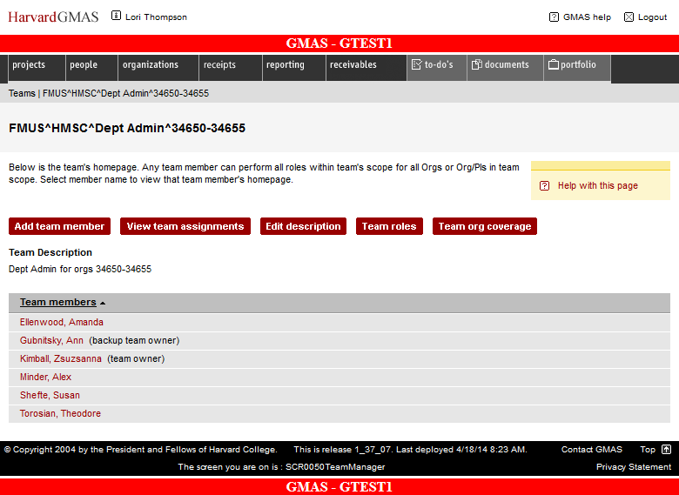
- You will now see the assignments for the team members
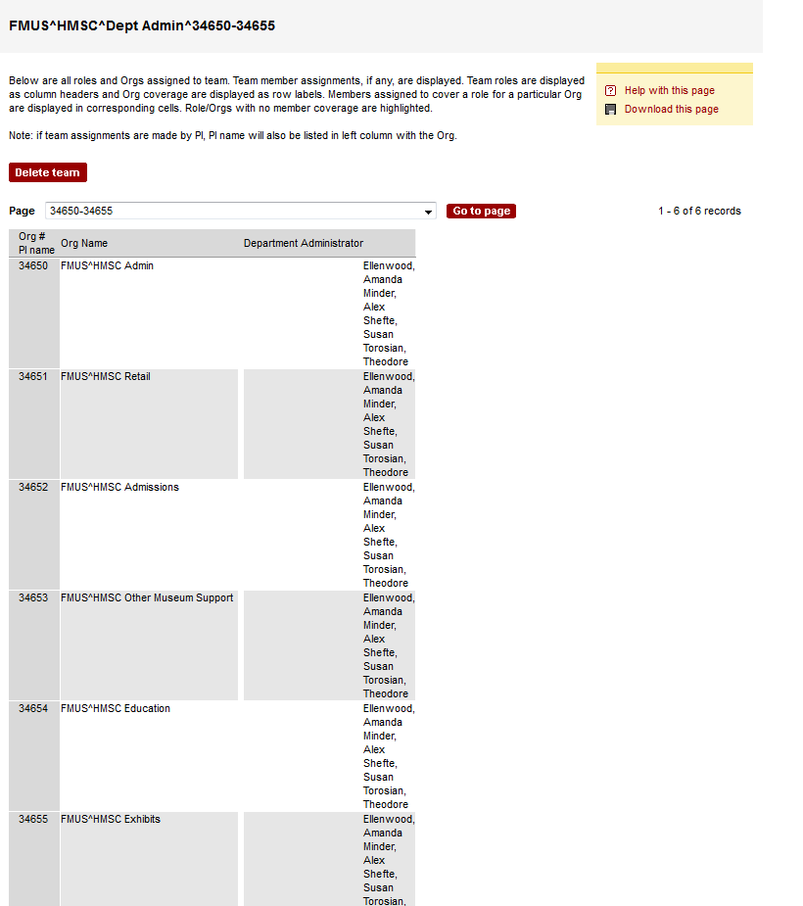

Exiting the Module
Once you have completed your assignments follow these steps to exit GMAS.
To exit the application, click the Logout button in the top right hand corner of the window.
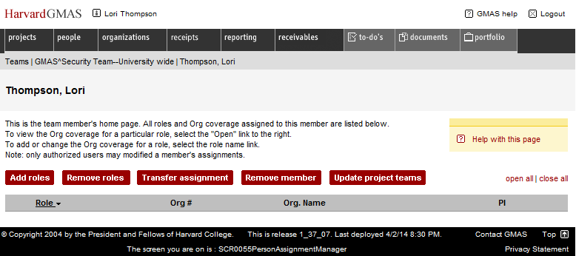
This will log you out of the application.
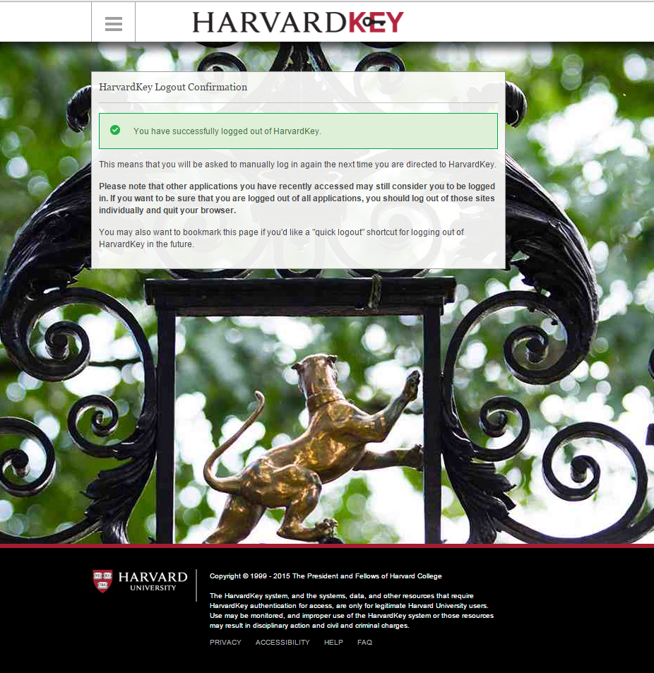

Questions?
If you have any questions, please contact the HUIT Support Center at 617-496-2001, or via email at ithelp@harvard.edu.

