Add User to Standing Team

Purpose
This document will outline how to add a user to a standing team. Standing teams are the mechanism used to give users org permissions in GMAS. When a team is created, team owners are assigned to each team and the owners manage the team membership, a.k.a. users, directly in GMAS, while this service manages the underlying structure of the team when needed.
Access GMAS Gateway
- To access GMAS go to https://gmas.harvard.edu/gmas
- Log in with HarvardKey. The GMAS Homepage will open.
- From the homepage, select the Standing Teams link
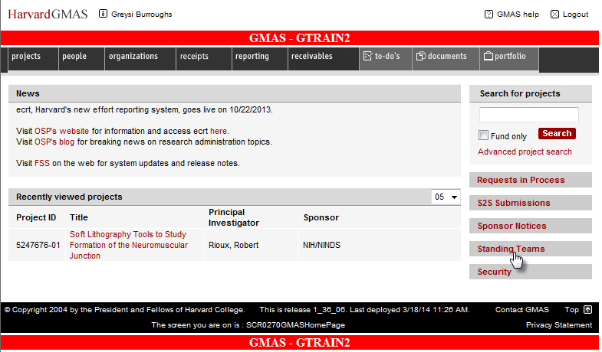

- Enter the standing team name or partial name in the Team Name search bar and select Search
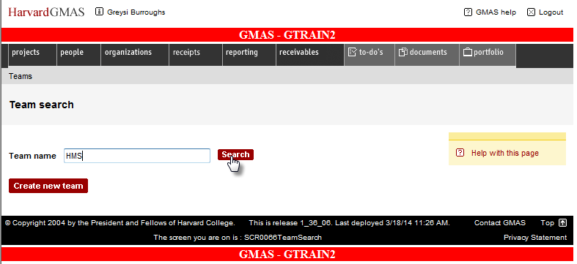
- A list of all the standing teams that match your search will appear; the screen displays 20 per page. Select desired standing team
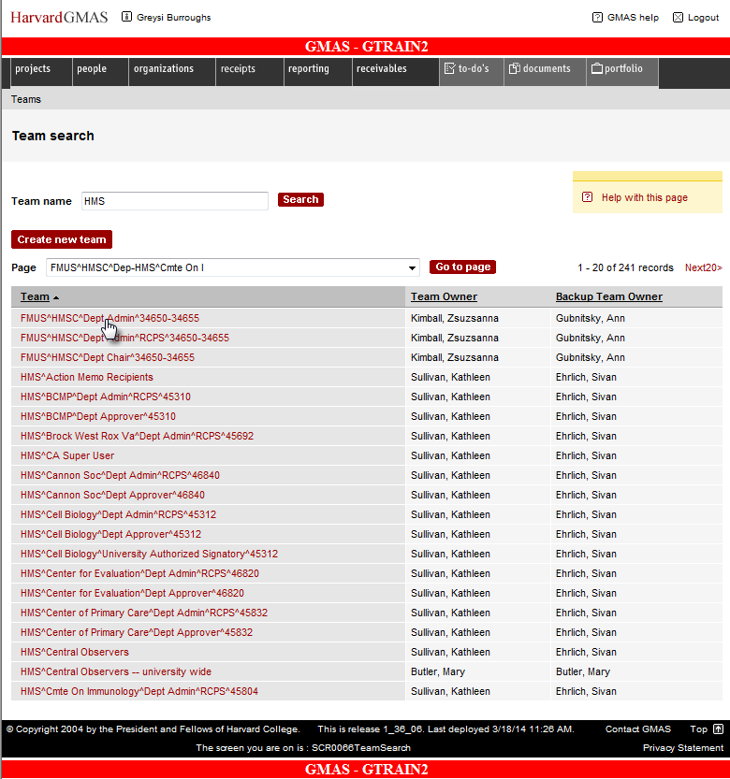

- Select the Add team member link
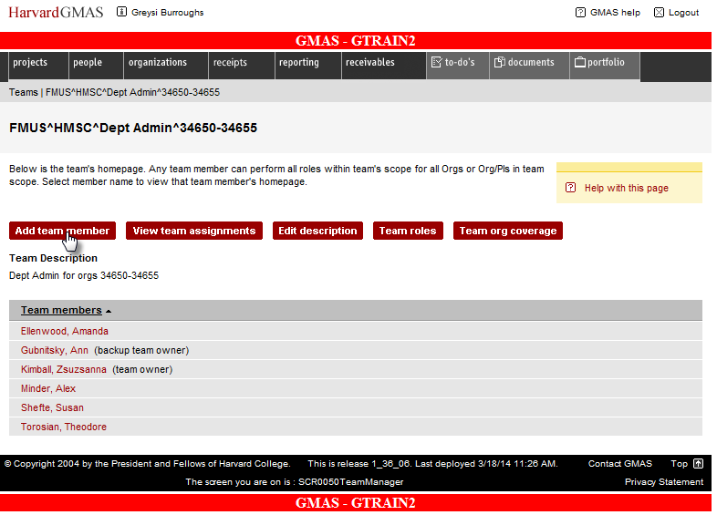

- Search for desired person by entering their HUID or their first name and last name. Click Search. Please note that a user must have their GMAS user flag turned on in order to be added to a team.
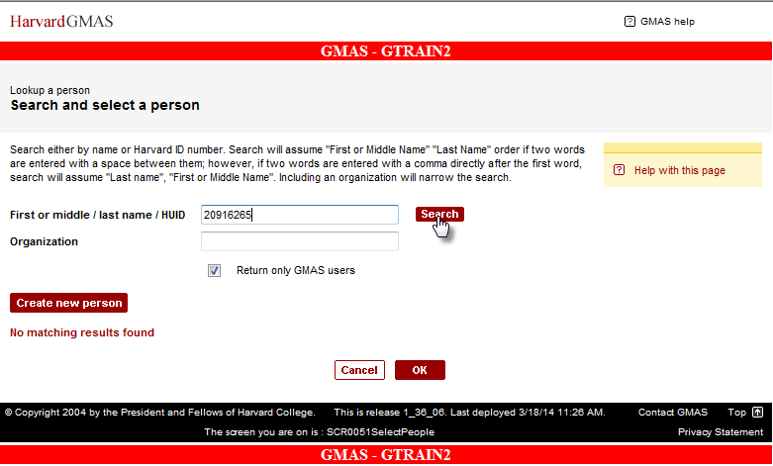

- Select the person by clicking the radio button to the left of their name. Then click OK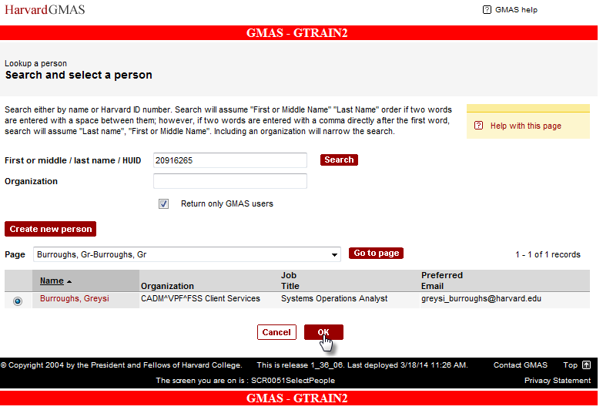

- The person will now appear in the list of team members
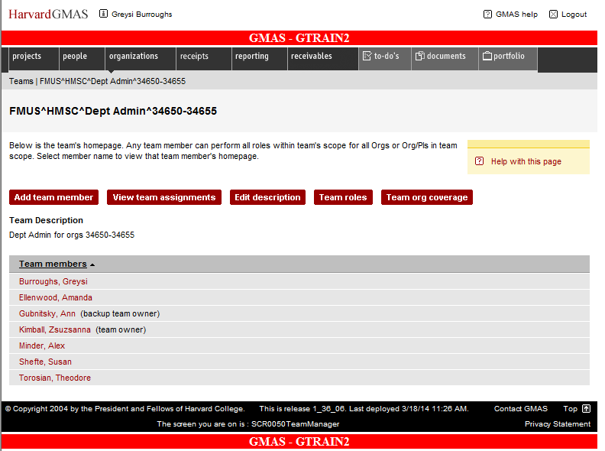

Exiting the Module
Once you have completed your assignments follow these steps to exit GMAS.
To exit the application, click the Logout button in the top right hand corner of the window.
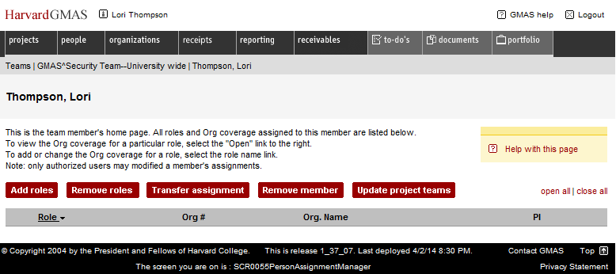
This will log you out of the application.
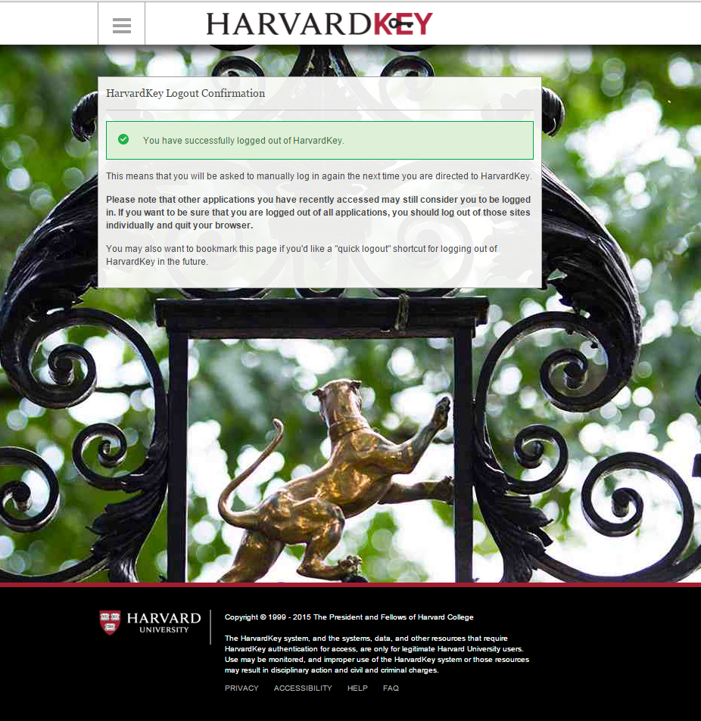

Questions?
If you have any questions, please contact the HUIT Support Center at 617-496-2001, or via email at ithelp@harvard.edu.

