End Dating Your Own Portfolio

Purpose
This document will outline how to end date your own portfolio. You should end date your own portfolio if you are leaving Harvard, you are transferring to a new job at Harvard, or you no longer need access to it. If you need to end date a portfolio for a user other than yourself then you will need to reach out to your authorized requestor and have them submit a request to FSS Client Services.
Access GMAS Gateway
- To access GMAS go to https://gmas.harvard.edu/gmas
- Log in with HarvardKey. The GMAS Homepage will open.
- There are a few ways to access your own portfolio.
  - Click portfolio from the homepage
  - Do a people search from the homepage
  - Search under
- From the homepage, select the People link
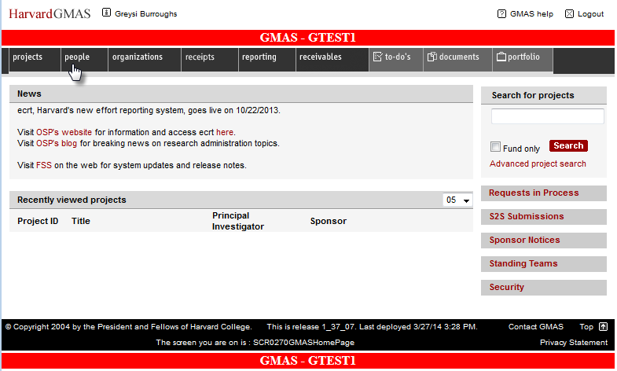

- Enter your name, partial name, or HUID in the search bar and select Search
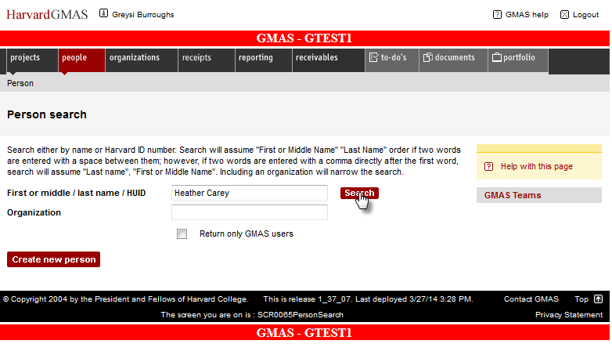
- Your name will appear. Click on the name
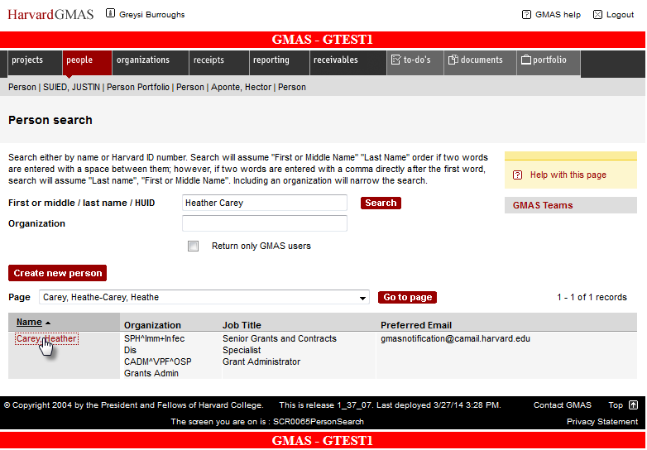

- The person’s profile will appear. Select the link Portfolio
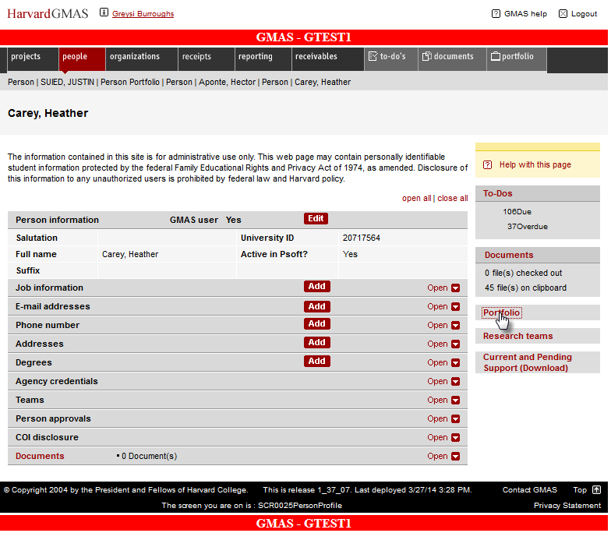

- Click the Reassign project roles button
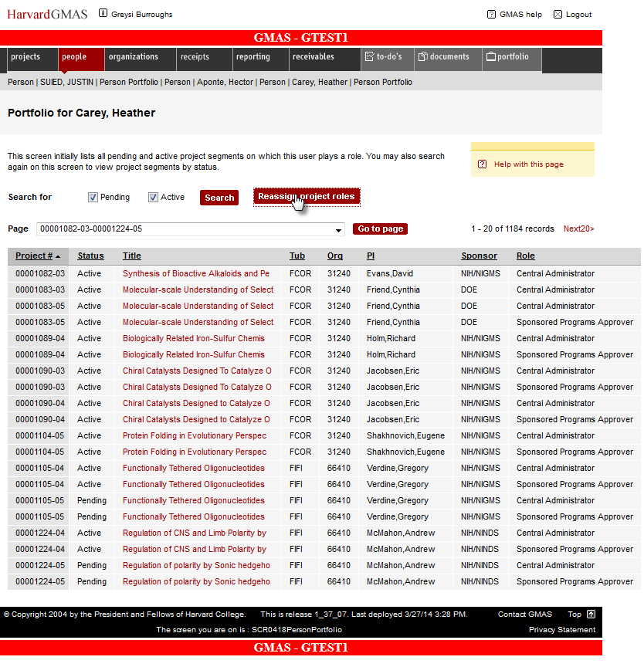

- All the projects assigned to the person will appear. Click the radio button next to End date selected portfolio items. Click on the projects that need to be end dated. In this example all will be end dated
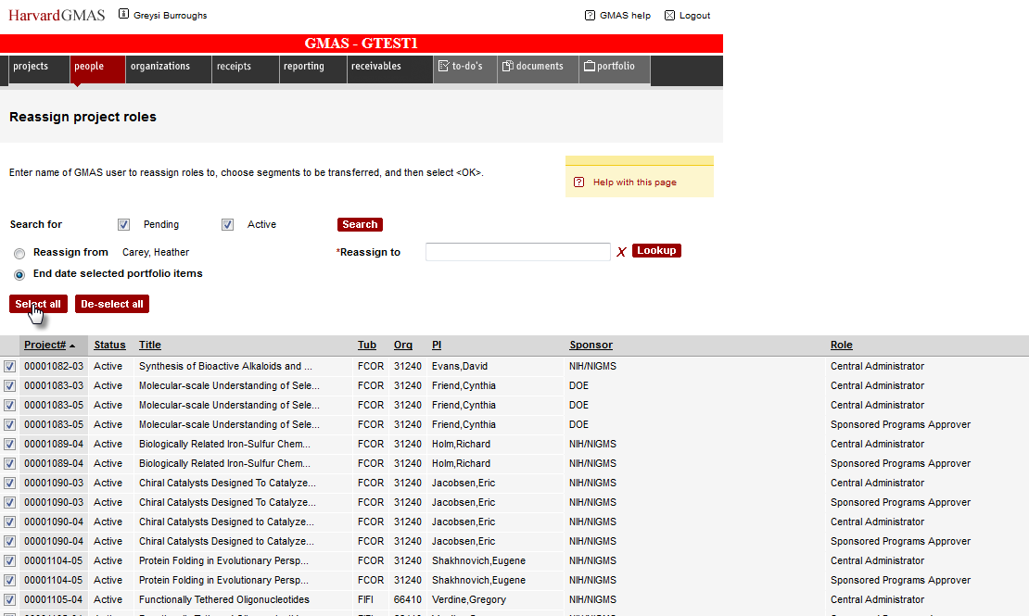

- Scroll to the bottom of the page and click OK to end date selected projects
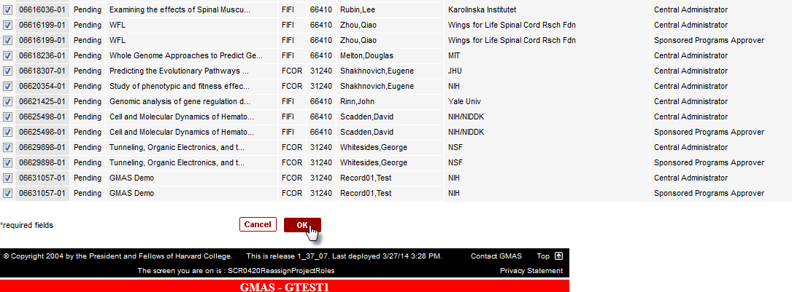

- The person’s portfolio has been end dated
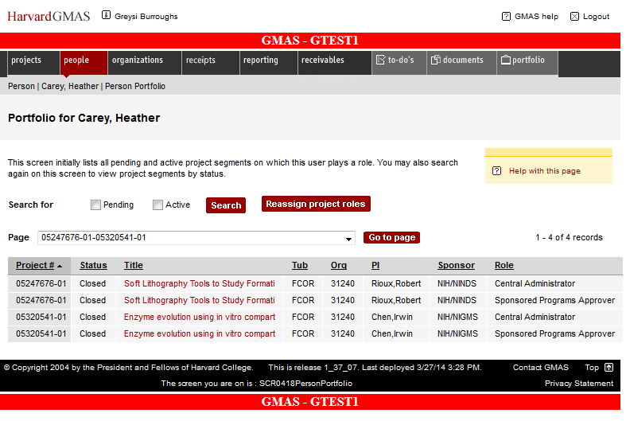

Exiting the Module
Once you have completed your assignments follow these steps to exit GMAS.
To exit the application, click the Logout button in the top right hand corner of the window.
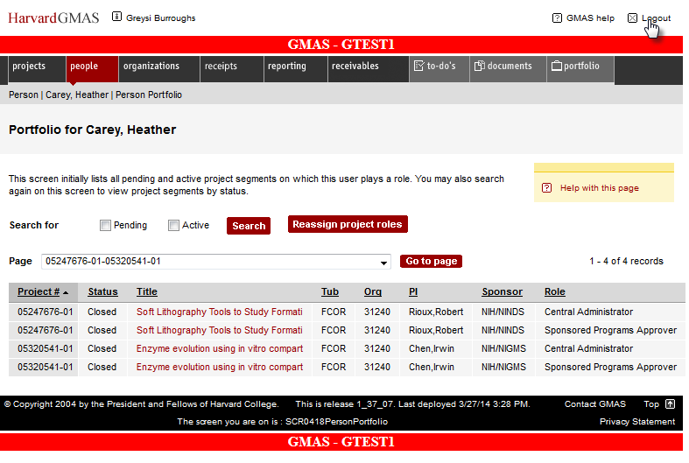
This will log you out of the application.
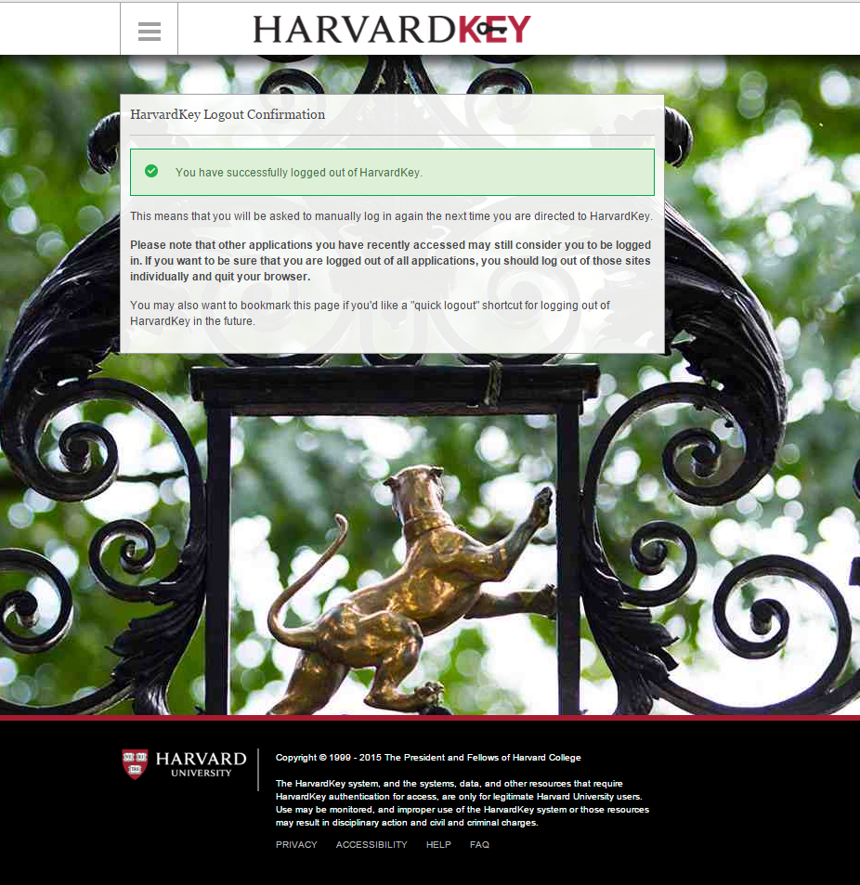

Questions?
If you have any questions, please contact the HUIT Support Center at 617-496-2001, or via email at ithelp@harvard.edu.

