How to Remove User from Standing Team

Purpose
This document will outline how to remove a user from a standing team. Standing Team Owners are responsible for removing users from the standing teams they are own.
Access GMAS Gateway
- To access GMAS go to https://gmas.harvard.edu/gmas
- Log in with HarvardKey. The GMAS Homepage will open.
- From the homepage, select the Standing Teams link
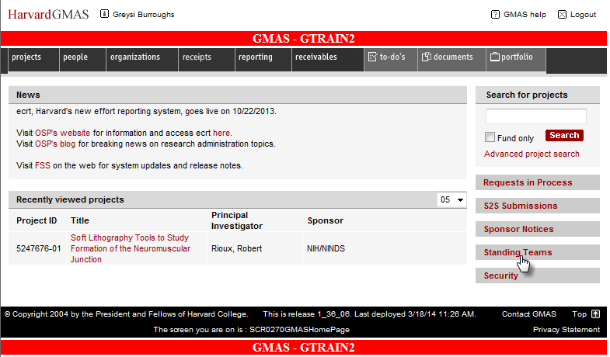

- Enter the standing team name or partial name in the Team Name search bar and select Search
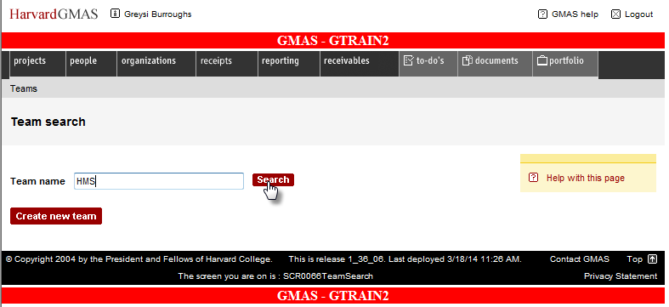
- A list of all the standing teams that match your search will appear; the screen displays 20 per page. Select desired standing team
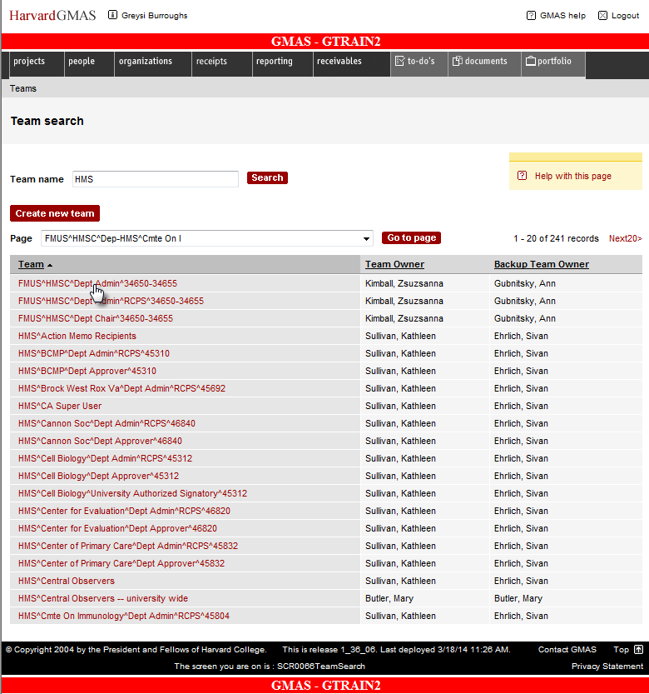

- Click on the team member that needs to be removed from the standing team
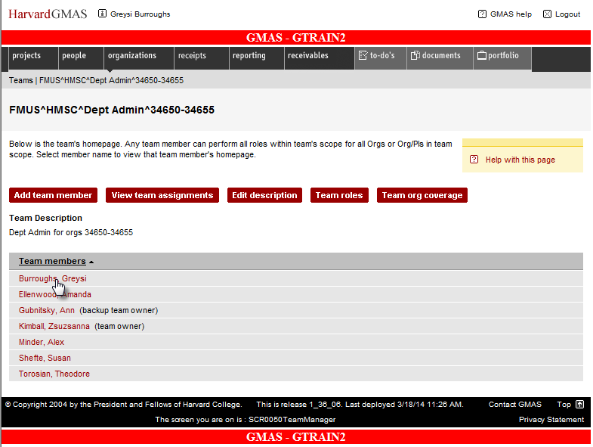

- Select the Remove member link
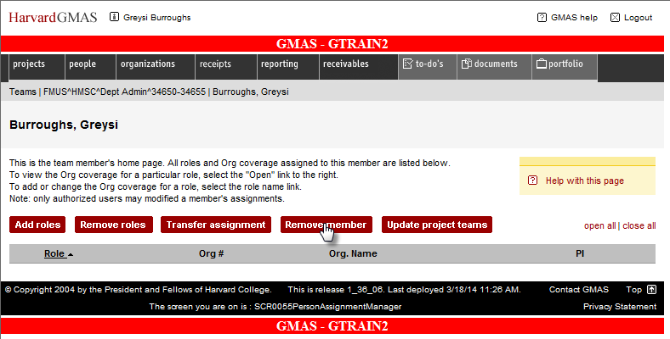

- The person has been removed from the standing team and no longer appears on the list of team members
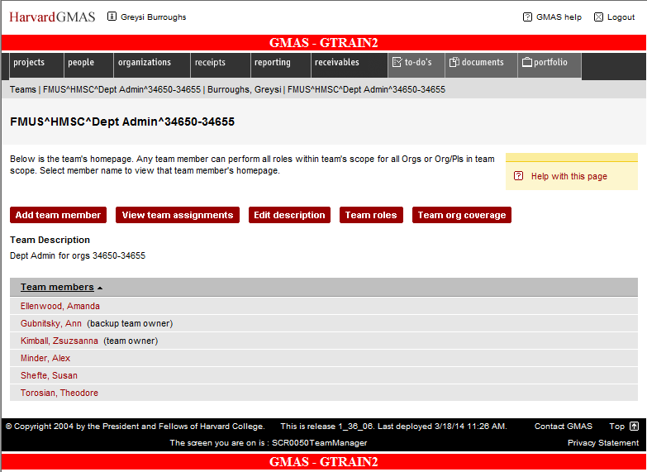

Exiting the Module
Once you have completed your assignments follow these steps to exit GMAS.
To exit the application, click the Logout button in the top right hand corner of the window.
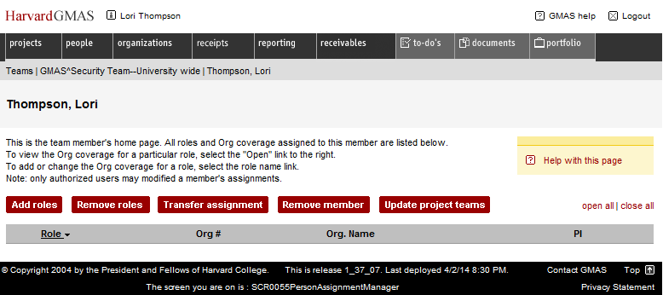
This will log you out of the application.
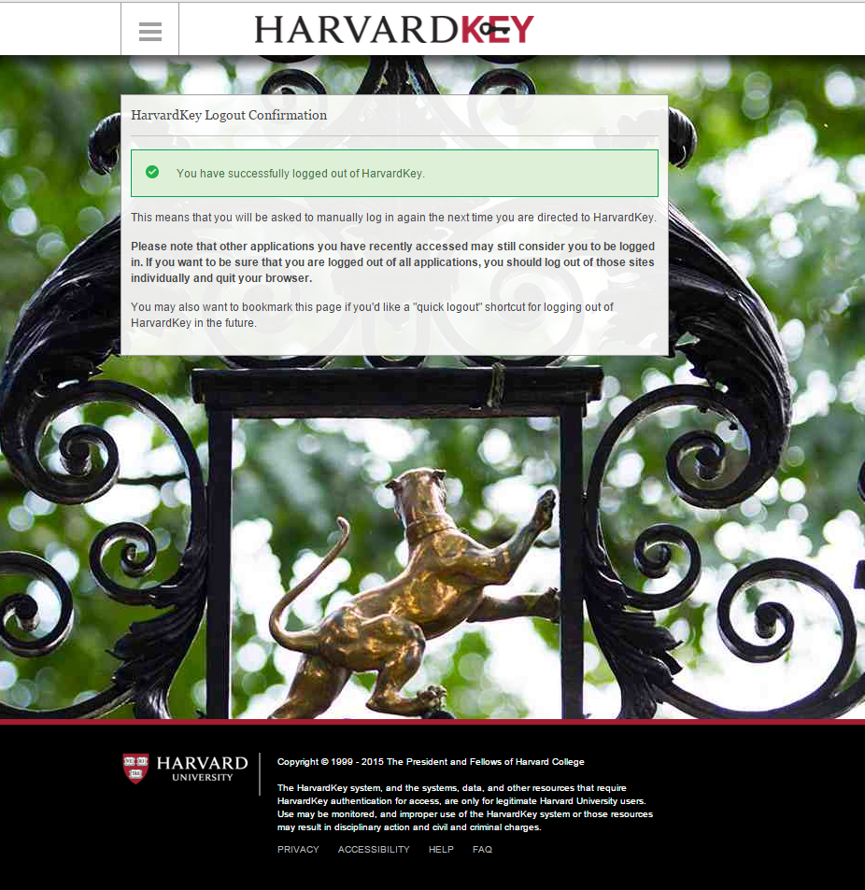

Questions?
If you have any questions, please contact the HUIT Support Center at 617-496-2001, or via email at ithelp@harvard.edu.

