One Way Federation - Leveraging Your Local Credentials
Harvard Medical School and Faculty of Arts & Sciences are Early Adopters
_______________________________________________
Harvard has been building application systems and network services for decades. Unfortunately, it has become more and more laborious for users to navigate through these systems. HARVie, Peoplesoft HR, CREW, GMAS, iSites/iCommons, Hollis – the acronyms and web links are hard to remember, much less each user id and password combination.

That’s why the IAM program came up with an innovative solution for using your native School, department or affiliated organization’s credentials to be able to login into these University central systems and services. Trust negotiation in identity management has been on many vendor and product roadmaps, and is finally becoming a reality between organizations. Harvard IAM introduced a new service in January 2014.

The Problem

People at the Harvard Medical School want to use their native credentials to log in to University applications and network services such as PeopleSoft. Faculty of Arts and Sciences (FAS) users want to use their School user id and password to access GMAS, HARVie and many other Central Administration systems.

People have employed manual techniques for memorizing or documenting the high volume of user ids and passwords needed to gain access to other University and School applications. One member of the IAM program team carries around an Excel spreadsheet with almost 100 sets of credentials.

Because of these problems, users have lost productivity. Their experience is frustrating and confusing. Importantly, security and privacy can also be easily compromised.

The Solution

“One Way Federation” (OWF) is an enhancement to the Harvard Personal Identification Number (PIN) system. As of early January 2014, OWF is now operative in PIN2.

OWF allows HMS users to enter their eCommons name and password to access PIN2 apps such as PeopleSoft HR. OWF also allows FAS and Central Admin users to enter the username and password for desktop and email access for PIN2 enabled applications. This eliminates the need for users to remember their HUID and associated PIN2 passwords.

Harvard Schools, departments, and affiliates can now choose to integrate with the OWF facility. The IAM program is staffed and ready to add other native credentials to PINs. Additional “federation” services and trusts exist when you click on one of the case studies at: http://www.incommon.org/federation/cases.html

You will notice, on the landing page depicted above right, two new radial buttons for the PIN system. It is as simple as clicking one of those radial buttons and re-entering your native credentials:

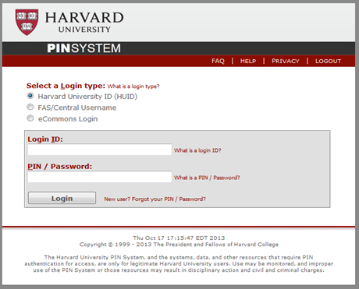
Harvard application owners do not need to take any action to enable this new option for users. PIN2 takes care of this automatically. Also, users can choose to continue to login to their applications with their HUID and PIN/password. If you are interested in these exciting developments, monitor the IAM program website; http://projects.iq.harvard.edu/iam

The Result

CIO Rainer Fuchs of the Harvard Medical School commented on OWF: “It’s particularly important for us at HMS. We have many local applications that need to be accessed by hospital-based individuals without HUIDs, which caused us to create eCommons IDs. They are easy to remember; e.g., rf82 in my case. At the same time, most people need to access PIN protected applications on a regular basis, with harder to memorize numeric HUIDs.

With the new one-way federation in place, users can now use the eCommons IDs they are familiar with to log in to all those applications. Not only does this simplify life for many employees, I believe it also improves security – no need any more to have Post-It notes with user names and passwords stuck to your computer screen!”

IAM Program Director Jason Snyder states “One Way Federation is just a beginning. Users want seamless, secure integration of services. IAM will be an enabler, and not a roadblock. You will see innovative solutions that increase productivity, enhance user experience, and reduce administrative overhead.”

