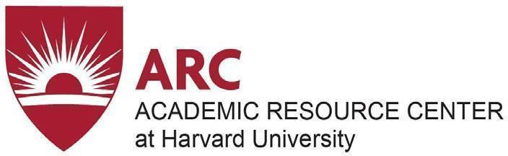
BIRD’S EYE VIEW— SPRING TERM 2021

WEEK | SUN | MON | TUES | WEDS | THURS | FRI | SAT
Dec 27 | 27 | 28 | 29 | 30 | 31 | Jan 1 | 2
Jan 3 | 3 | 4 | 5 | 6 | 7 | 8 | 9
Jan 10 | 10 | 11 | 12 | 13 | 14 | 15 | 16
Jan 17 | 17 | 18 | 19 | 20 | 21 | 22 | 23
Jan 24 | 24 | 25 Classes Start | 26 | 27 | 28 | 29 | 30
Jan 31 | 31 | Feb 1 | 2 | 3 | 4 | 5 No Classes | 6
Feb 7 | 7 | 8 | 9 | 10 | 11 | 12 | 13
Feb 14 | 14 | 15 No Classes | 16 | 17 | 18 | 19 | 20
Feb 21 | 21 | 22 | 23 | 34 | 25 | 26 | 27
Feb 28 | 28 | Mar 1 | 2 | 3 | 4 | 5 | 6
Mar 7 | 7 | 8 | 9 | 10 | 11 | 12 | 13
Mar 14 | 14 | 15 | 16 | 17 | 18 | 19 | 20
Mar 21 | 21 | 22 | 23 | 34 | 25 | 26 | 27
Mar 28 | 28 | 29 | 30 | 31 No Classes | April 1 | 2 | 3
April 4 | 4 | 5 | 6 | 7 | 8 | 9 | 10
Apr 11 | 11 | 12 | 13 | 14 | 15 No Classes | 16 | 17
Apr 18 | 18 | 19 | 20 | 21 | 22 | 23 | 24
Apr 25 | 25 | 26 | 27 | 28 Classes End | 29 | 30 | May 1
May 2 | 2 | 3 | 4 | 5 | 6 Exams Start | 7 | 8
May 15 | 9 | 10 | 11 | 12 | 13 | 14 | 15 Exams End

Harvard University • Academic Resource Center • 1414 Mass Ave 3R • academicresourcecenter.harvard.edu

