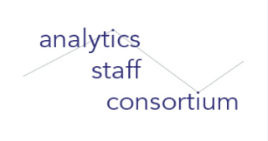

Analytics without Borders:

Conversations with Data-Driven Higher Ed Decision-Makers

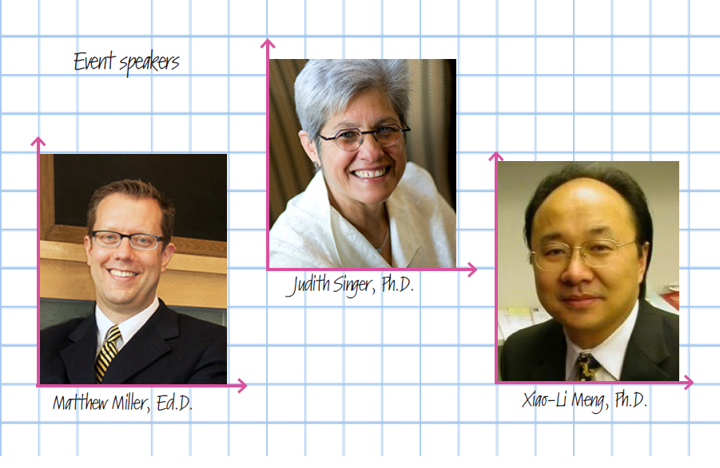

Date: Wednesday, November 15, 2017, 2:00pm to 3:45pm

Location: Askwith Lecture Hall, 1st floor Longfellow Building, 13 Appian Way, Cambridge, MA

Agenda
2:00pm – 2:05pm | Welcome from Victoria Liublinska, Sr. Research Analyst, Office of Institutional Research
2:05pm – 3:05pm | Invited speaker presentations:  - Judith Singer, Senior Vice Provost for Faculty Development and Diversity, James Bryant Conant Professor of Education  - Matthew Miller, Associate Dean for Learning and Teaching, Lecturer on Education  - Xiao-Li Meng, Dean of the Graduate School of Arts and Sciences, Whipple V. N. Jones Professor of Statistics
3:05pm – 3:15pm | Speaker panel Q&A
3:15pm – 3:45pm | Mix and mingle -- Light refreshments will be provided.

ASC web-site http://projects.iq.harvard.edu/analytics_staff_consortium
Mailing list http://calists.harvard.edu/mailman/listinfo/asc

