Colonial North American Project
Curriculum Support: The Colonial North American Project and the Digital Humanities
Approach:

This curriculum support paper offers instructors pedagogical assistance with the Colonial North American Project (CNAP) digital materials. It suggests themes contained within the collection that can be leveraged within existing curriculums either through traditional methods of research and exposition in the humanities and sciences, as well as through the use of tools used in what is commonly known as the digital humanities.

At the heart of this support paper is the assumption that the mass of archival material available digitally will challenge instructors and students to produce creative digital responses that add depth and context to existing scholarship on colonial North America. Ideally, digital uses of this material will also suggest new paths of study.

While this support paper encourages instructors and students to leverage CNAP materials through the digital humanities, it also encourages the association of traditional assignments with new technologies to obtain even greater enhancements in student learning.

Digital tools suggested in this curriculum support draft are free to use, and require at most creating user accounts to access full functionality. In some cases, instructors and students will benefit from requesting the assistance of their Information Technology department to create larger or shareable instances of their projects, or to integrate digital tools into existing classroom learning management systems, such as Blackboard and Canvas.

Themes suggested here are organized along two axes of inquiry—the global and the local—to underscore the power of global forces at play during the colonial era that contributed to forming the rich and diverse inner lives of the individuals who, in turn, reshaped the world around them.

Pairings between themes and digital applications are suggestions only. In most cases, each theme can be paired with one or several other digital applications depending on the projects instructors and students wish to create.

Integrating CNAP materials and digital humanities in the classroom:
- Handwritten archives can be difficult to decipher, even for trained professionals. Documents selected for this draft are legible with only some effort.
- The online collection of the CNAP (as of 11/01/2016) is a growing repository of documents that will have more and more refined ways of searching for particular sets of archival material. Broad searches, however, still reveal plenty of material. For advanced search functions of digitized CNAP materials, see here: http://hollis.harvard.edu/primo_library/libweb/action/search.do?vl(freeText0)=Colonial+North+American+Project+at+Harvard+University.&vl(51615747UI0)=lsr38&vl(394521272UI1)=all_items&vl(1UI0)=exact&fn=search&tab=everything&mode=Basic&vid=HVD&scp.scps=scope%3a(HVD_FGDC)%2cscope%3a(HVD)%2cscope%3a(HVD_VIA)%2cprimo_central_multiple_fe&ct=lateralLinking

- The applications selected for use with CNAP materials and learning modules require some practice before full integration into classroom exercises or research projects, but they do not require advanced computer skills.

- Don’t be afraid to experiment. In much the same way that writing leads to thinking, putting together digital assignments can lead to new and unexpected associations of knowledge.
- Integrate tools, assignments, themes for use in a syllabus when appropriate. No course has to be entirely digital.
Further reading on integrating the digital humanities in classes:
Johanna Cruckers, David Kim, Iman Salehian, Anthony Bushong, eds., “Introduction to Digital Humanities: Concepts, Methods, and Tutorials for Students and Instructors,” UCLA Center for the Digital Humanities, accessed October 29, 2016, http://dh101.humanities.ucla.edu/wp-content/uploads/2014/09/IntroductionToDigitalHumanities_Textbook.pdf
Ryan Cordell, “How Not to Teach the Digital Humanities,” Ryan Cordell (blog), February 1, 2015, accessed October 29, 2016, http://ryancordell.org/teaching/how-not-to-teach-digital-humanities/

Summary: Learning Modules and Digital Tools

Themes | Applications
Curating Digital Materials | Google Docs  Evernote  OneNote  Omeka  DevonThink
The World Around  Maps  Commerce, Contraband, and Piracy  News and Politics  Revolutions | (none)  Storymap JS (story map: storymap.knightlab.com) (alt: Timeline JS, timeline)  Buzzsprout (podcast)  NB (collaborative annotations)
The world Within  Disease  Recovering voices at Harvard | ARC GIS (mapping)  Omeka (curation)
A Final Assignment  Slavery | Story Maps (Storymap: https://storymaps.arcgis.com/en/)

Curating Digital Materials
Considering the CNA project’s growing database of digitally available materials, instructors and students will benefit from simple curation techniques to make the most of these materials.
Curation is an integral part of any digital exercise.
Instructors should encourage students to think of curation as more than listing and data hoarding. Curation is an active process of organization that helps make sense of collections of documents. The process of organizing and categorizing materials is a great way to begin understanding documents by assessing the metadata attached to documents (author, title, date, subject, type of document). A second benefit of curation occurs after assessing the contents of the document and allows for a refinement of the categories of organization once the material has been analyzed. Finally, thoughtful curation helps instructors and students form intellectual links between categories of materials creating a more comprehensive teaching and learning experience.
Online curation can be as simple or sophisticated depending on the user.
A simple example of curation can be copying and pasting links to documents in a Google Doc, or in OneNote.
Here is an example of a preliminary curation and annotation exercise using Microsoft OneNote (free and available for both Windows and MacOS).
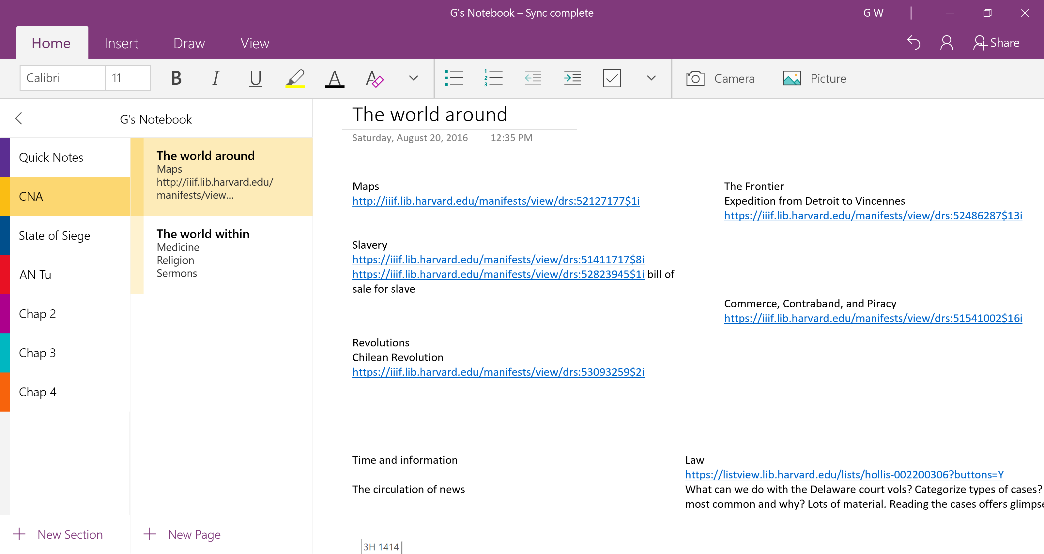
More sophisticated curation can involve using databases such as Devon Think (MacOS only) or Evernote (MacOS and Windows).
For a fantastic tutorial on curating and databases see: Rachel Leow, “on DevonThink and history research (I),” a historian’s craft (blog), October 29, 2016 (9:32 p.m.), https://idlethink.wordpress.com/2011/06/24/on-devonthink-and-history-research-i/

Maps (Working with objects)
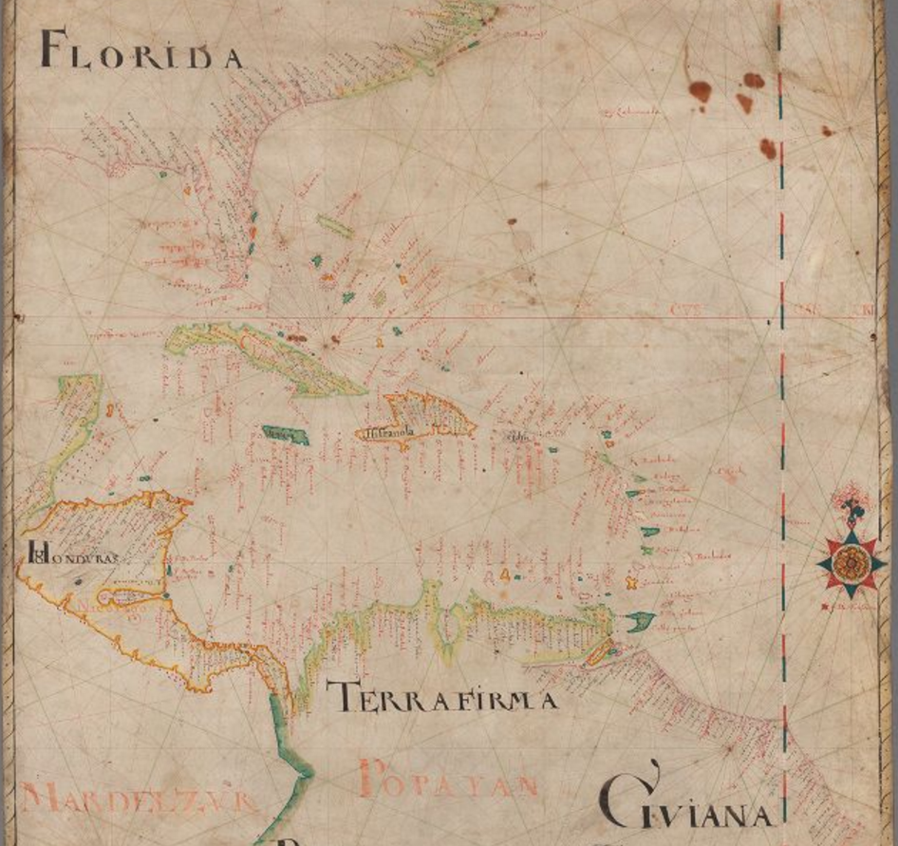
(Nicolas Comberford, active 1612-1670, “[Portolan chart of eastern North and Central America and northern South America]: manuscript, 1659,” Colonial North American Project at Harvard, accessed October 28, 2016, http://colonialnorthamerican.library.harvard.edu/items/show/12046)
CNAP documents:
Nicolas Comberford, active 1612-1670, “[Portolan chart of eastern North and Central America and northern South America]: manuscript, 1659,” Colonial North American Project at Harvard, accessed October 28, 2016, http://colonialnorthamerican.library.harvard.edu/items/show/12046
Manual of Navigation (http://colonialnorthamerican.library.harvard.edu/items/show/8808)
Further Reading:
Michael Gonchar, “Lesson Plan | Analyzing Maps to Better Understand Global Current Events and History,” New York Times, January 13, 2016, accessed October 28, 2016, http://learning.blogs.nytimes.com/2016/01/13/lesson-plan-analyzing-maps-to-better-understand-global-current-events-and-history/?_r=0
The beautiful portolan above is one of only a few visual representations of the Colonial North American world available through the CNAP’s online portal. It is a stunning representation of the Americas in the 17th century. It is also stunning for its representation of numerous points and vectors of contact between people.
Maps are important primary sources that reflect the people, times, and cultures that produced them. They are also learning tools that strengthen visual literacy, critical analysis, and synthetic learning, as well as promote interdisciplinary and creative thinking.
An especially pertinent map during lectures or classroom exercises is a great way of underscoring lecture points and of allowing students to internalize information differently. They are also handy tools to foster collaboration between students and think through problems of space and time visually.
Although the libraries at Harvard University have an impressive number of digitized maps of the 17th and 18th century readily available for use, a visit to the library allows students to get a greater sense of the materials used, the claims mapmakers make, and how maps seek to influence their users. An added benefit of a visit to the library is that students become even more acquainted with the library, research librarians, and archivists.
Exercise: Using HOLLIS+ find two maps available digitally and in hard copy that pique your curiosity. Note their call numbers, first, then jot down your impressions of the map, as well as any other metadata that seems relevant. During your library visit use the call number you noted to look up the map. Compare your impressions of the digital version with the physical copy. Discuss your findings in groups of three or four. What does the map reveal? What kind of materials were used in the creation of the map? Who made it? Why was it made? Is there a message that the map seeks to convey to users?

Commerce, Contraband, and Piracy (Storymap)
CNAP Documents:
Barbados, “A collection of autograph letters and original documents relating to the Island of Barbados in the 18th century, ca. 1730-1778,” http://colonialnorthamerican.library.harvard.edu/items/show/id/9190 (Seq. 1-27)
William Blair Townsend, 1723-1778, “William Blair Townsend letter and receipt books, 1743-1805, bulk 1744-1777,” Colonial North American Project at Harvard, accessed October 28, 2016, http://colonialnorthamerican.library.harvard.edu/items/show/12117
Further reading:
Wim Klooster, Illicit Riches: the Dutch trade in the Caribbean, 1648-1795 (Leiden: KITLV Press, 1998)
Matthew Mulcahy, Hubs of Empire: The Southeastern Lowcountry and British Caribbean (Baltimore: Johns Hopkins UP, 2014)
Jesse Lemisch, “Jack Tar in the Streets; Merchant Seamen in the Politics of Revolutionary America,” William and Mary Quarterly, 25 (1968): 371-407
Thomas Truxes, Defying Empire: Trading with the Enemy in Colonial New York (New Haven: Yale UP, 2008)
Software:
Storymap JS: https://storymap.knightlab.com/
For an in-depth tutorial of Storymap JS: https://www.youtube.com/watch?v=T-C64JO7lMg
Alternative: Timeline JS, https://timeline.knightlab.com
The Barbados and William Townsend series of documents are great place to tease out the global forces of commerce, law, and imperial competition in the 18th century. Numerous court documents and witness accounts illustrate the results of military and commercial competition between the French and British empires and their attempts to regulate and impose legal meaning on vast swaths of land and ocean, specifically in the Caribbean. There is plenty of material, especially in the Townsend papers, to also examine the circulation of commodities and information. Indeed, these series are useful to help students understand the scope of historical forces across time and space as information crosses through the Caribbean, Europe, and North America, and transits through lawyers, courts, governors, accountants, ship captains, and everyday people. A sequence of documents on plantation life in the Barbados series provides ample discussion material on the political economy of 18th century Caribbean islands.
Classroom exercises using this collection can include a story map. Storymap JS is free to use and requires only a Gmail account to login. Storymap JS helps user create narratives that show movement over time by combining timelines and maps. Each data point tells a small part of a broader story and can be underscored using illustrations or by linking to outside content.
Exercise: The owners of the Constant Maria brought a suit (libel) against the crew of the HMS Argyle for illegally seizing the Constant Maria and the cargo it contained. The owners of the Constant Maria argued that the crew they employed was not a pirate crew and they were transporting legitimate cargo. Mine the legal documents surrounding the impounding of the Constant Maria by the HMS Argyle. Look for information to summarize the entire case. Using Storymap JS put the narrative together. What are the facts? What is considered piracy and contraband? How does time and space impact the case? What can we say about the authority of imperial powers and the agency of local actors in the Caribbean?
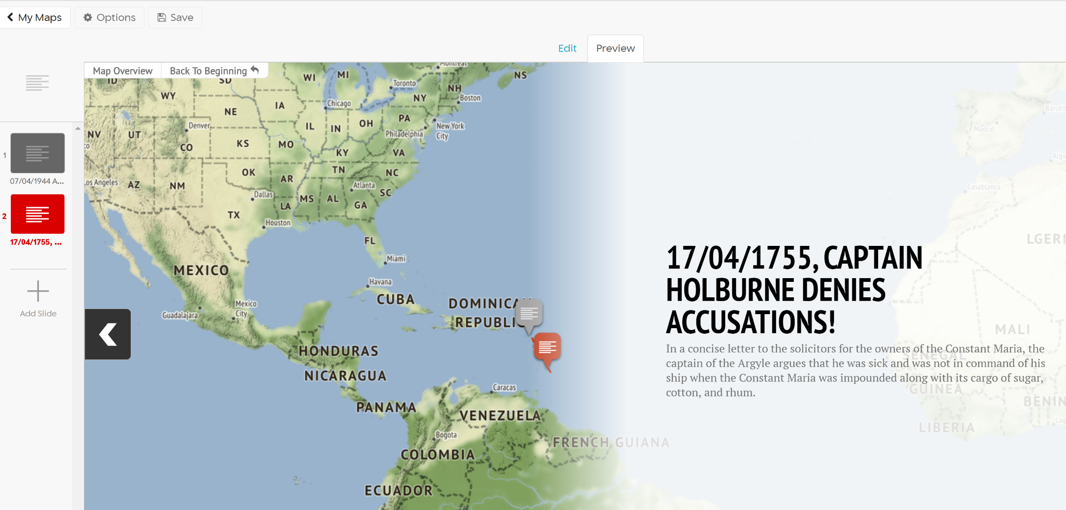
The Law (Word cloud)
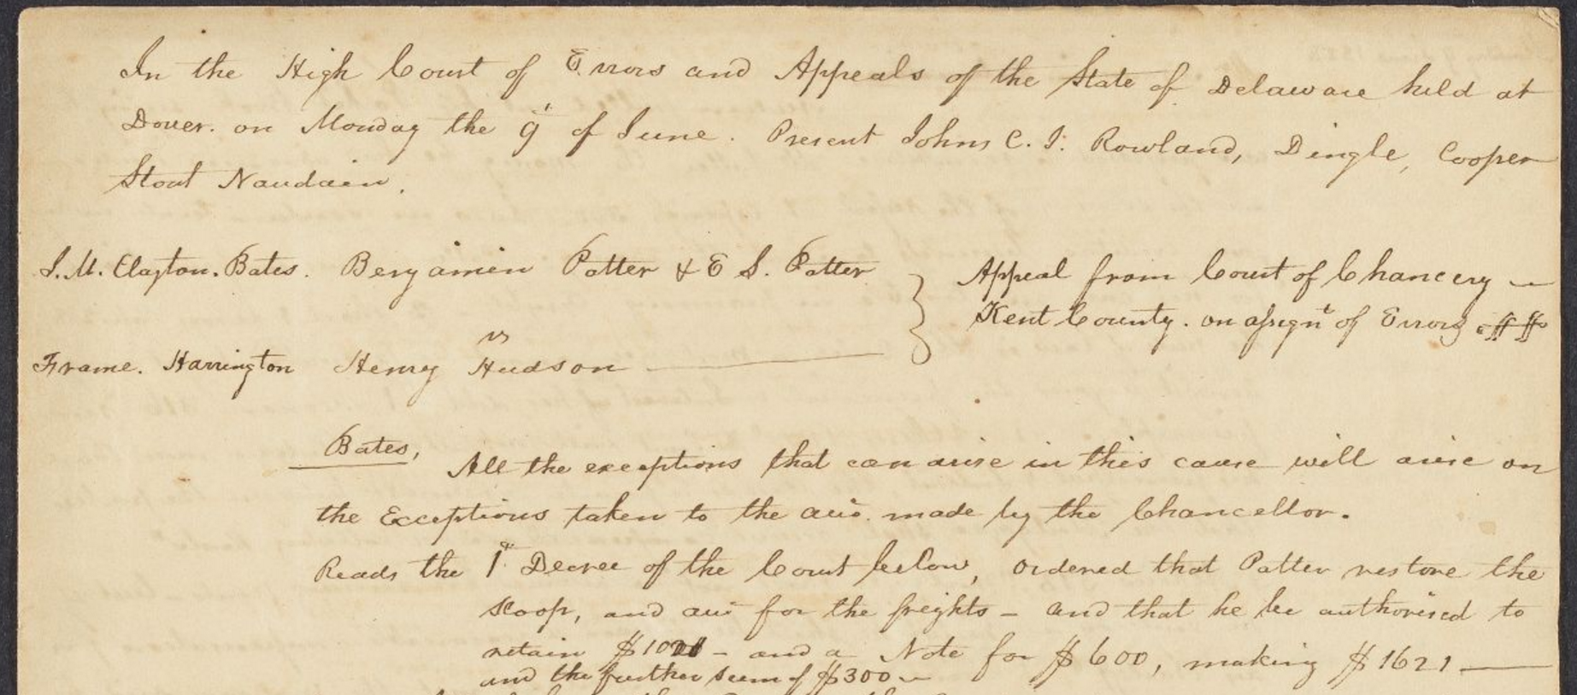
(Delaware Court of Common-Pleas., “Records, 1790-1805, vol. 10” Colonial North American Project at Harvard, accessed October 28, 2016, http://colonialnorthamerican.library.harvard.edu/items/show/9182 , seq. 73)
CNAP documents:
Dudley Hubbard, “Justice of the peace day book, 1797-1816,” Colonial North American Project at Harvard, accessed October 28, 2016, http://colonialnorthamerican.library.harvard.edu/items/show/9219
Lemuel Whitney, “Justice of the Peace record book, Windham, Vermont, 1799-1807,” Colonial North American Project at Harvard, accessed October 28, 2016, http://colonialnorthamerican.library.harvard.edu/items/show/12038
William Pynchon, 1590-1662, “Record of cases before the magistrate of Agawan, Springfield, Massachusetts, 1638-1702,” Colonial North American Project at Harvard, accessed October 28, 2016, http://colonialnorthamerican.library.harvard.edu/items/show/9123

“Town law journals from Concord, Mass.,” Colonial North American Project at Harvard, accessed October 28, 2016, https://listview.lib.harvard.edu/lists/hollis-001681629
Further Reading:
William E. Nelson, The Middle Colonies and the Carolinas, 1660-1730, vol. 2 of The Common Law in Colonial America (New York, Oxford UP, 2013)
G. Edward White, From the Colonial Years through the Civil War, vol. 1 of Law in American History (New York: Oxford UP, 2012)
Software:
Wordle: http://www.wordle.net/
Legal history doesn’t need to only be a retelling of a legal case, though that can be an interesting history to read, too. The CNA project contains numerous legal resources that provide students a deeper understanding of how people attempted to regulate the world around them. Legal developments are the product of societal trends, but engender them, too. The CNAP’s legal archives offer an intimate view of 18th and 19th century society, and offer several markers of how the law was adapted to reflect values and practices that changed according to times, environments, and people.
Exercise: Choose a section of a minimum of twenty pages in each record book. Ensure that your page sequences are for a same year. Using Word, list offenses, fines, and places. Copy and paste into Wordle to obtain results. Discuss your findings in small groups. What types of offenses stand out? Who is likely to be an offender? Do categories of offenders and offenses change over time? Why do you think they do or don’t?
News and Politics (Podcast)
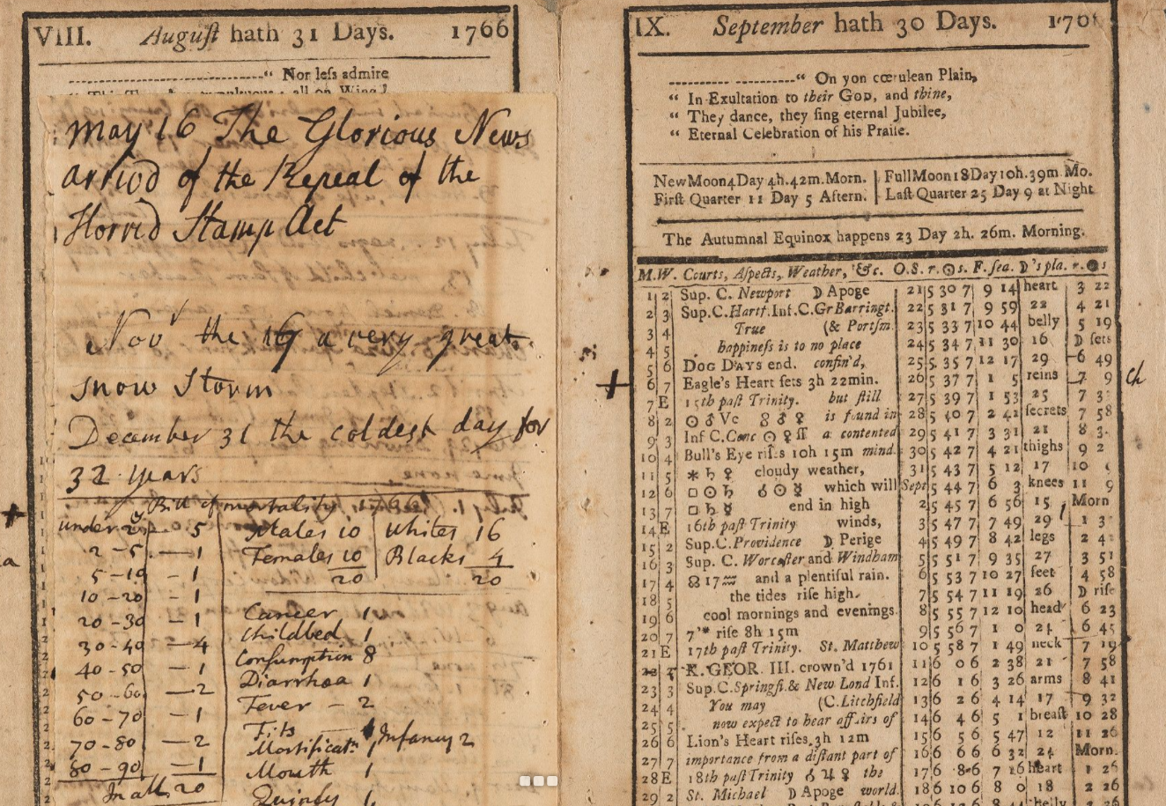
(“Annotated almanac, 1766,” Colonial North American Project at Harvard, accessed October 28, 2016, http://colonialnorthamerican.library.harvard.edu/items/show/8210, seq. 8)
CNAP Documents:
Almanac collection: http://colonialnorthamerican.library.harvard.edu/search?query=almanac
Further Reading:
Patricia Bonomi, A Factious People: Politics and Society in Colonial New York (Ithaca: Cornell UP, 2014)
Charles Clark, The Public Prints: The Newspaper in Anglo-American Culture, 1665-1740 (New York: Oxford UP, 1994)
Maya Jasanoff, “The Other Side of Revolution: Loyalists in the British Empire” The William and Mary Quarterly, April, 65 (2008): 205-232.
Robert Middlekauff, The Glorious Cause: The American Revolution, 1763, 1789 (New York: Oxford UP, 2007)
See Also, Alicia DeMaio, “Politics in the Early American Public,” Colonial North American Project at Harvard University Essays, http://colonialnorthamerican.library.harvard.edu/exhibits/show/politics/politics
Software:
Buzzsprout: https://www.buzzsprout.com/
A lot of great CNAP material is political in nature; the politics of 17th and 18th century North America were fraught, to be sure. The letters, almanacs, and news clippings available through the CNAP allow scholars to gauge public opinion. Inter-imperial competition, competition for resources, not to mention the revolutionary politics of the late 18th century make delving into the CNAP’s materials a great place to begin looking at the long-term trends that inform politics in North America today.
Exercise: Imagine you are a 17th century talking-head. Look through the collection of almanacs present in the CNAP and pick a date with an event that seems particularly newsworthy. What are the facts and what is your opinion on the event? What does your source convey? Make sure to take the marginalia into account, too. Using Beansprout, create a 6-minute segment on that day’s event. Before recording your podcast write a script of no more than 3 pages double-spaced. While writing it, remember this exercise requires you to take a side on an issue. To that end, think about how you want to approach the issue and how to quote sources effectively to provide context, first, and to eventually persuade, rather than simply inform the audience.
Revolutions (Annotations)
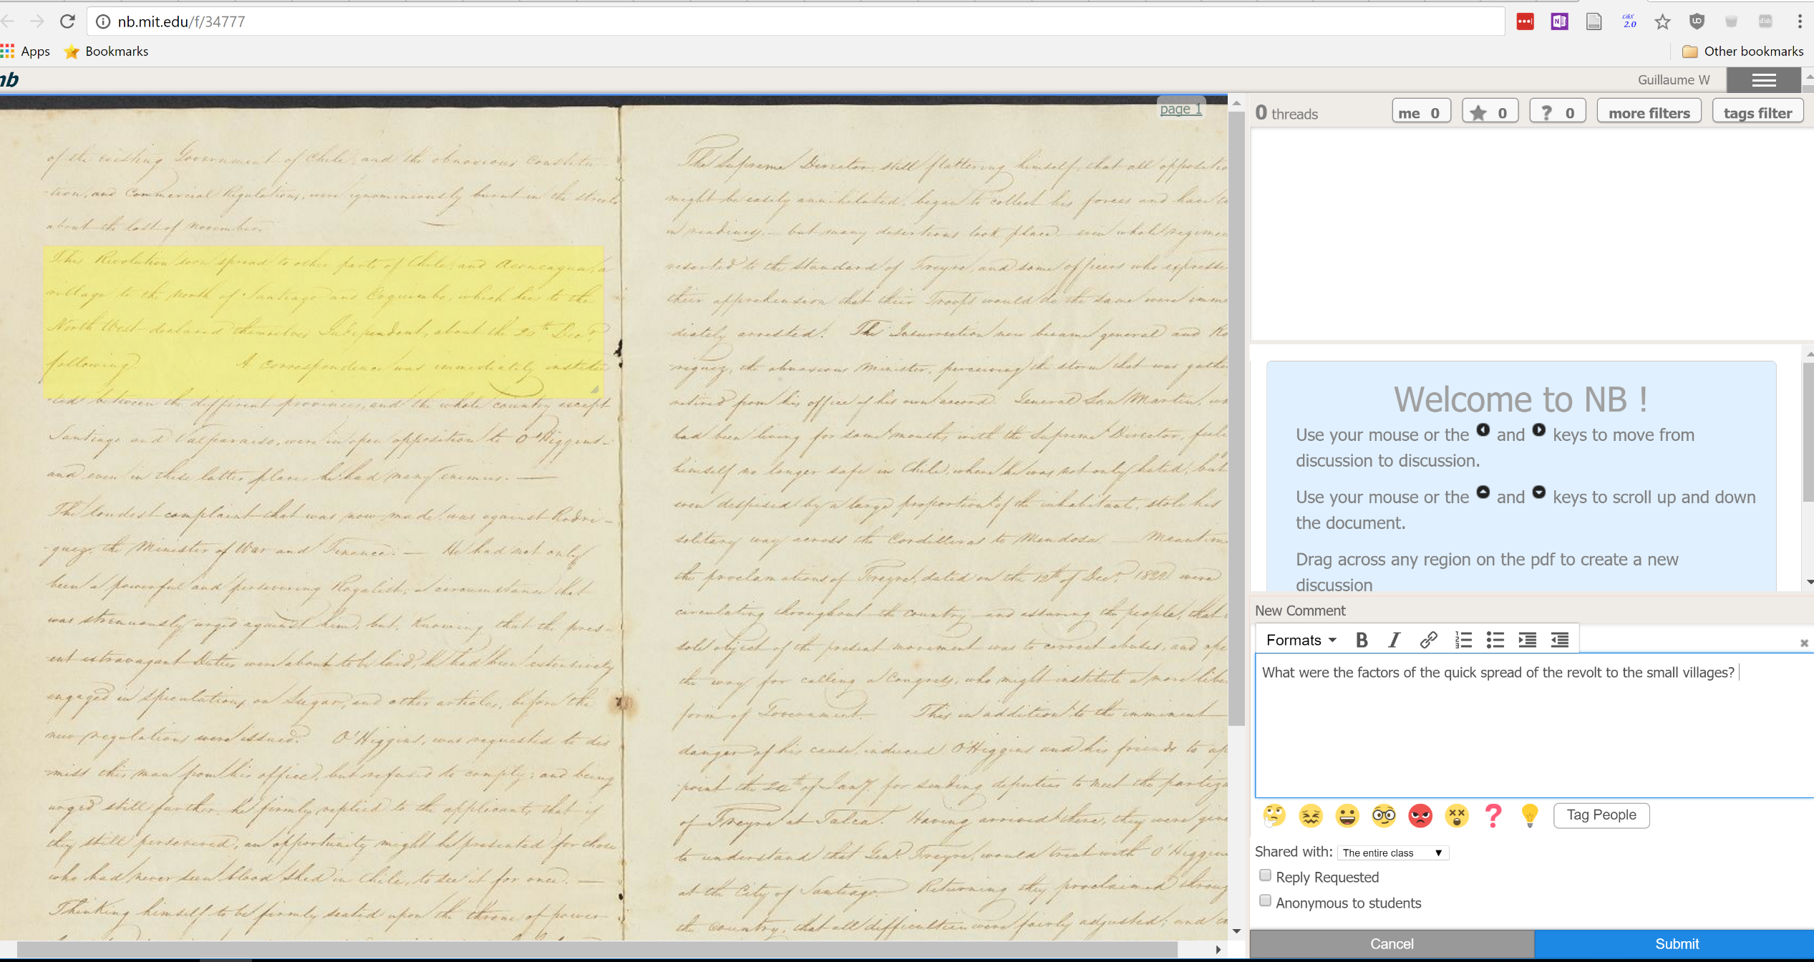

CNAP documents:
“Manuscript on the Chilean Revolution, undated,” Colonial North American Project at Harvard, accessed October 29, 2016, http://colonialnorthamerican.library.harvard.edu/items/show/11617
“Essay on the French Revolution and the Napoleonic Wars,” Colonial North American Project at Harvard, accessed October 29, 2016, http://colonialnorthamerican.library.harvard.edu/items/show/11619
Further Reading:
David Armitage, The Declaration of Independence: A Global History (Cambridge: Harvard UP, 2008)
Laurent Dubois, A Colony of Citizens: Revolution & Slave Emancipation in the French Caribbean, 1787-1804 (Chapel Hill: University of North Carolina Press, 2004)
Janet L. Polasky, Revolutions without Borders: The Call to Liberty in the Atlantic World (New Haven: Yale UP, 2015)
AHR Forum: Revolutions in the Americas, http://www.jstor.org/stable/i325440
Software: NB, nb.mit.edu; Crocodocs for Canvas is also a good alternative if PDFs are small. Google Docs is another free and simple way of annotating texts collaboratively.
The mid-18th century to the mid-19th century was a particularly turbulent time in the Atlantic World. While the American Revolution and the French Revolution are commonly used examples of the revolutionary fervor that characterized this period, revolutions from Haiti to Switzerland, from the United States to Chile, were animated by the strong currents of the Enlightenment, the shockwaves caused by the collapse of empires, and, as recent scholarship shows, by environmental forces such as the Little Ice Age.
The CNAP documents chosen here reflect the breadth of geographic scope contained within the archive, but are also valuable to identify the circulation of information and people that helped foment revolutions and independence movements.
Exercise: Collaborative annotation assignments work best as a whole of classroom effort. The point is to crowdsource questions, knowledge, and additional sources of information, as well as help students learn to thoughtfully analyze texts. Particularly dense texts are ideal candidates for collaborative annotation exercises. Each student is responsible for one annotation and one response to someone else’s annotations.

Disease (GIS Mapping)
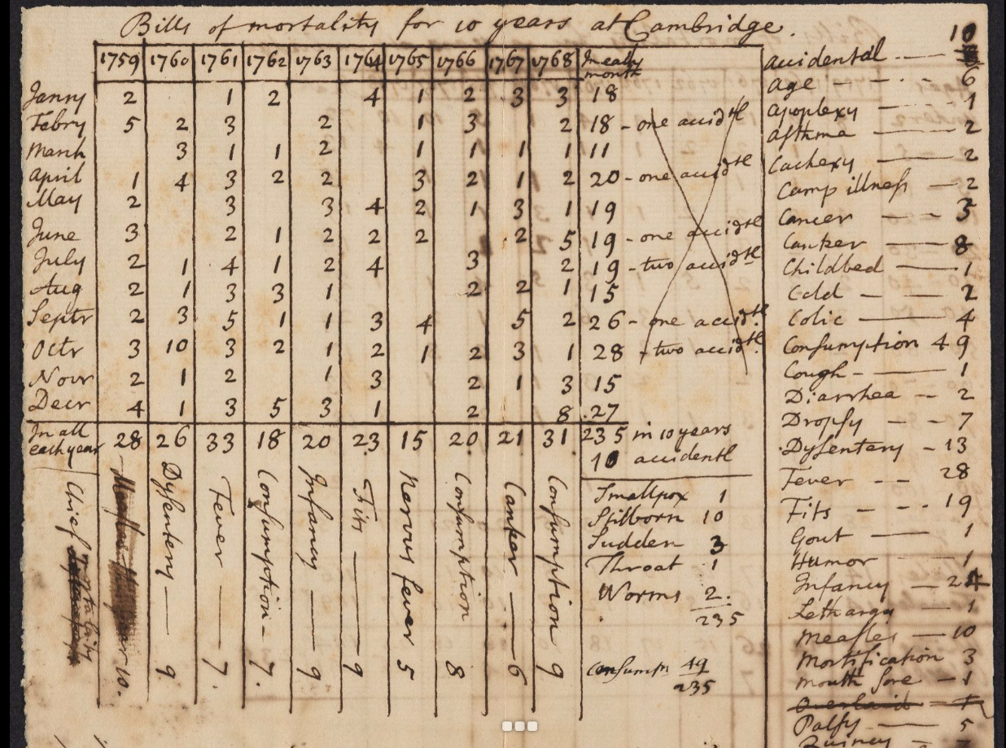
“Bill of mortality for ten years at Cambridge (manuscript chart), [1768],” Colonial North American Project at Harvard, accessed October 29, 2016, http://colonialnorthamerican.library.harvard.edu/items/show/8214 , seq. 2
CNAP documents:
The John Winthrop series, illustrated by the image above, is a first stop in any project on medicine using CNAP materials.
Brigham, Daniel, 1760-1837, “Doctor Daniel Brigham's Book, 1789-1810 (inclusive),” Colonial North American Project at Harvard, accessed October 28, 2016, http://colonialnorthamerican.library.harvard.edu/items/show/12127
“Student notes from medical lectures by Benjamin Rush, undated,” Colonial North American Project at Harvard, accessed October 28, 2016, http://colonialnorthamerican.library.harvard.edu/items/show/1214

Jeffries, John, 1745-1819, “Small Pocks, 1775-1779 (inclusive),” Colonial North American Project at Harvard, accessed October 29, 2016, http://colonialnorthamerican.library.harvard.edu/items/show/12107
Perkins, John, 1698-1781, “Observations Medical & Chirurgical by John Perkins, 1724-1774 (inclusive),” Colonial North American Project at Harvard, accessed October 29, 2016, http://colonialnorthamerican.library.harvard.edu/items/show/12139
See also: Benjamin Guild, 1749-1792, “Diaries of Benjamin Guild, 1776, 1778,” Colonial North American Project at Harvard, accessed October 30, 2016, http://colonialnorthamerican.library.harvard.edu/items/show/9178
Thomas Cradock, 1752-1821 and Cradock, Thomas, 1752-1821, “Account books of Thomas Cradock, 1786-1818 (inclusive),” Colonial North American Project at Harvard, accessed October 29, 2016, http://colonialnorthamerican.library.harvard.edu/items/show/12094
Further Reading:
John Blake, Public Health in the Town of Boston, 1630-1822 (Cambridge: Harvard UP, 1959)
Gerald Cates, "The Seasoning: Disease and Death among the First Colonists of Georgia," Georgia Historical Quarterly, 64 (1980): 146-158
Ann Carlos and Frank Lewis, "Smallpox and Native American mortality: The 1780s Epidemic in the Hudson Bay Region," Explorations in Economic History 49, no. 3 (2012): 277–290
Software:
ARC GIS (available either through Harvard or at ESRI)
The CNAP’s medical archive is as impressive a collection as it is a daunting one to handle. It is best dealt with in a history lab or similar collaborative, semester-long setting that unites history methodologies with advanced technical guidance and a specialist.
Disease and death were daily concerns for settlers throughout the Americas. A look at the marginalia in any of the almanacs contained in the CNAP archives reveals just how frequently deaths were recorded by the owners of the almanacs. Diseases like malaria were endemic in the southern colonies, and the northern ones were especially vulnerable to outbreaks of small pox. Boston experienced a particularly deadly epidemic of small pox in 1721 causing an outflux of the population that then caused the spread of the virus to the rest of the thirteen colonies.
In addition to examining the impact of disease on colonial society or the transmission of infection prevention, students and instructors will find that women are important figures in the history of medicine in the colonial era. They were midwives, nurses, and transmitters of medical knowledge. The CNAP collection on medicine offers important resources to also study the history of gender in colonial North America.
The Thomas Craddock notebooks are a fantastic source to get away from the theory of medicine to the practice of medicine in the colonial period.
Exercise: Using the CNAP entries suggested above as a starting point, delve further into the CNAP archives, both online and in the library, to identify a disease dataset suitable for study. Using GIS software map out instances of the disease over space and time.
Recovering voices at Harvard (Curation)
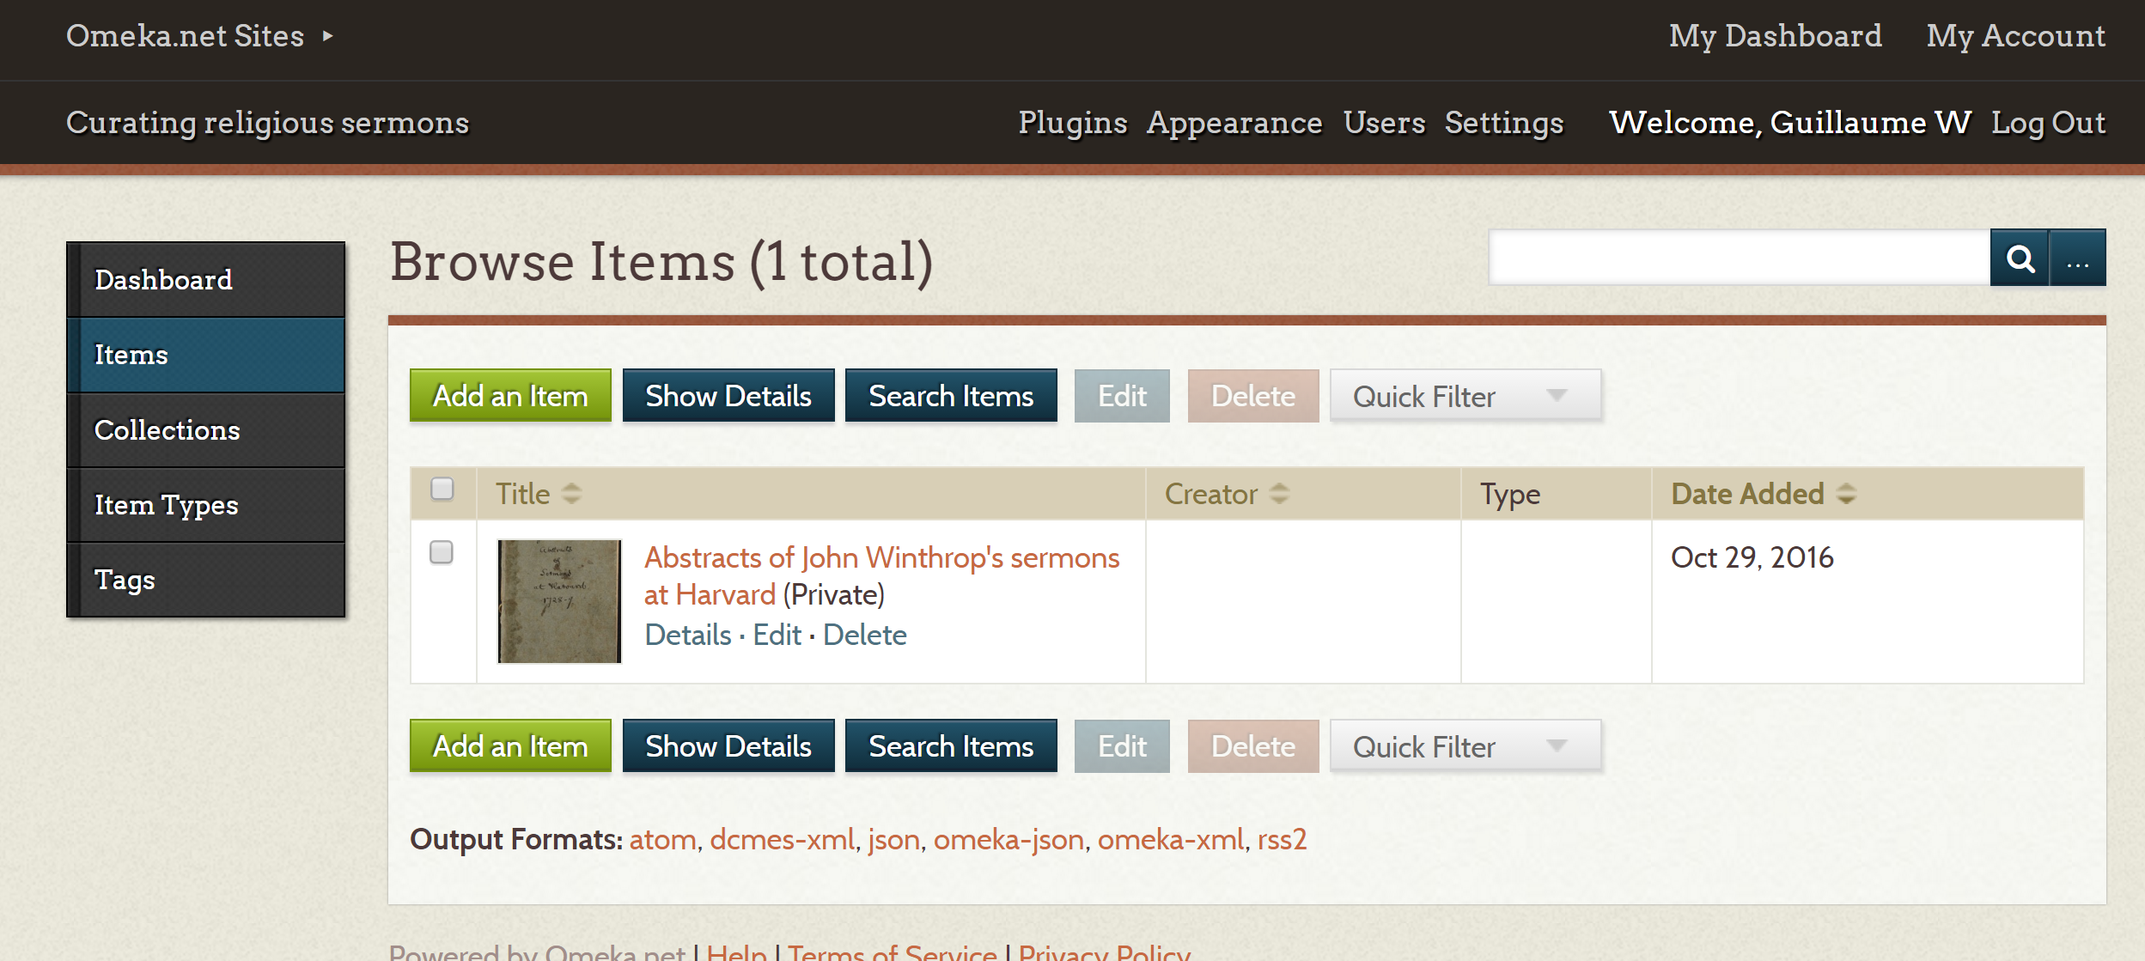
CNAP documents:
“Abstracts of sermons preached at Harvard College, 1728-1729,” Colonial North American Project at Harvard, accessed October 29, 2016, http://colonialnorthamerican.library.harvard.edu/items/show/8172
“Quarter bill book for the Classes of 1784-1801, 1784-1797,” Colonial North American Project at Harvard, accessed October 29, 2016, http://colonialnorthamerican.library.harvard.edu/items/show/7659
Debating Club of Resident Graduates (Harvard University), “Records of the Debating Club of Resident Graduates, 1792-1793,” Colonial North American Project at Harvard, accessed October 29, 2016, http://colonialnorthamerican.library.harvard.edu/items/show/8819
“Address to the students, 1791 September 17,” Colonial North American Project at Harvard, accessed October 29, 2016, http://colonialnorthamerican.library.harvard.edu/items/show/8506
“Official minutes, September 24, 1725-March 3, 1752,” Colonial North American Project at Harvard, accessed October 30, 2016, http://colonialnorthamerican.library.harvard.edu/items/show/8441
On Native Americans and Harvard, see:
“Conjectural restoration Indian College of 1655-56 to 1698 in Harvard College, photo lithograph on heavy paper, May 1934,” Colonial North American Project at Harvard, accessed October 30, 2016, http://colonialnorthamerican.library.harvard.edu/items/show/7916
“College Book 8, 1778-1803,” Colonial North American Project at Harvard, accessed October 30, 2016, http://colonialnorthamerican.library.harvard.edu/items/show/8699
Further Reading:
John Burton, Puritan Town and Gown: Harvard College and Cambridge, Massachusetts, 1636–1800. PhD dissertation, College of William and Mary, 1996
Jill Lepore, The Name of War: King Philip’s War and the Origin of American Identity (New York: Vintage, 1999)
Samuel Eliot Morison, Harvard College in the Seventeenth Century, (Cambridge: Harvard UP, 1936)
Laurel Thatcher Ulrich, Yards and Gates: Gender in Harvard and Radcliffe History (New York: Palgrave MacMillan, 2004)
Richard White, The Middle Ground: Indians, Empires, and Republics in the Great Lakes Region, 1650-1815, (New York: Cambridge UP, 2010)
See also, Victoria Baena, The Harvard Indian College,” The Crimson, March 24, 2011, accessed October 28, 2016, http://www.thecrimson.com/article/2011/3/24/harvard-indian-american-native/
Alicia DeMaio, “Female Laborers at Harvard,” Colonial North American Project at Harvard University Essays, http://colonialnorthamerican.library.harvard.edu/exhibits/show/laborers/laborers
Corydon Ireland “Harvard’s Indian College Poet,” Harvard Gazette, September 16, 2013, accessed October 28, 2016, http://news.harvard.edu/gazette/story/2013/09/harvards-indian-college-poet/
Software:
Omeka: www.omeka.org; Omeka tutorials: http://omeka.org/codex/Screencasts
The CNAP archive on Harvard is replete with interesting artifacts and useful information on the early days of the institution. Harvard was founded in 1636 to train clergy for the growing Commonwealth of Massachusetts and has since then acted as a hub for a variety of communities. Religion figures prominently, of course, but the sermons and the abstracts of the Harvard Debate Club reveal how the worries of everyday life and the concerns created by the hustle and bustle beyond the Yard crept into daily conversations.
The CNAP archive on Harvard is also a good place to teach students how to interrogate archives. Who creates archives, and why? Whose voices are heard in archives? Recovering the voices of communities, such as women and Native Americans, that are too often obstructed by the voices of the people who created the sources that are now in archives is an arduous, but important task. Indeed, learning to question sources and repositories can lead to new perspectives. Alicia DeMaio, for example, in her essay on female laborers, questions the sources contained in the CNAP repository, and is in turn able to add complexity to scholarship on women and the colonial era by arguing that far from being confined to domestic production roles, women were also integral to the labor market outside of the domestic sphere
Native Americans were part of a more complex history of Harvard, too. The Harvard Indian College is particularly striking example of this: the first bible printed in North America was printed at the Indian College for the purposes of converting Native Americans to Christianity. Deep archival work is needed to fully recover Native American voices, too.
Exercise: Create a public history exhibition. Using Omeka and the CNAP materials online pull together documents relevant to a particular aspect of life at Harvard. Examples of these aspects include religion at Harvard, the Indian College, and food at Harvard. Good exhibitions make an argument. Be thoughtful in how you approach your curation.
When working on Native Americans and women at Harvard, be creative and read your materials against the grain. Check for categories or terms that might be more capacious than a first glance would suggest.
Slaves (The Digital Essay)
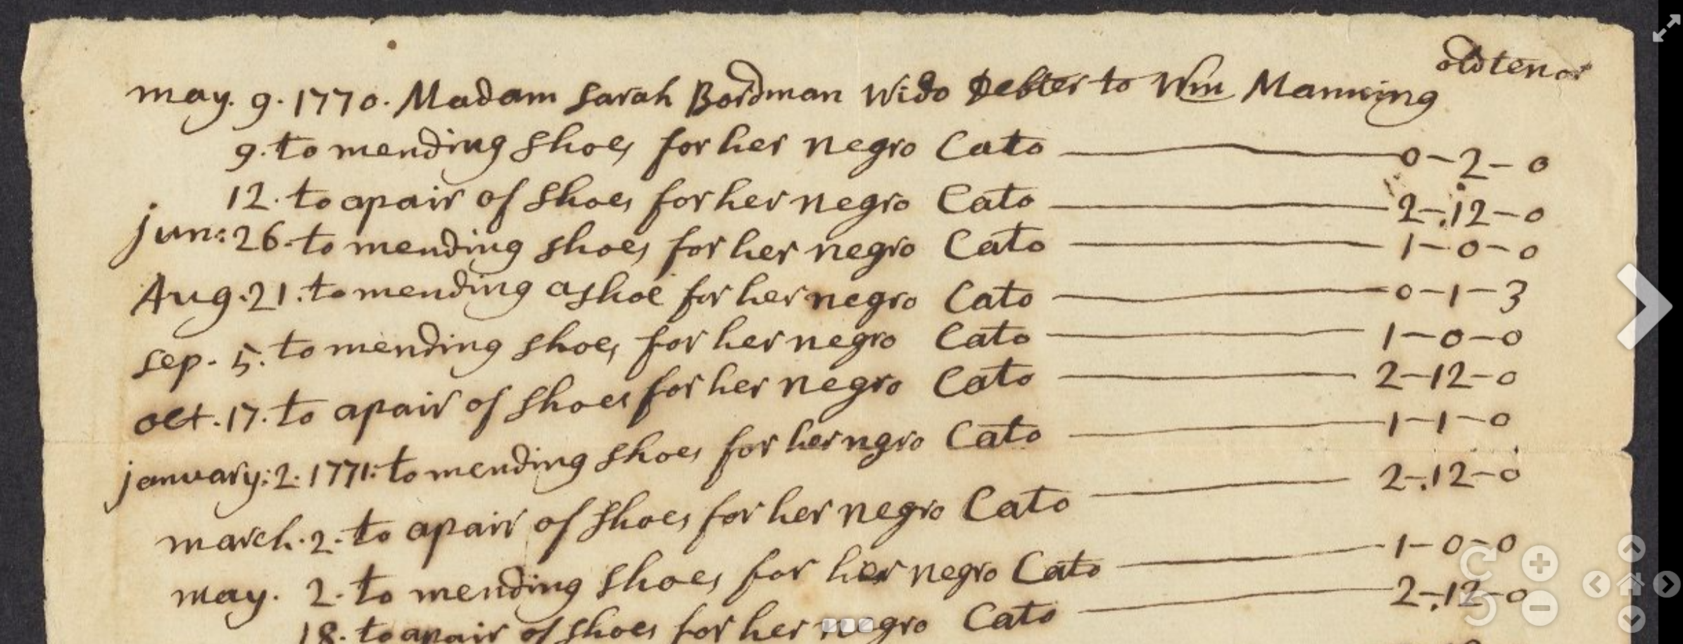

CNAP documents:

“Bill, 1771 August 23,” Colonial North American Project at Harvard, accessed October 29, 2016, http://colonialnorthamerican.library.harvard.edu/items/show/11927

William Blair Townsend, 1723-1778, “William Blair Townsend letter and receipt books, 1743-1805, bulk 1744-1777,” Colonial North American Project at Harvard, accessed October 28, 2016, http://colonialnorthamerican.library.harvard.edu/items/show/12117, seq. 26

“Deed of sale, 1716/7 January 1,” Colonial North American Project at Harvard, accessed October 30, 2016, http://colonialnorthamerican.library.harvard.edu/items/show/11887

Further Reading:

Bernard Bailyn, The Peopling of British North America: An Introduction (New York: Vintage, 1988)

Ira Berlin, Many Thousands Gone: The First Two Centuries of Slavery in North America (Cambridge: Belknap Press, 2000)

Vincent Brown, The Reaper’s Garden: Death and Power in the World of Atlantic Slavery (Cambridge: Harvard UP, 2008)

Michael Gomez, Exchanging our Country Marks: The Transformation of African Identities in the Colonial and Antebellum South (Chapel Hill: University of North Carolina Press, 1998)

Software:

ARC GIS Story Maps https://storymaps.arcgis.com/en/

The Digital Essay is a combination of text and the digital output created from exercises like the ones mentioned throughout this curriculum support paper.

For this particular exercise, Storymaps by ARCGIS provides a powerful tool to integrate text, images, video, and sound to create a multimodal essay. Other features include the ability to crowdsource stories.

For an extraordinary example of a digital essay, see:
Will Self, “Kafka’s Wound: Re-imagining the Literary Essay for the Digital Age,” The Space and the London Review of Books, accessed October 28, 2016, http://thespace.lrb.co.uk/

An estimated 7.7 million Africans were transported to the Americas between 1492 and 1800. The Atlantic slave trade was a profitable business spurred by the need for manpower to produce sugar, tobacco, coffee, rice, and eventually cotton. Indeed, it was the spread of tobacco cultivation that drew Chesapeake planters to turn to the transatlantic slave trade.

Slavery, however, was not only confined to the most southern of the thirteen colonies. It was not uncommon for New England farms and businesses to have slaves working as farm hands, personal servants, or stockers in shops.

Slavery became associated with race and created deep and long-lasting divisions between whites and blacks in the United States (and across the Americas). These divisions were compounded by the fear that thousands of slaves could revolt against their masters. In turn the rigid police and legal structures created to control slaves transformed places like the state of Virginia into “slave societies.”

CNAP materials on slavery are making their way through the digitization process. Existing material, however, provides fascinating granular detail on slave owners and their slaves. Though it requires significant contextualization and should be used in conjunction with a variety of other secondary and primary sources.

Exercise: The format of this final assignment is designed to give students creative freedom while still providing instructors opportunities to grade technical writing skills, and test for knowledge of the materials acquired throughout the semester. It is a hybrid between a classic research paper and a digital exhibit. Remember that this assignment should be the end result of the knowledge and technical skills imparted on students throughout the semester.

