Selections from the introduction to Nicholas Culpeper’s The English Physician, 1652 (emphasis added):

So precious hath the knowledg of the virtues of Herbs been in former times to men of quality, and indeed happy is that Nation, whose Rulers minde knowledg, as Solomon saith on the contrarary, We to that Nation whose King is a Childe; and indeed in ancient times people need little other Physick than such Herbs as grew near them, some footsteps of which and but a few onely, are now in use with us to this day, as people usually boil Fennel with fish, and know not why they do it but onely for custom, when indeed the original of it was founded upon reason, because Fennel consumes that flegmatick quality of fish, which is obnoxious to the body of man, Fennel being an herb of Mercury, and he so great an enemy to the Sign Pisces.

[Against “learned physicians” who keep their knowledge to themselves:]
Knowledge, saith Aristotle, is in Prosperity an Ornament, in Adversity a Refuge: and truly there is almost no greater enemy to knowledg in the world than Pride and Covetousness: Excellently said:
Scire volunt omnes, mercedem solver nemo.
(Although all men, in knowledge take delight, Yet they love money better, that’s the fright.)
And again, some men are so damnably proud and envious withal, that they would have no body know anything but themselves: the one I hope will shortly learn better manners, and the other be a burden too heavy for the Earth long to bear.

In this Art [of herbal knowledge] the Worthies of our own Nation, Gerard, Johnson, and Parkinson are not to be forgotten, who did much good in the study of this Art, yet they and all others that wrought of the nature of Herbs gave not a bit of a reason why such an herb was appropriated to such a part of the body, nor why it cured such a Disease; truly my own body being sickly brought me easily into a capacity to know that Health was the greatest of all earthly blessings… I cannot build my faith upon Authors words, nor believe a thing because they say it, and could wish every body were of my minde in this, to labour to be able to give a reason for every thing they say or do; they say Reason makes a man differe from a beast, if that be true, pray what are they that instead of reason for their judgement, quote old Authours, perhaps their Authours knew a reason for what they wrote, perhaps they did not, what is that to us, do we know it?

I knew well enough that the whole world and every thing in it was formed of a Composition of contrary Elements, and in such a harmony as must needs shew the wisdom and power of a great God. I knew as well this Creation though thus composed of contraries was one united body, and man an Epitome of it, I knew those various affections in man in respect of Sickness and Health were caused naturally (though God may have other ends best known to himself) by the various operations of the Macrocosm; and I could not be ignorant, that as the cause is, so must the cure be, and therefor he that would know the reason of the operation of Herbs must look up as high as the Stars; I always found the Disease vary according to the various motion of the stars, and this is enough one would think to teach a man by the Effect where the Cause lay: then to finde out the Reason of the operation of Herbs, Plants, &c. by the Stars went I, and herein I could find but few Authours, but those as full of non-sense and contradictions as an Egg is full of meat, this being little pleasing, and less profitable to me, I consulted with my two brothers, Dr. Reason, and Dr. Experience, and took a voyage to visit my Mother Nature, by whole advice together with the help of Dr. Diligence, I at last obtained my desires, and being warned by Mr. Honesty, a stranger in our days to publish it to the world, I have done it.

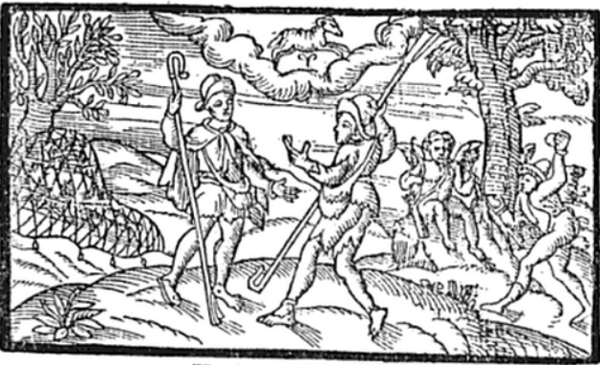
Woodcut Illustration from the Shepherd’s Calendar (1579), corresponding to the chapter on March, in which two youths discuss love and other pleasures associated with springtime. Note the appearance of a ram, symbolizing Aries, in the sky; Aries begins on March 21.

