Coaching As Leadership Practice

Why is coaching an important leadership practice?

Leadership in organizing is about enabling others to achieve purpose in the face of uncertainty. Coaching enables others.
Organizing campaigns are rich with challenges and learning opportunities, but we can be fish in the
water in which we are swimming, unable to see what we’re in the midst of. Coaching can help address this problem. Coaching can help individuals and teams not only overcome the immediate motivational, strategic, and informational challenges that may be hindering their effectiveness, but remind them of the critical role of learning to listen in exercising leadership.
What is coaching in organizing?
Coaching is a direct intervention in an individual or team’s work process to help them improve their effectiveness. Some examples of when coaching skills are necessary:
- Helping a leader overcome motivational challenges with their volunteers.
- Assisting a leadership team in creating strategy for their organizing campaign.
Coaching is useful whenever we are working to enable others to build their own capacity to act, and though the contexts vary, the process is very similar throughout.
Elements of Coaching

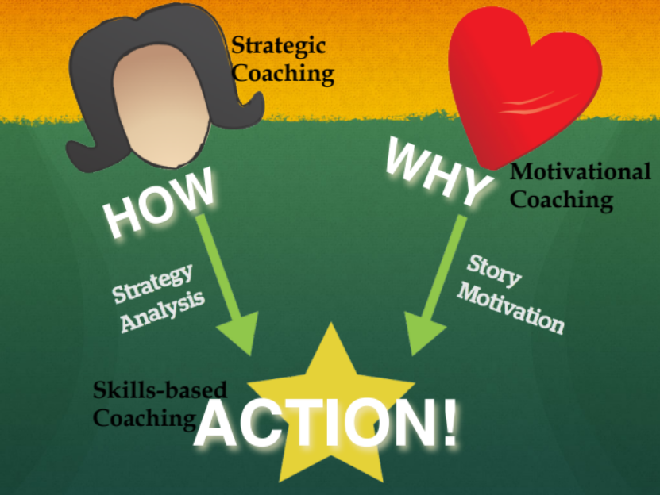
Coaching requires learning to identify a person’s or team’s strengths and weaknesses to help them
mobilize their strengths to overcome their weaknesses. People often know what they “should” do. But fresh eyes can help diagnose specific challenges they face while identifying ways to deal with them.
- Motivational (heart) coaching is intended to enhance effort.

- Educational (hands) coaching is intended to help acquire information or skills.

- Strategic (head) coaching is intended to help evaluate how to use resources to achieve outcomes.

Coaching Approaches

Corrective
Some coaching is aimed at helping improve poor performance (i.e., the coachee is overall not doing the leadership practice well and needs help getting up to a basic level).

Developmental
Some coaching is aimed at helping the individual achieve mastery (i.e., the coachee does the leadership practice well and is ready to become expert).

Basic elements of coaching are the same (i.e., motivational, strategic, and informational), but coaching strategies may differ (e.g., consult by asking reflective questions to develop mastery vs. consult by providing expert feedback to illustrate errors in how they are thinking about the task).

How Coaching Works – the 5 Step Process
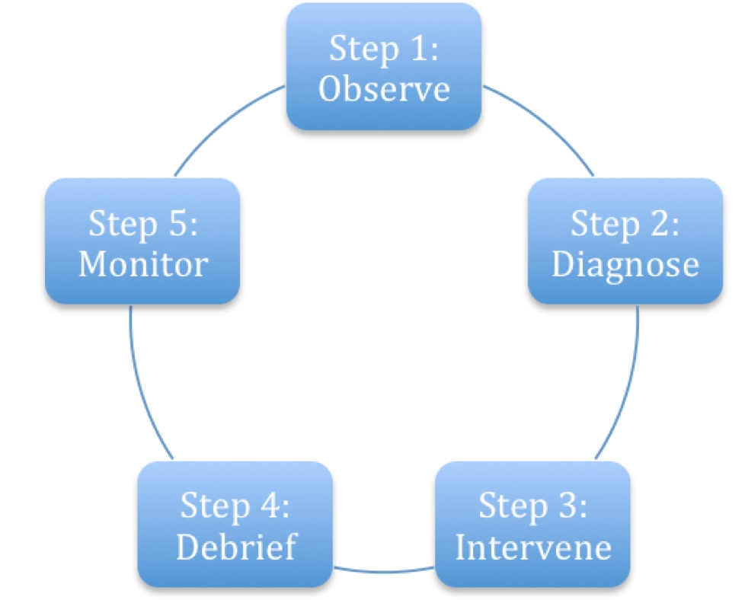
Coaching requires learning how to use four methods to implement 5 steps. The four methods are: ask questions, listen (head and heart), support, and challenge.
These are the 5 steps:
1. Observe: What do I see and hear?

Listen very carefully, observe body language, and ask very focused probing questions to satisfy yourself that you “get” the problem. It may take time to get the facts straight. But if you don’t
understand the problem, you can’t help solve it. Don’t be shy about asking specific “stubborn”
questions. This process can help the coachee articulate just what the problem is in a way they may not have before. So this process is not only about “getting information.”

2. Diagnose: What is the problem?

Getting the diagnosis right really matters. For example, if an organizer is struggling with strategy and you focus on getting them to try harder the result will only be frustration.
Is the challenge motivational (effort/heart)?

Is the individual struggling because s/he is not putting forth enough effort? Is she not trying hard enough because she’s embarrassed? Is he quitting too soon because of frustration or fear? Are they getting interference from other habits (e.g., someone well-versed in marketing speak may not know how to tell an authentic story)?

Is the challenge educational (information/skills/hands)?

Is the individual struggling because he lacks the skill to execute effectively? Does he not know how to do it? Is she getting interference from older habits or behaviors (like someone who is used to
selling products confusing this with telling a story of self)? Is it something you could model or role play with them?

Is the challenge strategic (strategy/head)?

Is the individual struggling because s/he doesn’t know how to use the information or skills that she does have. Does he understand the concepts or underlying principles clearly? Has he not thought it through carefully? Are the goals not achievable? Does the strategy make sense?
3. Intervene – What do I do?

Once you think you’ve figured out what the problem is don’t just tell the coachee what you think he should do! Find out what she thinks she should do. Ask questions that enable the coachee to see the problem, and allow you to see how the coachee sees the problem, and discern a way to solve it. Get the coachee’s views out on the table. The appropriate intervention depends on the diagnosis.

If the challenge is motivational you can:

• Encourage and exhort—you can do it!
• Offer a kick in the pants (with love)
• Help the person confront their fear, embarrassment, or other emotions that may get in the way of their ability to risk acting, persevering, trying new things. Communicate with empathy, hope, and affirmation of the coachee’s self-worth. Reward and praise courage
• Model courage and emotional maturity in your own behavior. Confess fear and explain how you move toward it rather than away from it.

If the challenge is educational, you can:

    - Model the behavior and invite the coachee to imitate you to get the “feel” of the activity
    - Break it down into small parts and invite the individual to try one at a time
    - Offer three or four different practice exercises and observe which ones work best for that
person.
    - Suggest others with whom the person can practice.
    - Suggest ways to figure out where to find the missing information.

If the challenge is strategic you can:
    - Work through a specific example with the person, asking questions to guide the strategic process. Then reflect on the process itself, asking them to describe how it worked?
    - Ask questions about how the individual is thinking about the practice (“Why did you choose that tactic?”)
    - Offer your observations, asking how the person might think about it differently (“At that point, were there other options? What might they have been? Why did you choose the one you did?)
    - Offer feedback on what you are hearing, asking if that describes the situation, at the same time, offering possible reframing of it.
    - Use silent reflection and self-diagnosis (“Why don’t you take a moment to think through what you believe is working and not working and let’s talk about that?).

4. Debrief: What did the coachee learn?

Ask your coachee to summarize his or her “take aways” from the session. Commit to next steps and decide when you will check back in. What went well? What are you challenged by? What are some possible solutions? What are your goals/next steps?

5. Monitor: How can I continue to support the coachee?

- Schedule periodic check-ins to support your coachee in integrating this new or revised solution into their regular practice.
- Find out from the coachee how the situation has changed.
- Assess whether the diagnosis and intervention was successful. Celebrate success!
Effective coaching is | Effective coaching is not
Showing up and being present to another  person’s experience, and listening with both your head and heart. | Being so prepared that you work out all the  answers for the coachee before you even hear or observe their challenges.
Helping the coachee explore and make sense of their challenges and successes, and what they learned from it all. | False praising of the coachee or only focusing on their strengths because you do not want to hurt their feelings.
Helping the coachee to find solutions to  challenges. | Solely criticizing the coachee.
Asking questions that both support and  challenge the person you are coaching. | Telling the coachee what to do.

More on Coaching
How do I prioritize who to coach in organizing?

When you have several individuals or teams to coach, where do you start? Where do you put most of your energy to get the best outcomes?


Invest your first coaching effort in those who are doing the best work. This seems
counterintuitive, but the purpose of coaching is not just to fix problems – it’s to help people achieve excellent outcomes.

Coaching your most innovative, productive people first maximizes their productivity, and preps you to coach others by giving you a detailed understanding of what excellent work looks like in practice. If your best folks get even better, they can help you coach and support their peers. Next, coach those who are showing promise. With what you’ve learned from the strongest groups, move on to those who are doing good work and help them make the leap to great. Utilize the tips in the 5 Step Coaching Process section for choosing interventions to help you tailor your coaching.

Finally, focus on the individuals and teams who are struggling. Watch these folks in action before jumping to conclusions. Are they struggling because of contextual factors, like a lack of resources, or because of inadequate skill or effort? Try investing a little more (resources, training or support), and see if outcomes improve. If so, great, keep coaching! If not, then assess whether this person is in the right role. Whether you’re coaching staff or volunteers, making sure the right people are in the right roles based on their skill and passion is a basic form of respect. While it’s painful for all involved in the short term, helping someone move on from a role that’s not well suited for them will only help everyone in the long term.

Be careful to set boundaries on your coaching with those who are struggling the most so that you continue to spend time and energy to keep your excellent folks going strong, and your good folks getting better.

How do I coach people to learn from failure?


In her book, Mindset, Carol Dweck argues that we all tend toward one of two mindsets: fixed or growth. The fixed mindset claims we’re born with our basic qualities, like intelligence or talent, which can’t improve or change (so why try?). Ever heard someone give a poor
presentation, then say, “I’m not a good public speaker”? That’s a fixed mindset.

The growth mindset asserts that we can develop our abilities through dedication and hard work. Our job as coaches is to cultivate a growth mindset in those we’re
coaching. That requires learning to look directly at failure and understand it so we can improve.

Here are some tips for learning from failure, while striving for success:

Create a culture of debriefing. Before work begins, schedule time to debrief into
every step. Make time after every event or project to evaluate what worked, what didn’t, and articulate key learnings together. Require short written reflections on major projects, especially those that fall short.

Differentiate between actions and context. It’s easy to hold someone responsible for every outcome. But success and failure are a combination of individual actions and situational context. As you develop a learning relationship with the person you’re coaching, pay close attention to the details. When does one action lead to success? Under what conditions does the same action lead to failure? Success
requires constantly evaluating the context and adapting our behavior to maximize good outcomes.

Interpret what happened. Coach the person you’re working with to interpret failure with clear eyes. Hiding failure or pretending it was success doesn’t fool anyone. Show those you coach that interpreting failure is an integral part of winning. Check out Barack Obama’s speech after his New Hampshire
primary loss for a great example of interpreting failure in a way that stays focused on driving for
success (http://www.youtube.com/watch?v=Fe751kMBwms).

Get back out there! Who wants to wallow in failure? Encourage those you coach to get out there and try again!

