Organizing: People, Power, Change
MLD 377

Organizing Notes
Charts
Reflection Questions

Marshall Ganz
Senior Lecturer in Public Policy
John F. Kennedy School of Government
Harvard University
Spring 2016

Organizing Notes

What Is Organizing?
Week 1

Leadership in organizing is rooted in three questions articulated by the first century Jerusalem sage, Rabbi Hillel:

“If I am not for myself, who am I?
When I am only for myself, what am I?
And if not now, when?

These three questions focus on the interdependence of self, other, and action: what am I called to do, what are others with whom I am in relationship called to do, and what action does the world in which we live demand of us now?
The fact these are framed as questions, not answers, is important: to act is to enter a world of uncertainty, the unpredictable, and the contingent. Do we really think we can control it? Or do we have to learn to embrace it? Uncertainty poses challenges to the hands, the head and the heart. What new skills must my “hands” learn? How can my “head” devise new ways to use my resources to achieve my goals? How can my “heart” equip me with the courage, hopefulness, and forbearance to act?
Leadership requires “accepting responsibility for enabling others to achieve purpose under conditions of uncertainty”. Conditions of uncertainty require the “adaptive” dimension of leadership: not so much performing known tasks well, but, rather learning what tasks are needed and how to perform them well. It is leadership from the perspective of a “learner” – one who has learned to ask the right questions – rather than that of a “knower” – on who thinks he or she knows all the answers. This kind of leadership is a form of practice - not a position or a person – and it can be exercised from any location within or without a structure of authority.
Organizing is a form of leadership. Organizers identify, recruit, and develop the leadership of others; build community around that leadership; and build power from the resources of that community. Organizers do not provide services to clients or market products to customers. They organize a community to become a constituency – people able to “stand together” on behalf of common concerns.
Organizers ask three questions: Who are my people? What is their urgent problem? How can they turn their resources into the power to solve their problem? They answer the questions in dialogue with their constituency by building relationships, telling stories, devising strategy, designing structure and taking action.
Organizers develop new relationships out of old ones - sometimes by linking one person to another and sometimes by linking whole networks of people together. One result is the formation of new networks of relationship wide and deep enough to provide a foundation for a new community in action.
Organized communities acquire agency – the capacity to act – by articulating why they must act – their story–and imagining how they can act –their strategy.
Organized communities learn to tell their story, a public narrative, of who they are: where they came from, where they are going, and what they must do to get there. Organizers work through narrative to deepen people’s understanding of their values, their capacity to share them, and to draw upon them for the courage to act. They learn to mobilize the feelings of urgency, anger, hope, empathy, and dignity, to challenge the feelings of inertia, apathy, fear, isolation, and self-doubt that inhibit action.
Organized communities learn to strategize how they can turn resources they have into the power they need to get what they want. Organizers engage people in understanding how they can act by deliberating on their conditions, locating the responsibility for those conditions, devising ways they could use their resources to change those conditions, a theory of change, and translating that theory into specific goals.
Organized communities accept the responsibility to act. Empowerment of a person begins with taking responsibility. Empowerment of a community begins with commitment – the responsibility its members take for it. Responsibility begins with choosing to act. Organizers challenge people not only to act, but also to act effectively.
Organized communities build relationships, tell stories, devised strategy, and take action most effectively with the support of a structure based on coaching, teamwork, and leadership development. They operate with leadership teams, based on shared purpose, interdependent roles, and agreed upon norms, avoiding the fragility of a single person doing it all or the chaos everyone doing everything. They create widely distributed leadership opportunities, cascading outward, like a snowflake, as opposed to narrowly held opportunities. They exercise accountability and offer support through ongoing coaching. In this way they can build communities which are bounded yet inclusive, communal yet diverse, solidaristic yet tolerant. They work to develop a relationship between a constituency and its leaders based on mutual responsibility and accountability.
Organizers work through campaigns. Campaigns are highly energized, intensely focused, concentrated streams of activity with specific goals and deadlines. Through campaigns, people are recruited, programs launched, battles fought, and organizations built. Campaigns polarize by bringing out those ordinarily submerged conflicts contrary to the interests of the constituency. One dilemma is how to depolarize in order to negotiate resolution of these conflicts. Another dilemma is how to balance campaigns with the ongoing work of organizational growth and development. And, win or lose, each campaign must conclude with analysis, learning, and celebration.

©Marshall Ganz, Kennedy School, 2015

Chart #1: What Is Organizing?

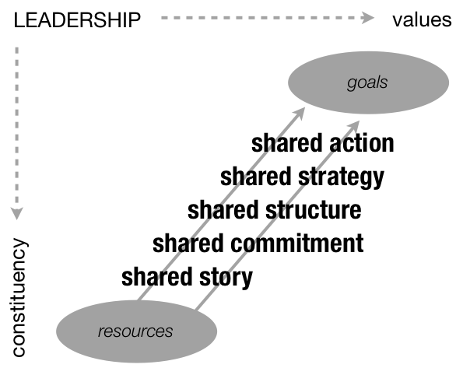

Chart #2: Three Ways to Combine
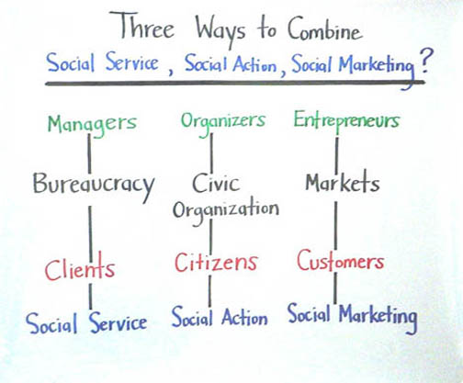

Chart #3: Two Ways to Structure Time
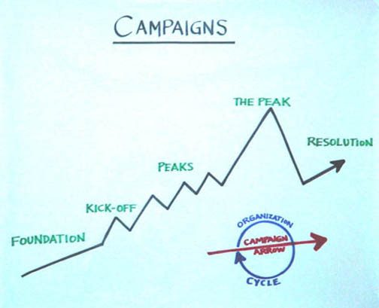

Organizing Notes

Learning to Organize
Week 1

Learning to organize is like learning to ride a bicycle. You can read good books about it, watch exciting videos, listen to learned lectures, but your learning doesn’t really begin until you get on the bike and begin to peddle. And, no matter how good the scaffolding - training wheels or parents holding the back wheel - sooner or later you will fall. And that’s the real moment of truth when you either go home, give up, and go to bed or you find the courage to get back on the bike and try again, even though you know you’re likely to fall, because you’ve discovered it's the only way you can learn to keep your balance. That, it turns out, is how we learn any kind of practice, including organizing. That is also the pedagogy of this course: explain concepts, model practice, create opportunities for you to practice, and debrief. In the way of “scaffolding” that can help prepare to take full advantage of this experience, consider the following.
In discussing the Buddha’s “Sutra on Knowing the Better Way to Catch a Snake”, in pointing to the difference between the “raft and the shore,” Thich Nhat Hanh helps distinguish among a framework to structure learning, how we learn, and what we learn. We may need a good raft to get us across a particular river, but the same raft may inhibit our progress if we hang onto it long after it has served its purpose.
To learn organizing, we need a raft because learning any new practice requires enough scaffolding to deal with the uncertainty, ambiguity and novelty. And when we face uncertainty, we often feel conflicting emotions. On the one hand, we may be fearful - things will go wrong, we will fail, others will see. We then retract, metaphorically at least, to protect ourselves from danger. On the other hand, we may also be curious - the unexpected can be exciting, bringing new opportunities for growth, calling us to try new things. Faced with the challenge of learning to act in new ways we seem to need to experience enough security to find the courage to risk exploring new behaviors. Learning to balance security and risk is not only key to our own learning, but to the learning of those with whom we work, for whom security may be more elusive and the risks greater. The framework we bring to learning organizing can serve as our "raft” for purposes of this course - a way to focus on critical tools, attend to key questions, observe the interaction of different elements, and share a common language so we can learn from each other's experience.
But organizing is fundamentally a practice – a way of doing things, with the “hands.” As Kierkegaard’s story of the helmsman at the wheel of a ship reminds us, learning practice is different from learning theory because it can only be learned from the experience of acting. ´ Acting requires the courage to take risks – risks of failure, making mistakes, losing face, rejection, etc. This is one reason your commitment to your project matters: the more deeply committed you are, the more you will learn because you will be motivated to risk new kinds of experience from which you can learn.
Organizing is also a theory, the work of the “head.” But understood well, theory is not some abstract principle to be “applied” in practice, nor is it how things “really” are. In fact, we theorize much of the time. We reflect on our past experience in an effort to simplify reality enough that we can draw general lessons about what we might expect under similar conditions in the future. We a generating “hypotheses” about the future, subject, of course, to testing.
So if we are to understand organizing practice we also need to pay attention to the theoretical “rafts” that we bring with us from our prior experience. These assumptions may have served us perfectly well in private life, especially when it comes to social interactions, but may not serve us so well in public life. Cognitive psychologists explain that we develop "schemata" to organize our understanding of the world. Schemata enable and constrain. They enable us to make sense of things, generalize, make choices, draw conclusions, and act. But, as stereotypes, they can also inhibit clarity of perception, cause us to see what we expect to see, and make it difficult for us to learn. In a sense, they can be understood as are our implicit “theories” of how the world works -- generalized lessons we learn from our experience, some of which we are not fully aware of, that inform what we expect.
Psychologist Ellen Langer proposes ways to learn to be more "mindful" of our assumptions so they constrain us less, allowing us to generate fresh ways of looking at things; creating new categories, considering multiple views, etc. So using theory "mindfully" requires stepping back from our experience, writing about it, reflecting critically upon it, and drawing lessons from it. And learning from experience requires entering into it with what Gandhi described as a “spirit of experimentation” – with the discipline to place it in perspective, compare it with that of others, and reflect on it analytically. And because organizing is relational – done in interaction with others – the more you can learn to mindfully distinguish among your actions, the actions of others, and how they interact, the easier it will become for you to learn from the data of your own experience.
The facility with which we learn to do new things depends to an important extent on how we approach learning: what educational psychologist Carol Dweck calls “mind-set.” When we try something new and we fail does this tell us something about what kind of person we are: smart or dumb, talented or ordinary, gifted or average, what she calls “fixed mind set”? Or does it tell us something about what we haven’t yet learned what she calls “growth mind set”? If “fixed” we are likely to avoid risk, deny failure when it occurs, blame it on external causes. If “growth” we are more likely to look at our own practice, discern ways to improve, and conclude that we simply have more work to do. Not surprisingly, her research shows that if we approach new challenges with a growth mind set will learn more quickly, resist less, and be far more open to feedback.
Learning organizing is not only a matter of hands and head, but also of the heart. My approach is rooted in a faith tradition that values people struggling interdependently to claim their dignity, a civic tradition claiming an equal right to self-determination, including holding leadership accountable, and a popular tradition of people finding ways to use their own resources creatively to effectively assert their interests. Although some tactics may be similar, the kind of organizing that is the focus of this course is not how to organize an army, a corporation, a marketing firm, or a social service agency. These values, or something similar, however, are found in cultures around the world as people found ways to deal with very similar kinds of challenges. Perhaps the most creative 20th Century innovator of democratic organizing was Gandhi. His combination of Eastern and Western traditions created a legacy further developed in the African freedom movement, the American Civil Rights movement, the work of Solidarity in Poland, and elsewhere. Organizing roots can be found, in fact, wherever people learned to collaborate, to challenge abuses of power, and to struggle to create a better life for their children.
To facilitate discussion I use charts because social processes can often be more easily visualized than verbalized. Four basic patterns I use depict relationship, purpose, feedback, and focus. Relational charts depict interactions, balances, and exchanges among parties fundamental to organizing. Purpose charts depict movement or development toward a goal, a peak, and an outcome. Loops - or more accurately spirals - depict ways action leads to outcomes that influence subsequent action. And focus charts show the effect of concentrating diffuse energy and resources on specific targets.
Coaching is one of the key learning, teaching, and leadership tools our pedagogy relies on. Coaching is a way to work with another person to enable them to improve their effectiveness. It is not about giving advice, preaching, making judgments, or telling someone what to do. But it can facilitate learning by enabling people to overcome three forms of challenge that most inhibit performance: motivational, educational or strategic. Motivational challenges have to do with effort; for whatever reason the individual is not motivated enough to take the risks needed to learn, to put in the hours needed to practice, or to put in that last ounce of energy needed to cross a threshold. Educational challenges include not having critical data needed to do the job, not having the skills required, lacking the experience to acquire good judgement. When someone has the information and the motivation, but doesn’t know where, when, and how to use that information to get the desired result – that’s a strategic challenge. We need to learn to distinguish among these challenges because if you are trying to get someone to try harder who doesn’t have the information you’re likely to just make things worse. On the other hand, if they’re very skilled, but, for whatever reason, aren’t putting forth effort, training may not help at all.
Learning to distinguish among these challenges – as well as how to intervene successfully - requires learning how to ask questions, how to listen (with both the head and the heart), how to support, and how to challenge. It is not all about praising people for strengths, criticizing them for weaknesses, or telling them what to do. It requires learning to identify a person’s strengths and their weaknesses in order to ally with - or mobilize - the strengths to overcome the weaknesses. Although some coaching may be “corrective” (telling the other person what to do), most coaching is “developmental” (enabling the other person to learn what to do).
Engaging in a new experience, critical analysis of that experience, and reflecting on the values within which that experience is rooted can be very challenging. This is why much of our work is interaction with others – constituency, classmates, colleagues, and instructors. This is not an "extra" but at the core of the learning process. Learning how to challenge, support, and motivate those with whom we work - and to accept challenge, support, and motivation from them - can be one of the most useful lessons you can take from this experience.

© Marshall Ganz, Kennedy School, 2015

REFLECTION QUESTIONS

- What do you most hope to be able to learn in this course?

- What do you think your greatest learning challenges are?

- How do you think working on your organizing project can help you learn?

- What can you do to facilitate your own learning?

Organizing Notes

What Is Public Narrative?

Week 2

The questions of what am I called to do? what is my community called to do?, and what are we called to do now? Are at least as old as Moses’ conversation with God at the burning bush. Why me? asks Moses, when called to free his people. And, who – or what – is calling me? Why these people? Who are they anyway? And why here, now, in this place?
Practicing leadership – enabling others to achieve purpose in the face of uncertainty – requires engaging the heart, the head, and the hands: motivation, strategy, and action. Public narrative can be used to access the emotional resources needed to respond mindfully by mobilizing hope over fear, empathy over alienation, and self-worth over self-doubt. Leaders learn how to tell a “story of self” that can communicate the values that explain why they have been called to lead; a “story of us” that brings alive values their community shares; and a “story of now” of the urgent challenge to those values that requires action. This articulation of the relationship of self, other, and action is also at the core of our moral traditions. As Rabbi Hillel, the 1st Century Jerusalem sage put it, “If I am not for myself, who will be for me? If I am for myself alone, what am I? If not now, when?” Narrative is the discursive process through which individuals, communities, and nations make choices, construct identity, and inspire action. Because we use narrative to engage the “head” and the “heart,” it both instructs and inspires - teaching us not only how we ought to act, but motivating us to act - and thus engaging the “hands” as well.
I first asked myself these questions in 1964, while I was completing my third year at Harvard College. I had become active in the civil rights movement and volunteered for the Mississippi Summer Project. In Mississippi, I found the calling I would pursue for the next 28 years – organizing migrant farm workers, community organizations, trade unions, and electoral politics.
In 1991, in order to deepen my understanding of my work, I returned to Harvard, completed my undergraduate degree, Class of 1964-92, an MPA in 1993, and a Ph.D. in sociology in 2000. When I joined the Kennedy School faculty, I discovered a second calling as a teacher, scholar, and advocate. And I found myself moved by values rooted in the same life experience that had set me on my first path: the work of my parents as rabbi and teacher; our experience of the Holocaust, and growing up with Passover Seders, challenged by the teaching that the journey from slavery to freedom passes from one generation to the next; and the critical eyes and the hopeful hearts of young people.
In recent years, scholars have taken up the study of narrative across a wide range of disciplines including psychology, sociology, political science, philosophy, legal studies, theology, literary studies, and the arts. Professions engaged in narrative practice include the military, the ministry, the law, politics, business, and the arts. This approach builds on our natural understanding of narrative, its analysis across the disciplines, and its practice across the professions.
Nineyears ago, convinced that a major challenge we face as individuals, as a culture, and as a nation is to reclaim our capacity to articulate, draw courage from, and act upon public values, I designed this approach as a way to learn how we can translate our values into action. The pedagogy is rooted in the nature of public narrative: a combination of Self, Us, and Now. We model public narrative, engage in reflection on narrative, learn how to coach one another, and learn how to evaluate based on a practical and analytic understanding of what we are doing. Public narrative is not public speaking. As Jayanti Ravi, one of my students from India put it: the course teaches how to bring out the “glow” from within, rather than how to apply a “gloss” from without.

Cognition, Motivation and Action: Why, How and What: Heart, Head, & Hands

Psychologist Jerome Bruner argues that we interpret the world in analytic and narrative modes. Cognitively mapping the world, we identify patterns, discern connections, test relationships, and hypothesize empirical claims – the domain of analysis. But we also map the world affectively, coding experiences, objects, and symbols as good or bad for us, fearful or safe, hopeful or depressing, etc. When we consider purposeful action, we ask ourselves two questions: why and how. Analysis helps answer the how question – how do we use resources efficiently to detect opportunities, compare costs, etc. But to answer the why question – why does this matter, why do we care, why do we value one goal over another – we turn to narrative. The why question in not why we think we ought to act, but, rather why we do act, what moves us to act, our motivation, our values. Or, as St. Augustine put it, the difference between “knowing” the good as an ought and “loving the good” as a source of motivation. It takes engagement of both the head and the heart to move the hands in a purposeful way, the domain of action.

TWO WAYS OF KNOWING

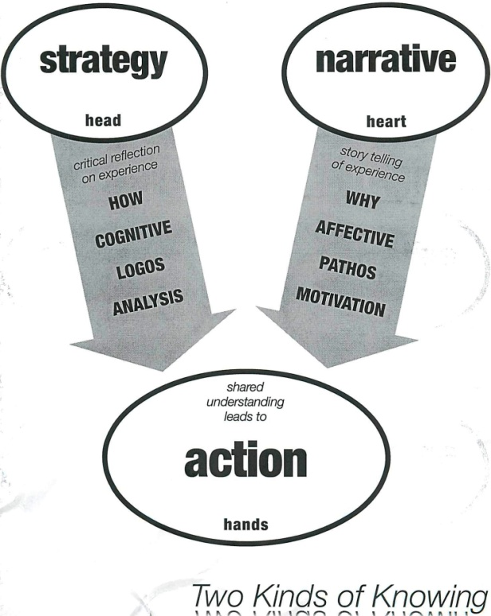

Values, Motivation and Action
To understand motivation – that which inspires action – consider the word emotion and their shared root word, motor –to move. Psychologists argue that information provided by our emotions, which we experience as feelings, is partly physiological, as when our respiration changes or our body temperature alters; partly behavioral, as when we are moved to advance or to flee, to stand up or to sit down; and partly cognitive since we can describe what we feel as fear, love, desire, or joy.
We also experience our values through our emotions. Our emotions provide us with vital information about how to live our lives, not in contrast to reasoned deliberation, but more as a precondition for it. Moral philosopher Martha Nussbaum argues that because we experience value through emotion, trying to make moral choices without emotional information is futile. She supports her argument with research on people afflicted with lesions on the amygdale, a part of the brain central to our emotions. When faced with decisions, they can come up with one option after another, but cannot decide because decisions ultimately are based on judgments of value. And if we cannot experience emotion, we cannot experience values that orient us to the choices we must make.
Some emotions inhibit mindful action in response to challenges while others facilitate it. Exploring the relationship between emotion and purposeful action, political scientist George Marcus points to two of our neurophysiologic systems – surveillance and disposition. Our surveillance system compares what we expect to see with what we do see, tracking anomalies which, when observed, translate into anxiety. Without this emotional cue, Marcus argues, we simply operate out of habit. When we do feel anxiety, it is a way of saying to ourselves, “Hey! Pay attention! There’s a bear in the doorway!” The big question is what we do with that anxiety. And the problem is that we are hard wired to react to anxiety with fear: we run away, we strike out, or we freeze, hoping “it” won’t notice us. When we lived in isolated bands roaming the countryside this reaction may have been quite constructive. On the other hand, when we began to form larger communities, we began to find ways to counter this fear ‘reaction’ with a far more purposeful and agentic “response.” Chief among these ways is the use of stories because stories are built around moments of challenge, and because we can identify with the protagonist of a story, we can feel what he or she feels, experiencing their sources of hope over fear, so that they become a resource for us in responding with hope over fear. If we are hopeful, our curiosity is more likely to be triggered, leading to exploration that can yield learning and creative problem solving. So our readiness to consider action, capacity to consider it well, and ability to act on our consideration rests on how we feel.
Leadership requires engaging others in purposeful action by mobilizing feelings that can enable a mindful – or agentic – “response” as opposed to a fearful “reaction”. This can produce an emotional dissonance, a tension that may only be resolved through action. Organizers call this agitation. For example, my fear of not upsetting the boss (teacher, parent, employer) because of my dependency on him or her may conflict with my sense of self-respect if the boss acts to violate it. One person may become angry enough to challenge her boss; another may “swallow her pride” and another may resist the organizer who points out the conflict. Any of these options is costly, but one may serve a person’s interests better than another.
As the chart below illustrates, while inertia – the security of habitual routine – can blind us to the signs of a need for action, urgency and sometimes anger get our attention. Fear can paralyze us, driving us to rationalize inaction (freezing), run away (flight) or strike out (fight);amplified by self-doubt and isolation, we may become victims of despair. On the other hand, hope can inspire us and, in concert with self-esteem (You Can Make A Difference) and solidarity (love, empathy), can enable us to find the courage to respond mindfully.
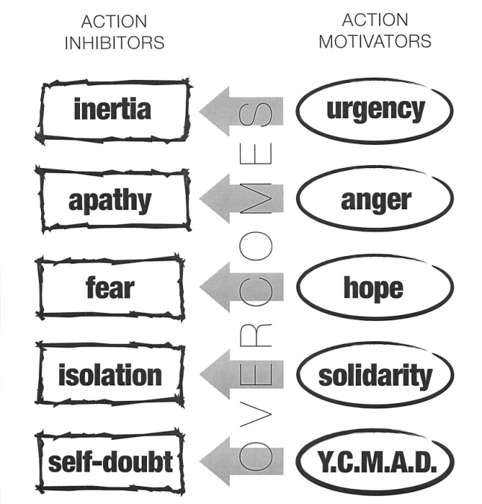

Urgency that captures our attention creates the space for new action, but is less about time than it is about priority. The urgent need to complete a problem set due tomorrow supplants the important need to figure out what to do with the rest of life. The urgent need to attend to a critically ill family member supplants the important need to attend the next business meeting (or ought to?). The urgent need to devote the day turning out voters for a critical election supplants the important need to review the family budget. Commitment and concentration of energy are required to launch anything new, and creating a sense of urgency is often the way to get the focused commitment that is required.
What about inertia’s first cousin, apathy? One way to counter apathy is with anger – not rage, but outrage and indignation with injustice. Constructive anger grows out of experiencing the difference between what ought to be and what is – the way we feel when our moral order has been violated. Sociologist Bill Gamson describes this as using an "injustice frame" to counter a "legitimacy frame." As scholars of “moral economy” have taught us, people rarely mobilize to protest inequality as such, but they do mobilize to protest “unjust” inequality. In other words, our values, moral traditions, and sense of personal dignity can function as critical sources of the motivation to act.
Where can we find the courage to act in spite of fear? Trying to eliminate that to which we react fearfully is a fool’s errand because it locates the source of our fear outside ourselves, rather than within our own hearts. Trying to make ourselves “fearless” is counterproductive if it means acting more out of “nerve than brain.” Leaders can “inoculate” by warning others that the opposition will threaten them with this and woo them with that. The fact that these behaviors are expected reveals the opposition as more predictable and thus less to be feared. But in reality, it is the choice to act in spite of fear that is the meaning of courage. And of the emotions that help us find courage, perhaps most important is hope.
Where do we go to get some hope? One source of hope is the experience of “credible solutions,” reports not only of success elsewhere, but direct experience of small successes and small victories. Another important source of hope for many is in faith traditions, spiritual beliefs, cultural traditions, and moral understandings. Many of the great social movements – Gandhi, Civil Rights, and Solidarity – drew strength from religious traditions, and much of today's organizing occurs in faith communities. Relationships offer another source of hope. We all know people who inspire hopefulness just by being around them. “Charisma” can be seen as the capacity to inspire hope in others, inspiring others to believe in themselves. Psychologists who have begun to explore the role of “positive emotions” give particular attention to the “psychology of hope.” More philosophically, Moses Maimonides, the Jewish scholar of the 12th Century, argued that hope is belief in the “plausibility of the possible” as opposed to the “necessity of the probable.” While it is always “probable” that Goliath will win, it is also true that sometimes David wins, a sense of the “possible” that we experience in our own lives as well. Hope emerges from this sense of possibility, freeing us from the shackles of probability.
Leaders counter self-doubt by attending to the self-efficacy of others, creating the sense that you can make a difference, or YCMAD. One way to inspire this sentiment is to frame action in terms of what people can do, not what they can’t do. If an organizer designs a plan calling for each new volunteer to recruit 100 people and provides no leads, training, or coaching, she or he will only create deeper feelings of self-doubt. Recognition based on real accomplishment, not empty flattery, can help, meaning there is no real recognition without accountability. Accountability does not show lack of trust, but is evidence that what one is doing really matters.
Finally, leaders can counter feelings of isolation with the experience of belovedness or solidarity. This is the role of mass meetings, celebration, singing, common dress, and shared language.
The way we feel about things, however, may have little to do with the present, but rather may be a legacy of lessons learned long ago. Suppose that, as a four-year-old, you are playing on a swing-set at the park when a bigger kid tries to kick you off. You run to your parent for help, but your parent laughs it off. In that moment you are angry and embarrassed, convinced that your parent doesn’t care. You now have learned the lesson that counting on others is a bad idea. As an adult, evaluating what to do about a pay cut, your past experience will make it unlikely that you will join other workers to protest. You fear counting on others, and you may even tell yourself you deserved that pay cut. If you are still in the grips of that fear when an organizer comes along and tells you that, with a union, you could keep the employer from cutting your pay, you will see that organizer as a threat, her claims suspect, and her proposals hopeless.
So exercising leadership often requires engaging in an emotional dialogue, drawing on one set of emotions (or values) which are grounded in one set of experiences, in order to counter another set of emotions (or values), grounded in different experiences – a dialogue of the heart. This dialogue of the heart, far from being irrational, can restore choices that have been abandoned in despair.

The Power of Story
The discursive form through which we translate values into action is story. A story is crafted of just three elements: plot, character, and moral. The effect depends on the setting: who tells the story, who listens, where they are, why they are there, and when.

NARRATIVE STRUCTURE
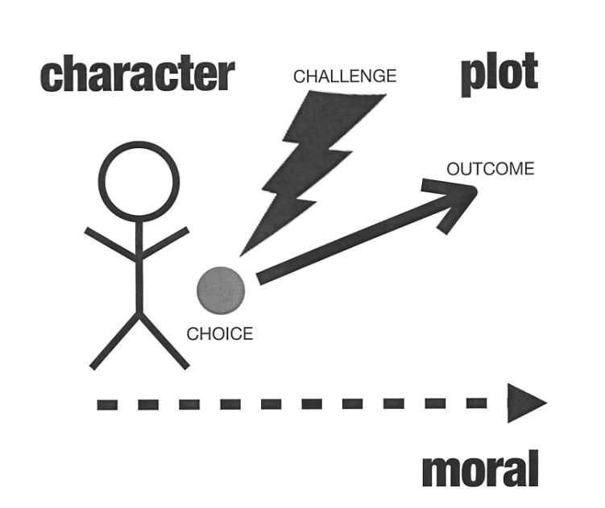

Plot
A plot engages us, captures our interest, and makes us pay attention. “I got up this morning, had breakfast, and came to school.” Is that a plot? Why? Why not?
How about: “I was having breakfast this morning when I heard a loud screeching coming from the roof. At that very moment I looked outside to where my car was parked, but it was gone!!!” Now what’s going on? What’s the difference?
A story begins. An actor is moving toward a desired goal. But then some kind of challenge appears. The plan is suddenly up in the air. The actor must figure out what to do. This is when we get interested. We want to find out what happens.
Why do we care?
Dealing with the unexpected – small and large – defines the texture of our lives. No more tickets at the movie theater. You’re about to lose your job. Your marriage is on the verge of break-up. We are constantly faced with the unexpected, and what we’re going to do. And what is the source of the greatest uncertainty around us? Other people. The subject of most stories is about how to interact with other people.
As human beings we make choices in the present, based on remembering the past and imagining the future. This is what it means to be an agent. But when we act out of habit, we don’t choose; we just follow the routine. It is only when the routines break down, when the guidelines are unclear, when no one can tell us what to do, that we make real choices and become the creators of our own lives, communities, and futures. Then we become the agents of our own fate. These moments can be as frightening as they are exhilarating.
A plot consists of just three elements: a challenge, a choice, and an outcome. Attending to plot is how we learn to deal with the unpredictable. Researchers report that most of the time that parents spend with young children is in story telling – stories of the family, the child’s stories, stories of the neighbors. Bruner describes this as agency training: the way we learn how to process choices in the face of uncertainty. And because our curiosity about the unexpected is infinite, we invest billions of dollars and countless hours in films, literature and sports events – not to mention religious practices, cultural activities, and national celebrations.
Character
Although a story requires a plot, it only works if we can identify with a character. Through our empathetic identification with a protagonist, we experience the emotional content of the story. That is how we learn what the story has to teach to our hearts, not only our heads. As Aristotle wrote of Greek tragedy, this is how the protagonist’s experience can touch us and, perhaps, open our eyes. Arguments persuade with evidence, logic, and data. Stories persuade by this empathetic identification. Have you ever been to movie where you couldn’t identify with any of the characters? It’s boring. Sometimes we identify with protagonists that are only vaguely “like us” – like the road runner (if not the coyote) in the cartoons. Other times we identify with protagonists that are very much like us – as in stories about friends, relatives, neighbors. Sometimes the protagonists of a story are us, as when we find ourselves in the midst of an unfolding story, in which we are the authors of the outcome.

Moral
Stories teach. We’ve all heard the ending – “and that is the moral of the story.” Have you ever been at a party where someone starts telling a story and they go on...and on...and on...? Someone may say (or want to say), “Get to the point!” We deploy stories to make a point, and to evoke a response.
The moral of a successful story is emotionally experienced understanding, not only conceptual understanding, and a lesson of the heart, not only the head. When stated only conceptually, many a moral becomes a banality. Saying “haste makes waste” does not communicate the emotional experience of losing it all because we moved too quickly – but it can remind of that feeling, learned through a story. Nor can we expect morals to provide detailed tactical information. We do not retell the story of David and Goliath because it teaches us how to use a slingshot. What the story teaches is that a “little guy” – with courage, resourcefulness, and imagination – can beat a “big guy,” especially one with Goliath’s arrogance. We feel David’s anger, courage, and resourcefulness and feel hopeful for our own lives because he is victorious. Stories thus teach how to manage our emotions, not repress them, so we can act with agency to face our own challenges.
Stories teach us how to act in the “right” way. They are not simply examples and illustrations. When they are well told, we experience the point, and we feel hope. It is that experience, not the words as such, that can move us to action. Because sometimes that is the point – we have to act.
Setting
Stories are told. They are not a disembodied string of words, images, and phrases. They are not messages, sound bites, or brands – although these rhetorical fragments may reference a story. Storytelling is fundamentally relational. As we listen, we evaluate the story, and we find it more or less easy to enter, depending on the storyteller. Is it his or her story? We hear it one way. Is it the story of a friend, a colleague, or a family member? We hear it another way. Is it a story without time, place, or specificity? We step back. Is it a story we share, perhaps a Bible story? Perhaps we draw closer to one another. Storytelling is how we interact with each other about values; how we share experiences with each other, counsel each other, comfort each other, and inspire each other to action.

Public Narrative: Self, Us, Now.

Leadership, especially leadership on behalf of social change, often requires telling a new public story, or adapting an old one: a story of self, a story of us, and a story of now. A story of self, communicates the values that are calling you to act. A story of us communicates values shared by those whom you hope to motivate to act. And a story of now communicates the urgent challenge to those values that demands action now. Participating in a social action not only often involves a rearticulation of one’s story of self, us, and now, but marks an entry into a world of uncertainty so daunting that access to sources of hope is essential. To illustrate, I’ll draw examples from the first seven minutes of Sen. Barack Obama’s speech to the Democratic National Convention in July 2004.

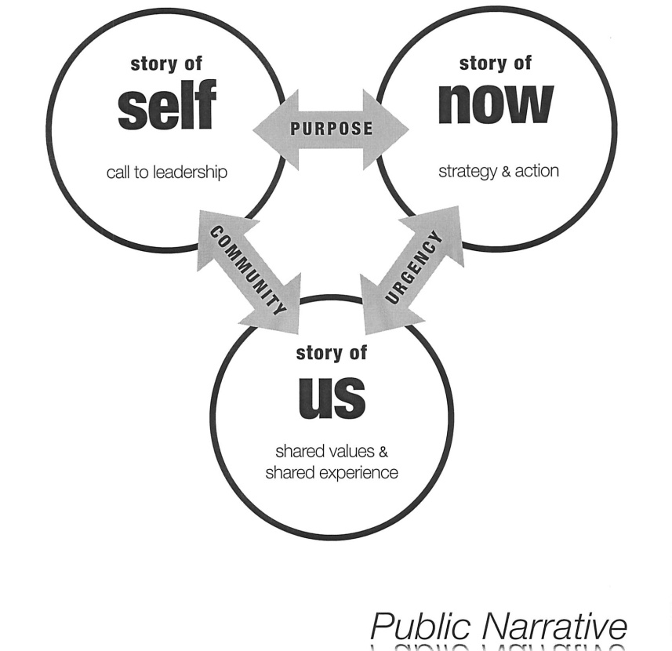

Story of Self
Telling one’s story of self is a way to share the values that define who you are -- not as abstract principles, but as lived experience. We construct stories of self around choice points – moments when we faced a challenge, made a choice, experienced an outcome, and learned a moral. We communicate values that motivate us by selecting from among those choice points, and recounting what happened. Because story telling is a social transaction, we engage our listener’s memories as well as our own as we learn to adapt our story of self in response to feedback so the communication is successful. Similarly, like the response to the Yiddish riddle that asks who discovered water: “I don’t know, but it wasn’t a fish.” The other person often can “connect the dots” that we may not have connected because we are so within our own story that we have not learned to articulate them.
We construct our identity, in other words, as our story. What is utterly unique about each of is not a combination of the categories (race, gender, class, profession, marital status) that include us, but rather, our journey, our way through life, our personal text from which each of us can teach.
A story is like a poem. It moves not by how long it is, nor how eloquent or complicated. It moves by offering an experience or moment through which we grasp the feeling or insight the poet communicates. The more specific the details we choose to recount, the more we can move our listeners, the more powerfully we can articulate our values, what moral philosopher Charles Taylor calls our “moral sources.” Like a poem, a story can open a portal to the transcendent.
Telling about a story is different from telling a story. When we tell a story we enable the listener to enter its time and place with us, see what we see, hear what we hear, feel what we feel. An actor friend once told me the key was to speak entirely in the present tense and avoid using the word “and”: I step into the room. It is dark. I hear a sound. Etc.
Some of us may think our personal stories don’t matter, that others won’t care, or that we should talk about ourselves so much. On the contrary, if we do public work we have a responsibility to give a public account of ourselves - where we came from, why we do what we do, and where we think we’re going. In a role of public leadership, we really don’t have a choice about telling our story of self. If we don’t author our story, others will – and they may tell our story in ways that we may not like. Not because they are malevolent, but because others try to make sense of who by drawing on their experience of people whom they consider to be like us.
Aristotle argued that rhetoric has three components - logos, pathos, and ethos – this is ethos. The logos is the logic of the argument. The pathos is the feeling the argument evokes. The ethos is the credibility of the person who makes the argument. – their story of self.
Social movements are often the “crucibles” within which participants learn to tell new stories of self as we interact with other participants. Stories of self can be challenging because participation in social change is often prompted by a “prophetic” combination of criticality and hope. In personal terms this means that most participants have stories both of the world’s pain and the world’s hope. And if we haven’t talked about our stories of pain very much, it can take a while to learn to manage it. But if others try to make sense of why we are doing what we are doing – and we leave this piece out – our account will lack authenticity, raising questions about the rest of the story.
In the early days of the women’s movement, people participated in “consciousness raising” group conversations which mediated changes in their stories of self, who they were, as a woman. Stories of pain could be shared, but so could stories of hope. In the civil rights movement, Blacks living in the Deep South who feared claiming the right to vote, had to encourage one another to find the courage to make the claim – which, once made, began to alter how they thought of themselves, how they could interact with their children, as well as with white people, and each other.
In Sen. Obama’s “story of self” he recounts three key choice points: his grandfather’s decision to send his son to America to study, his parent’s “improbable” decision to marry, and his parent’s decision to name him Barack, blessing, an expression of faith in a tolerant and generous America. Each choice communicates courage, hope, and caring. He tells us nothing of his resume, preferring to introduce himself by telling us where he came from, and who made him the person that he is, so that we might have an idea of where he is going.
Story of Us
Our stories of self, overlap with our stories of us. And it is likely that we tell more stories of us than any other kind of story. We participate in many us’s, some of them are long term, always being renewed by the telling of stories of self, and some of them over in a moment, flickering into being as the result of someone’s articulation of the shared experience we are having at that moment. And whenever we tell stories of these shared moments – funny stories, sad stories, celebratory stories, regretful stories – the experience with share with others of recalling these moments brings the values at the core of the meaning they hold for us alive. A story of us, then, is experiential not categorical. In other words it is not about any of the usual identity markers, but, rather, the experience of sharing values with others “in the room”. A story of “us” not only articulates the values of our community; it can also distinguish our community from another, thus reducing uncertainty about what to expect from those with whom we interact. Social scientists often describe a “story of us” as a collective identity.
Our cultures are repositories of stories. Stories about challenges we have faced, how we stood up to them, and how we survived are woven into the fabric of our political culture, faith traditions, etc. We tell these stories again and again in the form of folk sayings, songs, religious practice, and celebrations (e.g., Easter, Passover, 4th of July). And like individual stories, stories of us can inspire, teach, offer hope, advise caution, etc. We also weave new stories from old ones. The Exodus story, for example, served the Puritans when they colonized North America, but it also served Southern blacks claiming their civil rights in the freedom movement.
For a collection of people to become an “us” requires a story teller, an interpreter of shared experience In a workplace, for example, people who work beside one another but interact little, don’t linger after work, don’t arrive early, and don’t eat together never develop a story of us. In a social movement, the interpretation of the movement’s new experience is a critical leadership function. And, like the story of self, it is built from the choices points – the founding, the choices made, the challenges faced, the outcomes, the lessons it learned.
In Sen. Obama’s speech, he moves into his “story of us” when he declares, “My story is part of the American story”, and proceeds to lift of values of the American he shares with his listeners – the people in the room, the people watching on television, the people who will read about it the next day. And he begins by going back to the beginning, to choices made by the founders to begin this nation, a beginning that he locates in the Declaration of Independence, a repository of the value of equality, in particular. He then cites a series of moments that evoke values shared by his audience.
Story of Now
A story of now articulates an urgent challenge – or threat - to the values that we share that demands action now. What choice must we make? What is at risk? And where’s the hope?
In a story of now, we are the protagonists and it is our choices that shape the outcome. We draw on our “moral sources” to find the courage, hope, empathy perhaps to respond. A most powerful articulation of a story of now was Dr. King’s talk delivered in Washington DC on August 23, 1963, often recalled as the “I have a dream” speech. People often forget that what preceded the dream was a nightmare: the consequence of white America’s failure to make good on its promissory note to African Americans. King argued the moment was possessed of the “fierce urgency of now” because this debt could no longer be postponed. If we did not act, the nightmare would only grow worse – for all of us - never to become the dream.
In a story of now, story and strategy overlap because a key element in hope is a strategy – a credible vision of how to get from here to there. The “choice” offered cannot be something like “we must all choose to be better people” or “we must all choose to do any one of this list of 53 things” (which makes each of the trivial). A meaningful choice is more like “we all must all choose – do we commit to boycotting the busses until they desegregate or not?” Hope is specific, not abstract. What’s the vision? When God inspires the Israelites in Exodus, he doesn’t offer a vague hope of “better days”, but describes a land “flowing with milk and honey” and what must be done to get there. A vision of hope can unfold a chapter at a time. It can begin by getting that number of people to show up at a meeting that you committed to do. You can win a “small” victory that shows change is possible. A small victory can become a source of hope if it is interpreted as part of a greater vision. In churches, when people have a “new story” to tell about themselves, it is often in the form of “testimony” – a person sharing an account of moving from despair to hope, the significance of the experience strengthened by the telling of it.
Hope is not to be found in lying about the facts, but in the meaning we give to the facts. Shakespeare’s King Henry V stirs hope in his men’s hearts by offering them a different view of themselves. No longer are they a few bedraggled soldiers led by a young and inexperienced king in an obscure corner of France who is about to be wiped out by an overwhelming force. Now they are a “happy few,” united with their king in solidarity, holding an opportunity to grasp immortality in their hands, to become legends in their own time, a legacy for their children and grandchildren. This is their time! The story of now is that moment in which story (why) and strategy (how) overlap and in which, as poet Seamus Heaney writes, “Justice can rise up, and hope and history rhyme.” And for the claim to be credible, the action must begin right here, right now, in this room, with action each one of us can take. It’s the story of a credible strategy, with an account of how -- starting with who and where we are, and how we can, step by step, get to where we want to go. Our action can call forth the actions of others, and their actions can call others, and together these actions can carry the day. It’s like the old protest song Pete Seeger used to sing:

“One man’s hands can’t tear a prison down.
Two men’s hands can’t tear a prison down.
But if two and two and fifty make a million,
We’ll see that day come round.
We’ll see that day come round.”

Sen. Obama moves to his “story of now” with the phrase, “There is more work left to do.” After we have shared in the experience of values we identify with America at its best, he confronts us with the fact that they are not realized in practice. He then tells stories of specific people in specific places with specific problems. As we identify with each of them, our empathy reminds of pain we have felt in our own lives. But, he also reminds us, all this could change. And we know it could change. And it could change because we have a way to make the change, if we choose to take it. And that way is to support the election of Sen. John Kerry.
Although that last part didn’t work out, the point is that he concluded his story of now with a very specific choice he calls upon us to make.
Through public narrative leaders – and participants – can move to action by mobilizing sources of motivation, constructing new shared individual and collective identities, and finding the courage to act.

Celebrations

We do much of our storytelling in celebrations. A celebration is not a party. It is a way that members of a community come together to honor who they are, what they have done, and where they are going -- often symbolically. Celebrations may take place at times of sadness, as well as times of great joy. Celebrations provide rituals that allow us to join in enacting a vision of our community -- at least in our hearts. Institutions that retain their vitality are rich in celebrations. In the Church, for example, Mass is "celebrated." Harvard's annual celebration is called Graduation and lasts an entire week.
Storytelling is at its most powerful at beginnings -- for individuals, their childhood; for groups, their formation; for movements, their launching; and for nations, their founding. Celebrations are a way we interpret important events, recognize important contributions, acknowledge a common identity, and deepen our sense of community. The way that we interpret these moments begins to establish norms, create expectations, and shape patterns of behavior, which then influence all subsequent development. And we draw on them again and again. Nations institutionalize their founding story as a renewable source of guidance and inspiration. Most faith traditions enact a weekly retelling of their story of redemption, usually rooted in their founding. Well-told stories help turn moments of great crises into moments of “new beginnings.”

Conclusion
Narrative allows us to communicate the values that motivate the choices that we make. . Narrative is not talking “about” values; rather narrative embodies and communicates values. And it is through the shared experience of our values that we can engage with others, motivate one another to act, and find the courage to take risks, explore possibility and face the challenges we must face.

Organizing Notes

People, Power & Change
Week 3

Introduction

The first question an organizer asks is not “what is my issue” but “who are my people”? Identify the people whom you hope to organize, your constituency. What are their values, their interests their resources, and, in particular, their challenges? Why might they want or need to organize? Do they live in a particular neighborhood? Do they do a certain kind of work? Do they share particular concerns such as parents, elders, young people? Do they share common values, such as preserving the environment? Why do they care? How do you know? Have you talked with them? Although the source of your constituency’s concern may be local, regional, national or even global, because all organizing is locally rooted, sometimes we link organized constituencies together in coordinated campaigns. Sometimes people in one place, like South Africa during the struggle against Apartheid, may organize in one way (strikes, civil disobedience) while supporters of that struggle around the world may organize in other way (boycotts, political pressure, etc)
The second question an organizer asks is what kind of change do they need? What problems do they face? What challenges? Is their neighborhood deteriorating? Are their wages not keeping pace with the cost of living? Are their young people victims of official or unofficial gun violence? Are they morally outraged by the trafficking of young women? Is their children’s future at risk due to climate change? How would their world look if the problem were solved? Why hasn’t it been solved? What would it take to solve the problem?
The third question an organizer asks is not “how can I solve their problem for them” but “how can I enable them to work together to turn the resources they have into the power they need to achieve the change they need?
You will need to map the power to begin finding answers to these questions: in addition to your constituency, what other actions may have a stake in the problem? What are their interests and resources? Who is responsible for the problem? Who holds the resources that might solve it? Whose interests might oppose solving it? Whose interests might be allied? Whose interests might be competitive? Whose interests might be in collaboration? And whose resources are relevant even if their interests are not clear: media, courts, the public, etc.
Once you’ve mapped the power, based on your analysis of the change needed, decide on a strategic goal (specific, visible, plausible) on which to focus your effort; e.g., desegregating the busses, passing a local minimum wage ordinance, achieving union recognition, changing hiring practices, changing school text books, closing the local planned parenthood clinic, creating a new course, reallocating funding, etc. A strategic goal not only allows you to focus your efforts, but will also allow your constituency to leverage its resources, to build its capacity, and to motivate participation. Your “mountain top” or ultimate goal may be to stop gun violence in America, for example, but, given your circumstances, what more limited but strategic goal can you focus on that can contribute to building the power you will need to achieve you ultimate goal?
How can your constituency create the power it will need to achieve this strategic goal?
Could they collaborate to combine their resources to create enough “power with” each other to solve the problem: like forming a cooperative day care or organizing a credit union? Or does someone else have “power over” your constituency because they hold resources needed to solve the problem: a property owner, a bank, a public official, an employer. Could your constituency collaborate to use their own resources in ways to affect that other person’s interests enough to give them an interest in using their resources the way your constituency wants: like raising wages, passing a law, cleaning up their pollution, reducing the rent? This is what we call a “theory of change” and is what drives setting a goal, leading a campaign, and building an organization.
In this class you will organize a campaign, the real work of organizing is within one’s constituency. As Chart 1 shows, organizing is about enabling a constituency to develop the power it needs to assert its interests effectively, not only now, but in the future. That’s how power is shifted. Organizers begin by building a foundation within their constituency. This usually requires many one on one meetings to learn people’s concerns, discern the sources of the real problems, figure out the power dynamics, and identify, recruit and develop the leadership of a campaign. A campaign is a process through which your constituency can organize itself to create the power it needs to accomplish goals that will achieve the change they need. And running their campaign into an organization gives them access to the capacity to build on their successes into the future.

Chart #1
CAMPAIGN

Organization

Foundation
CONSTITUENCY

Although you answer these questions in dialogue with your constituency, their leadership, and others, you need to bring an initial road map of where you want to go and how you imagine getting there as a working hypothesis t so your journey can begin.

PEOPLE

Who are the Actors?

Constituency
Organizers transform a community into a constituency. A community shares values or interests. A constituency is a community organized to use its resources to act on those interests (from the Latin for standing together). Clients (from the Latin for “one who leans on another”) have an interest in services others provide. Customers (a term derived from trade) have an interest in a good a seller can provide in exchange for a cash resource.
Constituents are the heart of organizations that serve them. Clients and Customers are usually external to these organizations. Constituents can become "members” of the organization just as citizens become “members” of a democracy. Voters are constituents of an elected official. Workers employed by particular employers may be constituents of a union (why wouldn't they be constituents of their employer?). People with environmental concerns may become the constituents of environmental organizations.
Economist Albert Hirschman described three alternative responses to the need for change in a system: exit, voice, and loyalty. Constituents can influence the system through voice: making themselves heard through internal means. Customers and clients can only assert influence through exit, taking their resources elsewhere. The organizers job is to turn a community – people who share common values or interests – into a constituency – people who can act on behalf of those values or interests.
Organizers assume that people are not mere “objects” of “social forces” that “cause” them to do things, but are, in fact, “agents” of change or “actors.” As actors we remember, imagine, choose, and reflect on choices. Although "social forces" influence our choices, our choices also shape "social forces." Because we are not atomized individuals, floating in space, we exercise agency interdependently with others whose decisions affect our own. Can we understand the "drug problem", for example, without taking into consideration the myriad dealers, smugglers, and producers who mobilize to frustrate every attempt to solve it?

Leadership
Although your constituency is the focus of your work, your goal as an organizer is identify, recruit and develop leadership from within that constituency – initially, a leadership team – who will organize everyone else. Their work, like your own, is to “accept responsibility for enabling others to achieve purpose in the face of uncertainty.” They facilitate the work members of their constituency must do to achieve their goals, represent their constituency to others, and are accountable to their constituency. Leaders of large – or small - bureaucratic organizations may have little relationship with clients or customers. Leaders of civic associations, on the other hand, can only earn leadership through relationships with their constituents - club officers, union stewards, members of a parish council, etc. Full time or part time people who do the day-to-day work of the organization may also serve as leaders, whether volunteer or paid, even if not drawn from the constituency if they are accountable to it -- full time local union presidents, chairs of mission committees, and the people who pass out leaflets on behalf of a candidate. Most organizations have a governing “body” that decides policy, chooses staff, and may or may not be involved in day-to-day activities. In bureaucratic organizations, the governing body may be self-selected, selected by outside groups, or by donors or investors - but rarely include leaders drawn from among their clients.
You work with the leadership team you recruit by coaching them in the five organizing practices you are learning: relationship building, storytelling, structuring, strategizing, and action. Developing their leadership is not only the way you, as an organizer, can “get to scale.” It is how you can create new capacity for action – power – within your constituency. This is a critical difference between organizing and other forms of problem solving. To the extent powerlessness is responsible for the challenges your constituents face, developing the leadership who can mobilize others can create power where there had been none - thus getting at a root cause of the problem that needs to be solved.
Opposition
In pursuing their interests, constituents may find themselves in conflict with interests of other individuals or organizations. An employers’ interest in maximizing profit, for example, may conflict with an employees' interest in earning a living wage. A tobacco company's interests my conflict not only with those of anti-smoking groups, but of the public in general. A street gang's interests may conflict with those of a church youth group. The interests of a Republican Congressional candidate conflict with those of the Democratic candidate in the same district. At times, however, opposition may not be immediately obvious, emerging clearly only in the course of a campaign.
Supporters
People whose interests are not directly or obviously affected may find it to be in their interest to back an organization’s work financially, politically, voluntarily, etc. Although they may not be part of the constituency, they may sit on governing boards. For example, Church organizations and foundations provided a great deal of support for the civil rights movement.

Competitors and Collaborators
These are individuals or organizations with which we may share some interests, but not others. They may target the same constituency, the same sources of support, or face the same opposition. Two unions trying to organize the same workforce may compete or collaborate. Two community groups trying to serve the same constituency may compete or collaborate in their fundraising.
Chart #2: Map of Actors

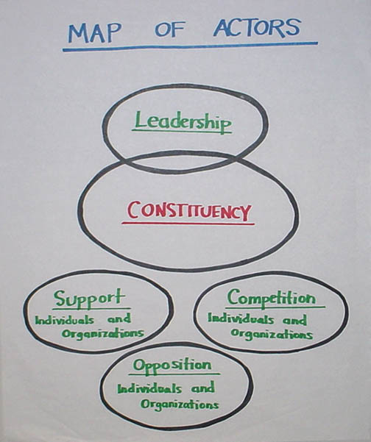

What are their Values, Interests, and Resources?

Why would the people whom you hope to organize want to organize? What do they value? What are their interests? Are those values or interests at risk ? How? The desire to create change most often comes as a response to some form of a present that has been made “intolerable”, not simply for the sake of making change. Your reasons for thinking they “ought” to organize might not be their reasons. How do you know? If a problem they are facing goes unaddressed, what will that look like? And how would the world look differently if it were addressed?
You can only find answers to these questions by interacting with your constituency, but you have to start with a “hypothesis.” Tools of social science, as well as past experience, can give you some idea where to look, what questions to ask, and how to get to know your constituency.
One set of tools is illustrated in Chart #3: Needs, Values, and Interests. Psychologist Clayton Aldefer describes motivational dynamics at work within us as driven by existence, relational and growth needs – physical wellbeing, social wellbeing, and developmental wellbeing. Our needs matter, but as cultural psychologist Jerome Bruner argues, we learn to value these needs – and ways to satisfy them –in cultural settings in which we grow up and interact with others. And because we are purposeful creatures we translate our values into goals – or interests – on behalf of which we mobilize resources.
Threats to these goals, the values that shape them or sudden opportunities to achieve them may create an urgent interest in organizing. Having learned to value education as a pathway to a good life, I may want to make sure my child gets a good one. But sharp increases in college tuition, for example, and cuts in public funds, may scuttle my plans. This might give me an interest in working with others to do something – to demand reductions in tuition, at least in public universities; to demand restoration of funds; to find scholarship alternatives. Our values shape our broad life goals and our interests specify outcomes we pursue to achieve those goals. We define our interests, however, which in Latin means, “to exist among,” in relation to others. Most of us have interests in many domains, some more immediate than others: family, community, work, faith cultural or recreational activities, and politics. Learning to interpret the interests of our constituents – and our own interests-- and the values that shape them -- is critical to understanding organizing.
Resources matter too. What kind of resource do they have at their disposable with which they can address their interests or meet possible challenges? Do they have the resources? Do they depend on others for their resources? What kind of resources matter? Who holds them?

Chart #3: Needs, Values, and Interests

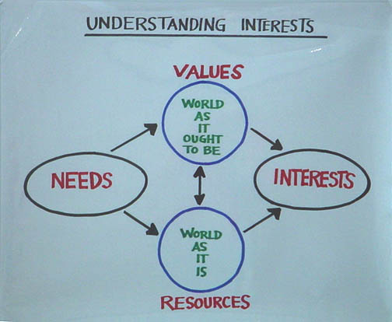
.

CHANGE

So what kind of change might your organizing project aim to achieve? What will be your goal? It may be early to specify a specific outcome for your project, but what goal could you imagine your constituency organizing to pursue? If inequity in education seems to be a challenge, what might more equitable education look like, concretely? If lack of diversity on the faculty seems to be a challenge, what might a more diverse faculty actually look like?
The goal of your project may not be to promise a solution to the whole problem, but it could be a step in the right direction. No one strategic goal can solve everything, but unless we choose “a” goal on which to focus our resources, energy, and imagination, we risk wasting precious resources in ways that won’t add up. This pyramid chart is one way to think about how goals may be nested: at each level of a campaign we imagine an outcome, assess resources available to achieve that outcome, and, in light of the context, figure out a way to turn those resources into the power to achieve that outcome (theory of change).

Chart #4

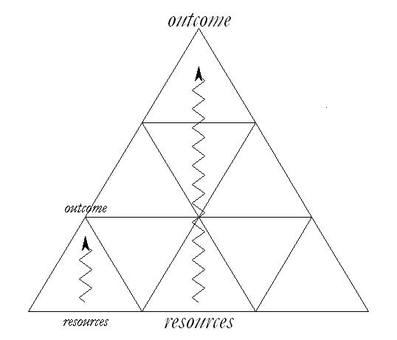
These are some criteria to consider in deciding on a goal for your campaign:

- Focuses your resources on a single strategic outcome.
- Builds your constituency’s resources and capacity
- Leverages your constituency’s strength and the weakness of the opposition.
- Is visible, significant, and important enough to motivate constituency engagement.
- Is contagious and could be emulate

POWER
Theories of Change

As you begin to identity what the goal of your campaign might be you also have to figure out how you can make it happen: your theory of change. This is challenging because we all have assumptions about how the world works, including why we have the problems we do, what it would take to solve them, and what we can do to make it happen. Articulating a “theory of change” is a way of making these assumptions explicit so they can be examined, evaluated, and, if necessary, replaced with a more realistic set of assumptions. Your theory of change becomes the foundation of your strategy – how to turn the resources you have into the power you need to get what you want.
To get at your theory of change, ask yourself why the problem you are hoping to solve hasn’t been solved already? In other words, what’s your theory of “no change”? Is it because the people who could solve the problem need more information? Do they realize it’s a problem, but don’t know how to solve it? Or do they simply have no interest in solving the problem. If they don’t, why not? In case of the Bus Boycott, for example, was the problem a lack of awareness as to the hurt that was being caused African-Americans (and, in reality, white Americans as well) by segregation? Was it due to the fact that whites and blacks weren’t “communicating”? Was it too costly to desegregate? Or was the white community committed to using its power to keep things as they were because they wanted them that way? Because it was the “right” way to order of their society, and it was in their political interest to keep it that way. This kind of analysis does not, in itself, produce strategy, but it is the first step in figuring out what KIND of strategy you will need to change things. It is a way to surface assumptions about why things are the way they are, that may or may not be so, but that influence your thinking as to what it will take to change them.
So what would it take to change things? If the folks in Montgomery thought the problem was one of “information”, perhaps they could have used their resources conduct an “awareness raising” campaign to communicate to white community just how bad segregation made the black community feel. If they thought the problem was one of of “communication” they might have tried to convene meetings with the white leadership to explain why everyone would be better off without segregation. But they concluded it was a power problem. Segregation persisted because the white community believed in it and had the power to make it so. It would only change if it became more costly to the interests of the white community – or those who held power within the white community – to stay the course than to change. Perhaps losing enough money would give them an interest in change. Perhaps having to pay court fines? Or perhaps it would take going to jail. Based on this analysis they developed a strategy that focused on buses, and, in turn, the tactics – litigation, the boycott, the carpools – through which they could enact that strategy.
The reason their strategy was an organizing strategy, however, and that it kicked off the civil rights movement in a way that Brown v. Board of Education had not, was that it was a particular kind of power strategy. Its power grew out of a commitment of the resources of almost every African-American in that community, beginning with the “feet” of the bus riders who would now use them to walk to work. So when victory was won it yielded not only a change in transportation policy but a newly empowered community, a more widely accessible form of struggle, and a whole new generation of leadership, and that is what sparked the growth of the movement. So it isn’t only power that creates change, but from whose resources that power is created that determines who is empowered by the change.
So what is power? Dr. King defined power as the “ability to achieve purpose.” “Whether it is good or bad,” he said, “depends on the purpose.” In Spanish the word for power is simply poder - to be able to, to have the capacity to. So if power simply describes capacity, why, as Alinsky asks, is it the “p-word” - something we don’t admit we want, acknowledge others have, or even talk about?
Relational Power
Richard Emerson argues that power is not a thing but a relationship. We all need resources to achieve our purposes. Sometimes we have access to all the resources we need, but more often than not our interests require access to the resources of another. This creates an opportunity for exchange: I can trade resources that I have so the other person can achieve their goals for the resources they have that I need to achieve my own. For example, my friend and I want to go to the movies and he has a car, but no money for gas, while I have money for gas, but no car. Based on this mutuality of interests we can influence each other to act interdependently, creating more “power with ” each other than we had singly. Bernard Loomer and Jean Baker Miller describe this as “power to,” “power with,” or interdependency. Mobilizing power in this way creates a whole greater than the sum of its parts. New immigrants, for example, may pool their savings in a credit union to make low interest loans available to its members -- increasing their financial power. "Power with” creates the capacity to accomplish together what we cannot accomplish alone.
Chart #5: Relational Power
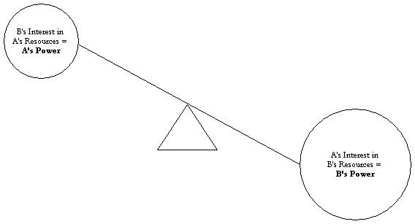
But what if four of us want to go to the movies and my friend’s car only has room for 2 passengers? We could draw straws to see who gets to go and who doesn’t, and each of those who get to go contribute half of the gas. But what if my friend decides that he has an interest not only in going to the movies, but also in making some money from the deal? It turns out that he has control over one resource, his car, that we all need, but no one of us controls the resources he needs, gas money. This imbalance of need, or dependency, gives him the leverage to exercise “power over” us by offering the two spots in the car to the highest bidders, regardless of how much the gas costs. But we still have an option, depending on how badly he wants to go to the movies. All four of us can get together and agree that we will only pay the cost of the gas and not a penny more. If he wants to go badly enough, we will have rebalanced the situation, turning it back into one of “power with.”
Organizing is suited to deal with both power problems. First, a constituency may organize to create power “with” one another, through interdependent collaboration, to achieve the change they want; e.g., a cooperative day care, a car pool, a credit union. Second, a constituency may organize to challenge “power” over them held by other actors; e.g., forming a union, conducting an issue campaign, running an election. Organizing uniquely not only “solves the problem” but enables a constituency to acquire power it didn’t have before. And this is what gets at the source of the problem: a powerless constituency. As Gandhi showed, the fact power is interdependent means that its exercise depends on the “cooperation” –or compliance - of the very people who are being taken advantage of. And they can “stop the machine” simply by refusing to cooperate.

Since power is relational you can use the four questions below to track it down:

Two Kinds of Power: Collaboration and Claims Making
Both kinds of power – power with and power over – are at work in organizing. Members of our constituency can create the power to achieve a shared goal by collaborating to use their resources interdependently in ways they had not done befor: e.g. cooperative childcare, and credit unions. On the other hand, where real conflicts of interest exist, organizing requires a “claims making” strategy, mobilizing constituency resources to alter relationships of dependency and domination. If workers combine their resources in a union they may be able to balance their individual dependency on their employer with his dependency on their labor as a whole. In this way dependent “power over” relationship can become interdependent “power to” relationship.
But creating the power to successfully challenge “power over” may require some “power to” first. Many unions, for example, began with death benefit societies, sickness funds, and credit unions. On the other hand, efforts that began to create “power with” may turn out to be actually challenging “power over” as conflicts of interest that were not previously apparent surface. The strongest opposition to a recent effort to create a community credit union in New York came from actors no one considered—the loan sharks and their political allies.
Three Faces of Power
Why are conflicts of interest not always apparent? As John Gaventa argues power operates on multiple levels, illustrated in Chart #6 below. We can detect the first “face” of power— the visible face—by observing who wins among decision makers faced with choices as to how to allocate resources. Attend a board meeting, city council meeting, legislative session, or board meeting and you’ll see one side win and another side lose, showing who’s got the power.
But there’s more to it than that. Who decides what gets on the agenda to be decided? And who decides who sits at the table making decisions? Lukes calls deciding what’s on the agenda and who sits at the table the second “face” of power. This can be observed when there are groups clamoring to get issues on the agenda, but can’t get past the “gatekeeper.” This is the situation that African Americans faced during many years of apparent “racial harmony” before the civil rights movement. There was no lack of groups trying to bring racial issues before Congress, but these issues rarely got to the point of congressional debate because those controlling the agenda kept them off the floor.
The third “face” of power is harder to detect. Sometimes the power relationships that shape our world are so deeply embedded that we “take them for granted.” Before the women’s movement, for example, few people claimed job discrimination against women was “an issue." Women’s interests were not being voted down in Congress (there were almost no women in Congress) and women’s groups were not picketing outside, unable to place their issue on the agenda. Yet women occupied subordinate positions in most spheres of public life. Were they “content” with this situation? Perhaps. But sometimes, even though people would like things to be different, they can’t imagine that they could be—enough, at least, to take the risks to make them so. To detect this face of power, Lukes says, you have to look deeper—beyond the question of who decides or who gets on the agenda to look at who benefits and who loses in the allocation of valued resources. If you then ask why the losers lose and the winners win, you may discover the power disparity at work. (This can be tricky because the winners always claim they "deserve" to win while the losers "deserve" to lose, and sometimes they convince the losers).
From this perspective, take another look at your project and ask the questions: What is the source of the challenges your constituency faces? Do your constituents lack the power they need to assert their interests? Do they lack resources? Or could they be using the resources they have better? Could they use them better by collaborating with one another (power with)? Could they use them more effectively by using them to influence the interests of others whose resources they need? Did someone fail to allocate resources, as in voting down a school-funding proposal? Were the concerns of those with similar interests kept off the agenda? Or do people just assume that this is how things are, so it is wise to make the best of themes legitimated? A couple of years ago, a student asked why so many Harvard students do public service as students, but abandon it in their professional lives. The most common explanation was that her generation just “doesn’t care.” She noticed that, in contrast to the very elaborate recruiting rituals each fall for investment banks and consulting firms, virtually no one was recruiting on campus for careers in public service. She thought this was an example of the third face of power and organized a "Careers and Social Responsibility" conference in response.

Chart #6: Three Faces of Power

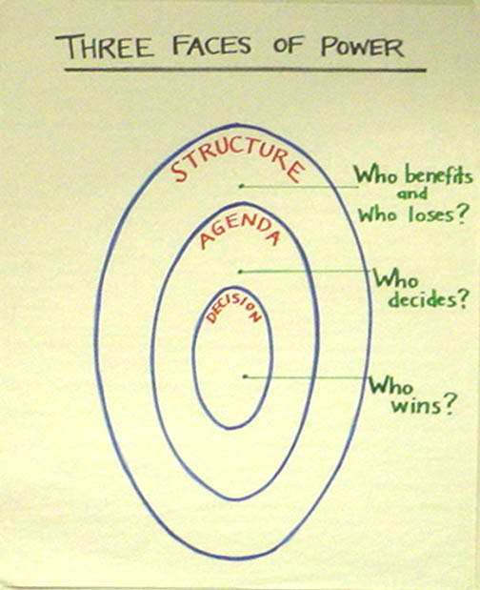

Organizing power begins with the commitment by the first person who wants to make it happen. Without this commitment, there are no resources with which to begin. Commitment is observable as action. The work of organizers begins with their acceptance of the responsibility to challenge others to do the same.

Power and Right
So what about “power” and “right”? What is the relationship between the two? This is the question Thucydides wants us to consider with his account of the Melian debate. Is being “right” enough? Is insisting on one’s “rightness” always responsible? What’s the relationship between being “powerful” and being “right”? What do you think?

The Rhythm of Organizing

The Campaign

The rhythm of organizing is the campaign: coordinated steams of activity focused on achieving specific goals. Campaigns unfold over time with a rhythm that slowly builds a foundation, gathers gradual momentum with preliminary peaks, culminates in a climax when a campaign is won or lost, and then achieves resolution (Chart #7).
Our word for campaign derives from a similar source as other words we have come across this semester -- the word for field, this time in Latin. Campaigns were conducted on fields of battle. They were concentrated, intense, had a clear beginning and end, and, usually, a winner and a loser. A campaign was an episode in a much greater undertaking, such as winning a war, but was made of a number of battles that together comprised the campaign. A campaign was not the whole nation, but an event in the life of the nation, which strengthened it or weakened it. Conducting a campaign is not the same thing as managing an ongoing program, but it is how programs are created, strengthened, or renewed.
A campaign is a way to organize time – one of the most valuable resources we have. As Gersick shows, organizations have a temporal life as well as a spatial one. Work gets done according to the internal rhythm of an organization that may be more or less well “entrained” with the rhythm of events in its environment. Many people note, for example, that student groups need to get started in the first weeks of the semester or they won’t get started at all. After mid-semester, the rhythm changes as people focus on finishing what they’ve begun, rather than beginning new things. Stephen Jay Gould says that time is sometimes a “cycle” and sometimes an “arrow.” Thinking of time as a “cycle” helps us to maintain our routines, our normal procedures, our annual budget, etc. Thinking of time as an “arrow” on the other hand focuses us on making change, on achieving specific outcomes, on focusing our efforts. A campaign is time as an “arrow.”
Chart #7

Foundation
Kick-off goal
Peak goal
Strategic goal
Evaluation
& next steps
Peak goal
Capacity
(people, skills, etc.)
Time

Why are Campaigns Strategic and Motivational?

A campaign is a strategic and motivational way to organize action. It is strategic because it is a way to create the capacity we will need to win, building it as our campaign unfolds. Each campaign peak lifts us to another level of capacity; moving from recruiting volunteers, for example, to putting those volunteers to work, recruiting supporters. It is motivational because it enacts an unfolding story of the hope that we can achieve our objective. As it progresses, we find we can make a difference. Our work acquires the urgency of genuine deadlines. The solidarity of collaborating with others in a common cause energizes us. A campaign allows us to turn our dissatisfaction (anger) to constructive purpose.
Campaigns facilitate targeting resources and energy on specific objectives, one at a time. Creating something new requires intense energy and concentration - unlike the inertia that keeps things going once they have begun. Campaigns are crucibles out of which new organizations, programs, or practices can emerge. Campaigns allow us to maximize the value of our time - our most limited resource. We can invest energy and commitment for a limited number of days, weeks or months at levels we cannot - and should not - sustain for long periods of time. As a campaign ends, we consolidate our “wins” or our “losses,” we return to “normal life," we regroup, and perhaps we undertake another campaign in the future. The “adventurous” quality of a campaign facilitates the development of relationships more quickly - and with greater intensity - than would ordinarily be the case. We more easily come to share a common “story” that we all take part in authoring
The timing of a campaign is structured as an unfolding narrative or story. It begins with a foundation period (prologue), starts crisply with a kick-off (curtain goes up), builds slowly to successive peaks (act one, act two), culminates in a final peak determining the outcome (denouement), and is resolved as we celebrate the outcome (epilogue). Our efforts generate momentum not mysteriously, but as a snowball. As we accomplish each objective we generate new resources that can be applied to achieve the subsequent greater objective. Our motivation grows as each small success persuades us that the subsequent success is achievable - and our commitment grows. The unfolding story of our campaign makes the unfolding story of our organization more credible and, thus, more achievable. Timing has to be carefully managed because a campaign can peak too quickly, exhausting everyone, and then fall into decline. Another danger is a campaign may “heat up” faster in some areas than in others - as some people burn out and others never get going. What role did timing play with DSNI? Why was Gandhi’s “salt march” a particularly good example of timing?
A campaign links relational, story, strategy, and action tactics as each lays groundwork for the next. We may begin the campaign with 5 organizers, each of whom uses house meetings to recruit 15 precinct leaders (75 people), each of whom goes door to door to recruit 5 volunteers for the phone bank (375 people), each of whom contacts and commits 25 voters (9375 people). Along the way, leadership develops, signs go up, people are talked with, rallies are held, and so forth. Using the 1988 California campaign plan, we turned 300 organizers into 11,000 precinct leaders into 100,000 house signs into 25,000 Election Day volunteers into 750,000 additional voters. Although it was not enough to elect our candidate President, we created a new wave of grass roots leadership for political efforts throughout the state for the next several years.
Campaigns provide an opportunity for learning by allowing for “small losses” in the early days of a campaign. As Sitkin argues, creating the space for “small losses” early on in a project offer participants the opportunity to try new things, which is essential to learning how to do them. And it affords the organization as a whole a chance to learn how to “get it right.” In most campaigns, we know that we will have to change the first “rap” that we write, once the “rubber hits the road” and we begin to use it. It is important to use the early phase of a campaign “mindfully” in this way so it isn’t just a preview of what we will do wrong on a large scale.
As is the case with strategy, campaigns are nested. Each campaign objective can be viewed as a “mini-campaign” with its own prologue, kick-off, peaks, climax, and epilogue. The campaign also “chunks out” into distinct territories, districts, or other responsibilities for which specific individuals are responsible. A good campaign can be thought of as a symphony of multiple movements, each with an exposition, development, and recapitulation; but which together proceed toward a grand finale. A symphony is also constructed from the interplay of many different voices interacting in multiple ways but whose overall coordination is crucial for the success of the undertaking. If this seems an overly structured metaphor, you may prefer a jazz ensemble.

What Are the Phases of a Campaign?

A campaign strategically integrates relational, motivation, strategic and action tactics - as well as leadership development - in each of five phases: a foundation, kick-off, peaks, the peak, and resolution. Use Campaign Chart #3 (page 5) to look for similar dynamics in the cases we read about or in your own project.

Foundation
During the foundation period, the goal is to create the capacity (the “power to”) with which to launch a campaign. A foundation period may last a few days, weeks, months or years - depending on the scope of the undertaking and the extent to which you start “from scratch." The foundation for the farm workers’ boycott campaign, for example, was built over a period of three years. During a foundation period, relational tactics are emphasized and typically include one-on-one meetings, house meetings, and meetings of small groups of supporters. Interpretive tactics include deliberation to clarify interests, identifying problems, thinking through how to turn problems into issues, researching the terrain, and designing a plan - as well as first formulating the story of the campaign. What kinds of action tactics are most useful for this period? (Remember, you want to build as broad a base as possible while not letting things heat up too quickly). This is the time to nail down resources, conduct a census, handle small issues (claims), deal with individual cases (collaboration), and so forth. This is a crucial period for leadership development. Initial leaders are identified and may be brought together in an “ad hoc” organizing, sponsoring, or campaign committee - a provisional leadership group with whom you can work to develop the initial stages of the campaign.

Kick-Off
The kick-off is the moment at which the campaign officially begins. A campaign doesn’t creep into existence, without anyone noticing... or it will fade away the same way. Setting a date for a kick-off creates the urgent focused concentration and commitment it takes to get things going. It is a deadline for initial recruiting, planning, and preparation of materials. Typically a kick-off takes the form of a big meeting or rally for which everyone with an initial interest is mobilized (relational). Leadership can be recognized there, the campaign story told, the plan ratified, and the program adopted (interpretive). In terms of action, sign-ups can be gathered, and commitments can be made to hold a meeting, make phone calls or pass out leaflets - and so forth. A kick-off is also a deadline for the formal delegation of leadership authority to those who will be responsible for carrying out the campaign. Short campaigns have a single kick-off. During the three years of the Grape Boycott, we had another kick-off each spring.

Peaks
The campaign proceeds toward reaching a series of peaks, each one building on what has gone before. By crossing the threshold of each peak, we are able to make the last burst of effort needed to break through to a higher level of capacity. In the example in the reader, we set an objective for organizer recruitment, precinct leader recruitment, voter identification, house sign distribution, Election Day organization, and total voter turnout. In the marches you read about, what were the peaks? What were the peaks of the Montgomery bus boycott? Were there peaks in the DSNI campaign? As the program unfolds, relational tactics that contribute to the peaks include recruiting, training, committee expansion, periodic “big meetings," etc. In the Pelosi campaign, we had a weekly Saturday AM rally at which new precinct leaders were recognized, voter contact results announced, and special training conducted. As to interpretation, peaks focus on development of issues and interpretation of actions and reactions. Increasingly, action tactics become the focus of attention as services are expanded, key events take place, or the conflict escalates. Leadership development continues as more responsibilities can be delegated, training continues, and more people are brought into the planning. The art of leading a campaign through this phase is in finding ever-new ways to broaden support, sharpen the issues, and renew commitment. It is also in devising peaks that are inspirational, yet achievable - and recovering from peaks not achieved.

The Peak
The campaign “peak” should come at the moment of maximum mobilization - even though it doesn’t always work out this way. I once ran a campaign that “peaked” at the kick-off. The leadership fell apart, losing the capacity to follow through on an exemplary mobilization. In some cases, the timing of the peak is predictable as in an election campaign. In other cases, those who lead the campaign can designate the peak. Chavez’s march to Sacramento, or his 28 day fast, Gandhi’s salt march, and the Selma to Montgomery march had “natural” peaks at their conclusion - which created a kind of “crisis” of expectation on everyone’s part. The resources mobilized to reach this peak - even though not directly targeted on the opposition - generated so much capacity that it caused the opposition to respond. In the farm worker’s boycott target, Schenley Industries was so fearful that the march would focus on them when it reached Sacramento that they signed with the union five days before it arrived. This victory turned the end of the march into a real peak as 10,000 people showed up ready to go right into the next boycott. Other times, the “peak” emerges from the actions and reactions of all those playing a role in the campaign. As the first few grape growers signed contracts, it created a powerful momentum - which we worked at heating up - and which continued to grow until the entire industry signed three months later. Relational tactics include mass meetings, rallies, marches, etc. Interpretive work is critical in bringing a campaign to a successful peak - deliberating about appropriate moves and interpreting events in the most persuasive way possible. The peak is the action program.
Resolution
Campaigns are either won or lost. Their effectiveness comes from the fact that they are commitments to achieve a clear, measurable, accountable outcome. Winning is not only a matter of claims making. If you are doing collaborative work, winning can mean establishing a new charter school by a certain date, enrolling a certain number of students in your program, or successfully completing a three-month program (with specific objectives). Only by risking failure do we make the kind of commitments that make success possible. This is how we can hold ourselves accountable to those with whom we make a contract. Resolving a campaign, however, means learning how to be successful at “winning” or at “losing." To succeed at winning you must realize when you have won. Alinsky says that organizers have to be well-integrated schizoids who know how to polarize to mobilize, but depolarize to settle. In the heat of a campaign, it's very easy to confuse the “purity” of one’s position with the interests of one’s constituency. When the grape growers were finally ready to sign with the union, we had to compromise on issues that had been very important to us, but would have prolonged the battle much more. It took serious interpretive work to realize that even though we hadn’t won everything, we had won. On the other hand, it is important to know how to lose. Never pretend a loss is really a win - as in "well we didn’t really win the election, but that doesn’t really matter because it wasn’t really important anyway." No one believes it, and it robs the commitment we put into the effort of its value. We need to acknowledge a loss as a loss, but put it into context, interpret what happened, accept responsibility, recognize those who contributed - and prepare for what comes next. Win or lose, a campaign should always conclude with evaluation, celebration, and preparation. When we win, we are sometimes so interested in celebrating we forget to learn why we won, what we did right and what we did wrong, and recognize those who contributed. When we lose, even when we do evaluate, we may not celebrate the hard work, the commitment, the willingness to take risk and all that was achieved. The important thing about campaigns is there is a “next time” - and it is important to prepare for it. Or, as many a Red Sox fan has been heard to remark, "Just wait 'til next season!"

© Marshall Ganz, Harvard Kennedy School, 2016

QUESTIONS

- Draw a map of your project that places your constituency at the center. How would you draw your leadership? An opposition? Supporters? Others?

- What challenges to the values or interests of your constituency do you hope to address? Why might they want to organize? How do you know? What outcomes might they achieve if they organize?

- What is your theory of change? Why do you need to organize power to achieve your goals? Where can your constituency get the power they need to achieve these outcomes? Power with or power over? How will they turn the resources they have into the power they need?

  - What are the INTERESTS of your constituency?

  - Who has the RESOURCES needed to address these INTERESTS?

  - What are the INTERESTS of those who have the RESOURCES?

  - What RESOURCES does the constituency have which could affect these INTERESTS?

- What have you observed about the three faces of power in your project? Is there anything that you or others can do to reveal them?

- How can you imagine your project unfolding as a campaign? When would it have its kick off? When would you have your first peak? What would make it a peak? What new capacity would you have built that will enable you to do something after the peak that you couldn’t do before?

©Marshall Ganz, Kennedy School, 2016
Organizing Notes

Relationships

Week 4

Leadership in organizing is based on relationships. This is a key difference between mobilizing and organizing. When we mobilize we access and deploy a person’s resources, for example, their time to show up at a rally, their ability to “click” to sign a petition (or their signature), of their money. But when we organize we are actually building new relationships which, in turn, can become a source not only of a particular resource, but of leadership, commitment, imagination, and, of course, more relationships. In mobilizing, the “moment of truth” is when we ask, can I count on you to be there, give me $5.00, and sign the petition. In organizing the “moment of truth” is when two people have learned enough about each other’s interests, resources, and values not only to make an “exchange” but also to commit to working together on behalf of a common purpose. Those commitments, in turn, can generate new teams, new networks, and new organizations that, in turn, can mobilize resources over and over and over again.
Relationship building is thus the key to organizing because it is the association of people with each other, not simply the aggregation of individual resources that can create a whole that is greater than the sum of its parts. And a de Tocqueville observed it is through association with each other that we can learn to reinterpret individual self-interests as a common interest on behalf of which we can combine resources. Relationship building goes far beyond delivering a message, getting a contribution, or soliciting a vote. Paid canvassers, telemarketers, or most email driven operations miss the fact that it is these “lateral” connections that create the “glue” – or social capital – to sustain the engagement, create organizational structure, enable strategizing, incubate new narrative, and develop the diversified leadership to conduct and ongoing struggle for change..
The basic skill required for relationship building is the one on one meeting. Using one on ones an organizer can create a foundation of local organization, rooted in commitments people make to each other, not simply to an idea, task, or issue. One and one meetings can create new working relationships, not simply mobilize signature, a donation, or a pledge of support. . One on one meetings can lead to house meetings – in which the “host” invites a network of his or her acquaintances to attend – some of whom will commit to holding their own meetings, activating social networks that weave their way through every community. The house meeting approach that was so successful in the 2004 Howard Dean New Hampshire campaign became the model for the best organizing in the Obama effort. One advantage of this approach for an “insurgent” effort is that it is a way to identify leaders – successful house meeting hosts – and avoid depending on established organizations that may resist change. In preparing for the 2008 South Carolina primary, for example, by October 2007, organizers had held 400 house meetings, attended by 4000 people, the foundation for a mobilization that would deploy 15,000 Election Day volunteers, most of them active politically for the first time.
Relationship building in a campaign can, indeed, have very dramatic results. But it usually begins long before a campaign is launched and is key building a foundation for a campaign. Organizers may conduct hundreds of these meetings to learn how people really do understand their problems, to learn where the sources of those problems lie, to figure out who holds power in the community, who would like to hold power in the community, who may have an interest in change, and who may fear change. Sometime this kind of work is structured as a “listening campaign”, the goal of which is conduct a certain number of meetings with members of a community by a particular date, at the end of which an emergent leadership group may have been identified who can bring others together to begin deciding what kind of campaign to do, focused on what objective, and with what theory of change.
A key question, then, is where does an organizer begin? Where might you find potential leadership? You may want to begin with recognized community leaders, but it can be hard to know who is “real” and who just hold a title, without also talking with other members of the community whom you can meet at community events, at parents meetings, or going door to door until you find a “hot lead”. Community leaders can be very important, especially if you hope to build an organization of organizations – religious leaders, labor leaders, parent leaders – and even if they are too busy, they may be able to refer to people within their group with leadership potential. This is how Fred Ross found Cesar Chavez in San Jose, based on a referral from the local priest. Of course one danger is that a leader whom you meet may not want any competition. This is an example of the Mexican saying, “entre menos burros, mas elotes”, the fewer the donkeys the more the corn. A challenge is to try to find good “leads” so you don’t use all your time in random contacts. You might want to make an announcement at a parents meeting and find leads that way. You might ask about earlier efforts to do something about education of some of the teachers. In building political organizations in campaigns we started with people who had already volunteered but we have also gone door to door in a neighborhood we need to organize until we find people willing to have a one on one and, perhaps using house meetings, go from there.
What Are Relationships?
How many of you have ever had a relationship? The fact is that relationship building is a part of our daily lives, something we are all “experts” on. While true, this fact points to a challenge in learning organizing. Because organizing is about working with people, we revisit many of our day to day activities, such as meeting new people, but from an analytic perspective: what’s really going on here, why does this work better than that, how can we become more strategically intentional about the relationships we form and can how we best go about forming them? As illustrated in Relationship Chart #1, relationships grow out shared values, beneficial exchanges, and mutual commitments.
On the one hand, they may be rooted in shared values. One way we can locate shared values, as we saw during our work on public narrative, is by sharing stories of self. And organizer might begin with a “lite” version of their story of self, just enough to give the other person some sense of who you are and why you want to talk with them, and then show your interest in them by probing for their story of self. Most people will not find this offensive, but rather quite interesting. We all are interested in people, it seems, who are interested in us. Then you can share more about your own story, noting points of convergent value, where you may find them. But this is only the beginning.
Another way to look at relationships is as exchanges. We each have certain interests and resources. Since most us cannot realize our goals by depending entirely on our own individual resources we need other people in our lives with whom we can create productive exchanges. I may be good at planning trips, but get stuck figuring out where to go. You may be good figuring out where to go, but get stuck making a plan to get there. So exchanging resources may be one way to address each other’s interests.

But a relationship is more than an exchange. If relationships were only exchanges they would all be “transactional.” But relationships have the potential to be “transformational” – to enable us to see ourselves, the world, and what we can expect of our world through new eyes. A relationship implies a future and assumes a past. A conversation over coffee contributes to a relationship only if there are to be more conversations. This commitment to a shared future - and the consequences of a shared past - transforms an exchange into a relationship. Gladwell’s account from the New Yorker of Lois Weisberg, a Chicagoan people-connector, highlights the role of relationships, even in the absence of formal authority, in “getting things done.”

Chart #1
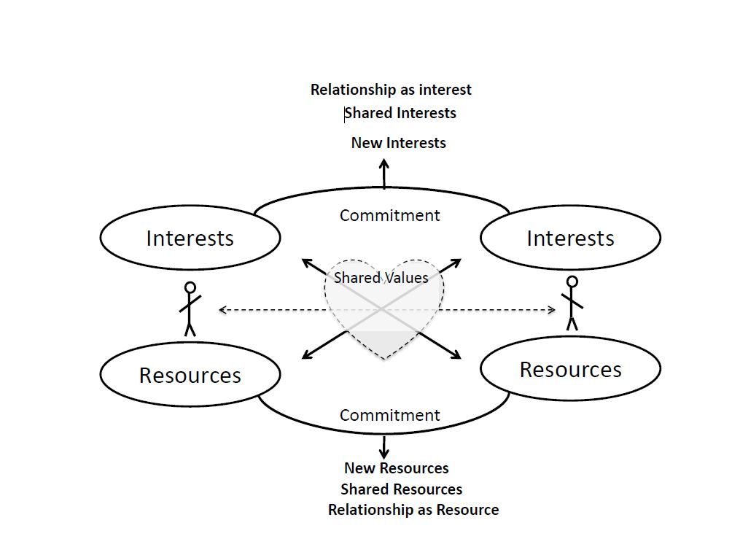

Building Relationships: Creating Social Capital
Relationships are beginnings, not endings. Unlike contracts, intended to protect our interests, relationships are open-ended, creating the opportunity for our interests to grow, change, and develop. Our interests may change as our interaction with others reveals new interests of which we had not been aware. For example, "Hmm...Before we talked I didn't realize I really wanted to be a doctor, but now..." We also may discover common interests of which we were unaware. As you remember from the skills workshop, we may find shared interests in music, in movies, or in doing something about the dining hall service. Most importantly, we begin to develop an interest in the relationship itself. To the extent we hope to preserve the relationship we must do lots of work to sustain it.
Just as the relationship becomes a source of new "interests," it can also become a new source of resources. We may discover new exchanges for our individual interests and resources. "I'll help you with your problem sets if you help me with my literature essay." Relationships may facilitate development of common resources. "Why don't we pool our funds to hire a tutor to work with both of us?" Most importantly the relationship itself can become a resource on which we both can draw.
New relationships construct new interests and new resources making them what Robert Putnam calls "social capital" - a source of "power to" which simply didn't exist before. This capacity or "social capital" explains why strongly "relational" communities are capable of collaborative action of all kinds. This emphasis on relationships, especially relationships among members, is the key building block of a civic association, a “voice” organization, distinguishing it from groups focused on providing services to the clients instead of relationship building.

Chart #2

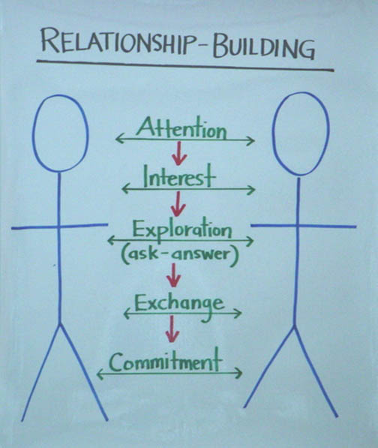

How We Create Relationships

How do we create a relationship? Relationship Chart #2 offers one way to look at this.

• First, we must catch each other’s attention. If I call up a minister to set up a meeting, it will help “get his attention” if I tell him someone he knows referred me. If I’m calling a potential volunteer on the phone, it will be important for me to use their name and explain how I got it. We may also be related to a common institution. Or, across a room full of people, we may just make eye contact.

• Once we have gotten each other's attention, we need to establish an interest in having a conversation. I may mention to the minister, for example, how I was told he was interested in doing something about domestic violence in his parish and that’s what I’d like his advice on. Or, I was told he is the key person from whom to get advice about what is really going on in the parish. Or, since we both happen to be taking the same class, maybe we should talk about how we can help each other.

• There usually follows a period of exploration - of asking and answering each other's questions, of probing for areas of common interest, of testing whether the other has anything to contribute to us, and whether we have anything to contribute to the other. A good place to start – and to see if we can discern enough shared values to want to work together is with the story of self-work that we did during our week on public narrative. The key here is learning to ask good questions, such as why a person has made the choices that they have made. Why did you go to school here rather than there? Why did you study this rather than that? Why did you decide to emigrate rather than remain at home? But we also need to learn about each other’s interests and resources. What challenges are you facing? Why? In your work life? In your family life? In your community life? And what resources do you bring? You know lots of people in the community? You’re a great sign maker. You have been an active member of your faith community. And as we begin learning each other’s answers to these questions, we learn more about each other, what moves us, and what we have to contribute.

• As a result of our exploration, we may begin to make exchanges - not just in the future, but then and there within the conversation. We may turn out to be a good listener for someone who needs listening. We may find we are learning a great deal from our interaction with the other person. We may find we have an opportunity to offer another person some insight, support, or recognition that they find valuable. We may find we can challenge the other person in ways that may bring them new insight. We may also discover a basis for future “exchanges” -- such as going to see a movie we both want to see, deciding to come to a meeting the other has told us about, taking responsibility to help pass out some leaflets, or just deciding to have another conversation.
Chart #3

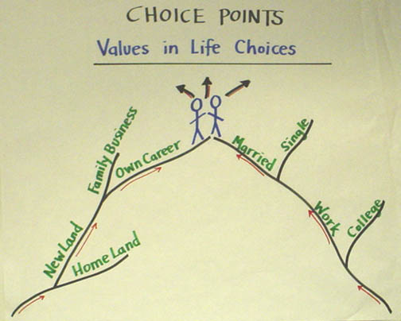

Finally, if we’ve determined a basis may exist for a relationship, we make a commitment to the relationship by agreeing to meet again, have coffee, come to the meeting, send emails, etc. What turns the exchange into a relationship is the commitment we make to each other and to the relationship. People often make the mistake of trying to go right to a commitment without laying a relational basis for it first.

Relational Dimensions:
Social Networks
Although we may enter into a relationship with one other person and they with us, this is only the beginning in a broader sense. When we enter into a relationship with someone, we become a new link in their social network, as they do in ours. Since social networks are the threads from which society is woven, the social networks we choose to draw upon to form an organization, or use the organization to build, is the most critical strategic choice we can make.
One very important distinction is between relationships with people “like us” and relationships with people “not like us” – what Granovetter calls “strong” and “weak” ties. By “strong” ties, he means ties with people who are “like us” -- homogeneous. By “weak” ties, he means ties with people who are “unlike us” -- heterogeneous. His insight is that strong ties may actually inhibit our capacity to organize. This is because they quickly create a closed-in, limited circle of people and resources. Lots of “weak” ties, on the other hand, may enhance our organizing capacity. This is because they open into broader networks of resources by opening the circle outward - an important way people find jobs. He shows how the fragmentation of residents of Boston’s West End into intense ethnically, religiously, familially, or culturally bounded networks inhibited their ability to combine and mobilize resources to resist urban renewal. Communities with “weak” ties found it easier to collaborate with each other and to find outside sources of support. For some purposes, strong ties may be very important - especially purposes we share with people “like us." But for purposes that are more inclusive than those suited to people “like us,” weak ties are the keys to success. Granovetter isn’t arguing “strong” ties are bad and “weak” ties are good -- just that they are very different and contribute to common efforts in different ways. Which kind of ties does your organization rely on? Does this work?

Roles
Another way of thinking about relationships is as “roles” in which we perform our parts, as in social “scenarios.” As Shakespeare wrote,

All the world’s a stage,
And all the men and women merely players…
And one man in his time plays many parts…

Sociologist Erving Goffman developed a powerful dramaturgical metaphor to help us understand the roles we play. He argues we could view our interactions as “performances," all of which have a somewhat strategic component to them. We both “play” our parts, and at some level, are conscious of the part we are “playing.” He showed the “facework” we do when interacting with others to maintain each other’s “face” and prevent distressing embarrassment if we drop “out of role." When relationships persist over time, we often think of the patterns of relational interaction we learn as “roles” we play in social “scenarios."
The more conscious we become of the “roles” we play in different social settings the more we can reflect on the extent to which our performance of these “roles” meets our own interests and those of others with whom we interact. Fear of “losing face” if we are rejected can make it very hard for us to ask for the kind of help we need -- as Cesar Chavez writes about when discussing his difficulty learning to ask for food. We also learn to play roles of deference and domination, reinforcing inequities of power through every personal interaction. An extreme example of this was in the interaction conventions of blacks and whites in the Deep South before the civil rights movement. Gendering of our public interactions can be viewed in this way as well.
One way we connect the roles we play, giving meaning to them, and making them accessible to others, is through our “stories” – our narrative of where we have been, the challenges we face (and have faced), and where we hope to go. When we enter into a relationship with another, we become “actors” in each other’s stories, not only exchanging resources and making commitments, but influencing how we think of ourselves and who we want to become. Learning each other’s “stories” is a critical step in forming, maintaining, and developing relationships.
Public and Private
Another important distinction is between “public” and “private” roles and relationships. We maintain many “private” relationships with friends, acquaintances, etc. But when we form organizations to pursue common goals, we formalize our relationships to make our roles within the organization explicit. When our friends become officers of an organization to which we belong, there is often a tension due to the introduction of “formality” – or “publicness” - into what had been a private informal relationship. New teachers are often tense about balancing the “private” ways they relate to their friends, colleagues, and family members and the “public” way they should relate to their students, including the authority they are expected to exercise. As a result, they have to negotiate a way to interact with their students that is true both to their own way of interacting with others and to the formal public role for which they have assumed responsibility. Similar issues arise for lawyers, doctors, social workers, ministers, and organizers. They arise any time we accept formal leadership roles. They require that we distinguish between the kinds of social interactions appropriate in our “private” relationships from those appropriate in our “public” relationships. Failure to make these distinctions can result in great personal cost to ourselves and to those with whom we work. This underscores how important it is that each of us has a place to go where we are not "on stage".
By understanding this distinction we can be more mindful when constructing our roles in relationships. In Roots for Radicals, community organizer Ed Chambers makes the useful distinction between being liked in our private lives and being respected in our public lives:

By acting publicly in order to be liked, people invariably violate their group or organization’s self-interest, usually by failing to hold public power brokers accountable at critical moments… What people need in public life is to be respected, which is similar to, but different from, being liked. That is why it is crucial to learn to act for respect in public, to be disinterested in being liked there, to look for liking in the private realm… The most recent in the continuing series of public figures who got liking and respect mixed up inappropriately was Bill Clinton, who thought he could mix public and private with impunity, be President and just plain Bill…. Prophets, visionaries, and ordinary people who value justice and democracy can’t be too concerned about being liked in the public realm, but they must insist on being respected there.

Relational Strategies and Tactics
Relationship building is central to the craft of organizing because it is within relationships that we develop new understanding of our interests and new resources to act on those interests. Within relationships we can create new direct experiences that may challenge each other’s existing “roles” and open up the possibility of new roles. We may show respect to those with little experience of being respected; we may challenge those with little experience of being challenged.

Relational Strategies
Most organizations employ some combination of a few basic relational recruiting strategies: recruiting individuals, networks, and organizations. Sometimes an organization is built in one way, but continues recruiting in another. Think about the advantages and disadvantages of each of these approaches in terms of your project.

• One approach is to recruit individuals for an organization out of new relationships. Organizers develop relationships with each individual they hope to bring into the organization. Initial recruiting may be done at tables, street corners, sign-ups at rallies, etc. Kris Rondeau combined this approach with the network approach described below.

• A second approach is to recruit networks for an organization out of old relationships. The organization is built by drawing people in through relational networks of which they are already part. New relationships are formed mainly between the organizer and the recruit, but the basic approach is to find people who can bring people in through their own pre-existing relationships. This is the approach Cesar Chavez used in building the Farm Workers. Sometimes networks are recruited from old organizations which act as incubators for a new effort. This was the role of many of the southern black churches and colleges in the civil rights movement.

• A third approach is to recruit organizations for a new organization. This requires building relationships with leaders of old organizations and drawing them into a relationship with each other to make a new organization possible. There are advantages in this approach in that it makes use of organizational resources that already exist, etc. But it also requires accommodating within the new organization to meet the interests of existing organizational leaders. This was Alinsky’s approach and is that of the Greater Boston Interfaith Organization.

Relational Tactics
Organizations also recruit by using different relational tactics, some of which fit with certain of these strategies better than others, as shown in Relationship Chart #4. House meetings, for example, fit with the network strategy. One-on-one meetings, on the other hand, are important for all three. It is also important to distinguish between a “lead” - someone who signed a list indicating interest - and a “recruit." A person is not a “recruit” until a relationship has been established on the basis of which their continued involvement rests.

Chart #4

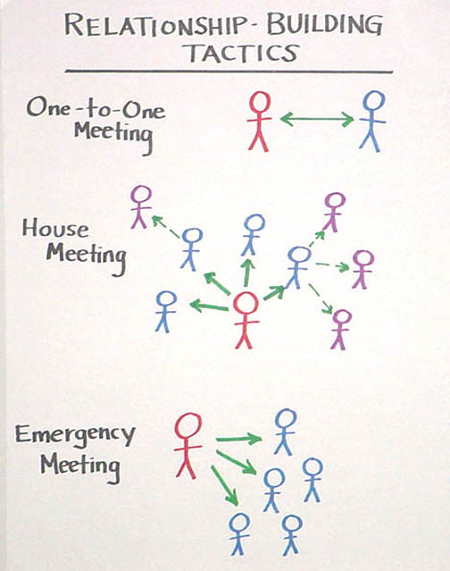

• One-on-one meetings are individual meeting between an organizer or leader and collaborator or potential member. The primary purpose is to build a relationship out of which further involvement in the organization may develop. The meeting is successful if it ends with a commitment to a “next step," which may just be another meeting. This tactic is very useful for building solid relationships among people who might not otherwise have them. Those of you who participated in the skills workshop at the beginning of the semester saw how one on one meeting could reveal interests we share with others that we never suspected to exist. You also found how much we can learn about each other and how well we can establish a rapport in a relatively short time. At the beginning of the semester, we had one-on-one meetings with each of you in the form of the interviews we scheduled. Kris Rondeau also made extensive use of one-on-one meetings, as do most IAF organizers, as recounted by Simmons.

• House meetings are designed to make use of networks. For a house meeting the organizer first holds a one-on-one meeting with someone whom he or she believes may enjoy lots of relations with other members of the community. At that meeting the person is persuaded to invite a number of his or her friends over to meet the organizer and hear about the organization. If the person agrees, the organizer then coaches the person on how to be successful in getting the people there. At that meeting the organizer leads a discussion of the organizational effort or campaign and asks each of the people present to commit to holding a similar meeting in their home. In this way, one can quickly meet with a large number of people in conversational settings as well as identify among the house meeting hosts a corps of potential leaders. In the 1987 Pelosi for Congress campaign in San Francisco, our team of 6 organizers held 87 house meetings attended by 600 people in just three weeks. In addition to being asked to host another meeting, attendees were asked to volunteer on a phone bank. At the end of the house meeting drive, the 87 hosts and another 50 very active volunteers were invited to a meeting at which they were asked to become precinct leaders. In this way, four weeks into the campaign, we had recruited “proven” leaders for 110 of the 150 precincts we needed to organize to cover the entire congressional district. Each also had their own corps of volunteers with whom to work.

• Emergency meetings are well suited to political campaigns or other efforts where “urgency” is very clear. In the 1987 Cranston for Senate campaign in California, we had to organize a get out the vote campaign in 1200 precincts in the African American and Latino districts of South Central Los Angeles, East Los Angeles, San Diego, San Jose and Oakland. We recruited 50 organizers responsible for recruiting 15 precinct leaders each. Since we had very little time (the whole campaign was done in 5 weeks), we got registered voter lists for each precinct that were coded as to which persons “always” voted, which one’s “occasionally” voted, and which ones “never” voted. The organizers set to work calling the “always” voters in their precincts, trying to recruit them for an “emergency” meeting the same afternoon or evening at the campaign headquarters. From among those who attended the organizers recruited precinct leaders for particular precincts who agreed to contact the “occasional” voters who lived there and to take the day off work on Election Day to help us get them out to vote. We wound up turning out 160,000 additional voters this way in an election Cranston won by only 110,000 votes.

Relationship Building
Online and Offline

What all these tactics have in common, although they vary in setting and in scale, is that they make it possible to develop direct relationships with people whom we hope to involve in the work of the organization. This is very different from relying on flyers, phone calls – or email. Relationships are about “influence” as well as “information” – while email can be very useful for sharing information; it is very limited as a means of establishing relationships.
On the other hand, one of the areas of the greatest creativity in recent years is at the intersection of online and offline organizing. We seem to be learning to distinguish between carpenters and tools. The best hammer in the world, won’t build a house. It takes a skilled carpenter, with a vision of what a house can look like, command of the craft of building houses, and a readiness to put new tools to use that can get the job done better. Similarly, the idea that new media technologies can in themselves enable people to “self-organize”, doesn’t work. Meet-Up, for example, one of the key platforms for organizing by the Dean campaign in 2004, facilitated thousands of meetings of people looking for others with similar interests (note the challenge of constructing “weak tie” relationships in this way), but suffered from a very high “mortality rate” because they offered no training, structure, or coaching that could enable these new groups to succeed. The craft of organizing – and leadership – is based on intuitive elements, such as story telling, strategizing, relationship building – but effective organizers are distinguished by having learned the “craft” of turning these elements into successful organization or movement. We all can sing, sort of, but artists dedicate themselves to mastering the craft. . . and the art.
Further, the extent to which the interpersonal commitments, and the knowledge, learning, and motivation associated with them, can be reproduced on line remains to be seen. In general, anonymity is the opposite of relationship building and commitment is made real by the combination of motivation and challenge when we interact face to face or with people with whom we have formed prior face-to-face relationships.
At the same time, we know that the skillful use of new media can powerfully amplify organizing in many ways. It can make it far easier for people who want to become involved to do so. In the summer of 2007, the Obama campaign had a backlog of over 100,000 potential volunteers that it didn’t yet have the capacity to engage. Once this capacity was built, however, this became a very important way to grow the movement. Similarly, it can put tools in the hands of people who are motivated to use them to find others who are interested near them, to reach out to others who may be interested, and, as in the phone bank operations during the campaign, to reach out to individuals in other states whom they could contact by phone. And the relative ease with which information can be shared greatly facilitates reporting, coordination, analysis, and, in general, transparency – as when the Obama campaign decided to share what had been closely guarded voter file information with volunteer leadership teams. Finally, the video capacity of u-tube and other video platforms turned out to be a highly significant way to share learning, motivation, and interaction that goes far beyond communications that are possible in writing or over the phone. In other words, the closer we get to face to face visual interaction, the more we can harness the power of new media to the kind of work we do through relationship building. For those interested in learning more about this, the following links will take you to a discussion of the internet and politics held shortly after the presidential election, hosted by the Berkman Center here at Harvard. You may recognize some of the participants.

http://cyber.law.harvard.edu/interactive/events/2008/12/internetandpolitics/ganz
http://cyber.law.harvard.edu/interactive/events/2008/12/internetandpolitics/bird
http://cyber.law.harvard.edu/interactive/events/2008/12/internetandpolitics/ganzandbird

Maintaining Relationships
Sustaining, maintaining and developing relationships are the “glue” to any organization - and is its ongoing work. Old relationships need to be renewed and new relationships developed. If this ongoing work is not done - and the relationships become unraveled -- it becomes harder and harder to accomplish the “tasks” that must be accomplished. We also may remain ignorant of “who” the people are who are in our organizations and what they have to contribute. And it is in the absence of solid relationships that the “political” difficulties and “factions” with which we are all familiar develop.
Marshall Ganz, Kennedy School, 2010

QUESTIONS

- How many one on one meetings have you had? What did you learn from them?

- What relational strategies and tactics are you using in your project?

- What kinds of commitments are you seeking through relationships in your project? How do you go about asking for commitments? How do you know when you have on?

- What are the differences in relationships you have built in your project and those that you build in your private life? How do you manage them?

Organizing Notes

Structuring Leadership

Week 5

What Is Leadership?

“Leadership is accepting responsibility for enabling others to achieve shared purpose in the face of uncertainty”
Many of us call to mind historic figures like Dr. Martin Luther King, Nelson Mandela, Jane Addams, Robert Kennedy or President Reagan. In reality, we find leadership everywhere - linking together networks through which we work to achieve common purposes. In every community, church, classroom, and organization hundreds of people are doing the work of leadership without which these efforts would not survive.
So what do leaders do that makes them leaders? They accept the responsibility for working with others to define desired outcomes and achieve them in an uncertain world. When we know what to do, when there are no surprises, no new challenges to face, and we’re following a routine, what need do we have of leadership? It’s when we enter the domain where the rules don’t quite work, where we don’t know which rules apply, where we’re trying to do something that hasn’t been done before – or that we haven’t done before - that’s when leadership enters the picture.
Leadership as Relationship

Relationships are the foundation of organizing, including the exercise of leadership. James McGregor Burns argues leadership relationships emerge through repeated “exchanges” or “transactions” among leaders and followers or constituents. Leaders offer resources constituents need to address their interests and constituents offer resources leaders need to address theirs in turn. These relationships may form between individuals, a team, a group, a community, or even a constituency enabled to work together effectively.
What do we exchange in this kind of relationship? Constituents may get a sense of empowerment, access to resources, help solving a problem, etc. Leaders may get the same things - and they get something that is worth accepting the responsibilities that come with leadership. Dr. King describes this as the “drum major instinct” - a desire to be first, to be recognized, and even to be praised. As much as we may not want to admit it, this might sound familiar. Rather than condemn it - it is, after all, part of us - Dr. King argues it can be a good thing, depending on what we do to earn the recognition we seek. He quotes Jesus as saying to James and John, “if you want to be my disciples you not only “can” be first, you must be first - first in love and first in service.”
With this view of leadership, who makes leaders? Can they be self-anointed? Can I decide one day that I am a leader? Or must I earn leadership by entering into relationships with those who enable my exercise of it? This makes it easy to recognize. There is a simple test. Is there a constituency? Fine speeches, a wonderful appearance, lovely awards and excellent work aside - no constituency, no leadership.

Leadership and Structure

Many of us may not want to think of ourselves as followers or as leaders for that matter. Often we are told, especially in elite institutions, that we are all leaders...or we should be. Leadership is highly praised, but no one says anything about good constituents, collaborators…or citizens. But organizations that depend on collective action can be effective only if people learn to practice good leadership and followership. Leading and following are not expressions of who we “are” but of what we “do” – in this meeting, committee, project, organization, or institution. We may play a leadership role with respect to one project and followership role with respect to another.
What are the differences in those roles? Most importantly, leaders accept responsibility for a “whole” – a whole team, a whole project, a whole job – while others accept responsibility for a “part” of the whole. Leaders accept responsibility for seeing to the work that a group must do to work together successfully.
“I’m The Leader”
But what type of leader should you be, and what are you looking for in others? Sometimes we think the leader is the person everyone goes to, like this “I’m the leader!” approach. But what does it feel like to be the “leader” in the middle? What does it feel like to be the arrow that can’t get through? What happens if the “leader” in the middle drops out?
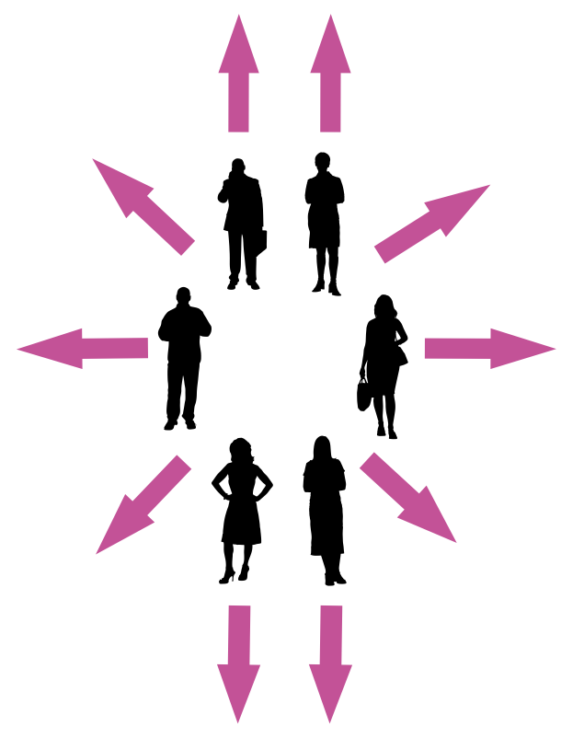
On the other hand, some of us question the whole concept of leadership. Shouldn’t everyone be considered a leader? Is leadership really necessary? Isn’t it repressively hierarchical? Why do we need this kind of structure at all? Can’t we just “come together”? Sometimes this works. But who’s responsible for coordinating everyone? And who’s responsible for pushing the whole group forward when you can’t reach a decision?
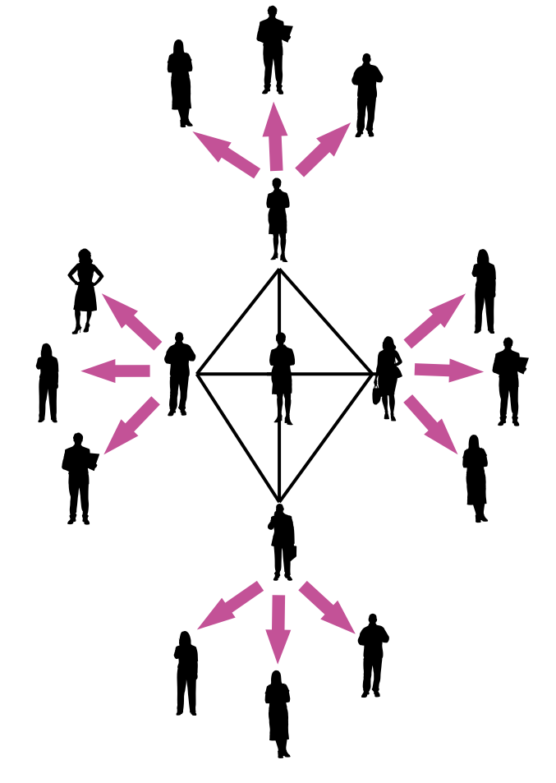
In her Tyranny of Structurelessness, feminist sociologist Jo Freeman argues that organization (or collaboration of any kind) simply doesn't work if we don’t have ways to assign clear responsibilities and hold ourselves accountable for fulfilling them. The idea of a structureless group, she writes, “becomes a smokescreen for the strong or the lucky to establish unquestioned hegemony over others.” And, “for everyone to have the opportunity to be involved in a given group and to participate in its activities the structure must be explicit, not implicit.”
“We’re All Leaders”
A third option is an interdependent leadership team in which individuals can bring complementary strengths to bear on solving a common problem. On the one hand, leadership doesn’t rest on one person. On the other hand, it is clear where responsibility for leadership does rest. Effective leadership doesn’t imply domination but rests on interdependence and collaboration to create more “power to,” based on the interests of all parties. Domination is the exercise of “power over,” a relationship that meets interests of the “power wielder” at the expense of everyone else.
Snowflake/
Interdependent Leadership
An organizer’s job is to reach out and find leadership from within his or her constituency who can who can recruit and coordinate others. They may not be people others usually see as leaders, but they are people committed to change, willing to invite others to join them in the hard work of moving a campaign forward.

These leaders will be the backbone of you organizing campaign. You must be able to trust them to delegate responsibility to other dedicated, reliable people, and to follow through on commitments. You may be the leader in the middle, or part of a leadership team in the middle, guiding others’ efforts and being held accountable for outcomes, but you will be deeply reliant on your relationships with others for success.

Leadership and Authority

We are wise to distinguish “authority” from “leadership.” Authority is a “legitimacy” of command usually attached to social positions, offices, or roles - legitimacy supported by cultural beliefs as well as coercive resources. An organization is a way to formalize authority relations among the participants – people’s rights and their obligations. Bureaucracies structure authority as a set of rules according to which manager’s direct subordinates. Markets structure authority as a set of rules according to which people make enforceable contracts based on their individual resources. Civic associations usually structure authority democratically in that leaders are accountable to the constituents whom they serve. Exercising leadership in a civic context can require more skill than other settings because it depends more on persuasion than on command.
Most of us have been in situations in which those with authority have not earned their leadership, but try to compel cooperation based solely on their legitimacy or "power over". In these circumstances, to what extent do we think our interests are acknowledged and addressed? How does this affect our motivation and performance?
Cultures have institutionalized beliefs about who is “authorized” to lead and who isn’t that can bar certain “kinds” of people from the opportunity to earn leadership. Leaders who develop under these conditions constitute a challenge to conventional ideas of authority. Authority can also be a resource a person can draw upon to earn their leadership. And sometimes leaders find authority has been conferred upon them as a result of their having earned their leadership. But leadership and authority is not the same thing.
Finally, we can distinguish leaders from “activists.” Hard working activists show up every day to staff the phone bank, pass out leaflets, and put up posters, and make critical contributions to the work of any volunteer organization. This is not the same, however, as engaging others in doing the work of the organization.
Leadership Development
Letting Others Lead

So if leadership is so important to organizations, how can organizations make sure they have the leaders needed to accomplish its mission? Organized people empower themselves to make lots of things happen less by the efficiency of their systems than by the depth of their leadership capacity. This is particularly true of civic associations that bring people together, facilitate understanding one another, and enable them to act together on common interests.
Take a look at the “leadership quotient” of your organization. How many leaders do you see doing leadership work? Is there one “leader” with everyone else linked to that leader like spokes to the hub of a wheel? Or are there lots of “leaders” linked with each other and with other members, multiple centers of coordination, inspiration and action. Are some people “followers” in relation to some “leaders” but “leaders” in relation to other “followers”? Or are some people always “leaders” and others always “followers”? Is it "leadership rich" or is it "leadership poor"?
Chart #1

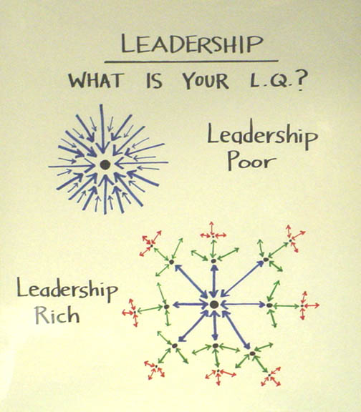

Giving Up Control to Build Power

Leadership Team or “Lone Ranger”

So why aren’t “leadership rich” organizations an everyday thing? Why is it that so often we wind up the dot in the middle of all the arrows? How can we build a “leadership rich” organization?
It’s not a new problem. As recounted in Exodus, Moses required the intervention of his father-in-law Jethro, who had his own interest in the matter to begin getting the picture. He was trying to do it all himself, but why? Because he was hungry for the power? Because he needed to keep himself busy? A more likely explanation is that, like many of us, he wanted it done right, and he thought that meant that he had to do it himself. But as long as he was trying to do it all himself, it couldn’t be done well, much would not get done at all. The belief that holding onto all the control would ensure all was done well was an illusion. So Jethro offered him a way out. Find the courage to let go of some of the control and risk letting others share in the responsibility for leading. But not just anyone – he urged him to find people with leadership potential, people who were “capable, God-fearing, and honest”.
As important as how we structure our organization is, nothing is more important than coming to terms with this fundamental question: are we willing, and able, to let go of enough control to let others lead? Can we let go of enough control to allow our organization to build the power that can only be achieved by letting it grow leadership rich?
Successful organizers form leadership teams with whom they can work early on in their campaign. Although it can be a mistake to recruit people to act as an "organizing committee" too early - especially if you are not careful to recruit people drawn from the constituency who are not seen as leaders or, at least, potential leaders - organizers more often err in delaying too long. The sooner you have a team of people with whom to work, the sooner the "I" of the organizer becomes the "we" of a new organization. Once you have formed a leadership team you can more easily establish a rhythm of regular meetings, clear decisions and visible accountability that will help make things actually happen. You don't build an organization of 500 people by recruiting them all yourself. You build it by finding people willing and able to commit to help building it with you. If you don't have a leadership team working with you by midterm, it’s time to look very closely at why.
Despite the “alpha” mythology, most effective leaders have always led through teams. Moses, Aaron and Miriam, for example, in the Exodus story or Jesus and His twelve disciples in the New Testament, or Martin Luther King, Ralph Abernathy, Rosa Parks, Jo Ann Robinson and E D Nixon during the Montgomery Bus Boycott.
Structuring a leadership team is a way to organize interdependent leadership – individuals working together to achieve a common outcome, like an athletic team, each person responsible for coaching the team on a different activity. Well-designed teams put to productive use the unique talents of the individuals who make up the team.
Structuring a leadership team creates strategic capacity: the ability to strategize creatively together in ways that produce more vibrant, engaging strategy than any individual could create alone. In the Obama campaign, the field structure created multiple layers of leadership teams to engage people creatively and strategically at all levels of the campaign. Each state had a state leadership team that coordinated regional leadership teams (of Regional Directors and Organizers), which coordinated local neighborhood leadership teams of volunteer leaders. At every level the people on leadership teams had a clear mission and could strategize creatively together about how to carry out their mission. This structure created multiple points of entry for volunteers, and multiple opportunities to learn and exercise leadership.
So why don’t people always work in teams?
We have all been part of groups that did not work well. They factionalize, alienate each other, or all the work falls on one person. Some aim to keep the pond small so they can feel like big fish. So many of us conclude: I’ll just do it on my own; I hate meetings, just tell me what to do; I don’t want any responsibility; just give me stamps to lick. For example:

• You are in a team meeting. You find that it’s never clear exactly whom you can count on to step up, take responsibility, and get the work done. So two or three people often wind up doing all the work, which means that no matter how hard we work, it still can’t get done.

• Whenever we need to make a decision we always seem to be missing some crucial piece of information, skill, or set of relationships.

• We talk and talk and talk, but, when it’s all over, we realized that we each had a different idea of the outcome we were talking about.

• When we get stuck, we have nowhere else to turn for help. We help each other as much as we can, we may contact another volunteer leader, but it’s not clear where we can go for expert advice.

There’s just one problem: we can’t become powerful enough to do what we need to do if we can’t even work together as a leadership team. But you can create the conditions that will increase the odds your team will work drawing on the craft of team design.

Three Outcomes of an Effective Team

- The team accomplishes the goals for which it is responsible.

- The team is operating in ways that make it better as a performing unit over time

- The team contributes the learning and well-being of individual members

Three Conditions for and Effective Team

These are conditions that you as an organizer are able to create in the way you design your leadership team: who is selected, what is required, what expectations you establish, etc.

• Your team is bounded. It is clear who is on the team and who is not on the team. It is clear how new people can join the team and what is expected of those who must leave the team.

• Your team is stable. People commit to clear terms of service: regular meetings, length of time, etc. Your team is not a revolving door, never knowing who will show up.

• Your team is diverse. Your team has the appropriate diversity of skills, talents, viewpoints, and constituencies that will be needed to do a good job.

Three Steps in Launching an Effective Team

These are three decisions that a leadership team must make at the very beginning to put itself on a constructive path. There are no “right” answers as to what these decisions must be, only that they must be made to give the team the structure it will need to do whatever it wants to do well.

• Establish a shared purpose. You do the work, based on your shared values and the relationships you have formed, to clearly articulate your common purpose as a team. It is clear, challenging, and matters. You have defined your goal, whom you work with, and the kinds of things you will do?

• Establish clear ground rules or norms. Your team sets explicit expectations of how you will work together: how you will make decisions, manage your time, and honor your commitments. What are things you will always do and what are the things you will never do. And how will you correct yourselves if you do them. Perhaps you most important norm is how you will make decisions. Steps that can guide effective decision making are: defining the problem, establishing criteria, brainstorming possibilities, synthesizing ideas, formulating options, evaluation options against the criteria, deciding. Some prefer deciding by vote; others, by consensus; others by delegating the decision to an individual.

• Organize the work into interdependent roles. Everyone should have responsibility for their own share of the leadership work needed to achieve the goal. Role requirements need to be clearly described. Team members need to assess their strengths and limiations, to the greatest extent possible, matching individual capabilities with role requirements. Because roles are designed to be interdependent, everyone has a stake in everyone else’s success. Team members speak up when they need help and get it. No one works in a silo that’s secretive to others. The team with diverse identities, experiences and resources brings more to the table than a team that is very homogeneous.
Leadership Development Cycle:
Identify, Recruit, Develop

Leadership development work occurs as a cycle, as shown in Chart #6: identifying potential leaders (opportunities for them to emerge), recruiting them into leadership positions (opportunities for leadership to be earned), and creating opportunities for them to develop their capacity (opportunities for leaders to grow) on an ongoing basis. It requires learning how to delegate - and mean it; creating a supportive organizational structure; and providing coaching.

Identifying leadership requires looking for it. Who are people with followers? Who brings others to the meetings? Who encourages others to participate? Who attracts others to work with them? Who do other people tell you to “look for??” Alinsky writes about community networks knit together by “native” leaders - people who take the responsibility for helping a community do its work out of their homes, small businesses, neighborhood hangouts, etc. They can be found coaching athletic teams, organizing little leagues, serving in their churches, and surfacing in other informal “schools” of leadership. Where would you look for these kinds of leaders around here?
Although leading is a matter of “doing” and not “being” – and people do leadership work in different ways - there are some clues you may want to attend to, especially when looking for people that will make good organizers. It is hard for a person who has not learned to be a good listener to become a good organizer. You have to understand the interests of your constituency if you are to help them act on those interests. Listening means learning to attend to feelings - empathy - as well as to ideas because the way we feel about things affects our actions more than what we think about them. Curiosity helps us see the novel as interesting rather than threatening, enabling us to learn how to face new challenges that are always a part of organizational life. A good imagination helps because strategizing is a matter of imagining different futures and possible ways to get to them. A sense of humor helps you from taking yourself and your troubles too seriously and helps keep things in perspective. A healthy ego is very important. Arrogance and a wish to dominate others are usually signs of a weak ego constantly in need of reassurance. Leadership also requires courage - the willingness to take risks, make choices, and accept the consequences.

Recruiting leadership requires giving people an opportunity to earn leadership. Since followers create leaders, they can’t appoint themselves and you can’t appoint them. What you can do is create opportunities for people to accept the responsibilities of leadership and support them in learning how to fulfill these responsibilities. If you have to get the word out for a meeting, you can get three of your friends to help you pass out leaflets in the Yard one day or you can find one or two people in each House who will take responsibility for recruiting 5 people from their House to attend. They earn their leadership by bringing the people to the meeting. What other ways can you think of that you can give people the opportunity to earn leadership?
No matter how careful you are, leadership development requires coming to terms with the fact that it entails risk. Risk small failures early in the life of a project in order to avoid big failures later on. If you take the risks required to learn to delegate, you will learn how to do it and you will learn who "comes through" and who doesn't. It is important to learn this with a small meeting at stake and not the monster rally of 5000 at which only 50 people show up. One reason to set up quantifiable goals, regular reports, and ongoing evaluation is to detect early failure and success so they become "learning opportunities" for everyone. "So, Mary, why did that work so well?" "So, Sam, what happened there? What could you have done differently?" Don't assume everyone is going to do everything right from the very beginning because it never happens. Also, it is often not completely clear what the "right" way is at the beginning of a project. Think about how to turn this fact to your advantage. Where can you get the courage to take the risk of letting other people share in the responsibility for outcomes you care about?
We only develop good judgment about whom to select by taking risks, making choices, experiencing success and failures, and learning from this experience - and we will still be surprised. On the other hand, the more experienced we are the better judgment we can begin to develop. There is no "rule book" to go to on this, but if you are afraid to risk making choices, you never learn to make good choices. Here are some questions you might ask yourself. How do you select to whom to delegate? How do you know who the right person is? How can you find out ahead of time? How do you know when a person is ready for a big job? Are you selecting them because they are easily available or because they are the right people for the job? Are you selecting them because they already know what to do because you have worked together before or because they "look as if they can learn what to do" with some good coaching? Or did you select them because you "heard" they were good? Where did you hear that? Who told you? Should you believe them? How do you know?

Developing leadership requires structuring the work of the organization so it affords as many people as possible the opportunity to learn to lead - delegation. Distributing the leaflets through House Committees, for example, shares the responsibility for engaging others with many people. It is true organizing the work in this way can be risky. You may delegate to the wrong people; they may let you down; etc. But as Moses learned from Jethro, if you fear delegating, the strength of the community is stifled and can never grow. But you can do things to increase the chances of success. Leadership training sessions help clarify what is expected of leaders in your organization, give people the confidence to accept leadership responsibilities, and express the value your organization places on leadership development.
Developing leaders is not about assigning tasks, but offering responsibility. It is different to ask: “would you make these 50 phone calls telling people about the meeting?” versus “would you take responsibility for getting 10 people to come to the meeting? You will? Great! Here’s some things that may help you contact them and get them there -- a list of names and phone numbers of people who said they were interested, 100 leaflets, some posters, and some sign-up sheets you could use to get commits." Do you see the difference? With the “task," the person can become a kind of yo-yo: go do this, come back for what’s next, go do that, come back for what’s next. They are “helping” you with your responsibility. With a “responsibility,” the person takes it and runs with it, and you can help them meet “their” responsibility. But when looking for someone to take responsibility, don't make the responsibility easier, and easier, and easier…until there’s nothing left. The challenge is in learning to motivate people to accept the level of responsibility needed to get the job done. And when a person has accepted responsibility, the motivation work continues. Keeping others motivated, keeping yourself motivated, and getting the work done go together. All are based on real accountability, lots of coaching, and lots of recognition of success.
Responsibility is only real, however, if the person is clearly accountable for the responsibility he or she accepted. Accountability should be regular, specific, and timely. The point of accountability is not to catch someone to punish them, but to learn what kind of results they are getting so everyone can learn from them. If someone is having trouble, we need to learn why so we can figure out what to do about it. If someone is being successful, we need to learn why so we can try the same thing in other places. Without accountability the most important learning we can do in the course of a campaign - systematic reflection on our own experience - is impossible. You cannot expect a person to take responsibility without authority. If you want someone to take the responsibility to get 10 people to a meeting, hold them accountable, provide training, offer support - but give them the authority to do what they’ve been asked to do. If you see or hear of them making a mistake - or think you can do it better - this means going directly to them, not around them or taking care of it for them. It is really a matter of basic respect.

Chart #2

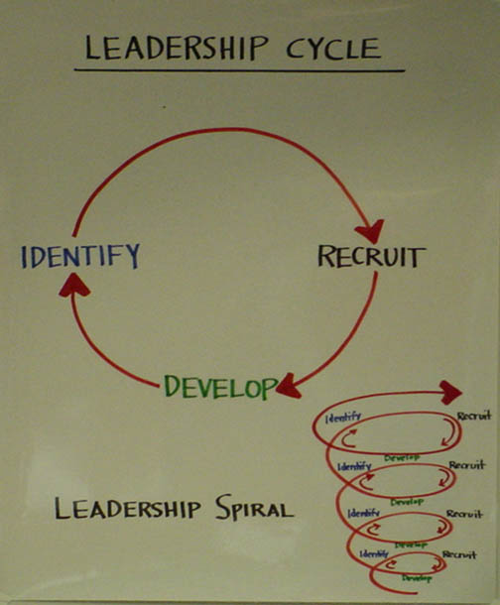
Leadership as Coaching and Coaching Leadership

Once a person accepts responsibility, it is in your interest to offer her as much support as she wants to ensure her success. The challenge is learning how to offer support without taking back the responsibility. “Oh, you’ll get the ten people to come? Great! Let’s sit down for a few minutes and “role play” just what you’re going to say to them." Or “give me a call to tell me how it's going - or if you run into problems.” A regular coaching session means you want to meet not because you think they are in trouble, but because you are interested in their work. These sessions can be very useful for learning what's really going on out there as well. And coaching is, of course, one of the best ways to make mentoring real.
The Hackman and Wageman article on team coaching is particularly useful in focusing on how to coach a leadership team, not only individuals, with sensitivity to the timing issues involved in a campaign type of project. Ongoing support for leadership development comes more and more to be in the form of leadership team coaching and teams themselves become more typical of how organizational life is being structured. And as more activity is outcome focused, rather that process focused, the more time issues will become critical. So learning how to coach multiple people within a changing time dynamic is will be critical for your success as an organizer.
Conclusion
Although identifying, recruiting and developing leaders is critical to the capacity - or power - of most organizations, it is the particular focus of organizers whose work is to be leaders of leaders. The primary responsibility of an organizer is to develop the leadership capacities of others and, in this way, of the organizations through which their constituents act on their common interests.

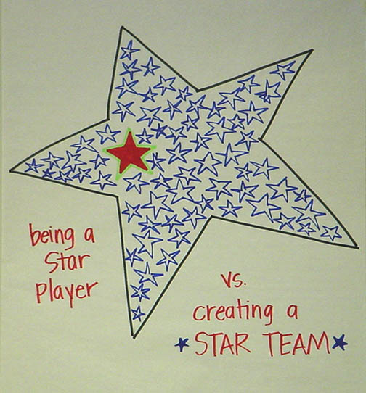
© Marshall Ganz, Kennedy School, 2014

QUESTIONS

    - Have you developed a leadership team? If yes, did your define a common purpose? If so, how? If not why not? Have you established norm? If not, why not? How often do you meet? Who does the agenda?

    - What are the various roles you have assigned for leaders in your team? Do they create opportunity for leadership development? How do you hold each other accountable?

    - Have you practiced coaching within your leadership team? If so how did it work? Who coached whom?

    - Do you, or others in your project/organization, have a conscious strategy for identifying, recruiting and developing leadership? What is it?

Organizing Notes

Strategizing
Week 6

Introduction

In the third week of the class we introduced organizing strategy by asking three questions: Who are my people (constituency)? What change do they need (goal? How could they use their resources to build the power they need to achieve that change (theory of change)?
Although the answers to these questions, especially the second and third, are developed in dialogue with your constituency, and much of it may change, unless you develop an initial road map of where you want to go and how you hope to get there, a hypothesis, your journey cannot begin.
The challenge now – about half way thru the class - is to revisit these questions, examine your hypothesis in light of your experience, and adapt your strategy to achieve your goals. You have new information: you’ve probed sources of your own values and those of your constituents with your work on story; you’ve learned about resources and interests from relationship building you are doing; and you reexamined the question of shared purpose in forming a leadership team.

• Are you clear about who the people you are organizing are, your constituency, other actors?

• What about the change that is needed? What problem is you’re trying to solve? How would the world look different? What is your strategic goal?

• What about your theory of change? Have you figured out how to turn your constituency’s resources into the power it needs to achieve its goals?

• What about your tactics? What are your principal tactics? Are you adapting them as need be to changing realities, while remaining focused on your goal?

• What about your campaign time line? Are you working toward peaks? Do you need to redefine them?

We explore these questions this week as we approach mid-point of the semester, a critical time, as Gersick’s research shows, to evaluate, learn, and adapt.
Strategizing, like story telling, is a way we exercise agency, making purposeful choices in the face of uncertainty. While story telling is a way we can articulate our purpose, strategizing is how we find a pathway to achieving that purpose. Both are natural capabilities. We begin telling stories almost as soon as we begin to speak and we begin to strategize as soon as we can conceive purposes, find that purpose frustrated, and have to figure out how to achieve it. The challenge in learning organizing is to step back a moment from this everyday activity, reflect on it more deeply, and bring greater intentionality to it so that it can become an element of the craft of leadership.
Strategy is how to turn what you have” into “what you need” to get “what you want” - how to turn resources into power, as shown in strategy chart #1. If we think of power as the influence one actor can exercise over another because of an imbalance in interests and resources, as shown in Strategy Chart #2, one way to correct the imbalance is to aggregate more resources. That’s why people form unions, advocacy organizations, or nations. But another way to correct the imbalance is to move the fulcrum on which the balance rests to get more leverage out of the same resources. Good strategists learn to get more leverage from resources that ARE available. Power is thus a matter of resources and resourcefulness. Because organizers try to create change, they often have to rely on resourcefulness to compensate for a lack of access to resources. Why do you think David was a good strategist? What role did motivation play? What role did resources play? What was the role of imagination?

Chart #1

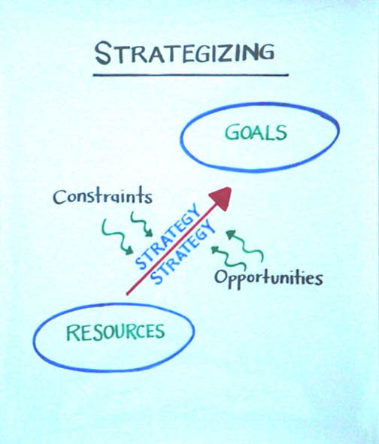

Strategy and Tactics

Strategizing in a way of imagining, theorizing or hypothesizing. It is the conceptual link we make among the places, the times and the activities with which we mobilize and deploy resources and goals we hope to achieve. It is how we can frame specific choices within a broader framework of purpose.
The word strategy comes from Greek for general - strategos. When armies were about to clash on the plane, the general (Strategy Chart #2) went up to the top of the hill and, with the goal of winning the battle, evaluated resources on both sides, reflected on opportunities and constraints imposed by the battle field, and how to deploy troops in ways most likely to achieve his goal. A good strategos not only had a good overview of the field. He also had intimate knowledge of the capacities of his men and those of his opponent, details of streams and bridges, and mastery of both the forest and the trees. Once the battle was underway, however, the best strategos was often back on the battlefield where he could adjust the plan as conditions changed.
The taktikas were the individual ranks of soldiers with specific competencies whom the strategos deployed to take specific actions at specific times and places. Tactics are specific actions through which strategy is implemented. Tactics are no less important than strategy, but they are different. A strategos with an excellent overview, but who misjudges the competence of his taktikas would be lost. Getting results, taking initiative successfully, requires developing the capacity for good strategy and good tactics.
Strategy is not something “big” and tactics, something “small”. In any setting – whether it is national, state or local or long term, medium term, or short term – in which we commit to a goal, consider our context, and figure how to turn our resources into activities (tactics) through which we can achieve our goal, we are strategizing.

Chart #2

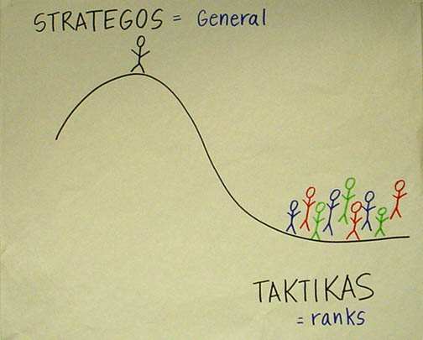

Strategy is Motivated: What’s the Problem

We are natural strategists. Although strategy is natural, however, we have to be motivated to strategize by a problem. How many times have you strategized today? We conceive purposes, meet obstacles in achieving those purposes, and we figure out how to overcome those obstacles. But because we are creatures of habit, we only strategize when we have to: when we have a problem, something goes wrong, something forces a change in our plans. That’s when we pay attention, take a look around, and decide what we have to do. And just as our emotional understanding inhabits the stories we tell, our cognitive understanding inhabits the strategy we devise.
This means we may have to step out of habitual routines, what we are “comfortable” doing, what we know how to do and consider novel pathways. This can be very frightening, even as it can be exhilarating. When we don’t strategize, it is often not because we don’t know how to, but because it can be very hard. When we strategize we give a voice to the future, enabling it to make claims on the present. This requires the courage to say no to current demands to commit to an uncertain future. When we must make choices about how to invest scarce resources, voices of present constituencies speak loudly, even though they were created by choices in the past. The voices of future constituencies are silent.
Our choices may turn out as we wish, but then again, they may not. Trying to shape the future may require choices that could involve substantial risk in the present. The first step in shaping the future, however, is to imagine it… and then to find the courage to act on our imagination.

Strategy is Creative: How Can We Solve the Problem?

Strategy requires that we develop our understanding of why the problem hasn’t been solved, as well as a theory of what we could do to solve the problem, a theory of change. And because those who resist change (and who don’t have the problem) often have access to greater amounts of resources, those who seek change (and do have the problem) have to be more resourceful. And we have to use our resourcefulness to create the capacity – the power – to get the problem solved. It’s not so much about getting “more” resources as it is about using one’s resources Strategy is creative, linking resources to outcomes through intentional choice of tactics.

Strategy is a Verb
Strategy is about turning “what you have” into “what you need” to get "what you want" – how to use resources you have to achieve your goals, given constraints and opportunities. It is an ongoing activity, not making a "strategic plan" at the beginning of a campaign that others will implement. Planning (getting an overview of the plan) can help those responsible for a campaign arrive at a common vision of where they want to go, how they hope to get there, and clarify the choices that must be made to begin. But the real action in strategy is, as Alinsky put it, in the reaction – by other actors, the opposition, and the challenges and opportunities that emerge along the way. What makes it "strategy" and not "reaction" is the mindfulness we can bring to bear on our choices relative to what we want to achieve, like a potter interacting with the clay on the wheel, as Mintzberg describes it. Although our goal remains clear, strategy requires constant adaptation to new information. Something worked better than we expected it to? Something did not work for unforeseen reasons. Things changed. Some people are opposing our efforts so we have to respond to their action. The launching of a strategic campaign is only the beginning of the work of strategizing. This is one reason it is so important to have a leadership team that reflects the full diversity of skills, information and interested needed to achieve your goal. We call this “strategic capacity.” (2)So strategizing is not a single event, but a process or a loop continuing throughout the life of a project (Strategy Chart #3). We plan, we act, we evaluate the results of our action, we plan some more, we act further, etc. We strategize, as we implement, not prior to it.
Strategy is Situated:
Connecting the View from the Valley with the View from the Mountain

Strategy unfolds within a specific context, the particularities of which really matter. One of the most challenging aspects of strategizing is that it requires mastery of the details of the “arena” within which it is enacted as well as the ability to go up on the mountain and see things with a view of the whole. The imaginative power of strategizing can be realized only when rooted within an understanding of the trees AND the forest.
One way to create the “arena of action” is by mapping the “actors” are that populate that arena as we did in Week Three. It may be time to revisit that picture. Who is your constituency? Where will your leadership come from? What other actors have an interest in the action as opponents, allies, supporters, and neutrals? In organizing, strategy is about how to influence the choices of other actors so creating a map of these actors, their interests, resources, and relationships can help you imagine the arena of play. But resources are also not always obvious and good strategy often involves discovering resources in unexpected places. You make judgments about constraints and opportunities within your "arena" of action.

Chart #3

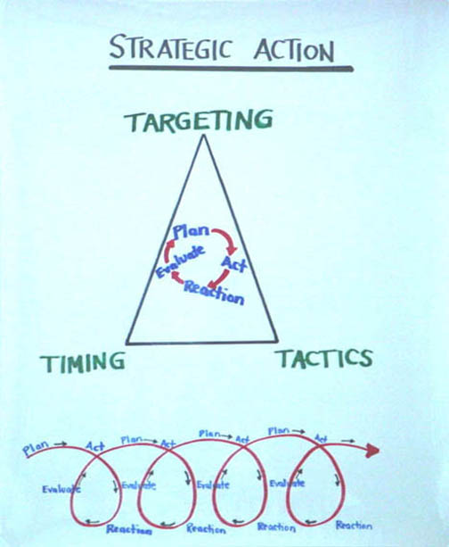

Five Strategic Questions
- Who are my people?
It's time to go back and review the questions we asked in week three: Who really is my constituency - the people with the problem who must be organized to use their resources in new ways to solve the problem. The organizers job is to turn a community – people who share common values or interests – into a constituency – people who can act on behalf of those values or interests.
Who really is the leadership? Do you have a real leadership team? Were they recruited from the constituency itself – people who, like you, are also able to “accept responsibility for enabling others to achieve purpose in the face of uncertainty?” Are you enabling them to learn the five organizing practices you are learning: relationship building, storytelling, structuring, strategizing, and action?
Are there supporters? People whose interests are not directly or obviously affected may find it to be in their interest to back your work financially, politically, voluntarily, etc. Have you run into any competitors or discovered any collaborators? These are individuals or organizations with which we may share some interests, but not others. They may target the same constituency, the same sources of support, or face the same opposition. Two community groups trying to serve the same constituency may compete or collaborate in their fundraising. And is there any opposition? In pursuing your goals you may find yourself to be in conflict with interests of other individuals or organizations. At times, however, opposition may not be immediately obvious, emerging clearly only in the course of a campaign. (2.5)

- What is the change they need? What is the problem you’re trying to solve? What would a solution look like? What is your strategic goal?

Now it’s time to reexamine the goal you committed to achieving by the end of the semester. To begin putting your resources to work solving your problems you have to decide where to focus: what goal can we work toward that may not solve the whole problem, but that will get us well on the way to solving the problem. No one strategic goal can solve everything, but unless we choose “a” goal to focus on we’ll risk wasting our precious resources in ways that just won’t add up.
Focus really matters. The Montgomery leadership team, recognizing they had a power problem, decided to focus on desegregating the buses in their community. They could have focused on any one of many challenges: public accommodations, schools, voting, housing, employment, etc. So why did they choose buses? The Federal Government has an interest in transportation which persuaded them that they could use the Federal Courts to order desegregation, as had occurred in Brown v. Board of Education. The goal was not only very visible, but it was a site of daily abuse, as Blacks had to pass between rows of Whites to their “place” at the back of the bus, give up their seat to any White who asked for it, and be subject to the authority of an armed bus driver – a microcosm of the whole system. And, as it turned out, they could leverage the resources of their constituency – in the form of feet and bus fare – in a way that not only brought economic pressure to bear on the bus company, but which strengthened the capacity of the constituency to act together. They might have been able to develop similar leverage with another goal, but this was the one they chose, and they stuck with it. Nor did they try to take on everything at once, realizing that winning this victory could create the foundation for many more, as it turned out that it did.
Specifics matter too. The more concrete, imaginable, and specific the goal, the more clearly you -- and others whom you hope to engage -- can focus your creativity on achieving it. So this requires committing to specific outcomes as the only way to bring real focus while, at the same time, remaining flexible as to means.

A laundry list of “what we are going to try" is not a strategy but a list of possible tactics. Three or four pathways, such as fund raising, outreach, and research is not strategy unless anchored to a specific goal to which you have committed. In the Bus Boycott mass meetings, car pools, and walking to work were tactics, not a strategy. The goal was clear, specific, and sustained – desegregating the buses. The tactics were constantly adapted. As Cesar Chavez used to say strategy is not so much about making the right decision as it is about making the decision that you made the right decision. How do we know when we need to adapt, or when we need to “stay the course?” One of the primary responsibilities of strategic leadership is to manage this tension between commitment and adaptation.
And so does motivation. In narrative terms, our strategic goal becomes a critical part of our “story of now”: we are faced with an urgent challenge, we look for hope we can meet the challenge, and we commit to a course of action, our strategic goal. Hope inspires not only in terms of the values in which it is rooted, but also suggests pathways of possibility. The vision of American democracy that Dr. King articulates in his Holt Street Baptist Church talk is a powerful one, as are the values of the faith he evokes, but he also identifies a source of hope for dealing with the problem at hand – the U.S. Supreme Court decision desegregating schools. The hope that is expressed in a story of now is not a picture of “flowers in May”, but of a way forward. A motivating vision, then, articulates a concrete, urgent need for change in moral (Injustice) and strategic (segregated busses) terms. It contrasts this challenge with a source of hope, also articulated in moral (justice) and strategic (desegregated buses) terms.
So in determining your own strategic goal, create a list of the criteria it needs to meet – solve the problem at hand, creative use of constituency resources, visible, develops leadership, etc. You then may want to brainstorm as many possible goals as you can, reflect on them, synthesize them, do it again. Then you must choose. Commit to a goal that you believe most likely to enable you to mobilize your resources (what you have) in as powerful a way as possible (what you need) to achieve that goal (what you want). There is no perfect choice. This is why strategy is hard. As Cesar Chavez used to say, “it’s not so much making the right decision, as it is making the decision you make the right decision.
In light of your analysis, consider the criteria that make for a good strategic goal:
- Focuses resources on a single outcome that may enable you to achieve greater outcomes.
- Enables your constituency to translate its resources into power, greater capacity.
- Leverages your constituency’s strength and the weakness of the opposition.
- Be visible, significant, and important enough to motivate engagement.
- Be contagious and can be emulated.
Check your goal against these criteria. Consider other options. Don’t be afraid to brainstorm, come up with crazy ideas, or change course. Evaluate your goals against these criteria – or others you consider important.

- What is your theory of change?
You may have begun with one theory of change, but, as you got into working on your project, realized that things worked differently than you had expected. So what is your current theory of change? How can your constituency can solve the problem? How does your initial theory of change stack up against your experience? Community organizers focus on ways in which the community itself can develop the capacity to solve its problems is because otherwise it is not very likely to remain solved, at last for very long. Unless the community – and the individuals who make up the community – begin to experience agency that they hadn’t experienced before, little is likely to change. The power we are focused on building doesn’t begin somewhere on high, but with the people themselves. It grows out of the ways we can influence on another. If your interest in my resources is greater than my interest in your resources, that gives me power over you – and I can use your resources for my purposes. On the other hand, if we have an equal interest in each other’s resources we can collaborate to create more power with each other to achieve our purposes than we can alone. So recall the four questions we asked in week three:
- What change do WE want?
- Who has the RESOURCES to create that change?
- What do THEY want?
- What resources do WE have that THEY want or need?
So the question is how can our constituency use its resources in new ways that will create the capacity it needs to solve its problems. Then come up with an “if-then sentence”, imagining ways your constituents could use their resources to achieve this goal. IF we do this, THEN that will likely happen.
Once you’re satisfied you are ready to articulate your organizing sentence: “We are organizing WHO to WHAT OUTCOME through HOW by WHEN.”

- What tactics will you use to achieve your strategic goal?

A tactic is a specific activity through which you implement strategy - targeted in specific ways and carried out at specific times. It’s the activity through which your strategy becomes real. Strategy without tactics is just a bunch of nice ideas. Tactics without strategy is a waste of resources. So the art of organizing is in the dynamic relationship between strategy and tactics, using the strategy to inform the tactics, and learning from the tactics to adapt strategy.
As we work toward our goal we learn from our successes and failures how to adapt our tactics to become more and more effective over time. The Bus Boycotters focused on a “master tactic” of a boycott, but also used litigation, organized a car pool, used contacts with the media, organized outside support, etc. etc. In fact, strategizing involves an ongoing creative stream of tactical innovation and adaptation as circumstances change, opportunities emerge, and reverses are suffered.
One important aspect of tactical decision-making is targeting - figuring out precisely how to focus limited resources on doing what is likely to yield the greatest result. One critical choice is about what problem you want to turn into an "issue" around which to mobilize. California organizer Mike Miller distinguishes between a "topic" such as education, a "problem" such as a lousy school, and an "issue" such as replacing this principal with another one. Topics become problems when they become real within people's experience. They become "issues" when a solution to the problem has been defined. The topic of racial discrimination becomes a problem when "I have to get on the bus at the front, pay my fare, get off, get on again at the back and sit (or stand) in the back even when there are empty seats in the 'white' section." A problem, in turn, becomes an issue when something very specific can be done about it by specific actors; e.g., telling the bus company to integrate the buses (a solution) or face a boycott. A good issue is achievable, yet significant. Another critical choice is about which decision-makers you will hold accountable for taking action on your issue.
It can be useful to develop a set of criteria to evaluate your tactics. Here are a few ideas (there are more in the readings by Sharp, Bobo, and Alinsky).
• Make the most of your own resources, as distinct from those of your opponent.
• Operate with the experience of your constituency, outside that of your opponent.
• Choose tactics that unify your constituency while dividing your opposition.
• Choose tactics that are consistent with your values.
• Choose tactics that are fun, motivational, and simple.

- What is your campaign plan, when are the peaks, and how are you deploying your tactics over time to build your power?

There are two ways to operate in the world—you can be reactive, as many organizations are, or you can be proactive. In order to be proactive you have to set your own campaign goals and timeline, organizing your tactics so that they build capacity and momentum over time. Timing is about sequencing your activities so as to retain the initiative, enhance your capacity as you move forward, build momentum, and take advantage of particular moments of opportunity.
For example, useful initial tactics yield resources that create greater capacity for next steps. A “peak” is a point at which you’ve created a new capacity that enables you to employ new tactics. Most campaigns have to devote an initial chunk of time to recruiting enough volunteers to create the “critical mass” that will allow them to reach out to get supporters on a large enough scale. This is what builds momentum. Like a snowball (not a snowflake), each success contributes resources, which makes the next success more achievable.
Another timing question is about when to “confront” the opposition or, in a collaborative campaign, when to confront you most difficult challenge. Alinsky also wrote that it was important never to seek a confrontation you cannot "win." Patiently building the capacity you need to launch a credible challenge to the opposition may avoid the necessity of confrontation - if they become convinced of your power. You keep the initiative by never concluding one activity until it is clear how it will lead to the next one. You also keep the initiative by expecting that every action you take will produce a reaction to which you have already considered how to respond. A campaign is a way to structure time.
As we discussed in week three, the timing of a campaign is structured as an unfolding narrative or story. It begins with a foundation period (prologue), starts crisply with a kick-off (curtain goes up), builds slowly to successive peaks (act one, act two), culminates in a final peak determining the outcome (denouement), and is resolved as we celebrate the outcome (epilogue). Our efforts generate momentum not mysteriously, but as a snowball. As we accomplish each objective we generate new resources that can be applied to achieve the subsequent greater objective. Our motivation grows as each small success persuades us that the subsequent success is achievable - and our commitment grows.
A campaign timeline has clear phases, with a peak at the end of each phase—one specific day when your whole organization will test its capacity together. After each peak, your staff, volunteers and members need time to rest, learn, re-train and plan for the next phase. Often organizations say, “we don’t have time for that!” Campaigns that don’t take time to reflect, adjust and re-train end up burning through their human resources and becoming more and more reactionary over time.
Strategic Capacity

As I argue in “Why David Sometimes Wins” devising good strategy is an ongoing creative process of learning how to achieve one’s goals by adapting to constantly changing circumstances. It is the result of inputs from people with diverse experience – people who have learned the “salient knowledge”, the “nitty-gritty” detail of the situations being strategized, but who have also learned that there is more than one way to look at things. It takes people who have learned what there is to know about the trees, but can also picture the whole forest. It takes people whose life experience, networks, and understanding link them to the diversity of constituencies whose mobilization matters to the success of the enterprise.
Strategy is most dynamic when the group responsible for strategy brings diverse experience, background and resources to the table. A key element in developing good strategy is use of deliberative processes that facilitate learning by hearing different points of view, encouraging dissent, resolving things through negotiation rather than fiat or consensus, etc. Who is responsible for strategizing in your area? How can you increase the diversity (the capacity) of this group to strategize creatively? Does the strategy team deliberate well? (Is there clear space created for open, creative brainstorming as part of the strategy process, before decisions are made?) Can the strategy team move quickly? (Is there a norm for making decisions in a way that includes everyone and also responds to the urgency of time?)
Finally, the more motivated a leadership teams, the more likely they are to come up with creative strategy. Factors encouraging motivation include viewing the work as a “vocation” or calling, participating in the decision making, enjoying the opportunity for some autonomy in acting on the decisions, etc. Although good strategy can be the fruit of a strategic genius, it is more often the result of a good strategic team that a good leader has put together.

Chart #4

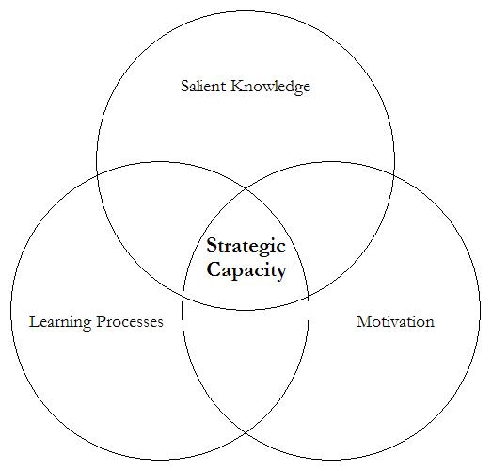

Story and Strategy

Organizing is not only about changing the world, nor is it only about changing what people think about the world -- it is about the connection between the two. Organizers argue taking people on a weeklong “reframing” retreat will change very little if they return to the same “structural” setting they left behind. On the other hand, organizers also argue that changing a “structural” setting without changing the people who operate within that setting, will also change very little. Insofar as people change, they may begin to acquire the power to change their circumstances -- and as people acquire the power to change their circumstances, they begin to change. This is one reason this course is called "people, power, and change."
On the one hand, organizers challenge people to interpret their experience differently. This is the value of the “outsider’s” perspective. Organizers don’t just provide “information” but challenge people to reframe their understanding of themselves and their experience through relationships, new stories (frame transformation), deliberative processes, and action tactics. On the other hand, organizers must also make the world accessible in terms of the frames people have (frame amplification, frame bridging, frame extension). This is the value of the “insider’s perspective. Outsiders don’t "frame" things as insiders do. This is why “reframing” is based not on one party doing a “snow job” on the other, but on a dialogic process between and among them. The work of turning “problems" into “issues” (reframing a problem as actionable) lies between the two. Much of the interpretive work of organizing involves finding ways to put new wine into old bottles. If people find they like it, they may decide to rebottle it.
Although story telling is primarily motivational and strategy is primarily analytic, a "credible strategy" plays an important part in a hopeful narrative. Devising a credible strategy and telling a motivational story go together. Most effective campaigns have a complementary "story" and "plan." How we can build from resources we have, how we can take advantage of opportunities, why the constraints will not overwhelm us, how each step leads to the next - all of these are elements in a plausible strategy. Just as good strategy gives individual tactics meaning by transforming them from isolated events into steps on the road to our goal, a good story gives our actions meaning by transforming us into participants in a powerful narrative. Analytics can also help us "deconstruct" an old story, on the way to learning to tell a new one. In organizing, our strategy and story are not only how we persuade ourselves that a particular course of action is worth the risk but also how we mobilize others without whose participation there would be no action at all.
©Marshall Ganz, Kennedy School, 2013
Power Jujitsu - Creative Tactics from the past

It’s important to remember that creative use of resources depends on the particular context we find ourselves in. We must look around and try to understand the current power relationships and develop tactics that allow us to shift those relationships of power. These examples from the past are not likely to be repeated, as today’s context is very different. Rather, their creative use of resources can spark our own creative thinking, just like Frida Kahlo looked to Diego Rivera for inspiration and then went out and did her own work.

California Farm Worker Peregrinación, 1966: 51 members of the National Farm Workers Association (NFWA) - precursor to the United Farm Workers (UFW) – undertake a 300 mile march from Delano to Sacramento to bring statewide and national attention to their struggle against Schenley Industries, a national liquor distributor and Delano grape grower with whom the NFWA had been involved in a protracted local dispute. The march, planned to coincide with the Catholic commemoration of Lent, brought renewed energy to a hard fought campaign. The thousands of supporters who showed their support to the marchers made Schenley reconsider their resistance to negotiating with the NFWA. Three days before arriving in Sacramento, Schenley agreed to terms on the first real union contract in California farm workers history. The movement was launched.

Flood the Store (Saul Alinksy): To protest the discriminatory employment policies of a department store, organizers threatened to bus 3000 Black customers in their Sunday best to the store and fill it. The Black customers also kept the clerks busy by asking detailed questions about the merchandise, then an hour before closing, they’d buy everything in sight and ask it to be shipped C.O.D., and upon delivery, they’d refuse it. Because it was credible, the threat itself proved enough to change the store’s hiring practices. An important lesson: the threat of a tactic is often more powerful than the tactic itself.

Bathroom Sit-In: Woodlawn Association (Saul Alinksy) In Chicago, to “persuade” authorities to keep their commitments to investment in the Woodlawn ghetto, they arranged for a sit-in at the airport’s restrooms. Protesters planned to come with books and newspapers, occupy the stalls and crowd the urinals, and stay there for hours on end. Again, the threat of this tactic, which at the time was completely legal, forced the political establishment to re-commit to the investment in Woodlawn.

Montgomery Bus Boycott: Combination of small individual resource (bus fare) into powerful collective capacity (withholding of all bus fares). A situation in which all the power seemed to be on the side of elite whites, the African-American community found ways to turn their individual powerlessness into collective power and eventually shifted the tides in a landmark campaign for equal rights.
QUESTIONS

- Who are your people? Has this changed? Why?

- What is your strategic goal? Has this changed? Why?

- What is your theory of change? Has this changed? Why?

- What tactics will you use? Why?

- What is your time-line as to how you will use them? Why?

Organizing Notes

Action

Week 7

We have been learning the work of leadership in organizing. We learned how to motivate people to translate their values into action with public narrative. We learned how relationship building could ground commitment to common interests. We learned how to strategize turning resources into power into goals. This week we focus on action – mobilizing and deploying resources to enact strategy in ways that can grow the motivation to participate even more. In an association, the most valuable resources are those its constituency can contribute - time, energy, effort - in a word, their commitment. This commitment of resources – volunteer resources in large measure – makes action possible. Whether holding a rally, conducting a delegation, or mounting a petition campaign, all action begins with a commitment. Action does not follow strategy; however, it unfolds together with it. We may learn what is possible only when taking action opens up new possibilities - as when Rosa Parks refused to get up our of her seat on a bus in Montgomery Alabama. Before getting to what it takes to make an action program work, organizers have key strategic choices to make about how to mobilize and deploy resources in general.
Resource Mobilization and Effective Action:

Paying the Piper and Calling the Tune
The way resources are mobilized affects how they can be deployed, and the way they are deployed affects how they can be mobilized, as illustrated in Action Chart #1. This helps clarify the relationship between action programs and resources. As Oliver and Marwell point out, resources mobilized from within a constituency can be deployed with accountability only to the constituency. Outside resources, on the other hand, often entail accountability to those who contribute them - placing limits on how they can be used. When a number of foundations decided that the environment was a priority, for example, some inner city organizations dependent on foundation funding decided that the interests of their constituents could be served by focusing on environmental programs.
Chart #1
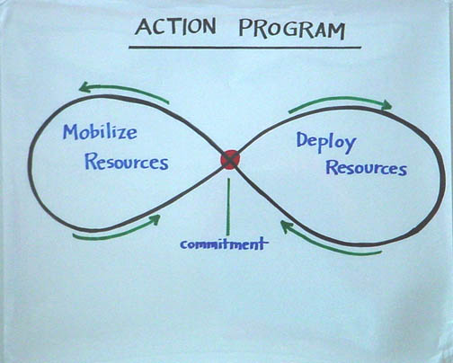
Similarly, devising tactics that require lots of money, if what you have is lots of people, can impose severe constraints on what you do. Basing your action program on tactics that require mobilizing people, on the other hand, can most directly empower your constituency, but it can constrain you to find tactics in which your people are willing to take part.
Although an organization can mobilize resources in a variety of ways, its center of gravity rests somewhere in the area described by Action Chart #2. If the center of gravity is in the inside/people box then it empowers the constituency, makes the organization accountable to the constituency, and limits the use of resources to the constituency's interest. One example is a union. On the other hand, if the center of gravity is in the outside/money box, then it can disempower the constituency (unless it is outside), make the organization accountable to its funders, and limit its tactics to those consistent with the interests of its funders. One example is a foundation funded service program.
Chart #2
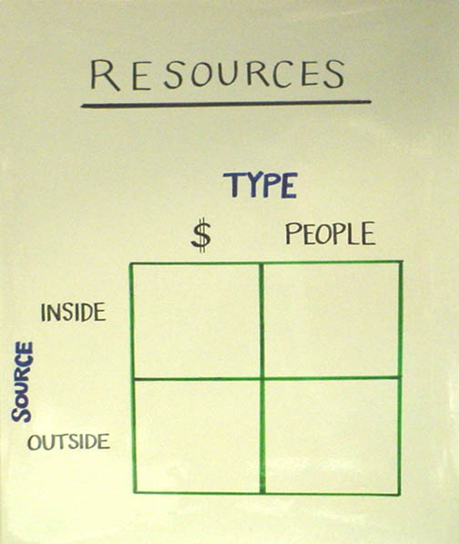
Finally, action programs that generate resources must be distinguished from action programs that drain resources. In union organizing, for example, the more successful the union, the more members it gets, the larger the dues base, the more leadership it can developed, and the greater its human and financial resources. Similarly, as some community organizations conduct parish renewal work among member churches, their human and financial capacity grows. Grant-based action programs, in contrast, often fail to generate new resources from the work they do - and keep themselves in a state of perpetual dependency.
The beauty of the grape boycott was that it was an action in which everyone could play a part - from a person who shunned grapes in a Florida supermarket, to a student who dropped out of school to come to work full time for the UFW, and everything in between. At one point in 1975, pollster Lou Harris found that 12% of the American public - some 17 million people - were boycotting grapes. The wider the opportunity to act, the wider the participation and the responsibility.
Action entails cost -- time, effort, risk, and hard work. Sacrifice can also be widely shared. The more widely it is shared, the more people have a stake in the outcome. The boycott is a good example of this as well. When one or two people do all the "sacrificing," they quickly become "burned out," while everyone else blames them for whatever goes wrong.
The flip side of shared sacrifice is shared success. When many people have an opportunity to contribute to the effort, they also share in its success. It is "their" victory, not someone else's victory. This, in turn, creates motivation and a sense of entitlement that facilitates accountability. The day after we won the Pelosi for Congress campaign in San Francisco, 15 Filipina women who had served as precinct leaders showed up at the campaign headquarters looking for Nancy (Pelosi). They had turned out her vote very effectively and played an important role in the victory. They had won, they said, and now they had come to find "Nancy" to get help on the immigration problems they had. This was exactly as it should be. It had been their work, their victory, and now they were entitled to enjoy some of the fruits of success.
There is no right or wrong answer to what an appropriate relationship between resources and action should be. Understanding the relationship is essential, however, so you can make conscious choices about how to set up your organization so it has a chance to accomplish its purposes.

Creating a Culture of Commitment

Outcomes, Commitments, Time, Contingency, Coordination

Regardless of whether one mobilizes resources from the inside or the outside and regardless of whether they are used to promote collaboration or make claims, there is a big difference between making something actually happen, and hoping, wishing, or dreaming that it will happen. One of the most common hazards in organizing is dismissing a strategy or a tactic because “we tried that and it didn’t work” when, in reality, it was never tried – not really. We called the meeting, but hardly anyone came. Oh? What was your attendance goal? Did you make a list of the people you wanted to come? Did you get a commitment from each of those people to come? Did you learn from your successes and your failures what you had to do to get a commitment? Did you follow up with reminder calls, especially on the day of the meeting? Did you get a list of who did come? Did you find out who had invited them? Did you compare their performance to that of others? Did you learn what made the difference?
Engaging in effective collective action poses particular challenges that require greater craft than if you were a “lone ranger” operating off by yourself somewhere. Moving significant numbers of people into coordinated action requires doing detailed thinking, anticipating contingencies, providing accountability and support, conducting training – all “craft” activities that need to be viewed as being as central to the action as the action itself, or there’s likely to be no action.
Unless you can answer these questions not only about a meeting, but also about every link in the chain of contingencies that turns resources into action, there is no “craft” in your work. It becomes almost impossible to evaluate the quality of your strategy, because your “craft” – the excellence with which you do things – is so poor. In order to bring “craft” to your organizing work, it is important to focus on the following: measurable outcomes, numbers of specific commitments, deadlines, and responsibilities.

Measuring Outcomes

What are the measurable outcomes you will accomplish and by when? Without clear outcomes, your team doesn’t know if it succeeded or failed in doing what it committed to do. As Fred Ross once said, if you can’t count it, it didn’t happen. How many votes will it take to win the election? How much loss must a company suffer for our boycott to succeed? The ancient war strategist Sun Tzu speaks about the importance of measurement in the pursuit of one’s goals:

The rules of the military are five: measurement, assessment, calculation, comparison, and victory. The ground gives rises to measurements, measurements give rise to assessments, assessments give rise to calculations, calculations give rise to comparisons, and comparisons give rise to victories.

The measurement of outcomes allows a group to assess, concretely, what is happening. Assessment allows a group to calculate how it is doing over the course of time. Have we secured as many votes as we had planned to secure at this point in our work? Calculation, in turn, allows one to compare one’s own outcomes with those of the opposition, or of previous efforts. If we continue at this rate, will we be victorious? What must we do in order to win? These sorts of comparisons, in turn, allow a group to continue or alter its course so as to ensure victory.
Measurement also allows us to learn by making visible who among us is succeeding, who is failing, and why. Who persuaded more people to sign up? Who was not able to persuade as many? What can we learn from this comparison? In other words, how can every organizer perform at the level of the most successful ones?
Similarly, concrete outcomes allow a group to focus clearly on the specific actions that it must take in order to produce these outcomes, and – in turn – what activities unrelated to the outcome can be eliminated. Without measurable outcome goals, it is easy for a group to lose focus, to be unclear about its goals and therefore, unclear about what actions it must take.
Creating measurable outcomes allows us to take control over our goals. Having measurable outcomes – turning out 25,000 votes, for example – lets us focus on something we can control. It becomes both a basis for evaluation and for learning. Was, indeed, 25,000 votes enough, as we thought? Or did the other candidate win despite our turning out 25,000? In the future, what should our outcome goal be?
As we discussed in the chapter on strategy, goals are embedded within goals. Measurements should thus be associated with each goal. Take the following example from a 1990 California campaign for two environmental propositions. Organizers recognized that they needed to secure approximately 75,000 votes statewide in addition to regular voters. This campaign divided their goals into phases:

- Phase I: Kickoffs – Turn out 500 people to 7 Kickoffs across the state on Saturday, October 20.

- Phase II: Voter ID – Recruit and train 1,000 Precinct Leaders to contact 300,000 Occasional Environmental Voters and identify 150,000 supporters among them—complete by 11/2 (14 days beginning with Kickoffs on 10/20)

- Phase III: Turn out 75,000 additional environmental votes on Election Day, November 6.

Of course, each of these outcome goals had several layers of outcome goals embedded within them – For example, how many people needed to be recruited to help turn out the 500 people on October 20, how many of those 500 people needed to assume leadership roles to recruit Precinct Leaders, how many hours did each of the 1,000 precinct leaders need to work every day in order to identify their voters.
Securing Commitments

Once we decide on upon desired outcomes we must organize ourselves to produce them. We must decide on the specific action we will ask people to take – the commitment we will ask them to make - such as signing a pledge not to eat grapes, making your own salt, not riding the bus, etc. To secure the participation of a large number of people, we must delegate the responsibility of securing these commitments to a wide range of leaders or potential leaders. One of the greatest challenges organizers face is in learning to ask for – and get – commitments. A commitment is a specific pledge of time, money, or action. Even if we are asking for a commitment to future action, however, a commitment will be stronger if a pledge to take the action is signed now. “Can we count on you to be at our meeting at 7:00 PM? Great would you mind putting your name and phone number down on the list so we can be sure how many chairs to put out and so we can give you a reminder call? I’ll try, I’ll do my best, maybe I’ll be there don’t count as commitment. The genuine commitments we secure, then, become an indicator of the outcome we will achieve.

Chart #3
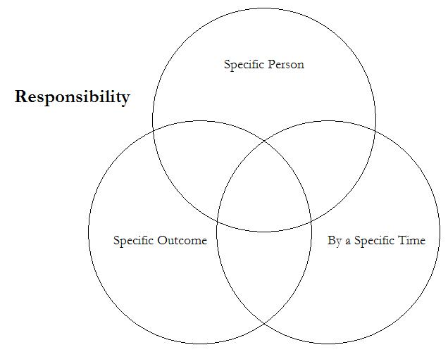

So there is a big difference between putting the word out about a meeting and getting commitments from people to attend. Unless organizers and volunteers ask or and obtain commitments to attend – in writing, if possible – meeting attendance will be a “crap shoot.” This is challenging because we fear being rejected, and we often fear placing others under obligation, because it obliges us as well. Whatever the reasons, it takes courage, training, and dedication to develop a team of leaders who are not afraid to ask for and get commitments. Without this, the “action” will remain always just a little out of reach.
Finally, there is also a big difference between making commitments and keeping them. Many of us have experienced saying we will arrive at 10, but instead we arrive at 10:15. We say we’ll get something done by Thursday, but don’t have it done until Friday. When we break commitments, even in small ways, the commitment itself begins to mean less for us and for others who are counting on us. We say we’re going to be somewhere by a certain time, while knowing we’ll likely be later. Within an organization, failure to honor commitments has a negative exponential effect. If commitment stops meaning very much for me, when I commit to organizing 2 house meetings per week with 15 people at each, am I really going to think that I’ll be able to? And if I don’t think I can, how hard will I work towards this goal?

Managing Time
The way we organize our time expresses our priorities. Whatever we say, how we spend our time is what we actually do. This is so because often time is our most valuable resource, especially collective time – time in a meeting, in an action, at a rally, etc. Gandhi is reported to have said that a “deal without a date is not a deal”. In other words, it is not only a question of what you will do, but the date by when you will do it. Deadlines are not only a way to coordinate; they are a way to create the urgency that it takes to give action the priority it requires to get done. Without deadlines, there is no urgency and, as a result, it is very unlikely that what you set out to do will happen.
How we prioritize time within a campaign affects the value organizers place on their work. In campaigns in which meetings never start on time, if they are held at all, in which some people’s needs trump everyone else’s, in which meetings people prepared for get cancelled, pretty soon, no one believes their work has any value, except for a few at the top. This can be deadly for a volunteer effort, where organizers have to persuade volunteers of the value of their contribution, but themselves feel undervalued.

Managing Contingency:
Reminder Calls
The world of organizing is a world of contingency…everything can go wrong. Someone forgets to unlock the hall, the sound system is missing a cable, someone forgot to order the chairs, the map got printed backwards, half the flyers didn’t get printed on time, someone’s car has a flat tire, the date was mistranslated in the Spanish version, etc. etc. etc. Any human endeavor has to deal with contingency. But in a setting in which inexperienced people are trying to achieve major tasks, under pressure of time and with fewer resources than they need – typical of most organizing situations – the potential for disaster is always lurking just around the corner. And much of this we can’t do anything about.
But there are forms of contingency that we can do a great deal about, and it is on those that we must concentrate. For example, asking a person for a specific commitment – and getting them to sign it – removes some of the contingency as to whether they’ll show up at the meeting or not. In general, one of the most important aspects of the organizer’s craft is finding ways to remove as much of the contingency as possible – there will still be plenty to go around.
For example, an organizer’s responsibility does not end with securing a commitment. Organizer Larry Tramutola recounts learning this lesson from master organizer Fred Ross:

Pointing to the chart and handing me a colored marker, he told me, “Write down everything you have to do each day. Who are you meeting Monday?”

I went over to the butcher paper and wrote down the names and times of the three people that

I was supposed to meet that day.

Fred continued, “OK, now when are you calling these people to remind them that you are coming to see them?”

Remind them I was coming to see them? “I hadn’t thought of that,” I told Fred.
“Well, write that down,” he stated firmly. “Reminding is the essence of organizing.”

He went over to [the] butcher paper and wrote in the Sunday column: ‘Make reminder calls to:’ Then, he listed the names and phone numbers of the people I was to visit the following Monday.
The lesson continued. “What time are you calling them?” he asked, and before I could answer, he instructed me, “Now write down the time.” I did.

But he was not through with me yet. “OK, now on Monday, before you meet with them, you need to call them again, right?” Fred asked.

I just nodded quietly while privately thinking that all this reminding and writing down was a bit of overkill. It was only weeks later that I came to understand that these details, and the discipline to put them into practice, are absolutely essential to good organizing. At the time, though I had not learned that for myself, and I certainly did not want to challenge Fred, so I said nothing.

Fred went on. “Good. Now write on the butcher paper the time that you plan to call them, so you don’t forget. It is always good to call people right before you visit them, so you don’t waste time if they are not there.”

And by the way, he continued, “While you are at the house of one of the people on your list, ask if you can use their phone to call your next appointment. That way they’ll see how serious you are,” he said.

He goes on to reflect on Fred’s coaching:

When volunteers who had promised to come to help pass out leaflets did not show up, he would say, “I’ve told you that you need to remind people to come. When you are not successful organizing, you need to take the responsibility. It is not their fault they didn’t show up. It’s yours. You either didn’t do a good enough job inspiring them, or you didn’t follow up and let them off the hook. Either way it’s your fault.”

Of course, Fred practiced what he preached, holding himself responsible for ensuring Larry’s success as he held Larry responsible for ensuring that others made good on their commitments. Tramutola recalls being coached at the end of each day by Ross:

We started every call with what I had accomplished during the day. He peppered me with probing questions that demanded thoughtful answers and accountability: “Why did you do that?” “What did you say when he said that?” The interrogation went on for two hours and often longer, as I had to report and relive my successes and failures of the day. Fred asked me one question after another, and unless I was prepared to simply hang up and walk away from what I was doing, there was no escape or relief. But I endured the torment, partly out of pride and partly because I knew Fred was teaching me invaluable lessons about the importance of follow-through and disciplined work.

Good coaches know what questions to ask, and know when they are not getting complete answers from those they are coaching. In different organizing situations, there are different questions that are important to ask, and different ways of recognizing when people are bullshitting.

Coordination
Bringing all these elements of collective action craft together – outcomes, commitments, responsibility, time, and coaching all takes coordination. And coordination requires coordinators, a schedule, and measures. Those responsible for providing leadership must make the time to meeting before and action, during an action if need be, and afterwards to evaluate the action. Managing an effective team means scheduling time for the team to meet, to receive training, and for its members to receive one on one coaching as needed.
Coordination also requires benchmarks to evaluate – and adapt to – results. Where are we, in terms of our goals? How might we need to adjust our behavior in order to achieve our measurable outcomes? Who is doing well? Who is doing poorly? How might we need to adjust our measurable outcomes given what has happened over the last period of time?
This also means organizing space to reflect the goals of the group. Paul Milne discusses the importance of organizing physical space in such a way that the focus of the organization is on outcomes – for example, the number of votes secured through phone calls and house meetings is turned into a large chart that hangs in the line of sight of anyone who enters headquarters: “When you walk through an organizing office, it ought to remind people of what needs to be done, what’s important, what things should happen next. The place should have an orienting effect.”
Perhaps most important for coordination, however, is a regularly scheduled coordination meeting that can serve as an “eye” in the hurricane, the order at the core of what can feel like a chaotic enterprise. For this to work, however, it must be sacred. When I was coordinating Nancy Pelosi’s first campaign for Congress in 1987, I was looking for an opportunity to establish this practice. We had just begun our daily coordinators meeting when someone came running into the room shouting, “Nancy’s on the phone! Nancy’s on the phone! She’s got to talk to you right away!” All eyes turned to me. Was our time really sacred or not? “Please tell Nancy that we’re in our coordinators meeting”, I said. “I’ll call her as soon as we’re done.” A big sigh of relief. From that point on, we never had any problem sticking to our daily meeting.

Motivating Engagement
(Commitment, Effort, Learning)

Since action is ultimately what organizing is all about – changing the world – it’s remarkable how often we turn the work of action into a test of how committed we are rather than an opportunity to enhance motivation, deepen commitment, and create opportunities for leadership development.

- You’ve been doing well at recruiting new volunteers but they only show up to phone bank once or twice and you never hear from them again? How can you keep them coming back?

- You have one person who “always” runs the tabling operation but they’re gone for the year. How do you replace them? And, come to think of it, they and a couple of their close friends are the only ones who ever show up to do tabling. Could this be an opportunity?

- It gets pretty tiring, having to tell everyone exactly how to do their work – whether it’s the check-ins for a conference, getting the food lined up for a celebration, planning for a hearing. How come I always have to tell everyone exactly how to do these jobs when they ought to know how to do it? People just don’t care, do they?

You can meet these challenges by making your leadership team learns how to design tasks that insure high quality work by making full use of your resources that motivate those who perform them, and that create more opportunities for leadership development.

How does motivational task design work?

Social scientists have found that tasks designed to yield “intrinsic” rewards (inherently satisfying) produces greater motivation, commitment, and adaptive learning than tasks that only yield financial, recognition, or status rewards. When deigning tasks for volunteers this is even more important.

All three conditions that make for motivational task design must be present:

- Experienced meaningfulness: the task is important in the overall scheme of things.
- Experienced responsibility: how well the task gets done is up to me.
- Experiences results: as I do the work I can see whether or not I’m doing it well.

These conditions can be established by designing tasks in the following ways:

- Task significance – understanding and recognizing the impact of the work on the world.
- Task identity – one’s own contribution, from start to finish, is clear in the final result.
- Skill variety – engaging a variety of skills, including heart, hands, and head.
- Autonomy – having the space to make competent choices about how to do the work.
- Feedback – results visible to the person performing the task as they perform it.

Using this guide as a diagnostic we can evaluate tasks to determine how motivational they are, redesign them to make them more motivational, and construct them so as to create a leadership ladder, opportunity for people to earn greater responsibilities.

Evaluating an Action Program
Finally, we can evaluate the efficacy of our “action” program in three ways:

• First, does it solve the problem at hand? Did you get done what you set out to do? Are there more books in the school, for example? Did more money get allocated for environmental protection?

• Second, does it strengthen the organization? Did it deepen understanding, build relational commitment, and generate new resources?

• Third, does it facilitate the growth of individuals who take part in the action? Did people learn, did they gain confidence, were they energized - or were they completely burned out?

Chart #4

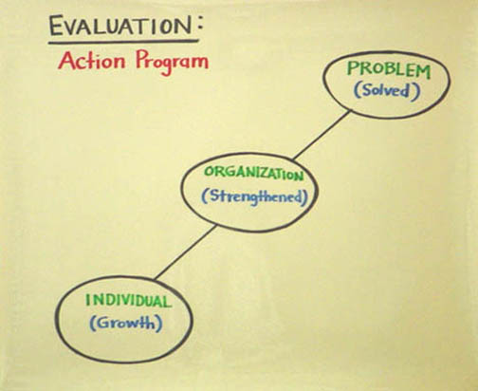

Conclusion
Returning to Cesar's house meeting, an event at the beginning of his efforts to build the UFW, let's reexamine the tactics. What were the relational tactics he used? What kind of interpretive tactics did he use? And what kind of action tactics did he use? The goal of the work we have done over the last three weeks is to see how these three kinds of tactics can be woven together in effective organizational strategies - of which this house meeting is an excellent example.

©Marshall Ganz, Kennedy School, 2013

QUESTIONS

- What is the “action program” of your project? Be very specific. What are new participants asked to do?

- Where does you organization get the resources it needs to carry out its action program? Does it draw more heavily on people, money or both? What impact does this have?

- How are you creating a “culture of commitment” in your action program?

- Using the diagnostic checklist, how motivational is your action program? Does it create opportunities for leadership development?

- Evaluate your action program using the three questions from Hackman: Does it solve the problem at hand? Does it strengthen the organization? Does it facilitate the growth of individuals who take part?

Organizing Notes

Organization:
Communities in Action

Week 8

This week we look at communities in action -- organizations through which we mobilize common resources on behalf of common interests. Last week we discussed how relational, interpretive and action tactics could be strategically and motivationally woven together as campaigns. This week we look at how to structure organizations - formalizing our relationships, our methods of interpretation, and our action routines - to make ongoing effective collaboration possible.
Organizations do just three things: they meet, they act, and they celebrate. Although the concept of organization is simple, working as a social change organization in practice is not easy. As collective enterprises that express individual and common purposes, organizations entail inherent tensions or dilemmas. We cannot eliminate these tensions, nor should we try to because they are vital sources of energy and renewal. We must learn to manage them. The first step to doing this is to recognize the tensions that exist. In this chapter we focus on four key tensions in membership associations: inclusion vs. exclusion, stability vs. change, unity and diversity, and part vs. whole.
Inclusion vs. Exclusion:
Bounding the Organization
Who is “in” and who is “out”? And who decides who is “in” and who is “out”? Because every inclusion is also exclusion, as soon as we define the “we” that makes up our group, we have defined a “not-we” outside of the boundaries of our group. On the one hand, this may limit our capacity for collaboration. On the other hand, a community without boundaries – or, for the matter, a marriage, a family, or any other kind of group – can’t exist. So it is not a question of whether or not we bound an organization, but rather how we bound it that gives it an identity – an identity that those of us who participate in it share.

Although he is writing about small groups, Richard Hackman, in Leading Teams, observes:

To work well together, team members need to know who they are. Members are sure to run into difficulties if there is so much ambiguity about who is actually on the team that they cannot reliably distinguish between the people who share responsibility and accountability for the collective outcome and others who may help out in various ways but are not team members.

A community we can enter any time we want (when it is convenient, when it is doing what we want) and exit any time we want (when it is inconvenient, when we disagree) is a community of rights but no obligations. Without obligations, however, it never becomes a community. Obligations give us an interest in making the community work, even when it is difficult and we disagree with it. Communities without obligations – or commitment – can never generate social capital because we never know if there is “a there really there.” Consumers enter a marketplace at will, exercise their preferences, and exit. Constituents, on the other hand, are responsible for governance of their community. Acceptance of obligations entitles one to voice within it.
Furthermore, it is necessary for groups to be bounded in order that trust can be built among the members of a group, as Smith and Berg articulate:

For a group to develop the critical internal relationships so that it can become an entity worthy of being trusted, it needs to have the trust of its members and the assurance they will stand by the group through the bad times and the good. The paradox of trust can be represented by the conundrum of a cycle that depends on itself to get started: for trust to develop in a group, members must trust the group and the group must trust its members, for it is only through trusting that trust is built.

Without knowing who is in a group, the cycle of trust – difficult to begin, even with organizational boundaries in place – is even more difficult to set in motion.
Bounding an organization also entails setting norms for the organization. While norms will develop naturally whether or not we set them explicitly, we are better off being explicit. As Hackman explains, we must set norms explicitly in order to counter human tendencies that actually lead to unproductive organizational work:

The first ordinary tendency is our disposition to react to whatever captures our attention and demands a response, rather than to actively scan our environment for less obvious problems and opportunities that may call for nonstandard actions… A second human tendency… is our understandable impulse to have harmonious interactions with others, to be approved rather than rejected by our teammates, and generally to keep anxieties as low as possible.

As a group sets explicit norms to approach its work proactively, and agrees on “the outer-limit boundaries of what behaviors are acceptable,” it can effectively counter these tendencies.

Change vs. Continuity
Maintaining an Interest in Change
If the purpose of an organizing campaign is to create lasting change, doesn’t that set up a paradox? We create structure to create continuity but we challenge it to create change.
As a membership association develops and becomes more successful, it will tend to grow larger, become more geographically diffuse, acquire more assets, engage in tasks of greater complexity, try to preserve more lessons from their pasts, and try to extend their horizons farther into the future. This development both requires and facilitates greater complexity in authority structures, routines of practice, and resource configurations. Seeing to the operation of the organization itself takes the commitment of more – and different - resources, energy, and leadership.
Initiating an organization requires commitment of resources, energy, and leadership as well, but they are used in ways closely linked to the organization’s purposes – especially if experience of the organization itself is one such purpose (the purpose of a church, for example, is largely realized through participation in is core organizational activity, shared worship). As more resources are devoted to the organization itself, the goals of the organization may become confused with the organization itself as a goal. This is especially problematic if, as it grows, the organization’s work becomes more specialized, requires more full time elected or appointed staff. Such a staff begins to compete for organizational resources and can use its control over resources to insulate itself from membership accountability.
Further, a kind of “elective affinity” may come into play as this organizational tension reflects conflicts in our own feelings about stability and change. On the one hand, our curiosity, sense of adventure, desire to learn may draw us to innovate. On the other hand, our need for predictability, proficiency and stability, may cause us to fear innovation. Although most of us experience both kinds of pull, some us are drawn more to the innovative, evangelical, and experimental and others to the stable, predictable, and proficient. And since people with one disposition converge on different parts of an organization than those of the other, the possibility of constructive synergy or organizational fragmentation are both created. This challenge can become acute in membership associations because their success growing their membership creates the constituency most inclined to resist investment of organizational resources in further growth. And it becomes particularly acute in that control over organizational resources falls naturally into the hands of those stabilizing the organization to a greater degree than those growing it – into the hands of bishops, in other words, rather than missionaries. Because of the way this works, it is very important to build in strong accountability mechanisms – at both the individual and the organizational level - from the beginning.

Unity vs. Diversity
Organizational Creativity
Unity is the source of a membership association’s power because it is through combination that it acquires the resources that it has to deploy. On the other hand, diversity is often the most critical source of an association’s creativity, accountability, and ability to learn. As social psychologists have learned, the more homogeneous a group, the better it can be at “taking the hill”; but the more diverse a group, the better the decisions it will make about whether to “take the hill” or not. Dissent, in other words, can be associated with better decisions, but poorer performance. Unanimity can be associated with better performance, but poorer decisions.
Hackman writes, “A well-composed team strikes a balance between having members who are too similar to one another on the one hand and too different on the other.” Again, this is a concept that is simple and yet not easy. For one, we tend to self-select into groups with people who share many of our characteristics; we tend to seek harmony. Diverse groups often begin less harmoniously, often experiencing rough sledding early in their lives as members struggle to figure out how to work together (and interpersonal conflict definitely is not a boon to performance). But if members make it through their early difficulties, they are likely to come up with products that are significantly more creative than those generated by more homogeneous teams whose interactions are smoother from start to finish.
Too much unity (such as Janis’s “groupthink”) can stifle an organization by destroying its responsiveness to its constituency and its capacity for renewal. If an association fragments into factions, each of which views its interests as the interests of the whole, it loses the capacity to discern the common interests that make combination possible, let alone the capacity to translate those interests into the effective mobilization and deployment of resources. Furthermore, while dissent is critical for decision-making processes, dissent on its own can be divisive and lead to scapegoating within an organization.

A group may need to be able to receive negative feedback about its processes in order to learn and grow; however, the message may feel like an assault on the group’s norms…. the carrier of such messages is often dealt with as a deviant which, in turn, helps to strengthen those norms, or as a scapegoat which provides some internal catharsis enabling the group to remain unchanged. The bind is that the group may elect not to listen to the very things it needs to hear. Instead, it may choose to reject the carrier of the message so that it does not have to deal with the message, treating the concerns as ‘belonging’ to the person expressing them rather than seeing this as an integral part of the group itself.

The challenge, then, is to design an organization in which interests and resources are concentrated enough to assure effective action, but diffuse enough to assure a capacity for change.
The Part vs. the Whole:
National Purpose, Local Action
Much of our discussion has assumed associations consist of a single organizational entity. Although groups that are exclusively local do operate as single entities, most successful membership associations combine local units in broader, often three tiered, federated structures that span the distance between local, state, national and, in some cases, transnational. And although it is the fashion to contrast the local, democratic, and responsive with the national, oligarchic and unresponsive, it is more often the case that it is the local that becomes oligarchic and unresponsive.
Political scientist E. E. Schattschneider, writing about political conflict, argues that widening participation by linking groups across localities is a way to amass the power one needs to accomplish organizational goals (it pools resources, creates a broader strategic venue). Additionally, it facilitates accountability – both to one’s constituency and to the broader goals on behalf of which one organized in the first place. Schattschneider claims that elites try to localize conflict, while insurgents try to broaden the arena of conflict – they can access more allies, more diverse resources, more observers who can be mobilized for support. Federated organizations can create venues within which local elites can be held more accountable as well.
This argument didn’t begin with Schattschneider, of course, but was made by James Madison in Federalist Paper # 10, when he argued that large democracy is preferable to small democracy because it is harder for a single faction to take control, turning the “common interest” into factional interest. We seem to have forgotten this idea with our more recent focus on the virtues of direct democracy over those of representative democracy.
The greater the exclusively of local control and organization, the more vulnerable it is to oligarchy, not at the top, but at the bottom. Not only does this stop the democratic process where it must be rooted, it contributes to the fragmentation of organizational resources as each local group becomes a Madisonian ‘faction”, seeing its own interest as the interest of the whole. In organizations of this type, the “whole” is reduced to the lowest common denominator, becoming less than the sum of the parts, rather than more.
There is another argument as well that relates to the ways in which associational members come to understand their interests. Each of us has multiple levels of interest. For example, a person who works as a carpenter in commercial construction in San Francisco, with an organizational affiliation that is similarly local, will come to understand his or her interest in that way. On the other hand, if s/he also belongs to an organization that links all San Francisco building trades, s/he may come to see his or her interest more as a “building tradesperson”, rather than simply a carpenter. And if, that unit, in turn, links people who work in the building trades with other working people in the area, it may emerge that there are working people’s interests – such as transportation costs, access to health benefits, etc. – that are far more broadly shared and which make broader mobilization possible. And if they are also affiliated with a political party or other political grouping that links working people with others in a similar economic situation, but who earn their incomes differently, interests may emerge in public schools, parks, and other public facilities. In other words, the associations with which we affiliate are not merely a “reflection” or our interests; they construct our understanding of those interests as well.
One example of the relationship among local control, accountability, and broader mission is in the labor movement. Unions structure themselves in a variety of ways, one of which is their degree of decentralization and centralization. Examples of highly decentralized unions are drawn from the building trades, craft unions, and others that operated in local labor markets in which they could assert control by organizing highly skilled workers. These unions typically had very large locals, they operated autonomously, and they paid a very small per capita to their national organizations, which were typically governed by a national board dominated by the leaders of the large local unions. Examples include the Teamsters and the Operating Engineers.
At the other extreme were the highly centralized unions. These typically were industrial unions that organized employees of companies operating across multiple localities such as autos, rubber, or steel. They could often only assert control in local labor markets by leveraging the influence that they had in some places where they often enjoyed political support, on other places where they did not. In the auto industry, for example, the UAW was able to use leverage it held in Michigan, where it had conducted effective sit-down strikes without interference from a friendly Governor, to organize other states where the politics or labor market conditions were far less friendly. These unions typically had locals of diverse sizes, organized into districts or regions or departments within which they had to collaborate to arrive at common positions, paid large per capita to their national organizations, and were governed by a board dominated by leaders elected on a regional or national basis.
Which were more oligarchic? Which were more corrupt? And which are most resistant to change. The fact is that the more local, decentralized, and autonomous, the more oligarchic, corrupt, and conservative the organization. The more national, centralized, and integrated the organization is, the more democratic, honest, and progressive it will be. Today, for example, the most successful union organizing in the country is being carried out by SEIU, a union of some 1.6 million members, and one that had to utterly restructure itself internally to move from the old large autonomous local model to a newer more centralized, more focused, more effective, and, arguably, far more democratic model.
In sum, translocal structures can create a balance between part and whole that give insurgents room to maneuver, decreases the control of local elites, and draw members into broader strategic venues, creating the opportunity for them to develop broader understandings of interests they share with others in like circumstance.

Managing the Tensions
Other than the tension between inclusion and exclusion inherent in the bounding of an organization, the following are some ways to consider for managing the tensions of change and continuity, unity and diversity, and part and whole

Pushing Responsibility Down and Broadening Participation
An organization committed to leadership development and wide participation is better equipped to engage with change on an ongoing basis than an organization that walls its leadership off in a tight circle of control. Sustained commitment to identifying, recruiting and developing new leaders and to finding new ways to engage one’s members more broadly requires organizational leadership to respond to the new currents, new ideas, and new challenges that are out there. So, wide participation can also be viewed as a way to assure ongoing responsiveness to the need for change, albeit within a framework with substantial continuity.
Similarly, openness to bringing in new people and broadening participation confronts leaders with the challenge of how to engage different kinds of people, people with different backgrounds, and, at the same time, create venues within which they can express their concerns, be heard, and see evidence of organizational responsiveness.
And the more extensively responsibility is shared among the leadership and membership of an association, the more the “parts” come to understand – and play a part in – the “whole”, and the more the “whole” has to understand about the interests and resources of the “parts.”
This is all very good, but what are the consequences of taking this approach for organizational performance in general? In membership associations, the more widely we share responsibility for organizational results, the greater the interest we acquire in the common effort, and the more resources we will commit to its success. It may be more “efficient” to get 5 people to spend the whole day collecting signatures in a city, but it may be more “effective” to get 10 teams of 5 to spend one hour each getting signatures in their own neighborhoods. Similarly, scholars of work organization have shown that pushing responsibility down, or “vertically-loading” jobs, can increase motivation and – by extension – productivity.
Second, pushing responsibility down not only empowers an association by engaging the resources of more people, but it empowers people within the organization because it provides them with access to the resources with which to exercise accountability. The more members share the responsibility for doing the work, the more getting the work done depends on their cooperation. And the more cooperation it requires, the more control over resources that can make accountability real are placed in more hands. If only five people can do the work, theirs is the only cooperation required - so they are also the only ones who can exercise real accountability. On the other hand, if it takes 50 people to get the work done, their cooperation is required.
When an organization’s work depends not on resources generated by the efforts of many people, but on resources generated by a single fundraiser, who holds real power within the organization? Have you ever been in a meeting where you start hearing about what the funders will support and won’t support and why we need to do this or that so we can get the money – all, of course, interpreted by the person responsible for raising the money? No matter how democratic the formal structure of an organization, if one person’s work drives it, that person will “have the say.” This is why effective democratic leadership rests on a solid practice of delegation – a practice that we focused on during our discussion of leadership.
Action entails cost, but also holds promise of recognition. The more widely shared the cost – or sacrifice - the more people have a stake in the outcome. If one or two people do all the “sacrificing,” they quickly become “burned out,” while everyone else blames them for whatever goes wrong. Similarly, when many people have an opportunity to contribute, they can also claim a share in success. It is “their” victory, not someone else's. This, in turn, creates motivation and a sense of entitlement that facilitates accountability.
The beauty of the grape boycott was that it was an action in which everyone could play a part – from a person who shunned grapes in a Florida supermarket to a student who dropped out of school to come to work full time for the UFW, and everything in between. At one point in 1975, pollster Lou Harris found that 12% of the American public – some 17 million people – were boycotting grapes. The wider the opportunity to act is, the wider the participation, the responsibility, and the accountability on the leaders will be.
It might not be surprising, then, we sometimes resist pushing responsibility down or widening participation to the extent that it threatens our control.

Collaborative Organization:

Diversity as an Asset
Establishing collaborative work practices within an organization - teams, group deliberation, evaluation, peer learning, etc. – can help address the change and continuity challenge. A key barrier to ongoing adaptive change is an isolated leadership, resistance to open evaluation, avoidance of the openness that teamwork requires, etc.
Similarly, we can manage the tension of unity and diversity more easily based on collaborative work practices. Leading a unified organization requires more than the defensive maneuver of “avoiding faction”. It requires designing the organizations’ work proactively so that it requires greater interdependence, thus enhancing collaboration. One of the dangers of “professionalizing,” is that we may minimize interdependence. Instead of relying on a team of volunteers (and their inefficiencies) we hire someone to do their job. But something is lost with this choice. Whom does this empower within the organization? Whom does it disempower?
Effective collaboration depends on skilled leadership, a chief art of which is learning to blend the unique capacities – and deficits – of different people. This, of course, goes to the tensions around part and whole as well. Work assignments are the result of a negotiation between the actual persons – their personalities, their experience, their talents, and their difficulties – and the "roles" they are needed to play. If everyone were the same age, race, gender, had the same skills, life experience, and so forth, their “power to” would remain limited because of so little opportunity for productive interdependence. We can't lift a table if we all lift the same corner at the same time. But if we each lift our own corner, we can. The trick is to match people and corners.
Effective collaboration also requires some continuity within an organization. Richard Hackman offers this anecdote:

NTSB (National Transportation Safety Board) staff combed the agency’s database to identify the circumstances under which aircraft cockpit crews are most likely to get into trouble. They found that 73 percent of the incidents in the NTSB database occurred on the crew’s first day of flying together, and 44 percent of those took place on a crew’s very first flight.

Hackman continues, “They learn who is especially knowledgeable or skilled about which aspects of the work and thereby build the team’s capability to actually use what members know and know how to do.”
Productive collaboration, then, is the result of harmony not homogeneity. This is what it means to learn how to construct community based on difference. The idea is to create a “star team,” not to be a “star player.” A coach begins with the common interest a team has in winning. But it only becomes a winning team if the coach learns how to combine the unique strengths and weaknesses of each player. The team then has an interest in remaining a team.

Dissent Is Not Disloyalty
Organizational Accountability
The capacity of a democratic organization to respond to its constituency and to new conditions is based on accountability. Democracy grows out of a claim that leaders may lead in the public interest not because they are virtuous, but because the public has the power to hold them accountable. Accountability (as in electoral competition) can also be a mechanism that requires democratic leaders to respond to new circumstances. For democratic organizations, then, responsiveness and renewal are directly tied to legitimacy of dissent. Accountability only works if it is linked to open debate of different points of view.
The contribution of a “loyal opposition” is not only to hold leaders accountable, but also to deal with the change and continuity challenge, by giving voice to alternatives that can stimulate adaptive response to change.
For this to work, however, requires engaging a full diversity of perspectives, meaning we have to learn to manage difference – neither denying it nor accepting it as absolute. To make “dissent” legitimate, we develop agreed upon ways to continue collaborating, even when we disagree. This requires “decision rules” – rules that allow us to make decisions, move forward, and get work done, even if everyone doesn’t agree. Formal procedures for debate, discussion, voting and evaluation can help by “depersonalizing” disagreements. Roberts Rules of Order did have its uses.
Leaders can also work to develop a culture which values difference by affirming the single voice that the rest of the group tries to drown out rather than joining the chorus. Learning to deliberate in ways that affirm our commonalties, while protecting dissent, can transform our diversity into an asset, which can aid us in realizing and acting upon our common interests. It is equally important to learn to celebrate in ways which both affirm the distinctiveness of our identities and the communality of our organizational undertaking.

Principles in Practice
How do the practices of pushing responsibility down, broadening participation, working collaboratively, and honoring dissent play out in the way an organization meets, acts, and celebrates?
Chart #1
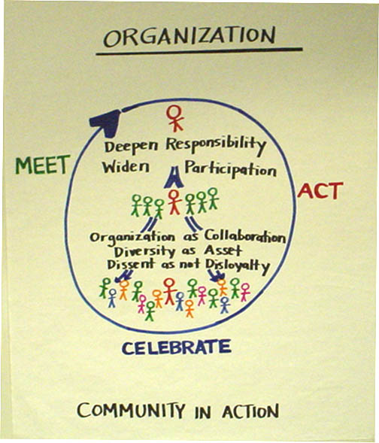

Meetings
While many meetings can take place between two individuals or small groups (indeed, some must), one way an organization comes to life is as a group of people in a room deliberating about what they can do together.
How does pushing responsibility down and broadening participation work in a meeting? How much effort is made to turn people out? Who participates in the planning team for the meeting? Who speaks in the meeting and what do they have to report on?
How about working collaboratively? What is the role of committees? How are committee reports handled? Is any collaborative work done in the meeting, like brainstorming?
And how about understanding dissent is not disloyalty? Is there a role for a “devil’s advocate”? How is debate structured? Are there rules of respect in place?

Acting
The second thing organizations “do” is “act” – conduct programs, run campaigns, provide services, etc.
How does pushing responsibility down and broadening participation work in acting? How widely has the responsibility for mobilizing participants been spread? Has responsibility for turnout been pushed all the way down, or only for sharing information? Are there teams? Team captains?
How about working collaboratively? How was the action planned? Who participated? Are there regular evaluations? Who participates?
And how does one understand dissent as different from disloyalty? What procures exist for people with complaints to have them heard? Does the leadership look for opportunities to act on suggestions voiced as dissent?

Celebrating
Finally, organizations celebrate their narrative, their successes, their setbacks, and their milestones.
How does pushing responsibility down and broadening participation work in celebrations? Is it a catered meal, or a potluck? Are professional entertainers hired, or are members called upon to contribute? Who does the decorations?
How does working collaboratively come into play? The whole way a celebration is planned, the way committees do their work, and how the event itself is conducted can be an opportunity for widespread collaboration or, the opposite, professionalization.
And how does understanding that dissent is not disloyalty help? Think creatively about how to honor different points of view, different perspectives, and different angles on what is being celebrated.
Chart #2

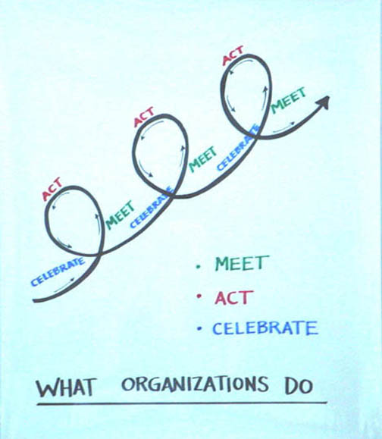

CONCLUSION

In sum, building powerful civic associations poses important challenges that only come fully into play as we begin to succeed. The responsiveness, relevance, and continued vitality of our organizations depend in great part on how we learn to manage the dilemmas of change and continuity, unity and diversity, and part and whole. We have suggested three practices that can help: pushing responsibility down and broadening participation, working collaboratively, and institutionally recognizing that dissent is not disloyalty.

© Marshall Ganz, Kennedy School, 2002

QUESTIONS
- What are you doing in your organization to widen participation and deepen responsibility?

- How do the meetings, actions and celebrations of the organization strengthen the organization? Could the organization conduct these actions better?

- How do you and your organization manage the dilemmas of unity and diversity, inclusion and exclusion, responsibility and participation, and leadership and accountability? Does it work? Could it work better? How?

Becoming a Good Organizer

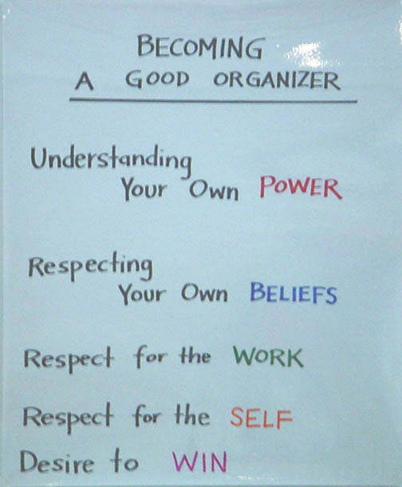
QUESTIONS

- What have you learned about yourself this term about becoming an organizer? What does it take to do this work well?

- What kind of support will you need after the class to continue to learn how to organize?

3. How might you apply the tools of organizing to your future calling?

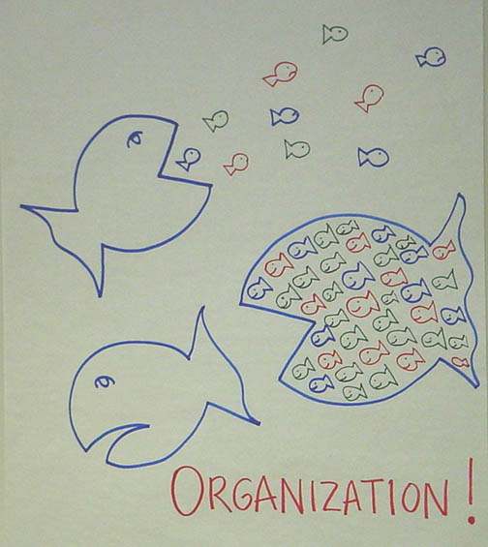
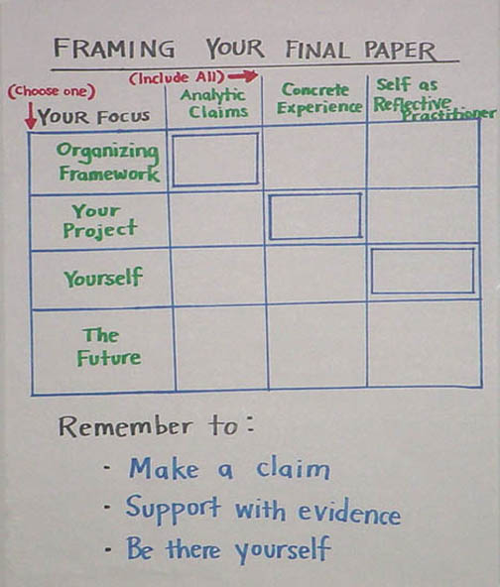

Pirke Avot (Wisdom of the Fathers)
Marshall Ganz, “Leading Change: Leadership, Organization and Social Movements”, Chapter 19,
Thich Nhat Hanh, (1993), Thundering Silence: Sutra on Knowing the Better Way to Catch a Snake, "The Raft is Not the Shore" (pp. 30-33), (Berkeley, Paralax Press).
Jordan Petersson, (1999), Maps of Meaning: The Architecture of Belief. (New York, Routledge).
M.S. Kierkegaard, “When the Knower Has to Apply Knowledge” from “Thoughts on Crucial Situations in Human Life”, in Parables of Kierkegaard, T.C. Oden, Editor. (P)
Robert B. Westbrook (1991), John Dewey and American Democracy, (Ithaca, NY, Cornell UP.)
Susan Fiske and Shelly E. Taylor, (1991), Social Cognition, Chapter 6, "Social Schemata," (pp.139-42, 171-81), (New York, McGraw-Hill.)
Ellen J. Langer, (1989), Mindfulness (Cambridge: Perseus Books); (1998) The Power of Mindful Learning, (Cambridge, Perseus Books).
Howard Gardner, (1992), The Unschooled Mind, (New York, Basic Books.)
Mohandas Gandhi, (1957), An Autobiography: The Story of My Experiments With Truth, (Boston, Beacon Press.)
Carol Dweck (2006), Mindset: the new psychology of success, (New York, Ballantine Books).
Richard Hackman and Ruth Wageman, “A Theory of Team Coaching” , Academy of Management Review, April 2005, p.269 -287.
Jerome Bruner, (1986), “Two Modes of Thought”, Chapter 2 in Actual Minds, Possible Worlds (Cambridge: Harvard University Press, p.11 – 25.
St. Augustine
G. E. Marcus, (2002), The Sentimental Citizen. (University Park, PA, Penn State University Press).
Martha Nussbaum, (2001), Upheavals of Thought: The intelligence of emotions. (New York, Cambridge University Press).
G. E. Marcus, (2002), The Sentimental Citizen. (University Park, PA, Penn State University Press).
Anger as contrast of is and ought.
W. A. Gamson, (1992), Talking Politics. (New York, Cambridge University Press).
Scott (1976)
Martin E.P. Seligman and Mihaly Csikszentmihaly, (2000), “Positive Psychology: An Introduction”, American Psychologist.
Maimonides.
Aristotle, The Poetics.
Charles Taylor, (1989) Sources of the Self: The Making of Modern Identity. (Cambridge: Harvard University Press).
Aristotle, The Rhetoric.
Alasdair Macintyre, “The Virtues, the Unity of a Human Life, and the Concept of a Tradition” in Memory, Identity, and Community: the Idea of Narrative in the Human Sciences”, edited by Lewis P. Hinchman and Sandra K. Hinchman, State University of New York, 2001, p. 241 – 263; Margaret Somers, (1992). “Narrativity, narrative identity, and social action: Rethinking English Working Class Formation” in Social Science History 16: 591-629; Margaret Somers. (1994). “The narrative constitution of identity: A relational and network approach.” Theory and Society 23: 605-649.
Dr. Martin Luther King, “I Have a Dream”, Washington DC, August 28, 1963
The Bible, Exodus 3:9.
William Shakespeare, Henry V, Act IV, Scene 3.
Seamus Heaney, (1991), “The Cure at Troy”, Farrar, Straus, and Giroux
Seeger, Pete, (1964), Fall River Music, Inc.
Albert Hirschman, (1970), Exit, Voice, and Loyalty, (Cambridge, Harvard University Press), p.16.
C. Alderfer, (1972), Existence, Relatedness and Growth. (New York, Free Press).
J. Bruner
R. Emerson, (1962), "Power-Dependence Relations." American Sociological Review, 27: 31-41.
B. M. Loomer and Jean Baker Miller, (1976), "Two Kinds of Power," The D.R. Sharpe Lecture on Social Ethics, October 29, 1975." Criterion 15(1): 11-29.
J. Gaventa, (1982), Power and Powerlessness: Quiescence and rebellion in an Appalachian Valley. (Champaign, IL, University of Illinois Press).
Gould, S. J. (1987). Time's Arrow, Time's Cycle: Myth and metaphor in the discovery of geological time. (Cambridge, Harvard University Press).
Sim Sitkin, (1992), "Learning Through Failure: The Strategy of Small Losses", Research in Organizational Behavior, Vol.14, (pp. 231-266).
J. M. Burns (1978). Leadership. (New York, Harper and Row).
Martin Luther King, J., (1986 (1991)), The Drum-Major Instinct (4 February 1968). A Testament of Hope: The essential writings and speeches of Martin Luther King, Jr., (New York, HarperCollins) 259-267.
J. Freeman, (1970), "The Tyranny of Structurelessness." Women's liberation movement, USA.
The Bible, Exodus 18.
P Oliver and G. Marwell, (1988), Mobilizing Technologies for Collective Action. Frontiers in Social Movement Theory. A. Morris and C. M. Mueller. (New Haven, Yale University Press), 251-271.
Tzu, Sun, The Art of War. 65.
L. Tramutola, (2003), Sidewalk Strategies: Seven Winning Steps for Candidates, Causes and Communities, (Turnkey Press), 39
Interview with Paul Milne, (2005), July.
Hackman and Oldham, 1980
Hackman, Leading Teams. 22-25.

