DRAFT v6, APSA
.

Technology Optimism or Pessimism about Genomic Science:
Social Scientists versus the American Public

Jennifer Hochschild, Harvard University
Maya Sen, University of Rochester
August 24, 2013

Paper prepared for presentation at the annual meeting of the American Political Science Association, Chicago IL, August 29-September 1, 2013. DRAFT: Please do not quote or cite without permission from the authors. We welcome comments and suggestions; please send them to hochschild@gov.harvard.edu or msen@ur.rochester.edu.

Many thanks to Patrick Moynihan for substantial advice on designing the GKAP survey, and the staff at Knowledge Networks for their professionalism in implementing it. Medha Gargeya, Michael Anthony George, and Angela Primbas provided excellent research assistance. Alex Crabill, Graciela Carrasco, Mayya Komisarchik, Brendan McElroy, and Ben Gruenbaum were invaluable research assistants. We greatly appreciate the time and attention provided by our interview subjects, and wish that we could thank them by name. Finally, thanks to Gail Henderson, Eleanor Singer, Peter Marsden, and Tom Smith for enabling and helping to create the 2010 General Social Survey module.

This research was sponsored by the National Science Foundation through the GSS, and by a Robert Wood Johnson Foundation Health Policy Investigator Award to Hochschild and Sen.

ABSTRACT

Members of the general public, as well as experts, express varying levels of technology optimism or pessimism about scientific endeavors. Tolerance for risk may vary according to cognitive or affective characteristics of the individual, the social context, the content of the enterprise being evaluated, or some other dimension; the theory is underdeveloped. In this paper, we explore technology optimism and pessimism through the lens of responses to various arenas within genomic science. The novelty of genomics in the public realm -- along with its unusual combination of life-and-death implications for individuals, stupefyingly complex technology, and broad but as-yet-unknown societal implications -- make it an excellent subject for the study of policy formulation, political consolidation, and individual’s responses to the frontiers of knowledge.
We use three new sources of evidence: in-depth elite interviews, content analysis of prominent articles, and a new public opinion survey. The paper focuses on three features of technology optimism -- the impact of scientific knowledge and value predispositions in the American public, the impact of value dispositions (given high levels of scientific knowledge) in genomics experts across various academic disciplines, and tensions between public and expert opinion. We find that the most knowledgeable citizens and liberals or Democrats are the most optimistic about genomics, and that religious conviction is associated with less optimism. However, scholars in more liberal disciplines are less optimistic about genomics than scholars in relatively more conservative disciplines. We offer suggestions to explain the disparity between public and expert views, and raise questions about the political and policy implications of the tension between ordinary citizens and academic elites with regard to genomics and other scientific endeavors or technologies.

Scientists are optimists – why else would we devote so much effort to devising intricate experiments to tease out new knowledge? We also continue to innovate, to solve problems, perceived and real. Our world is rife with potential tragedies: rapidly dwindling resources, new diseases that spread with frightening speed, the effects of global warming. The role of science in protecting our lives and our planet is crucial and dramatic. . . . We are learning quickly.
--(Arnold 2012): 10

[F]orensic DNA repositories are gathered by the state without consent and are maintained for the purpose of implicating people in crimes. They signal the potential use of genetic technologies to reinforce the racial order not only by incorporating a biological definition of race but also by imposing genetic regulation on the basis of race. . . . As the ideology that race is important to genetics . . . is spreading, we are also witnessing the escalation of a particularly brutal form of state control over large numbers of people on the basis of race.
--(Roberts 2011): 264-5

The next 10 years will dwarf the previous 60 [in results from DNA sequencing].
--Ronnie Andrews, head of medical sciences at Life Technologies,
quoted in TIME 5/20: Business 4

A variety of disciplines -- psychology, economics, sociology, political science, and others – all engage with a dichotomy that we label technology optimism or pessimism. Frances Arnold’s effort to solve “our world’s . . . potential tragedies” through science represents one pole; Dorothy Roberts’ claim that forensic DNA biobanks are a “particularly brutal form of state control” represents the other. The basic distinction goes by a variety of names: risk seeking versus risk aversion, preference for type 1 or type 2 errors, technology optimism or pessimism, and perhaps others. at its core is the question of whether an individual, group, or polity should, at the margin, be more engaged with protecting vulnerable individuals or the society against possible or probable disasters, or more focused on promoting possible or probable gains. Ideally, of course, one will do both -- but where a choice must be made, actors differ dramatically in where they place priority.
As the phrase “technology optimism” suggests, science policy is one arena in which the appropriate level of risk is a newly prominent concern. Google Ngrams show both phrases, “technology optimism” and “risk averse,” to be almost never used before the 1970s. “Risk averse” rose steadily, plateauing by 1990 and remaining in constant use thereafter; the use of “technology optimism” remained flat for the two decades after 1978, then rose steeply and remained in more constant use after 2000. In short, as science became more central to public discourse and political decision-making, the question of one’s stance toward its opportunities and dangers emerged more fully in the public arena.
The scientific optimist “is centered on advancement concerns. . . . [He or she is driven] by motivations for attaining growth and supports eager strategies of seeking possible gains even at the risk of committing errors or accepting some loss”. A technology pessimist, in contrast, “is centered on security concerns. . . [and] supports vigilant strategies of protecting against possible losses even at the risk of missing opportunities of potential gains” [both quotes from (Hazlett et al. 2011): 77) ]. An optimist may support construction of nuclear power plants on the grounds that they can provide a clean, cheap source of energy to replace coal and oil; a pessimist focuses on the nuclear catastrophe that can be unleashed by natural disasters or human sabotage or error. An optimist envisions great medical benefits emerging from research on embryonic stem cells; a pessimist sees a threat to society’s recognition of life as sacred.
As these examples suggest, technological risk aversion does not map readily onto conventional political ideologies of left and right. However, alternative theories about why individuals, organizations, or policies have different tolerances for risk are many, varied, noncumulative, and inconclusive. They range from personality characteristics to cognitive biases [ (Slovic 1987); (Tetlock 2005); (Taylor and Brown 1988)] , a history of group oppression or privilege (Urban and Hoban 1997), the play of market forces or electoral calculations, or modernity itself [ (Ghatak 2011); (Beck 1992)]. This paper uses those theories to frame hypotheses about technology optimism in the general public, but also adds a crucial new dimension: the ways in which disciplinary frameworks are associated with experts’ preference for type 1 or type 2 errors. We do not make causal arguments with regard to experts; one may become a bench scientist out of enthusiasm for lab work -- or the reverse. Instead, our focus is on the comparison between the mass public and academic experts because it enables engagement with an important paradox: legal scholars and social scientists in some disciplines who are deeply knowledgeable about genomics tend to be technology pessimists, while genetics researchers and the American public at large, especially the well-educated or genetically knowledgeable, tend to be technology optimists. Relatively high levels of knowledge, in short, are associated with two opposite judgments of the risks entailed by genomic science.
Our eventual goal is to compare the pattern of optimism or pessimism with regard to genomics to the patterns of optimism or pessimism with regard to other scientific arenas, especially climate change and manned space travel, in order to see whether genomic science has a distinct valence. Preliminary evidence suggests that it does, but we cannot yet prove it. Our goal in this paper is more modest: to understand the correlates of technology optimism in the general American public, to trace patterns of technology optimism across different academic disciplines, and to compare highly knowledgeable lay persons with genuine experts. With those tasks completed, we can draw conclusions about the links among genomic science, scientific knowledge, and the taste for risk versus protection in an arena in which “the next 10 years will dwarf the previous 60.”
The argument develops as follows: We begin with a brief case study to show what is at stake, scientifically and politically, in the tension between advancement concerns and security concerns in genomics. We then briefly review findings on the links between various individual characteristics, especially education or scientific knowledge, and technology optimism. After deriving testable hypotheses from this literature, we describe three new datasets: a content analysis of 408 articles by social scientists, legal scholars, and genetic researchers; interviews with forty-nine experts in the same fields; and a new survey of Americans’ views about genomic science. Together, these sources of evidence enable us to compare genomics experts’ and lay persons’ levels of technology optimism, and to uncover a tension between the two sets of actors. We conclude by exploring its possible causes; its consequences remain unknown.

What Is at Stake? The Aedes Aegypti Mosquito
“Researchers estimate that mosquitoes have been responsible for half the deaths in human history” [(Specter 2012): 40. All quotations in this section are from this article.] The Aedes mosquito transmits the deadly diseases of yellow fever and the “terrible. . . break-bone fever,” dengue. Dengue has no vaccine or cure; it can be controlled only by killing the insects that carry it through (ever-increasing use of ) insecticides. A British company has developed a technology for genetically modifying male mosquitoes so that they can mate but their offspring die before reaching maturity; the goal is to eradicate the species.
The head of Brazil’s National Program for Control of Dengue is cautiously optimistic about the experimental release of genetically modified Aedes in some Brazilian communities: “ ‘I am not saying this alone will solve the problem or that there are no risks. There are always risks-- that’s why we start with small studies in geographically isolated neighborhoods. But people are dying here and this mosquito is resistant to many insecticides. We really do need something better than what we have’ ” (p. 39). Community residents are less cautious. “In Juazeiro, where few families remain unaffected by dengue, the Moscamed team and its mosquitoes are treated with reverence” (p. 39). But others view the experiment differently. The executive director of the British environmental group GeneWatch describes the genetically modified Aedes as “Dr. Frankenstein’s monster, plain and simple. To open a box and let these man-made creatures fly free is a risk with dangers we haven’t even begun to contemplate” (p. 39).
Dengue broke out in Key West, Florida, in 2009 after seventy-three years of absence. The number of cases has remained small, but as the director of the Florida Keys Mosquito Control District points out, “ ‘A couple of hundred cases here could be devastating to the tourist economy’ ” (p. 43). Should the genetically modified Aedes be released in Key West? The Mosquito Control director ruminated, “ ‘If this actually worked we would win in every possible way. Other approaches are more costly and more environmentally challenging. The data looked solid, and certainly we need to think differently about mosquito control than we have in the past’ ” (p. 43). But opponents mobilized before a hearing, describing it as a meeting to discuss “ ‘releasing and testing genetically modified (man-made) mosquitoes on you, your family, and the environment’“(p. 44). All public comments at the hearing were hostile and emotions ran high, with accusations that the government has already secretly released dangerous new life forms. A researcher at the British environmental group EcoNexus spelled out the Floridians’ concern more systematically:
Genetic modification leads to both intended and unintended effects. . . [particularly] if the mosquitoes are eliminated altogether. . . . What will fill the gap or occupy the niche should the target mosquitoes have been eliminated[?] Will other pests increase in number? Will targeted diseases be able to switch vectors? Will these vectors be easier or more difficult to control? (p. 44).
Scientists say that these questions have been addressed, and “if the results [of the research] were put to the vote of biologists, the overwhelming response would be: the potential benefits far outweigh the risks” (p. 44). It is not biologists, however, who vote on such questions; in fact, it is unclear who “votes” in the United States federal government. Are genetically modified mosquitoes animals (thus under the jurisdiction of the Department of Agriculture) or drugs (thus under the FDA)? More profoundly, should citizens, or even their legislators, be able to vote on trial releases of the modified Aedes? Who can and should weigh the risks of these “ ‘robo-Franken mosquitoes’ ” (p. 46) against the risks of insecticide or dengue fever? The Brazilian official is a committed democrat: “ ‘There is only one way to get people on your side: talk to them. This is a new technology. It is scary. But it also carries tremendous possibilities. People are not stupid. You just have to tell them all of that. Lay it out so they can decide’ ” (p. 46). Perhaps his faith is warranted -- but the politics of making decisions about genomics innovations, from the tiny Aedes mosquito to who knows where, are at least as difficult as the science itself. And the politics are deeply intertwined with the degree to which one is willing to risk the dangers of new technologies in order to obtain their benefits in solving old problems.

Proposed Links among Scientific Literacy, Values, and Technology Optimism or Pessimism
Public hearings in an aroused community are an important form of politics, as the Florida Keys Mosquito Control director discovered, if he did not already know. But contentious events do not necessarily reflect overall public opinion on a given issue. Luckily, scholars have investigated when and why lay people accept technological risks in the hopes of gain, or relinquish possible gains when risks are perceived to be high. Unluckily, they have reached no consensus even on what kinds of variables to examine, never mind how those variables operate or how much they matter.
Not surprisingly, psychologists focus on personality traits, cognitions, perceptions, and emotions when exploring technology optimism or pessimism. Sociologists focus on demographic characteristics, information flows, context and circumstance, and the subject’s position in a structure of inequality. Economists focus on the role of technology in corporate activity and in market developments, as well as on the economic standing of a given actor. And so on. As political scientists, we are focused on the political and ideological associations with excitement about or fear of genomic science. Since genomics is a very new and complex field, public attitudes are only beginning to develop and congeal. One would ordinarily expect the public’s relatively shallow attitudes to resemble the positions of the political party to which they are attached ((Goren 2005), (Popkin 1993); (Kuklinski and Quirk 2000); (Lau and Redlawsk 2001)] – but in this case, there are no clear Republican or Democratic party positions on genomic science or its particular uses. Few elected officials have taken a position on genomics beyond the almost unanimous House and Senate support for the 2008 Genetic Information Nondiscrimination Act (GINA). Furthermore, Thus the public may be especially likely to follow the lead of experts, whose attitudes of course are more fully developed [(Zaller 1992); (Brossard and Nisbet 2007)]. For that reason, we focus not only on the public’s current level of technology optimism or pessimism about genomics, but also on the views of a wide array of scholars and on comparisons between lay and scholarly attitudes.
In the absence of simple associations between public opinion and political parties’ stances, we turn to existing research on public attitudes toward science. That is, a plausible first step in understanding technology optimism or pessimism about genomics would be examining variables associated with technology optimism or pessimism about science in general or other scientific endeavors.

Scientific Literacy: The oldest and most fully developed line of argument is known as scientific literacy. Starting in the 1970s (Shen 1975), analyses of opinion toward developments in science and technology have focused on measures of the public’s knowledge about scientific facts and the nature of scientific inquiry [for a small sample, see (Bodmer 1985; Brossard and Lewenstein 2009); (Nisbet and Goidel 2007)]. Although Shen proposed that appropriate literacy might vary in different contexts (e.g. what one needs to know as a consumer of science may differ from what one needs to know for understanding scientific culture), most work addresses the type of scientific literacy needed for effective citizenship (Durant 1994); (Kolsto [accent] 2001)]. Operationalizations vary, but Jon Miller has established the widely-accepted premise that an acceptable level of public or civic scientific literacy is the sophistication needed to understand science articles in major newspapers (Miller 1983; 1998; 2004).
Surveys generally implement the concept of scientific literacy through a battery of questions about processes (e.g., the scientific method or probability theory) and specific areas of knowledge (e.g., definitions of DNA or a black hole). Collectively, the surveys that Americans know little about scientific processes, although knowledge is increasing. “In 1988 just 10 percent of U.S. adults had sufficient understanding of basic scientific ideas to be able to read the Tuesday Science section of the New York Times. . . . By 2008, 28 percent of adults scored high enough to understand scientific ideas at that level” [(Swanbrow 2011), citing (Miller 2010)]. Furthermore, the picture is uneven with regard to specific scientific topics. By 2008, at least 80 percent of Americans knew that light travels faster than sound, that “all plants and animals have DNA,” and that “the center of Earth is very hot.” But only half knew that “electrons are smaller than atoms,” only a quarter could define a molecule, and only a fifth could define a stem cell. The proportion of Americans who accepted the concept of continental drift, agreed that astrology is not scientific, accepted the theory of human evolution, or concurred that the universe started with a “huge explosion” declined between 1988 and 2008 (Miller 2010: 246).
Most important for our purposes, high levels of scientific literacy are associated with high levels of support for scientific endeavors. As Miller puts it, civic scientific literacy
is the key link between science and technology policy and democratic government. As modern science has become more expensive and more controversial, it has inevitably moved into the public arena. Science and technology are essential to a wide array of public policy objectives in environmental and biomedical areas but are also essential tools for sustaining American competitiveness in the emerging global economy . . . . Scientific literacy is . . . a prerequisite for preserving a society that values science and is able to sustain its democratic values and traditions (Miller 2010: 253).
Thus the scientific literacy model implies:
Hypothesis 1A, The Public’s Scientific Literacy: the more that members of the general public know about genetics or genomics, the more they express technology optimism (or are risk-seeking, or prefer type 1 errors), about the field or particular applications.
Relaxing “scientific literacy” from knowledge about a particular subject to knowledge about science or the scientific method in general enables a broader hypothesis:
Hypothesis 2, The Public’s Level of Education: the more education they have, the more people express technology optimism (or are risk-seeking, or prefer type 1 errors), about the genomic science or particular applications.
Nothing in the scholarly literature implies a break in the link between scientific knowledge and support for scientific endeavors. Since experts in the field have substantially more scientific literacy than members of the public, under the scientific literacy model they should be significantly more likely to endorse and even champion genomics research. In addition, they have a unique self-interest in promoting their own research and research in their field of expertise. Thus:
Hypothesis 1B, Experts’ Scientific Literacy: genetics or genomics experts are even stronger technology optimists (or are more risk-seeking, or are even more likely to prefer type 1 errors), than even the most knowledgeable members of the general public.
We offer no hypothesis about experts’ education analogous to hypothesis 2, Public’s Level of Education since almost by definition, genomics experts have advanced professional or academic degrees. So there is no variation on this variable.

Value Predisposition Models: Two strong critiques challenge the scientific literacy model. At the aggregate level, people who lack scientific literacy are often engaged with or optimistic about science and technology. As even Miller points out, “[f]or the last 15 years, approximately 70 percent of US adults have reported that they are very interested in new medical discoveries” and most Americans are “enthusiastic” about science (Miller 2004: XX). Forty-three percent of the more than 34,600 GSS respondents accumulated since 1973 express “a great deal” of confidence in “the scientific community” – roughly twice the proportion with a reasonable level of scientific literacy -- while only 7 percent report “hardly any confidence at all.” Even more, 48 percent of the 37,000 queried since 1973, express great confidence in medicine. These are the two strongest endorsements among the thirteen institutions that have been the subjects of the GSS’s repeated confidence questions.
In addition, attitudes toward scientific topics vary considerably among people with similar levels of scientific literacy, according to a meta-analysis of two hundred articles (Allum et al. 2008). Studies have even found a negative association between scientific literacy and support for specific scientific arenas, such as manipulation of human embryos (Evans and Durant 1995). The evidence on the scientific literacy model is thus mixed.
These mixed results spurred development of the value predisposition model [(Nisbet 2005; Ho et al. 2010)]. In addition to general or specific knowledge and the use of
cues from friends, family, group members, and co-workers [(Fiske and Taylor 1991); (Scheufele and Lewenstein 2005)], the public might invoke values and religious commitments when they evaluate science [(Brossard et al. 2009); (Ho et al. 2008); (Hayes and Tariq 2000); (Sturgis and Allum 2004)]. Particularly relevant here is the argument that ideological conservatives are more skeptical of science and technology research, development, and funding than are liberals [(Gauchat 2012); GAUCHAT 2011; (Binder 2002)]. For example, in the 2012 American National Election Study (ANES), almost two-thirds of self-defined liberals, compared with just over one-third of self-defined conservatives, wanted to increase federal spending on science and technology. Three fifths of liberals agreed that government should use the scientific method always or most of the time to solve important problems, compared with just over a quarter of conservatives.
Some even argue that conservative elites seek to distort or inhibit scientific research -- that there is a "Republican war on science" (Mooney 2005). As Mooney’s book title implies, elites can be just as driven by values and religious faith as the mass public, and experts too are not immune from moral and ideological commitments. They may even be especially nonneutral in arenas where their knowledge and experience are extensive [(Gross 2013); (Tetlock 2005); (Halberstam 1972)] or when they are in a discipline that is committed to or highly attuned to normative inquiries, including policy proposals or distributive concerns. Thus, as with scientific literacy, we offer two parallel hypotheses:
Hypothesis 3A, The Public’s Value Predispositions: deeply held religious or moral values, or ideology, are associated with levels of optimism or pessimism about genomics or particular aspects of it. Depending on their content and the scientific endeavors at stake, value predispositions may reinforce or contradict the technology optimism associated with scientific literacy and education.

Hypothesis 3B, Experts’ Value Predispositions: Given that they are devoting their professional life and reputation to genetics or genomics, life scientists’ values reinforce their scientific literacy, implying very high levels of technology optimism. In contrast, the values of legal scholars and some social scientists may contravene the optimism associated with scientific literacy, implying low levels of technology optimism.

Knowledge, Values, and the Public’s Technology Optimism or Pessimism about Genomics
Through Knowledge Networks, we fielded a survey in May 2011 of 4,291 United States adults. The Genomics Knowledge, Attitudes, and Policies survey (GKAP) was stratified by race or ethnicity; table 1 shows the number of respondents in several categories especially relevant to this analysis. The survey included roughly 100 questions about genetics and genomics, and we received Knowledge Network’s demographic information on these respondents as well as self-reports on use of technology, religiosity, many aspects of personal and family health status, and several forms of political activism. The survey included knowledge items, views of the relative importance of inheritance and environment in determining various traits, levels of support for various uses of genetics or genomics, views on government regulation and funding, links between genetics and morality or religion, trust in various actors, the role of genomics in racial differences, and other questions. (The questionnaire is available from the authors upon request.)
We analyzed the data using standard regression techniques. The outcome variables are respondents’ level of technological optimism or pessimism about each of four aspects of genomic science (and climate change, for comparison). Thus we repeated the analyses five times, each time with a different optimism/pessimism answer regressed on a variety of variables designed to test the hypotheses. Because the response categories are ordered (from pessimistic to optimistic), we employ ordered logistic regression, with respondents weighted so that the final analyses were representative of the U.S. national population. In all instances, we drop respondents who did not answer the question. We present the results visually; for each outcome, the plots represent coefficients, with 95% and 90% confidence intervals around the point estimates. Unless otherwise noted, whites comprise the baseline category to which racial and ethnic minorities are compared. High school graduates comprise the baseline category for the education variable.

Descriptive results: Table 1 provides descriptive results for variables of particular theoretical importance or interest; we refer to these data through the course of the discussion.

--Table 1 here--

GKAP asked parallel questions about “research on inherited diseases especially likely to affect people of one race or ethnicity,” “development of genetic tests to determine an individual’s likelihood of getting an inherited disease,” “the use of DNA samples collected from patients or the general public for scientific research,” and “the use of DNA samples collected from people convicted of a serious crime for law enforcement purposes.” For purposes of comparison, we asked parallel questions about “efforts to slow or prevent global warming, sometimes termed climate change.” For each arena, we asked respondents if research or activity would lead to “more good than harm,” “equal amounts of harm than good,” or “more harm than good” for society. We also asked, separately for each arena, whether respondents trust scientists, government officials, and private companies to act for the public good (with slight variations in question wording, explained below). Here we report mainly on the harm/good items; regression analyses for the trust items are available from the authors.
Note initially that three-fifths of the 1416 respondents in a 2010 GSS module on genetics and genomics agree that genetic testing will do more good than harm for society, compared with a quarter saying the opposite. Figure 1 shows a similar response among all GKAP respondents, now with the finer-grained questions about particular genomics arenas and the comparison case of climate change.

--Figure 1 here--

The distributions are skewed to the right; the American public is more likely to say that research into these arenas will result in a net good for society than to say the reverse, especially with regard to use of DNA samples for law enforcement purposes (purple). Few perceive net harm to society, with a partial exception for research on global warming (green).
Nevertheless, GKAP respondents express mixed views about the elites who generate or oversee genomic and other sciences, as table 2 shows:

--Table 2 here--

In three arenas, respondents are very consistent; they trust scientists the most (seven in ten), government officials next (half), and the private sector least (just over two fifths). They express unusually high levels of trust in both police officers, and judges and juries, with regard to legal biobanks – and unusually low levels of trust in all three actors with regard to climate change.

Regression Analyses: We turn now to the hypotheses about variations within the public’s overall tendency toward technology optimism, particularly with regard to scientific knowledge, education, religious or moral values, or ideology. Figures 2 through 6 show the results from ordered logit regressions where the outcome variables are perceptions of the ratio between harm and good for society in pursuit of each of the four genomics arenas, and global warming. In all analyses a positive direction indicates more optimism; the respondent agrees that research on the technology in question is more likely to do “ more good than harm” for society rather than “more harm than good” to society.
We operationalize levels of knowledge as the number of questions relating to DNA that respondents answered correctly; the total possible was 3 (see table 1 and note 9). We included Knowledge as a categorical variable, so as to capture the possibility that the effect of scientific literacy could be non-linear (e.g., that the change in optimism increases more dramatically when getting one question right rather than zero, as compared with getting three questions right rather than two). We also include control variables that consistently appear in the research literature on attitudes toward policy issues (such as Citizen, South, Income, Age, Gender, and so on).

--Figures 2-6 here--

The figures reveal strong and consistent support for hypothesis 1A, the Public’s Scientific Literacy. Across all five policy arenas, increased knowledge about genetics is associated with increased optimism, with substantively and statistically significant differences between a person who answers all three knowledge questions correctly and a person who answers none correctly. We see some (though not as conclusive) evidence for hypothesis 2, the Public’s Level of Education. In all five policy arenas, respondents with doctorates or other professional degrees have higher levels of optimism than those with a high school degree. With regard to climate change, research on racially-inflected inherited diseases, and medical biobanks, the association between optimism and level of education is very close to linear. Similarly, in general, although not in every one of the nine regression analyses, respondents with access to the internet were more likely to see more good than harm to society in these scientific endeavors.
We also see evidence for hypothesis 3A, the Public’s Value Predispositions. Respondents who identify as either liberal or Democratic are more likely than moderates and conservatives, or than Independents and Republicans respectively, to support tests for inherited diseases, research into genetic diseases that may be racially inflected, DNA collection for medical or scientific use, and efforts to mitigate climate change. Respondents do not, however, differ by ideology or partisanship in support for forensic biobanks. Those who report attending religious services at least weekly are significantly less likely to see more good than harm for society in several policy areas, compared with those who attend fewer or no religious services. Except with regard to global warming, Baptists evince consistently, though slightly, more technology optimism than the non-religious; Catholics and Other Protestants show no consistently distinctive pattern. Finally, although this point cannot be taken as a causal argument, people who report that a given endeavor conflicts with their religious or moral beliefs are much more likely to see more harm than good in it than do those whose religious or moral views support the endeavor or are irrelevant to it.
Although this point is not central to the current paper, we note important variations by race and ethnicity of GKAP respondents. African Americans are more technologically pessimistic than whites on all five scientific endeavors. Hispanics are more pessimistic than whites on two of the five, and more optimistic on two others. Asians are less optimistic than whites with regard only to legal biobanks. This set of patterns also warrants further investigation – in particular, by examining racial and ethnic patterns in the levels of trust in scientists, government officials, and private companies to act in the public interest on these five arenas. Among the control variables, citizens consistently show more technology pessimism than do noncitizens; this result warrants further analysis but at present we have no explanation.
Looking across the five parallel analyses suggests an important modification to the public opinion hypotheses: the nature of the scientific endeavor is substantively important in determining levels of and correlates with technology optimism or pessimism. Forensic biobanks stand out among the four genomics arenas for their distinct pattern, especially in race-specific topline responses, whereas global warming shows a much stronger association with partisanship and ideology than do any of the genomics items. That suggests that the underlying political valance of an issue affects the extent to which and the direction in which individual characteristics and values are meaningfully predictive. We return to this point in the conclusion.
Overall, we have confirmed two well established models in the literature on technology optimism and pessimism. That is reassuring about the models, the survey, and the American public, but it is not a major intellectual breakthrough. The real payoff from the GKAP analysis will occur when we compare its results to a parallel analysis of genomics experts’ views– the topic to which we now turn.

Academic Discipline, Values, and Experts’ Technology Optimism or Pessimism about Genomics
Two sets of evidence provide the relevant information on experts’ level of enthusiasm about genomic science.

Elite Interviews: During the past two years, we have conducted forty-nine interviews with genetics and genomics researchers, medical personnel, government officials both elective and appointive, legal scholars, social scientists from various disciplines, and representatives of advocacy groups. (We plan to do roughly fifty more.) The interviews were open-ended and loosely structured, generally starting with a brief introduction to this project and the simple query, “So, tell me the three most important things we need to know about the relationship between genomics and politics or policy.” Given the knowledge, passion, and generosity of our interview subjects, that tended to be enough of a cue to keep them talking for an hour or so. Their views are sufficiently varied, and the topic sufficiently broad, that we have not yet seen much overlap among interview subjects’ responses. We offered all respondents confidentiality; although some put their comments on the record, all responses are anonymous in this paper. These interviews have done a great deal to shape our analysis, but the transcripts are not yet systematically coded. We offer at this point some illustrative pairs of observations reflecting technology optimism and pessimism on particular aspects of genomics.
On genetic ancestry testing:
- People have the right to gain access to own genetic information. The government should [only] control companies to ensure that tests are accurate and based on real science, to ensure that companies explain results and give consumer access to genetic counselors (interview #29);
- Both scientists and consumers should approach genetic ancestry testing with caution because (i) the tests can have a profound impact on individuals and communities, (ii) the assumptions and limitations of these tests make them less informative than many realize, and (iii) commercialization has led to misleading practices that reinforce misconceptions. . . . Test-takers may . . . may suffer emotional distress if test results are unexpected or undesired. Test-takers may also change how they report their race or ethnicity on governmental forms. . . . This could make it more difficult to track the social experiences and effects of race and racism” (Bolnick et al. 2007): 399.
On direct-to-consumer (DTC) genetic medical information:
- “Should the FDA regulate [DTC genetic tests as medical devices]? We testified, and there are no data that people who do DTC testing suffer any harms. There are a lot of things where people do suffer harm-- this shouldn’t be at the top of the list for regulation. People aren’t getting much benefit [from DTC tests], and waste money -- but it’s not like gambling, people do derive personal intangible benefits. . . .
I’m pretty agnostic. I’m a scientist -- look at the data. The APOE data show that people did not become depressed [after receiving information about an increased risk of Alzheimer’s disease]. We are psychological animals that know how to protect ourselves. People already have a lot of information regarding family, and make attributions that may be highly inaccurate. So one could argue that genetic information could relieve people. . . .
The real challenge for science to is to ensure that the public has a sharp and keen understanding [of the role of genetics in behavior or disease.] They do, the public gets it regarding the complexity of gene/environment [interaction] (Interview #35).
- [Genomic sequencing] is an unbelievably cool scientific tool. . . . [But the idea that] “knowing your own genome is empowering” is just silly, [comes from] a political motivation to get money, is wildly oversold, will come back to bite us later. The return of [all] results runs headlong into the way that the health care system is governed. Some tests do harm; returning everything will increase costs [as people demand new tests]. How can we do this responsibly in a context where medical professionals should exercise stewardship? . . . [A focus on DTC testing] distracts attention from what makes a big difference [in health outcomes] – eat right, exercise, regardless of genetics (Interview #40).
On biobanks for use in the criminal justice system:
- “The DNA database is neither as large or as current as it could be. . . . The increased ability to solve cold cases is a compelling argument to expand Idaho’s database. . . .DNA evidence is the gold standard of forensic science. It has the ability to free the innocent, and to blindly identify the perpetrator from a database of human profiles. However, DNA evidence can also be misused, misunderstood, or under-utilized” (Visser and Hampikian 2012): 47, 49, 62-63)
- “Are there distinctive harms or benefits within your area of expertise?” Answer: “invasion of privacy; collection of genetic evidence by (legal) compulsion or by stealth/lack of informed consent; lack of oversight of labs; exploitation of genetic material without express legal authorization” (legal scholar, Qualtrics survey)
This small sample of contradictory observations barely scratches the surface of debates about the impact of genomics; to this list one could add not only the Aedes Aegypti mosquito but also prenatal genetic testing, race-based medicine, familial searching from forensic databases, genetically modified food, gene patenting, the reporting of incidental findings, privacy, epigenetics, genetic discrimination by employers and insurance companies, personalized medicine, the balance between a focus on genetic and environmental causes of phenotypes, and probably a dozen others. On all of these issues, both interviews and other statements make it clear that views range from optimism and eagerness to plunge into the unknown to pessimism and concern about risks to vulnerable individuals and groups or the society at large.

Article Coding Project: We identified prominent articles by social scientists, legal scholars, and life scientists through two methods. The first focused on the most prominent across all relevant disciplines as indicated by the number of citations. Using the Thomson Reuters Web of Science’ Social Sciences Citation Index (SSCI) and Arts and Humanities Index, we identified the 150 articles with the largest number of citations from 2002 through 2011, using keywords DNA, genetic(s), or genomic(s). We searched in 24 fields as defined by these two citation indices. We eliminated XX articles on the grounds that they were not social science as usually understood (e.g. “Use of Bleach to Eliminating Contaminating DNA from the Surface of Bones and Teeth” (2005), #11 in citation count; “Genetic Evidence Implicating Multiple Genes in the MET Receptor Tyrosine Kinase Pathway in Autism Spectrum Disorder” (2008), #52 in citation count). We have not yet been able to find YY articles and a few have not yet been coded, leaving 111 articles with complete coding.
Choosing articles by citation count enables us to identify the most prominent, but the resulting list of articles is skewed by discipline for reasons that may have more to do with disciplinary norms about citation than with genuine influence. Substantively, as table 3 shows, it includes a lot of articles in some disciplines and none in others in which we are interested. We therefore used a second selection method as well – within a given discipline, identifying the most cited articles in the highest-impact journals. More particularly, we focused on eleven social science disciplines, broadly defined, law, and the biological sciences (the disciplines are identified in table 3). Within each, we identified the ten journals with the highest 5-year impact factors as of 2011, using the Journal Citation Reports for the Social Sciences. For each journal, we used SSCI to identify the twenty most cited papers for 2002-2008, and the twenty most cited papers for 2009-2012, with the same keywords [genetic(s), genomic(s), and DNA]. For each time period, we chose the twenty most cited articles. Finally, we identified the ten journals with the highest impact factors in science; using the same search criteria, that has so far yielded 31 articles for coding and will end up with approximately 60.
This procedure for identification and selection could have yielded up to 400 articles per discipline (20 articles in each of 2 time periods X 10 journals) for thirteen disciplines, or a total of 5200 articles. Luckily, we found many fewer, since in some disciplines the search yielded only a few articles in many journals and no articles in some. The number of articles per discipline ranges from five in Cultural Studies to close to 200 in Psychology and Anthropology, for a total of something over 500 codable items in the second search.
We have not yet completed the coding but can report results for 480 articles at this point in the project. They range through all of the disciplines; however, the proportion of articles that have been coded varies across disciplines so our results here are preliminary and subject to change. Table 3 presents the basic descriptive information about the coding (so far) of the two searches:

--Table 3 here--

Even with the coding incomplete, table 3 reveals important patterns with regard to social scientists’ engagement with genomic science. In the search using simply the citation count, almost three tenths of the articles are in the field of education. That probably reflects both interest in the question of genetic components of intelligence or academic achievement and disciplinary norms about the article publication and citation. The relatively large number of articles in Ethics indicates the intense interest of bioethicists in the new field of genomics, probably enhanced by the ELSI funding made available by the National Institutes of Health (NIH) and (in an earlier period) the Department of Energy. Note (in column 4) that Ethics also includes more articles in prominent journals than almost all of the other social science disciplines.
Turning to the search by discipline, journal, and citation count, we see that four of the eleven social science disciplines engage much more extensively in analysis of genomics and its many manifestations than do the remaining seven. (Again, note that had we followed exactly the same identification rules for these four disciplines as for the others, up to twice as many articles would have been identified as appropriate for coding in each discipline.) We have already discussed the likely reasons for so many articles in Ethics. The large number in Psychology reflects interest in the genetic bases of traits and behaviors, the norms of publication and citation in that discipline, and the sheer number of psychologists and psychology journals. The large number in Anthropology mainly reflects the intense interest of physical anthropologists, whose work resembles that of biologists, in the links between genotype and phenotype. Relevant work in the History and Philosophy of Science and Technology is closely linked to research in Ethics. In short, disciplines differ both in their genuine substantive engagement with genomics, and in the structure and norms of publication and citation.
We turn now to the core of the article coding analysis, an examination of levels of technology optimism and pessimism within and across social science disciplines and the law.
Four trained Ph.D. students who did not know the thesis or focus of this paper hand-coded each article. (They will complete the coding; their intercoder reliability so far averages 78 percent across the eighteen substantive questions in the code sheet. The code sheet is available from the authors on request.) The key coding instruction for this paper is:
- Author(s)’ overall valence and intensity with regard to impact or value of genetics/genomics ON THE OUTSIDE – that is, its actual or likely effect on society, or in medicine, law, racial definition, etc. [Strongly positive; Moderately positive; No occasion for authorial stance – either irrelevant, or technical /descriptive/methods or Neutral; Moderately negative; Strongly negative; Mixed views]
Table 4 shows the results so far of the coding of these two items; the disciplines are arrayed from those showing most technology optimism about genetics or genomics to those showing the least (again, note that in some cases the results are based on a small number of articles or a small proportion of the articles to be coded). For comparison, we also show the results of the coding up to this point of prominent articles in the biological sciences. For ease of exposition, we combined the two positive categories, the two negative categories, and the categories of “no occasion or neutral” and “mixed.” Panel A reports the results of the search using only a citation count, and panel B reports the results of the search conditioning on discipline, high-impact journals, and citation count.

--Table 4 here--

Despite its incompleteness, the patterns revealed by the coding project are suggestive. Overall, a majority of genomics experts in the social sciences and biology express no valence or mixed views about the new technology. It is perhaps telling that the authorial stance of neutrality or balance holds even more strongly among the most cited articles than among those stratified by discipline. In some sense, that is an artifact of the variation among disciplines across the two search strategies; the results of the first search are heavily influenced by the field of Education in which neutrality is normatively preferred, while the second search includes Law and more Ethics articles, in which normative stances are permitted or encouraged. But in some other sense, the fact of many Education articles, relatively few Ethics articles, and no Law articles in the first search is itself a substantively meaningful finding. Given that these results indicate the most cited articles across the social sciences over the past decade, we can perhaps infer that readers prefer little authorial stance to a strong position on the risks and opportunities presented by genomics.
In addition and more importantly, we find considerable difference across disciplines. The more positivist or quantitative social sciences -- Criminology, Political Science, probably Economics (we reserve judgment till more articles are coded), and Psychology – have the highest proportion of technology optimism about genomics. The more interpretivist or qualitative social sciences – Law, Ethics, History or Philosophy of Science and Technology, and (non-physical) Anthropology – show a relatively greater proportion of technology pessimism. We anticipate the same result for Cultural Studies and Ethnic Studies once the remaining articles are coded. Sociology, of course, ranges across positivist and interpretivist epistemologies, but as many of its practitioners are skeptical about as are enthusiastic about the possibilities of genomic science.
In sum, hypothesis 1B, Experts’ Scientific Literacy, receives mixed support; in some disciplines the highly knowledgeable authors who express an opinion are disproportionately optimistic about the science they study. In other disciplines, however, expertise, when accompanied by opinion, is associated with technology pessimism -- and in greater proportions among these experts than among the knowledgeable public.
We lack any direct measures of experts’ value predispositions analogous to the survey items in GKAP; nevertheless, there are good grounds for arguing that hypothesis 3B, Experts’ Value Predispositions, fits the pattern of results from the coding more than the hypothesis about experts’ scientific literacy. Several surveys over the past half century have shown academics, particularly those in the humanities, law, and some of the social sciences, to be disproportionately on the ideological left. In 1969, the Carnegie Commission on Higher Education surveyed about 100,000 full time faculty in a stratified sample of 303 schools around the United States. The response rate was 60 percent. Sixty-four percent of social scientists described themselves as “very liberal” or “liberal,” as did 54 percent of faculty in the humanities and 52 percent of law professors. Only 35 percent of faculty in the biological sciences and 34 percent of those in education gave the same self-descriptions (Ladd Jr. and Lipset 1975): 60). Data on faculty signers of anti-Vietnam War statements provided finer-grained distinctions within the social sciences; according to the Profession Representation Index, sociologists and anthropologists were the most intense liberal activists (with an index score of 304), followed by philosophers (287), political scientists (284), psychologists (281), economists (211), historians (166), biologists (85), and scholars of education (18) (ibid.: 67).
The most extensive recent survey was conducted in 2006 with a stratified sample that yielded 1,416 full-time faculty respondents, who are representative of those “teaching in nearly every discipline and type of institution” (Gross 2013): 35). Overall, 58 percent of social scientists, 52 percent of humanists, and 45 percent of biological and physical scientists identified as liberal (Gross and Simmons forthcoming 2013). Within those large divisions, 38 percent of sociologists and 15 percent of political scientists and historians describe themselves as radicals or being on the far left; in biology, however, “virtually no one is on the radical left” (Gross 2013: 46-47). Data on political party identification are the most extensive at the discipline level, and one sees considerable variation within the general tendency toward faculty liberalism (in the American usage of that term). Among the eight disciplines relevant to this paper for which data are available, those with the highest proportions identifying as Republican (scholars of elementary education, economics, and criminology) are relatively technologically optimistic with regard to genomics, whereas most of the disciplines with the lowest proportion of Republican identifiers (Psychology, Biology, Political Science, Sociology, and History) are relatively technologically pessimistic about genomic science (Gross and Simmons forthcoming 2013: table 1-8). (We cannot, of course, infer anything from that pattern about the political ideology of the authors of our coded articles.)
The match between genomics experts’ ideology and their technology optimism or pessimism about genomics is not perfect. But at a general level, scholars in the more leftist academic divisions – the social sciences and humanities –worry more about the risks of genomics than do scholars in the less leftist division of the natural sciences. At a more fine-grained level, within the social sciences and humanities, the disciplines that identify as more liberal or less Republican, and are more politically activist, tend to be the disciplines that, when opinions are expressed, are more skeptical about genomic science. Hypothesis 3B, Experts’ Value Predispositions does a better job than hypothesis 1B, Experts’ Scientific Literacy, in making sense of differences between social scientists and humanists on the one hand and biologists on the other. It also helps to explain differences among social science and humanities disciplines in the relative proportions of technology optimism and pessimism.
But these findings leave us with several new puzzles. It may commonly be the case that the more one knows about a scientific endeavor, the more one supports it – that generalization holds strongly and consistently for the American public with regard to genomics (and climate change), but it does not hold uniformly for scholars who are genomics experts. Similarly, it may commonly be the case that the left is more pro-science than the right -- that generalization holds weakly but consistently for the American public with regard to genomics (and climate change), but does not hold for scholarly experts with regard to genomics.

Discussion and Conclusion
The frame shifting [from technology pessimism to technology optimism] goes deep, it is not superficial. [It is a shift] from, “Is this technology harmful?” to “How can we make it helpful?” You ask very different questions (Interview #35).

The long tail [of genomics] is eugenics (Interview #33).

“NIH tends to see itself as liberal – answer any questions, pursue knowledge” (interview #35)

The novelty of genomic science in the public arena -- along with its unusual combination of life-and-death implications for individuals, stupefyingly complex technology, and broad but as yet unknown societal implications -- make it an excellent subject for the study of policy formulation and political consolidation. Few Americans have given significant thought to genomics. But if GKAP is a good indication, the public is capable of coherent, intelligible, substantively meaningful responses to the field in general and distinct arenas within it. Genomics experts, in contrast, have by definition given significant thought to genomics, and they too offer coherent, intelligible, substantively meaningful responses to the field in general and distinct arenas within it.
Thus we found analytically clear explanations for variations in technology optimism about genomic science: scientific knowledge and value predispositions in the public, and (given no variation in scientific knowledge), value predispositions among the experts. Here is where the project becomes interesting. The public and experts at least diverge and at most are contradictory. As ordinary Americans show more genetics knowledge or more educational attainment, they consistently show more technology optimism -- but both within and across academic disciplines, the interviews and coding show that experts range from technology optimism to pessimism. Liberals in the American public are technology optimists, like the NIH in the quotation above -- but members of the most liberal disciplines tend to be the most technologically pessimistic.

Why the Difference between Public and Experts? Perhaps members of the American public, even those with a lot of schooling and some genetics literacy, simply do not know enough of the dangers of genomic science to be appropriately risk averse. In this view, genomics is the genie in the lantern; its promises are alluring but human fallibility makes genuine benefit from yielding to its blandishments unlikely. Geneticists may be fully honorable and brilliant scientists, but they are blind to the dangers of letting loose “Franken-mosquitoes,” broadly defined, on the American public. Only experts, with their deeper knowledge and broader vantage point, can see past the clear potentials to the murkier risks.
A second possible explanation focuses on a different interpretation of hypothesis 2B, Experts’ Value Predispositions. Arguably some social scientists’ stock in trade is to view with alarm. Hundreds of scholarly papers since the 2008 presidential election have been written to prove that the United States is not a post-racial society, but only a few argue that the United States is no longer a racial hierarchy. One can see similar imbalances in analyses of the difficulties versus the potentials of immigrant incorporation, the costs versus the benefits of growing economic inequality in western societies, or the burdens compared with the advantages of racial and gender intersectionality. On occasion, at least, the right seems more eager to do research on the potentialities of new social policy ideas such as vouchers or charter schools, or new technologies, such as drones or fracking. Perhaps we are witnessing a reversal of Albert Hirschman’s “rhetoric of reaction,” such that at present the academic left is more likely than the political right, or the public in general, to point to the futility, jeopardy, and perversity of major societal changes, including but not only in the arena of genomic science (Hirschman 1991).
This rather controversial possibility points toward a more substantive explanation of relatively high levels of technology pessimism in some social science disciplines. The concept of genetic inheritance at the core of genomic science can readily evoke “the long tail [of] eugenics,” as one interview subject put it. Everyone in this arena knows the history of nineteenth century racial science and twentieth century eugenics. The Tuskegee syphilis experiment remains a vivid warning for some scholars [(Jones 1992); (Washington 2006); (Reverby 2009)]. The use of DNA in the criminal justice system can be readily seen as “building Jim Crow’s database” (Levine et al. 2008). The potential for invading individuals’ and families’ privacy is deeply threatening, and has historical and contemporary precedents that make it plausible. Genetic inheritance can even be seen as a threat to the idea of free will, human agency, or the dignity and autonomy of the person. Hence articles with titles such as “Genes, Genomes and Genealogies: The Return of Scientific Racism?” (in Ethnic and Racial Studies, 2007), or “Coding and Consent: Moral Challenges of the Database Project In Iceland” (in Bioethics, 2004).
Most generally, for roughly half a century, almost all social scientists have concurred that race is socially constructed and not biologically “real.” Many concur that most diseases have a social and environmental etiology as much as a biological cause, that the search for genetic causes of individual traits or capacities is not only fruitless but dangerous, that new technologies can make the criminal justice system even more overweening or biased, that employers and insurance companies must not be trusted with personal information, that genetics and environment or choice are polar opposites. No one doubts that genomic science offers unprecedented hope for curing certain terrible diseases, but the risks of its use beyond the medical arena can seem great. In this view, it is entirely appropriate that World Economic Forum experts and industry leaders told Scientific American in early 2013 that only the possibility of economic failure in emerging nations outweighs the likelihood and impact of danger from “unforeseen consequences of new life science technologies” (Guterl 2013) : 82).
Major questions remain. Among them are why experts are more attentive to these dangers than the public at large, and why experts are more willing to jeopardize possible benefits in order to minimize possible costs of developing this new science. Furthermore, genomics is not the only scientific endeavor in which experts on the left are more technologically pessimistic or risk averse (or simply opposed) than their counterparts on the right, and more technologically pessimistic than the public at large. Use of nuclear power for energy, deployment of unmanned drones, human spaceflight, and electronic surveillance techniques are other examples. So how will tensions between popular support, especially from liberals and the knowledgeable in some arenas, play out in the political and policy realms when it is tension with expert skepticism, especially from the left of the academy?
Answering those questions will require further development of the theories of scientific literacy and its successors, deeper analysis of the politics of risk seeking or risk aversion, more research on the norms and cultures of the academy, and greater attention to the ways in which genomic science will shape many aspects of life over the next few decades.

References

Allum, Nick, et al. (2008). "Science Knowledge and Attitudes across Cultures: A Meta-Analysis " Public Understanding of Science 17(1): 35-54.
Arnold, Frances (2012). What Is Life? Bulletin of the American Academy of Arts & Sciences: 9-10.
Beck, Ulrich (1992). Risk Society: Towards a New Modernity. London, Sage.
Binder, Amy (2002). Contentious Curricula : Afrocentrism and Creationism in American Public Schools. Princeton NJ, Princeton University Press.
Bodmer, Walter (1985). The Public Understanding of Science. London, England, Royal Society.
Bolnick, Deborah, et al. (2007). "The Science and Business of Genetic Ancestry Testing." Science 318: 399-400.
Brossard, Dominique and Bruce Lewenstein (2009). A Critical Appraisal of Models of Public Understanding of Science:Using Practice to Inform Theory. Communicating Science: New Agendas in Communication. Khalor, LeeAnn and Patricia Stout. New York, Routledge: 11-33.
Brossard, Dominique and Matthew Nisbet (2007). "Deference to Scientific Authority among a Low Information Public: Understanding U.S. Opinion on Agricultural Biotechnology." International Journal of Public Opinion Research 19(xx): 24-52.
Brossard, Dominique, et al. (2009). "Religiosity as a Perceptual Filter: Examining Processes of Opinion Formation About Nanotechnology." Public Understanding of Science 18(5): 546-558.
Durant, John (1994). "What Is Scientific Literacy?" European Review 2(1): 83-89.
Evans, Geoffrey and John Durant (1995). "The Relationship between Knowledge and Attitudes in the Public Understanding of Science in Britain." Public Understanding of Science 4(1): 57-74.
Fiske, Susan and Shelley Taylor (1991). Social Cognition, 2nd Ed. . New York, McGraw Hill.
Gauchat, Gordon (2012). "Politicization of Science in the Public Sphere: A Study of Public Trust in the United States, 1974 to 2010." American Sociological Review 77(2): 167-187.
Ghatak, Saran (2011). Threat Perceptions: The Policing of Dangers from Eugenics to the War on Terrorism. Lanham MD, Lexington Books.
Goren, Paul (2005). "Party Identification and Core Political Values." American Journal of Political Science 49 (4): 881-896.
Green, Robert et al. (2009). "Disclosure of Apoe Genotype for Risk of Alzheimer's Disease." New England Journal of Medicine 361(3): 245-254.
Gross, Neil (2013). Why Are Professors Liberal and Why Do Conservatives Care? Cambridge MA, Harvard University Press.
Gross, Neil and Solon Simmons (2009). "The Religiosity of American College and University Professors." Sociology of Religion 70(2): 101-129.
Gross, Neil and Solon Simmons (forthcoming 2013). Xx. Baltimore MD, Johns Hopkins University Press.
Guterl, Fred (2013). Rising Risks. Scientific AmericanScientificAmerican.com/feb2013/graphic-science: 82.
Halberstam, David (1972). The Best and the Brightest. New York, Random House.
Hayes, Bernadette and Vicki Tariq (2000). "Gender Differences in Scientific Knowledge and Attitudes toward Science: A Comparative Study of Four Anglo-American Nations." Public Understanding of Science 9(xx): 433-447.
Hazlett, Abigail, et al. (2011). "Hoping for the Best of Preparing for the Worst: Regulatory Focus and Preferences for Optimism and Pessimism in Predicting Personal Outcomes." Social Cognition 29(1): 74-96.
Hirschman, Albert (1991). The Rhetoric of Reaction: Perversity, Futility, Jeopardy. Cambridge MA, Harvard University Press.
Hjorleifsson, Stefan, et al. (2008). "Decoding the Genetics Debate: Hype and Hope in Icelandic News Media in 2000 and 2004." New Genetics and Society 27(4): 377-394.
Ho, Shirley, et al. (2008). "Effects of Value Predispositions, Mass Media Use, and Knowledge on Public Attitudes toward Embryonic Stem Cell Research." International Journal of Public Opinion Research 20(2): 171-192.
Ho, Shirley, et al. (2010). "Making Sense of Policy Choices: Understanding the Roles of Value Predispositions, Mass Media, and Cognitive Processing in Public Attitudes toward Nanotechnology." Journal of Nanoparticle Research 12(xx): 2703-2715.
Hochschild, Jennifer, et al. (2012). "Technology Optimism or Pessimism: How Trust in Science Shapes Policy Attitudes toward Genomic Science." Brookings Issues in Technology Innovationhttp://www.brookings.edu/research/papers/2012/12/genomic-science(21).
Jones, James (1992). Bad Blood: The Tuskegee Syphilis Experiment, New and Expanded Edition. New York, Free Press.
Kolsto [accent], Stein (2001). "Scientific Literacy for Citizenship: Tools for Dealing with the Science Dimension of Controversial Socioscientific Issues." Science Education 85(3): 291-310.
Kuklinski, James and Paul Quirk (2000). Reconsidering the Rational Public: Cognition, Heuristics, and Mass Opinion. Elements of Reason. Lupia, Arthur et al. New York, Cambridge University Press: 153-182.
Ladd Jr., Everett and Seymour M. Lipset (1975). The Divided Academy: Professors and Politics. New York, W.W. Norton.
Lau, Richard and David Redlawsk (2001). "Advantages and Disadvantages of Cognitive Heuristics in Political Decision Making." American Journal of Political Science 45(4): 951-971.
Levine, Harry, et al. (2008). Drug Arrests and DNA: Building Jim Crow's Database. New York, Council for Responsible Genetics.
Miller, Jon (1983). American People and Science Policy: The Role of Public Attitudes in the Policy Process Elmsford NY, Pergamon Press.
Miller, Jon (1998). "The Measurement of Civic Scientific Literacy." Public Understanding of Science 7(xx): 203-223.
Miller, Jon (2004). "Public Understanding of, and Attitudes toward, Scientific Research: What We Know and What We Need to Know." Public Understanding of Science 13(xx): 273-294.
Miller, Jon (2010). The Conceptualization and Measurement of Civic Scientific Literacy for the Twenty-First Century. Science and the Educated American: A Core Component of Liberal Education. Meinwald, Jerrold and John Hildebrand. Cambridge MA, American Academy of Arts and Sciences: 241-255.
Mooney, Chris (2005). The Republican War on Science. New York, Basic Books.
Nisbet, Matthew (2005). "The Competition for Worldviews: Values, Information, and Public Support for Stem Cell Research." International Journal of Public Opinion Research 17(xx): 90-112.
Nisbet, Matthew and Robert Goidel (2007). "Understanding Citizen Perceptions of Science Controversy: Bridging the Ethnographic—Survey Research Divide." Public Understanding of Science 16(4): 421-440.
Popkin, Samuel (1993). Information Shortcuts and the Reasoning Voter. Information, Participation, and Choice. . Grofman, Bernard Ann Arbor, University of Michigan Press: 17-35.
Reverby, Susan (2009). Examining Tuskegee: The Infamous Syphilis Study and Its Legacy. Chapel Hill, University of North Carolina Press.
Roberts, Dorothy (2011). Fatal Invention: How Science, Politics, and Big Business Re-Create Race in the Twenty-First Century. New York, New Press.
Scheufele, Dietram and B Lewenstein (2005). "The Public and Nanotechnology: How Citizens Make Sense of Emerging Technologies." Journal of Nanoparticle Research 7(xx): 659-667.
Schuster, Jack and Martin Finkelstein (2006). The American Faculty: The Restructuring of Academic Work and Careers. Baltimore MD, Johns Hopkins University Press.
Shen, Benjamin (1975). Scientific Literacy and the Public Understanding of Science. Communication of Scientific Information. Day, Stacey. New York, Basel S Karger: xxx.
Slovic, Paul (1987). "Perception of Risk." Science 236(4749): 280-285.
Specter, Michael (2012). The Mosquito Solution. New Yorker: 38-46.
Sturgis, Patrick and Nick Allum (2004). "Science in Society: Re-Evaluating the Deficit Model of Public Attitudes." Public Understanding of Science 13(xx): 55-74.
Swanbrow, Diane (2011) "U.S. Public's Knowledge of Science: Getting Better but a Long Way to Go." University of Michigan News Servicens.mich.edu/new/releases/8265 ns.mich.edu/new/releases/8265.
Taylor, Shelley and Jonathon Brown (1988). "Illusion and Well-Being: A Social Psychological Perspective on Mental Health." Psychological Bulletin 103(2): 193-210.
Tetlock, Philip (2005). Expert Political Judgment: How Good Is It? How Can We Know? Princeton NJ, Princeton University Press.
Urban, D and T. Hoban (1997). "Cognitive Determinants of Risk Perceptions Associated with Biotechnology." Scientometrics 40(2): 299-331.
Visser, Rick and Greg Hampikian (2012). "When DNA Won't Work." Idaho Law Review 49: 39-67.
Washington, Harriet (2006). Medical Apartheid: The Dark History of Medical Experimentation on Black Americans from Colonial Times to the Present. New York, Doubleday.
Zaller, John (1992). The Nature and Origins of Mass Opinion. New York, Cambridge University Press.

Table 1: Selected characteristics of GKAP respondents, 2011 (N= 4291, unweighted)*

8th grade | Some high school |  |  | High school degree |  |  | Some college |  |  |  | Associate degree |  |  |  | Bachelor’s degree |  | Master’s degree |  |  | PhD or professional degree
179 | 333 |  |  | 1090 |  |  | 965 |  |  |  | 359 |  |  |  | 813 |  | 398 |  |  | 154
White |  | Black |  |  |  | Hispanic |  |  |  | Asian |  |  |  | Multiracial |  |  |  |  | Hawaiian  or Pacific Islander
1143 |  | 1031 |  |  |  | 1096 |  |  |  | 337 |  |  |  | 635 |  |  |  |  | 49
0 genetics questions correct |  |  |  |  | 1 genetics question correct |  |  |  |  |  |  | 2 genetics questions correct |  |  |  |  |  | 3 genetics questions correct
1071 |  |  |  |  | 1473 |  |  |  |  |  |  | 1125 |  |  |  |  |  | 622
Baptist |  |  | Other Protestant |  |  |  |  | Catholic |  |  |  |  | Other Christian, Other |  |  |  |  | None
735 |  |  | 605 |  |  |  |  | 1129 |  |  |  |  | 1123 |  |  |  |  | 661
Attends religious services more than weekly |  |  |  |  |  |  |  |  |  |  |  | Attends religious services weekly or less
593 |  |  |  |  |  |  |  |  |  |  |  | 3698
Liberal |  |  |  |  |  |  |  |  | Moderate |  |  |  |  |  |  | Conservative
1189 |  |  |  |  |  |  |  |  | 1422 |  |  |  |  |  |  | 1251
Democrat |  |  |  |  |  |  |  |  |  |  |  | Republican (where is “not strong Repub.” In summary stats?)
2715 |  |  |  |  |  |  |  |  |  |  |  | 1048
*rows do not always add to 4291 because DK/NA/Refused are not included.
Table 2: Trust in Elite Actors, GKAP 2011

 | Trust XXX to act in the public good “a lot” + ”some”
 | Scientists | Government officials | Private companies
Research on group diseases | 70 | 50 | 45
Tests for inherited disease | 72* | 49 | 44
Research biobanks | 70 | 50 | 45
Legal biobanks | -- | 70** | 76***
Efforts to slow global warming | 59% | 40% | 33%
Note: DK/NA are excluded from the denominator; for all items, fewer than 5 % of respondents did not answer.

* ”doctors” rather than “scientists”
** “police officers” rather than “government officials”
*** “judges and juries” rather than “private companies”

Table 3: Disciplines and Articles in Two Searches

Discipline | Simple Citation Count |  |  | By Discipline, Journal Impact Factor, and Citation Count
 | Articles downloaded | Articles coded |  | Articles downloaded | Articles coded
Anthropology | 1 | 1 |  | 45 (5 journals not done; will include the 80 most cited) | 16
Criminology | -- | -- |  | 33 | 19
Cultural Studies | 1 | 1 |  | 5 | 1
Economics | 6 | 6 |  | 13 (only 5 journals done) | 8
Education | 33 | 31 |  | -- | --
Ethics | 18 | 18 |  | 80 (includes those most cited) | 83
Ethnic Studies | -- | -- |  | 24 | 4
History and Philosophy of Science and Technology | 11 | 11 |  | 80 (includes those most cited) | 51
Law | 12 | 11 |  | 27 | 35
Political Science | 5 | 5 |  | 31 | 16
Psychology* | 4 | 4 |  | 80 (includes those most cited) | 76
Public Health | 2 | 2 |  | -- | 8
Public Policy | 3 | 3 |  | -- | --
Sociology | 10 | 10 |  | 35 | 21
Other – discipline not coded | 9 | 8 |  | -- | --
Biological Sciences | -- | -- |  | 40 (2002-08 not done) | 31
TOTAL | 115 | 111 |  | 493 | 369
*identified as “Psychology, multidisciplinary” in Journal Citation Reports

Table 4: Valence of articles in various disciplines, with regard to genetics or genomics, 2002-2012

- Results for 111 most cited articles, regardless of discipline, across 24 fields
 | Positive | Negative | Neutral, Mixed, or No occasion | Number of articles coded
Education | 7 | 0 | 24 | 31
Political science | 4 | 0 | 1 | 5
Other discipline | 2 | 0 | 6 | 8
Cultural studies | 1 | 0 | 0 | 1
Economics | 1 | 0 | 5 | 6
Psychology | 2 | 1 | 1 | 4
Ethics | 3 | 2 | 13 | 18
Public policy | 0 | 0 | 3 | 3
Public health | 0 | 0 | 2 | 2
Anthropology | 0 | 0 | 1 | 1
History or philosophy of science and technology | 0 | 1 | 10 | 11
Sociology | 1 | 3 | 6 | 10
Law | 0 | 3 | 8 | 11
TOTAL | 21 (19%) | 10 (9%) | 80 (72%) | 111 (100%)

- Results for 369 most cited articles in most prominent journals, in 12 disciplines
 | Positive | Negative | Neutral, Mixed, or No occasion | Number of articles coded
Criminology | 12 | 0 | 7 | 19
Political science | 9 | 1 | 6 | 16
Economics | 4 | 0 | 4 | 8
Psychology | 29 | 5 | 42 | 76
Law | 13 | 9 | 13 | 35
Ethics | 26 | 20 | 37 | 83
Public health | 3 | 2 | 3 | 8
Cultural studies | 0 | 0 | 1 | 1
Sociology | 6 | 6 | 9 | 21
History or philosophy of science and technology | 2 | 5 | 44 | 51
Anthropology | 1 | 4 | 11 | 16
Ethnic studies | 0 | 2 | 2 | 4
TOTAL, not including biology | 105 (31%) | 54 (16%) | 179 (53%) | 338 (100%)
Biology | 7 | 3 | 21 | 31
Figure 1: Technology Optimism across Scientific Arenas, GKAP 2011

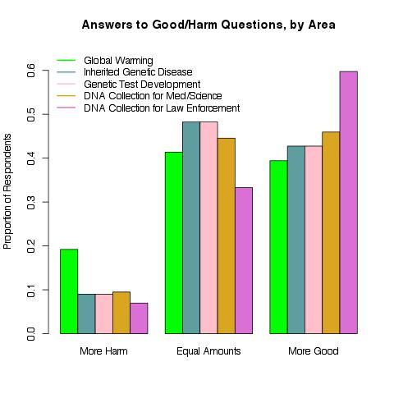

Figure 2: Technology optimism with regard to research on inherited diseases especially likely to affect people of one race or ethnicity, GKAP 2011

- Including religious beliefs

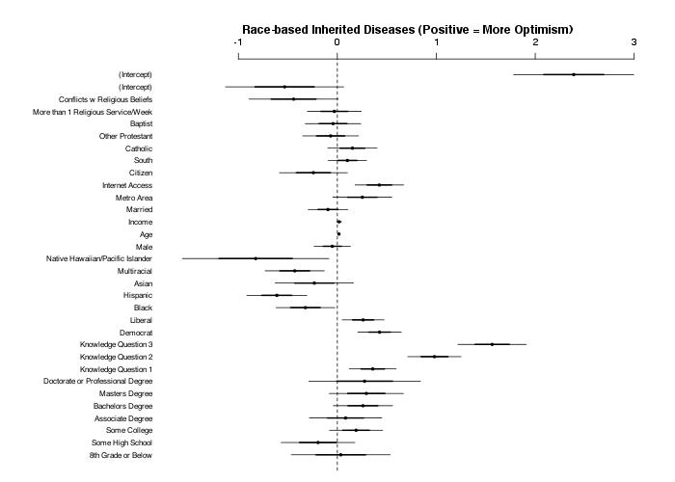

B. Including moral beliefs
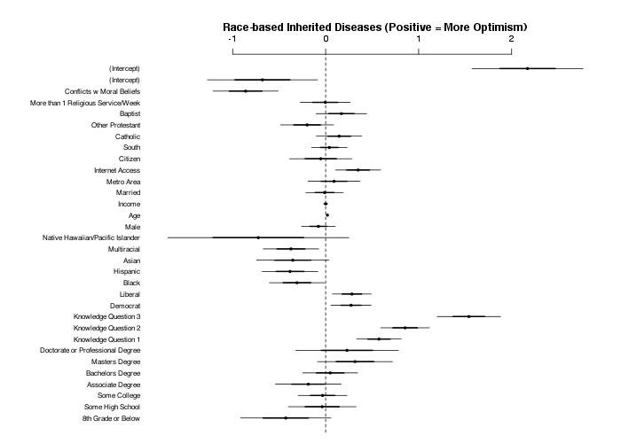

Figure 3: Technology optimism with regard to development of genetic tests to determine an individual’s likelihood of getting an inherited disease, GKAP 2011

- Including religious beliefs

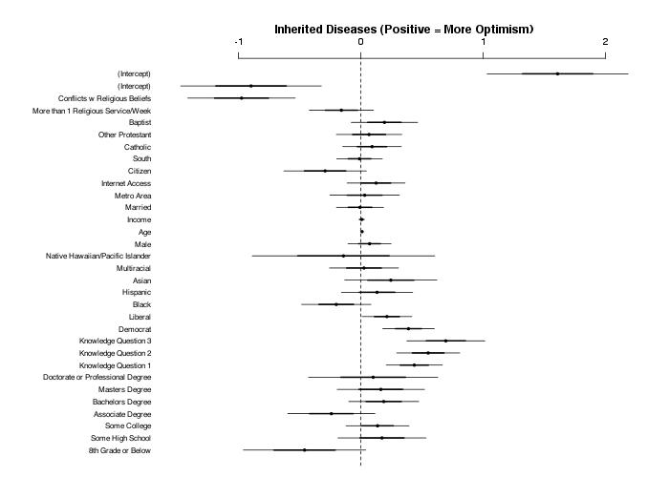

- Including moral beliefs
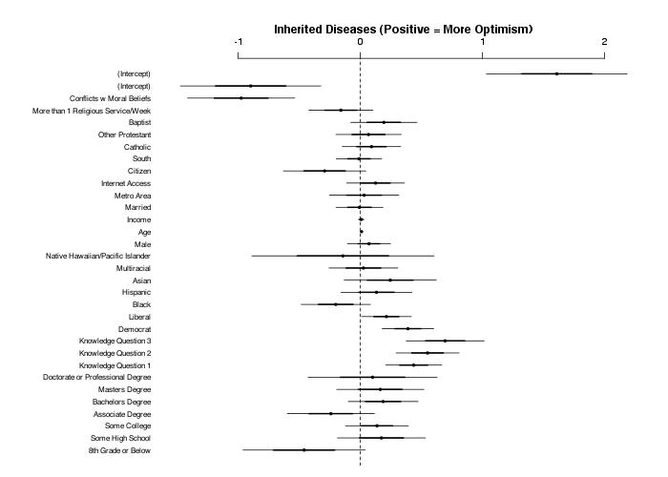

Figure 4: Technology optimism with regard to the use of DNA samples collected from patients or the general public for scientific research, GKAP 2011

- Including religious beliefs

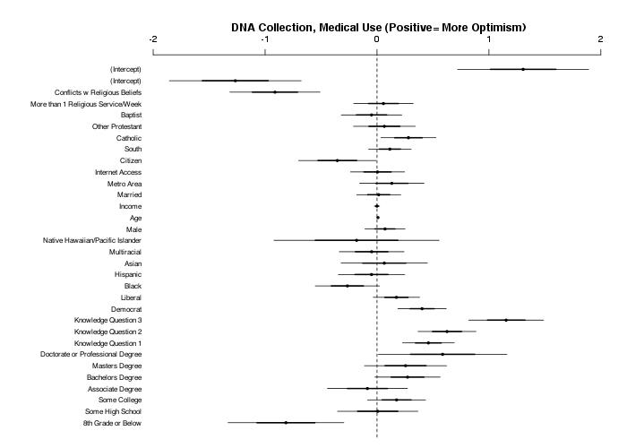

- Including moral beliefs

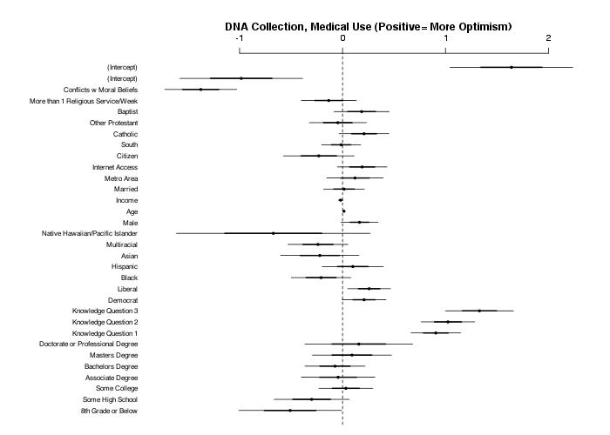

Figure 5: Technology optimism with regard to the use of DNA samples collected from people convicted of a serious crime for law enforcement purposes, GKAP 2011

- Including religious beliefs
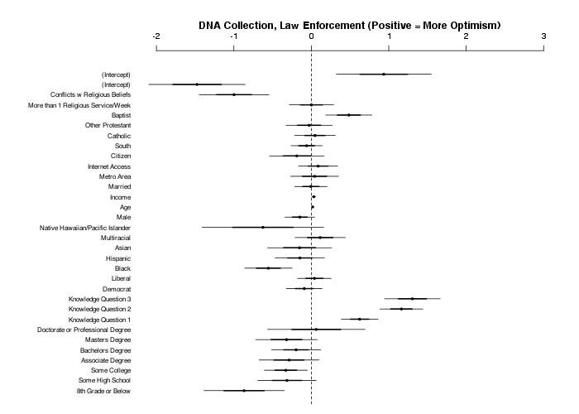
- Including moral beliefs
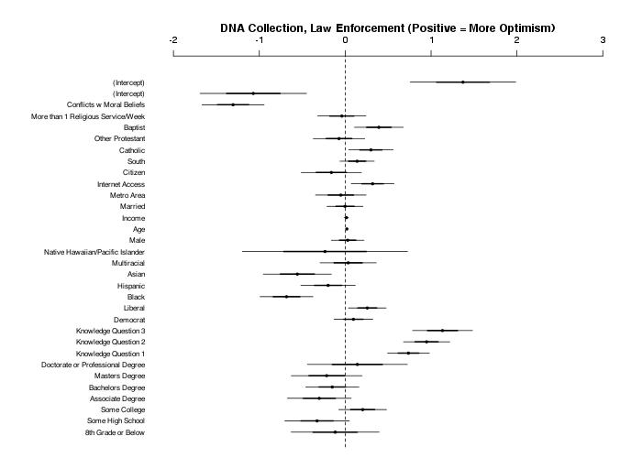

Figure 6: Technology optimism with regard to efforts to slow or prevent global warming, sometimes termed climate change, GKAP 2011

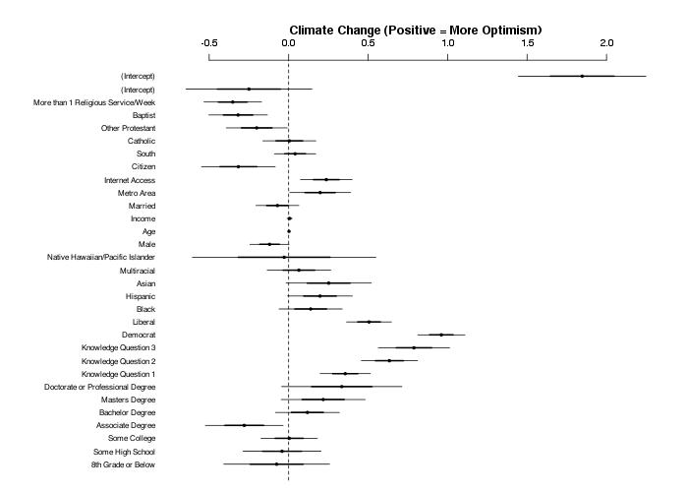

The phrase “technology optimism” is in widespread use, but we first learned it in the context of genomics from (Hjorleifsson et al. 2008). In this paper we treat it as roughly synonymous with risk seeking (aversion) and preference for type 1 (type 2) errors.
One can describe not only individuals but also institutions and policies as implicitly technologically optimistic or pessimistic. A technologically optimistic institution or policy will promote research and development, provide funding, minimize regulation, and create incentives for innovative practices. It will focus, in short, on achievement. A technologically pessimistic institution or policy will encourage oversight, set high barriers to approving controversial new products, move cautiously in reconfiguring governmental agencies, and seek rules to limit misuse of genetic information. It will focus, in short, on protection. Whether technology optimism/pessimism is more usefully understood as a characteristic of human actors or of groups, policies, and institutions is a key question for the larger research project of which this paper is a part.
For an explanation, see http://www.genome.gov/10002328.
Analysis by authors. The next highest is the Army, at 40 percent across 36,400 respondents since 1973. At the other end of the continuum, 12 percent endorse organized labor, and 14 percent endorse both television and Congress. Confidence in medicine has declined, from an average of 53% saying “great deal” across the six surveys of the 1970s to 39% saying the same across the six surveys of the 2000s. Confidence in science declined only 2.5 percentage points from the average of 45% in the 1970s.
Analysis by authors. Liberals (conservatives) were defined as extremely liberal + liberal (extremely conservative + conservative). Moderates’ (slightly liberal + moderate + slightly conservative) support for added federal spending fell between the two extremes; they were much closer to conservatives with regard to government use of science to solve problems.
A respondent could identify with a racial group or as multiracial while also being Hispanic (that is, “Hispanic” is an ethnicity rather than a race in GKAP). However, because many self-identified Hispanics opted not to provide a racial identification, we divided the sample into mutually exclusive categories and treat Hispanics as a “race” from here on. Latinos could take the survey in Spanish (n = 578) or in English (n = 518). We do not focus on racial characteristics in this paper, but we offer them in table 4 for the sake of transparency in explaining the sample.
Collapsing across categories results in similar inferences.
For all GKAP responses, DK/NA represented no more than approximately 3% of the sample; we are therefore not concerned that these individuals are systematically biasing our results.
Variants of this question have been used in surveys around the world, and in arenas ranging from space flight to regulation, Congress, and Facebook.
Figure 1 and some of the explanatory sentences come from (Hochschild et al. 2012).
For each genomics item, half of the sample was asked if the particular endeavor conflicted with, was supported by, or was irrelevant to their religious views; the other half received a parallel question about their moral views. (In each question, the respondent had the option of reporting no religion, or no relevant moral views.) That split sample item explains why the four genomics questions each have two regression analyses; given time constraints, we did not ask the religion/morality question about climate change.
We also have about 4000 open-ended responses to two queries on whether and why respondents would be willing to contribute their own DNA to a medical biobank, and (separately) to a forensic biobank. Those responses have been coded but not yet analyzed.
The reference here is to (Green 2009).
19 out of first 110; check rest
5 out of first 110; check rest
For law, we chose the ten journals that averaged the highest across three ranking systems, the Journal Citation Reports, law review impact factors as determined by Washington and Lee University School of Law (http://lawlib.wlu.edu/LJ/index.aspx), and the top law reviews as measured by eigenfactor (http://www.concurringopinions.com/archives/2010/10/the-top-law-reviews-eigenfactor.html).
Both for reasons of practicality and so that a few disciplines would not overwhelm the overall patterns, we truncated the downloading and coding at the 80 most cited articles (in the highest impact journals) in History and Philosophy of Science and Technology, Psychology, and Ethics. The same will obtain in Anthropology when that search is complete. We also dropped a few journals that were clearly irrelevant to the social science of genomics, especially in physical anthropology. We substituted the next journals on the impact factor list in those instances. The count of coded articles is not yet fixed, since the identifying and downloading continues in a few disciplines.
ELSI stands for Ethical, Legal, and Social Implications [of Genomics]. More formally, “the National Human Genome Research Institute's (NHGRI) Ethical, Legal and Social Implications (ELSI) Research Program was established in 1990 as an integral part of the Human Genome Project (HGP) to foster basic and applied research on the ethical, legal and social implications of genetic and genomic research for individuals, families and communities. The ELSI Research Program funds and manages studies, and supports workshops, research consortia and policy conferences related to these topics” (http://www.genome.gov/10001618). NIH sponsors and generously funds several programs for research grants, conference grants, pre- and post-doctoral training grants, and career development grants. It also sponsors seven interdisciplinary Centers of Excellence in ELSI Research in major universities, and offers opportunities for additional centers to be funded (http://www.genome.gov/15014773#al-4).
The American Journal of Bioethics appears in both disciplinary lists, and a full complement of 40 articles was found in it. We include them in the discipline of History and Philosophy of Science and Technology.
Judging by discussion with the student coders, our own knowledge of the relevant academic literatures, and the results so far of the coding project, we believe that the coders made quite conservative judgments; they did not attribute a valence to an article unless the author(s) explicitly stated a viewpoint or the viewpoint was clearly apparent. We plan to recode the articles in the “Neutral, Mixed, or No occasion” category to see if our longer experience in interpreting academic discourse yields a larger proportion of substantive results with positive or negative valence. If it does, as we anticipate, we will present both sets of findings and enough examples to permit readers to reach their own judgments about whether the more or less conservative interpretation of articles’ valence is appropriate.
We plan to examine the articles in the category of Public Health to see if they can be resolved into the foundational disciplines of economics, sociology, or something else.
The index divides “the percentage of all full-time faculty employed in a given field by the percentage of all faculty signers who are in that subject. A score of more than 100 means that the field is represented among the petition signers in a higher proportion than among the faculty at large” (Ladd and Lipset 1975: 67).
Another survey found an “overall shift from 1969 to 1997. . . to the left,” especially in education and the humanities (among the disciplines relevant here) (Schuster and Finkelstein 2006); quote is in Gross 2013: 33 and data are in Gross 2013: 181).
Gross and Simmons also examined professors’ religious faith. They found relatively small differences across the humanities, social sciences, and physical and biological sciences in reports of atheism or religious conviction. There were, however, considerable differences within these broad divisions. Among the disciplines relevant to this paper, half of the psychologists reported that “I don’t believe in God,” compared with 28 percent of the biologists, 23 percent of the political scientists and economists, 18 percent of the sociologists, 9 percent of the historians and scholars of criminal justice, and none of the faculty in elementary education. (The proportions reporting no doubts about God’s existence followed the same pattern, in reverse) (Gross and Simmons 2009): 116). This pattern accords roughly with our coding results; with the exception of criminologists, the disciplines in which scholars are most inclined toward atheism are also the disciplines in which scholars are relatively favorable toward genomic science. As with political ideology, we cannot infer anything from that accord about the religious convictions of the authors of our coded articles. Nor is it obvious how to reconcile three patterns: the left tends to have less religious conviction, the left tends to be more pro-science, in this arena those with less religious conviction are also more pro-science.
We hope to expand this project to compare public views of other controversial scientific efforts or technologies to the views of experts, in at least a few arenas. We note for now that fewer than a third of the public wants to reduce the use of nuclear power to provide energy (Gallup Poll, March 27, 2013; Nuclear Energy Institute Poll, Feb. 2013), that about seven in ten think the benefits of human space flight outweigh its risks (Attitudes toward America’s Space Program Survey, April 2008), and that 72 percent favor the use of drones “to carry out missile attacks against suspected terrorists in foreign countries” (CBS News/New York Times Poll, May 2013).
The three items testing genetics knowledge were: - Location of DNA in the body (in every cell in the human body, only in specific organs and cells in the human body, don’t know enough to say) – 72 percent correct - Share of white person’s genes identical to those of a black person (more than half, about half, less than half, don’t know enough to say) – 44 percent correct - Share of human being’s genes identical to those of a mouse ( more than half, about half, less than half, don’t know enough to say) – 17 percent correct

