Additional Examples of Stimuli

Target panels are noted at the top of each set. Stimuli are listed in blocks of:

- Normal
- Semantic Only
- Structural Only
- Scrambled

TARGET
- 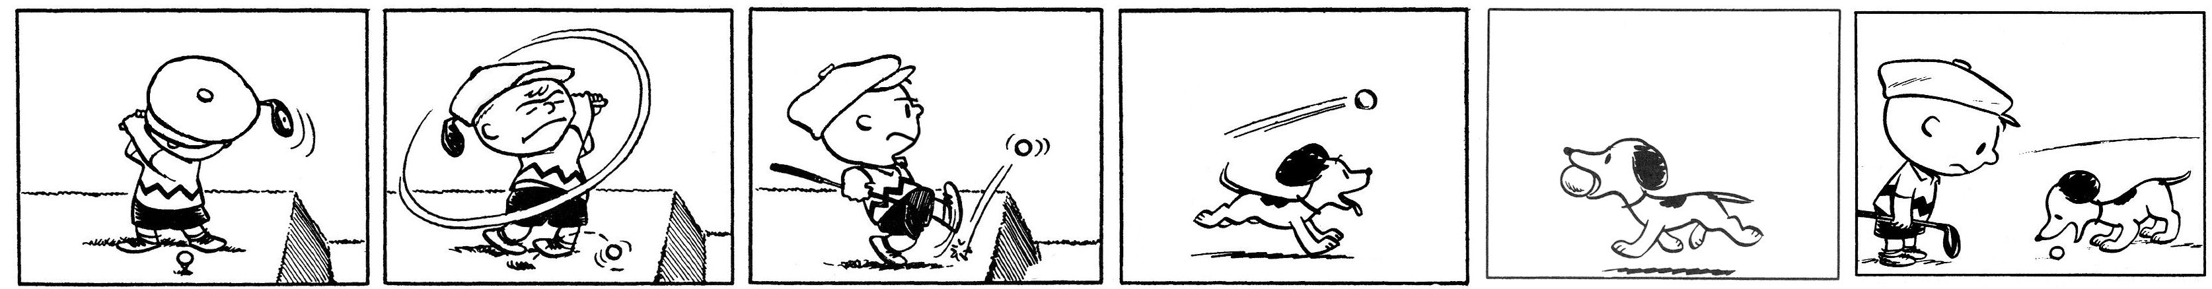
- 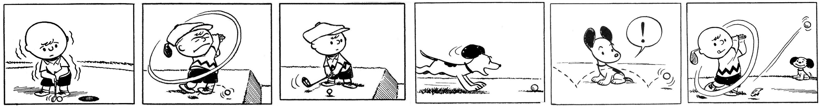
- 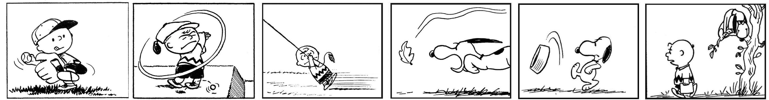
- 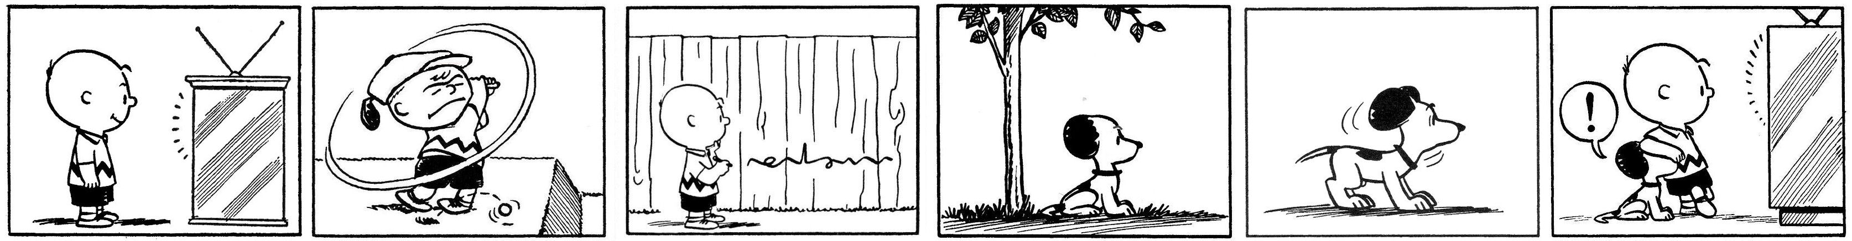

TARGET
- 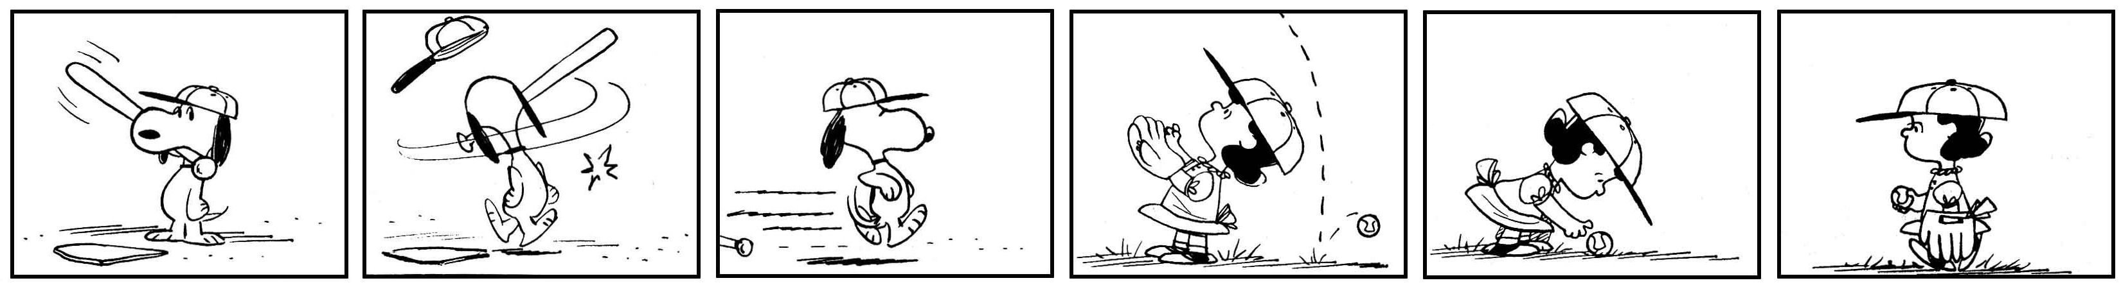
- 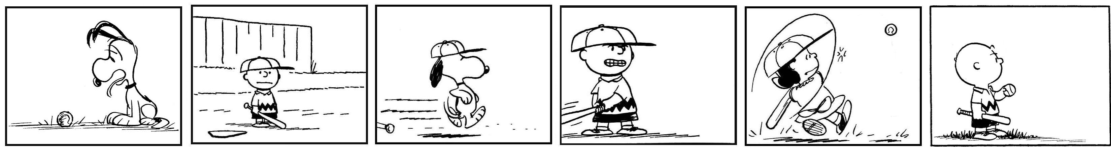
- 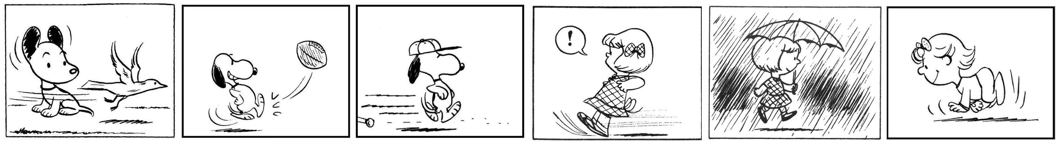
- 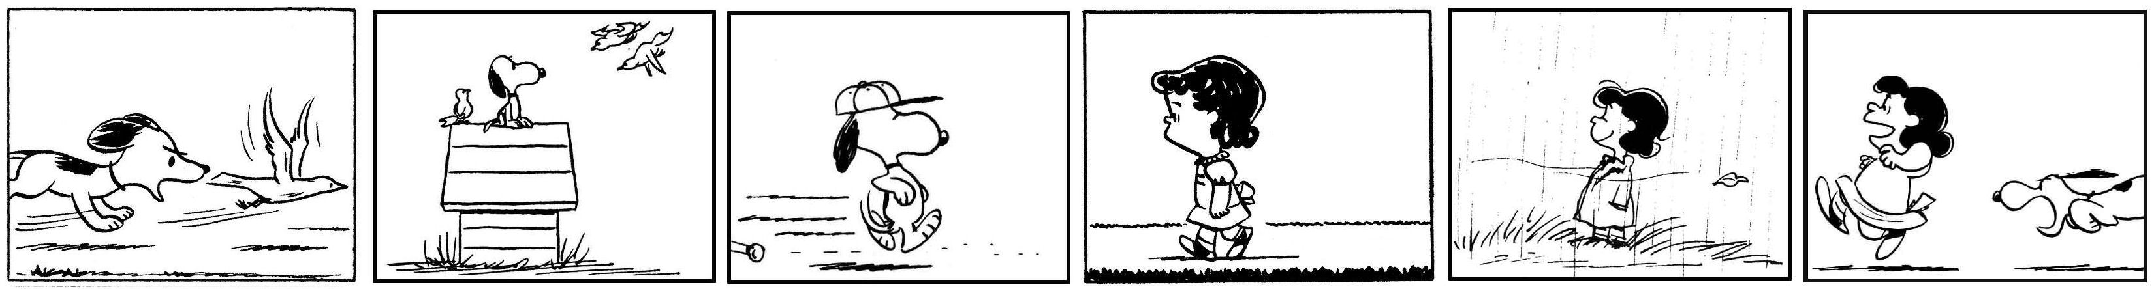

TARGET
- 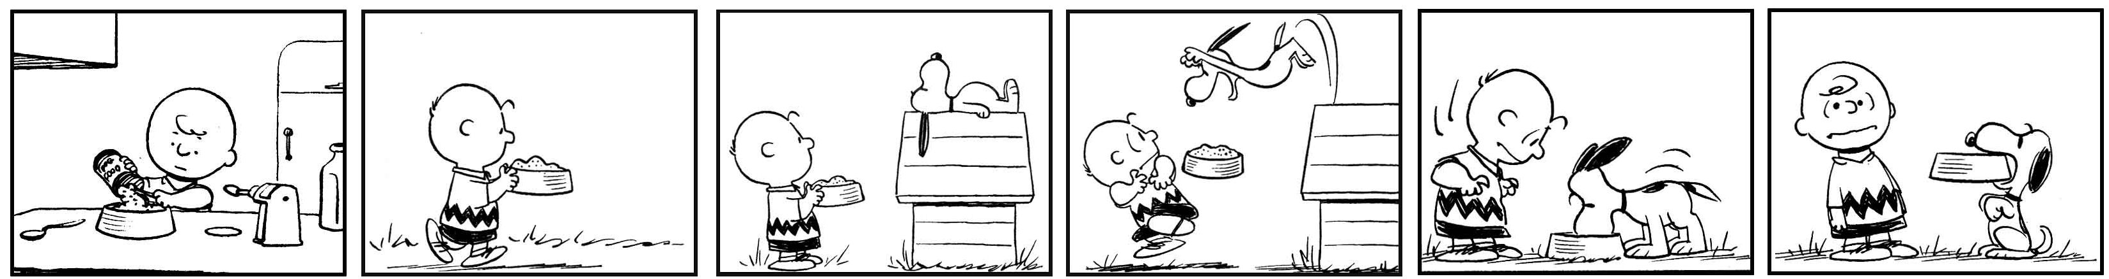
- 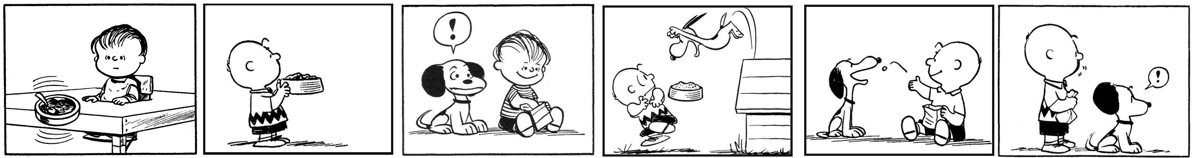
- 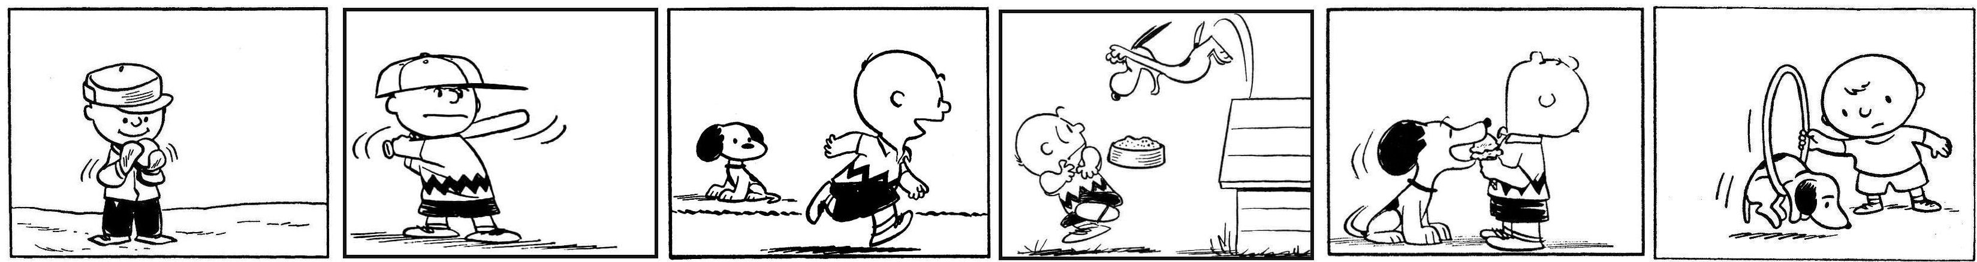
- 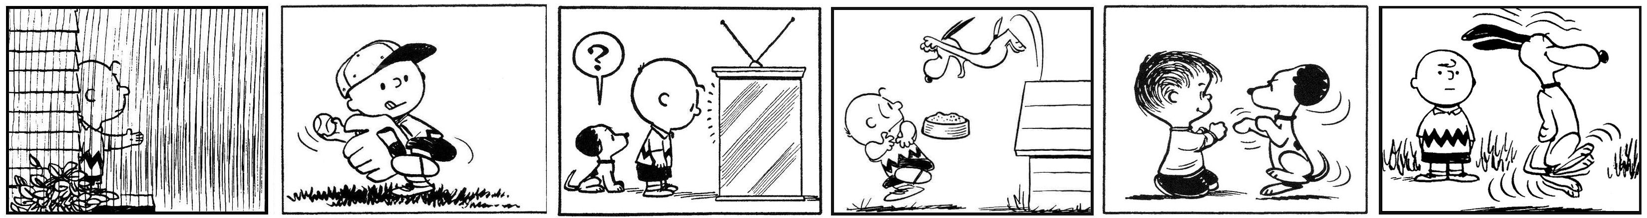

TARGET
- 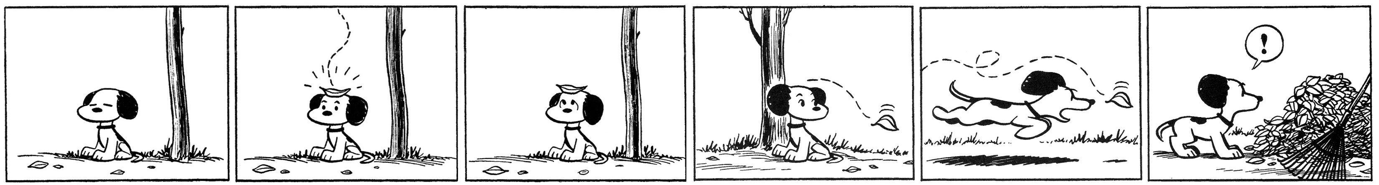
- 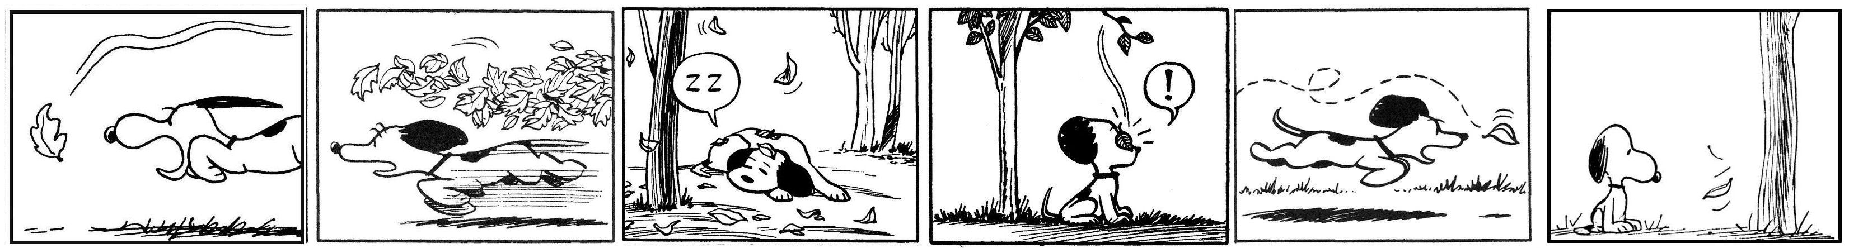
- 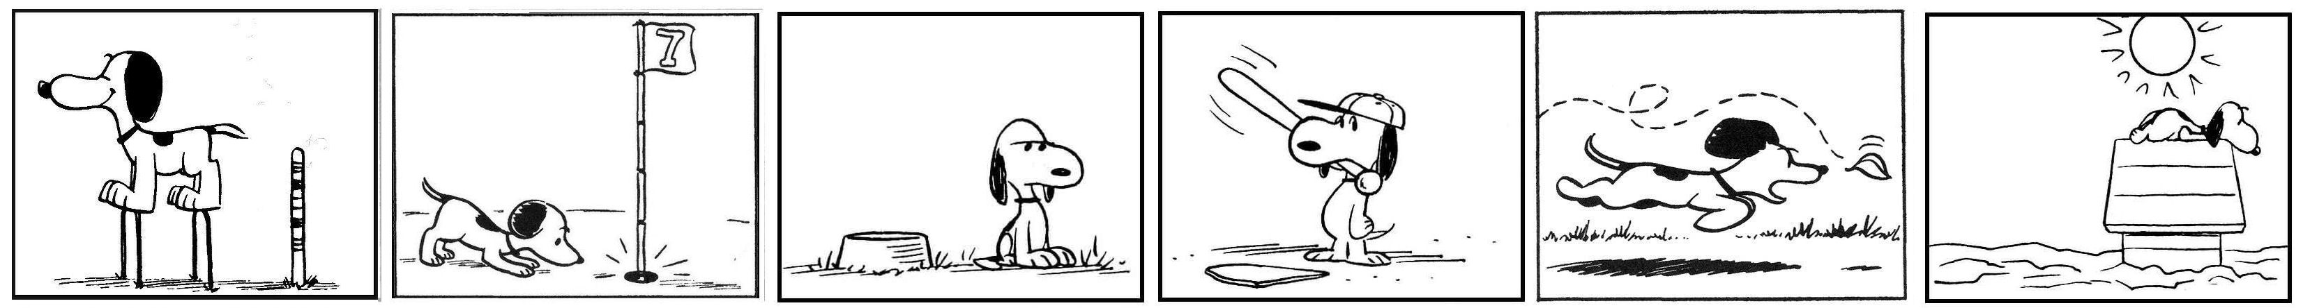
- 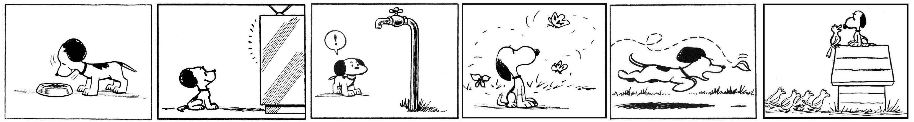

TARGET
- 
 