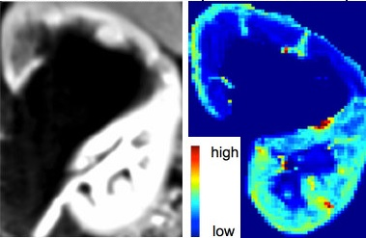
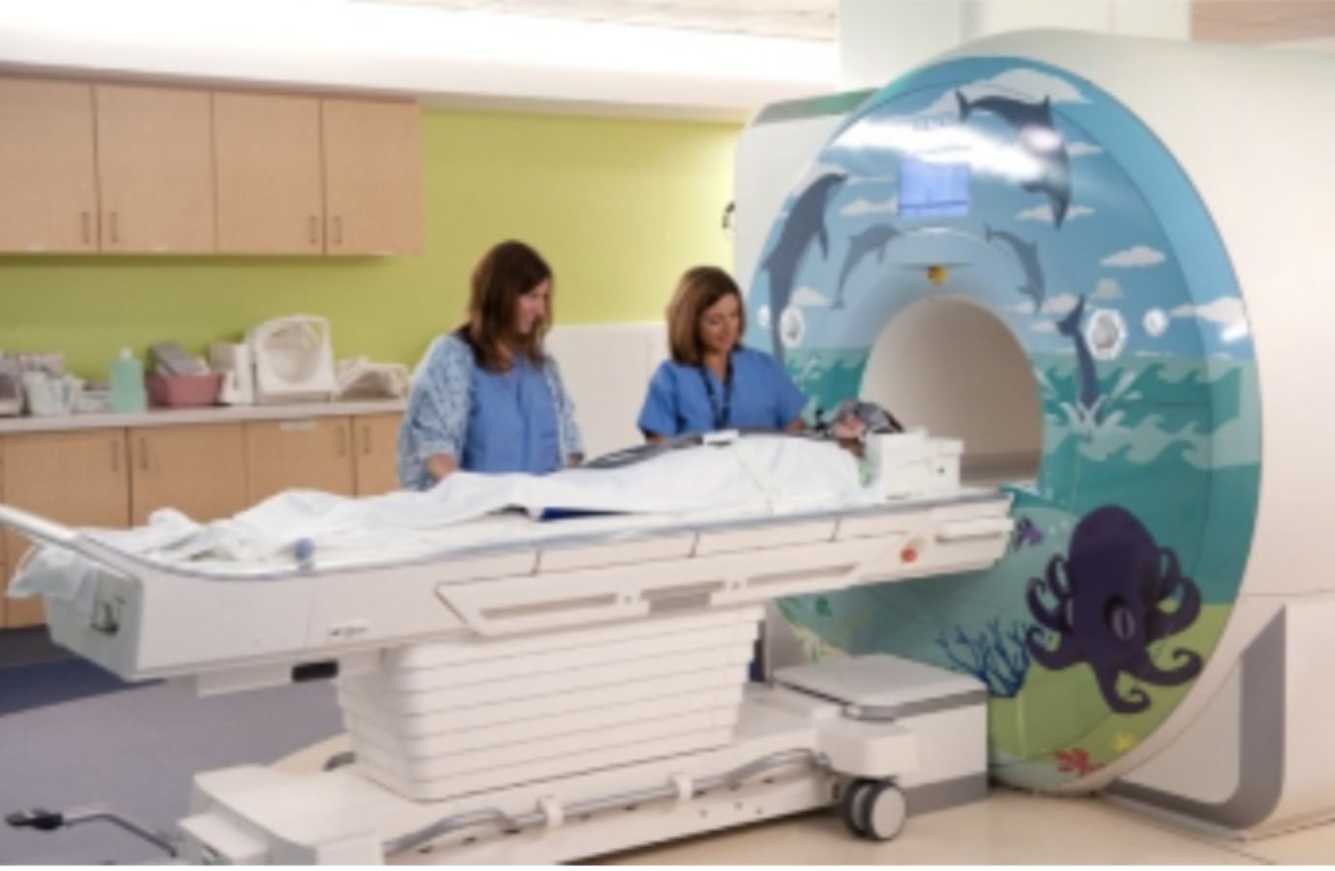
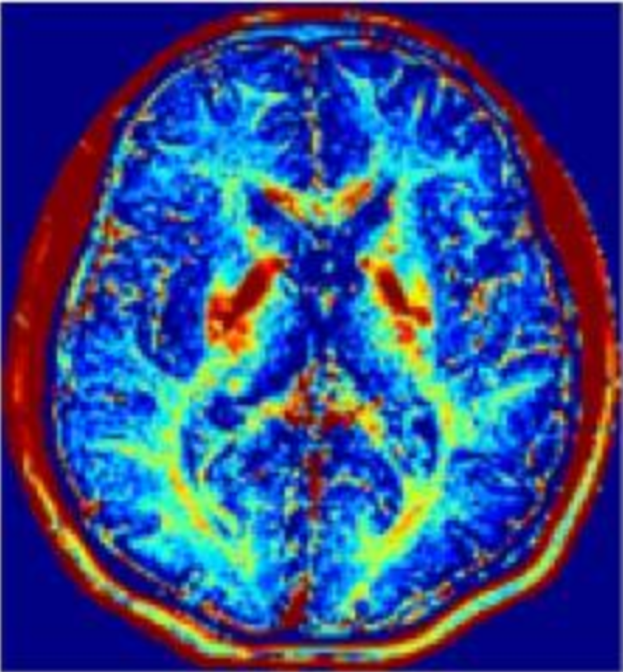
Multiple Postdoctoral positions at Boston Children’s Hospital and Harvard Medical School
Position description: The Computational Radiology Laboratory (CRL) directed by Prof. Simon Warfield at Boston Children’s Hospital and Quantitative Intelligent Medical Imaging (QUIN) lab directed by Asst. Profs. Sila Kurugol and Onur Afacan at Harvard Medical School has several immediate opening for highly motivated post-doctoral research fellows to develop automated image analysis using deep learning tools, motion-compensated image reconstruction algorithms, and motion-robust quantitative MR imaging techniques to compute imaging markers of disease from MR images of abdomen and brain for projects funded by the National Institutes of Health.
The researchers will develop highly innovative imaging and image processing techniques and software tools including image segmentation, registration approaches, machine learning algorithms to analyze images, correct for motion and distortion, and reconstruct high-resolution images and estimate quantitative model parameters to generate marker of disease in using several quantitative MRI techniques. The researchers will have access to radiologists, MR physicists, will have mentorship from an expert team of principal investigators and will attend courses and seminars offered at Boston Children’s Hospital, Harvard Medical School, and Harvard Catalyst.
About CRL and QUIN: The mission is improving our understanding of the structure and function of the brain and other organs of the human body, in order to improve our capacity to diagnose and treat disease. CRL and QUIN labs are located at Boston Children’s Hospital (BCH), which is ranked #1 in US News ranking of pediatric hospitals. Researchers at these labs are affiliated with Harvard Medical School which is ranked #1 in US News ranking of medical schools. Boston is known as a hub for healthcare and medical innovations, and a beautiful city full of top-rank universities. Opportunities for cross-training and networking are enormous with several top-rank universities (Harvard, MIT, Northeastern, and Boston University), top-rank hospitals and medical research centers, and biotechnology and pharmaceutical companies in the neighborhood.
Position 1: Postdoctoral fellowship in machine learning methods for MR image analysis
Minimum requirements
- PhD in electrical or biomedical engineering, computer science, medical physics, or a related field with a research focus on biomedical image processing/medical image computing, machine learning, computer vision, and/or magnetic resonance imaging
- Demonstrated record of high-performance scientific programming with python and/or C++
- Demonstrated record of high-quality publications in the field
- Demonstrated analytical, verbal thinking and scientific writing skills

Highly desired qualifications:
- Experience in machine learning/ deep learning in MRI
- Experience in MR image analysis
- Experience in semi supervised learning/ transfer learning/ active learning

Position 2: Postdoctoral fellowship in quantitative MRI

Minimum requirements
- PhD in electrical or biomedical engineering, computer science, medical physics, or a related field with a research focus on biomedical image processing/medical image computing, machine learning, computer vision, and/or magnetic resonance imaging
- Demonstrated record of high-performance scientific programming
- Demonstrated record of high-quality publications in the field
- Demonstrated analytical, verbal thinking and scientific writing skills

Highly desired qualifications:
- Experience in machine learning/ deep learning in MRI
- Experience in MR image acquisition
- Experience in MR image reconstruction
- Experience in MR image analysis
Position 3: Postdoctoral fellowship in MRI physics and signal processing
Minimum requirements
- PhD in electrical or biomedical engineering, computer science, medical physics, or a related field with a research focus on biomedical image computing, magnetic resonance imaging, pulse sequence development
- Demonstrated record of high-quality publications in the field
- Demonstrated analytical, verbal, and scientific writing skills

Highly desired qualifications:
- Demonstrated record of high-performance scientific programming
- Experience in one of the following is preferred:
  - Experience in MR image acquisition
  - Experience in MR image reconstruction
  - Experience in MR image analysis

To apply: Please send your CV along with a copy of a technical paper, the desired start date, a paragraph including statement of goals and three references to Dr. Sila Kurugol (sila.kurugol@childrens.harvard.edu) and Dr. Onur Afacan (onur.afacan@childrens.harvard.edu). Computational Radiology Laboratory, Boston, USA. http://crl.med.harvard.edu/

