Science Center Custodial Staff

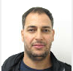Mohamed Himmad, supervisor
Science Center B11.30
email: mohamed_himmad@harvard.edu
cell: 617-485-9486 office: 6-1252
6AM-2:30PM shift
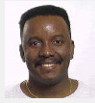Michel Montimes, daytime crew chief
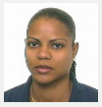 Sanyi Rodriquez
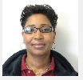 “Mary” Erline Celestin
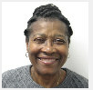 Yanic Volmar

2:30PM-11PM shift

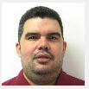 Cristian Diaz, evening crew chief
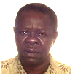Louverture “Charlie” Charles
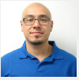Kevin Callero-Diaz

