How HarvardKey holders set up a profile in the Harvard University Funding Portal

Go to this link: https://harvard.communityforce.com/Funds/Search.aspx
Select “Login” from the upper right corner (see screen shot below)
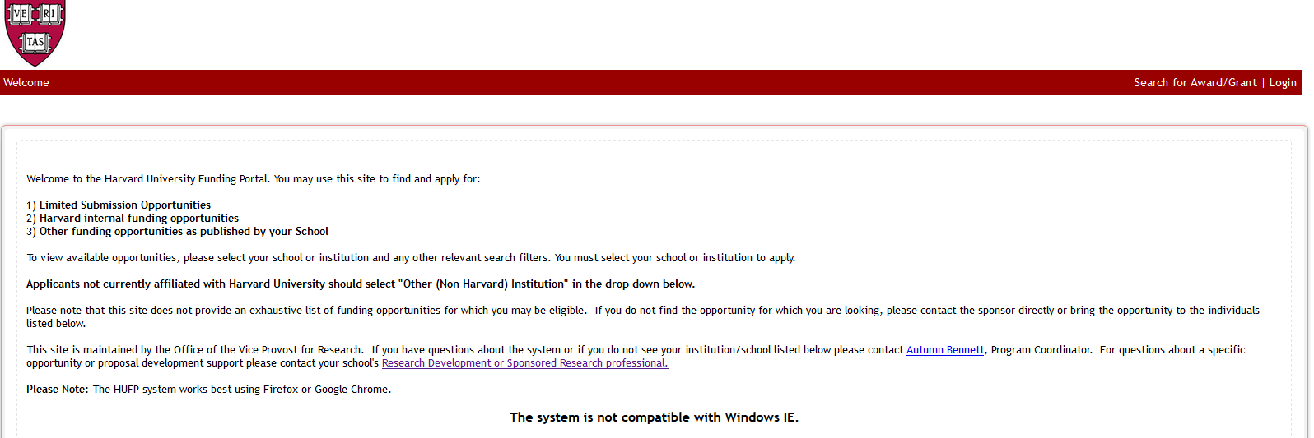

The next screen on your computer will look like this:
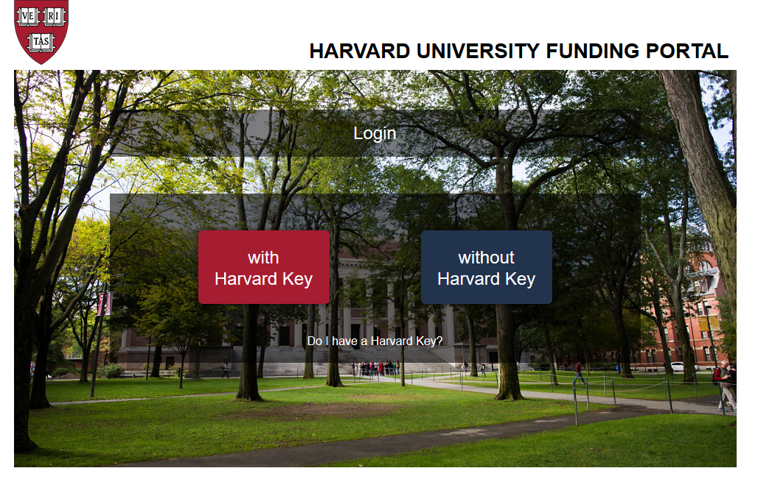
Select the “with Harvard Key” option

The next screen to appear is the Harvard Key login page.
Please enter your KEY information in the fields below

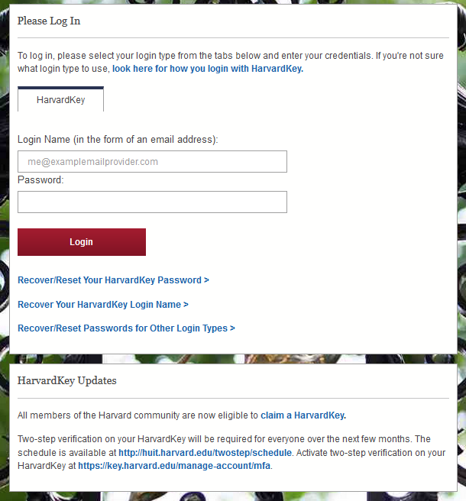

The next and final step is a one-time registration process where you will be asked
- First name
- Last name
- Email
After this step, users can log in to the portal from anywhere, at any time by going back to the Login screen.
Please note: Due to the Harvard IT security environment, first time users must register in the portal using their Harvard issued computer. A proxy cannot establish a user account on behalf of another.

