Setting up a profile in the Harvard University Funding Portal for applicants at institutions other than Harvard

Go to this link: https://harvard.communityforce.com/Funds/Search.aspx
Select “Login” from the upper right corner (see screen shot below)
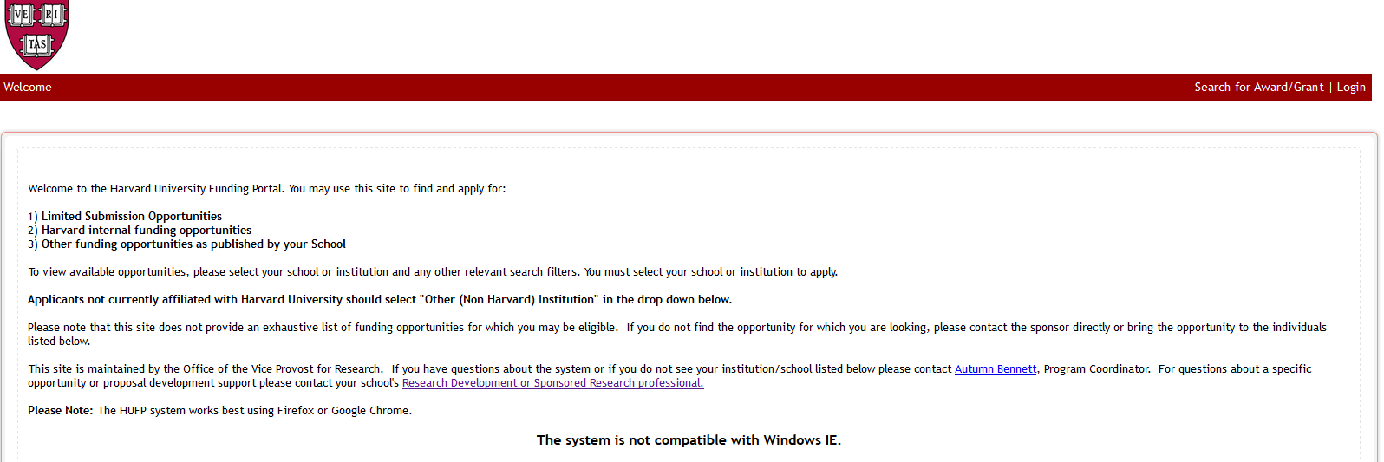

The next screen on your computer will look like this:
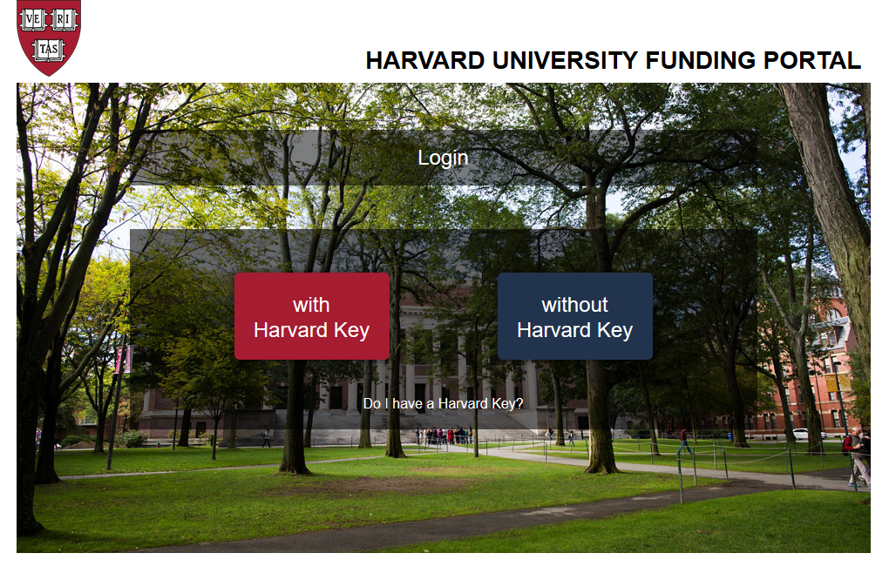
Select the “without Harvard Key” option

The next screen instructs users based on their status with the system:
- If a New User, please select “Create New Account”
- If a Returning User, please enter the email address and password used when first registering with the portal

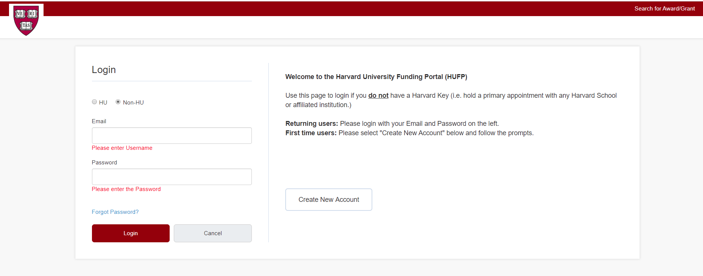

NEW USER Registration Screen:
